act_report

May 10, 2020

1. Introduction

In this paper I want to communicates the insights and displays the visualizations produced based on wrangled data of tweet archive of Twitter user @dog_rates, also known as WeRateDogs. WeRateDogs is a Twitter account that rates people's dogs with a humorous comment about the dog. The account was started in 2015 by college student Matt Nelson, and has received international media attention for its popularity. WeRateDogs asks people to send photos of their dogs, then tweets selected photos rating and a humorous comment. Dogs are rated on a scale of one to ten.

1. Insights and visualizations

According to the analysis the dog called Stephan (Chihuahua) got the most 'likes' (120993) and most retweets (56901), three the most popular dog names are Cooper, Charlie and Oliver and it's more likely that user post one image per dog.

The majority of users prefer to utilize the mobile Tweeter application, as the following diagram shows. Much less people use Tweeter web client and TweetDeck.

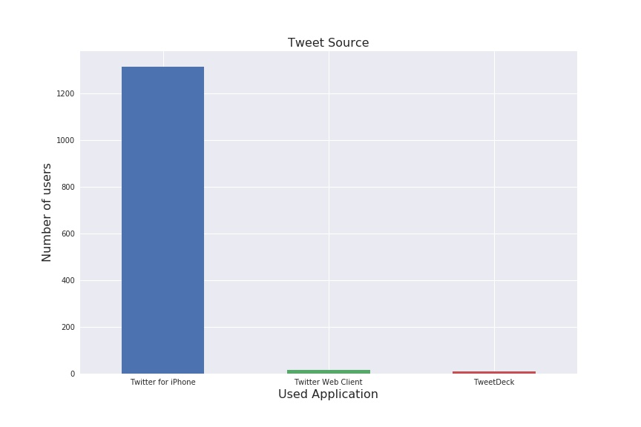

Three the most popular dog breeds are Golden Retriever, Pembroke and Labrador retriever. The ranking of ten most popular dog breeds are shown on a picture below

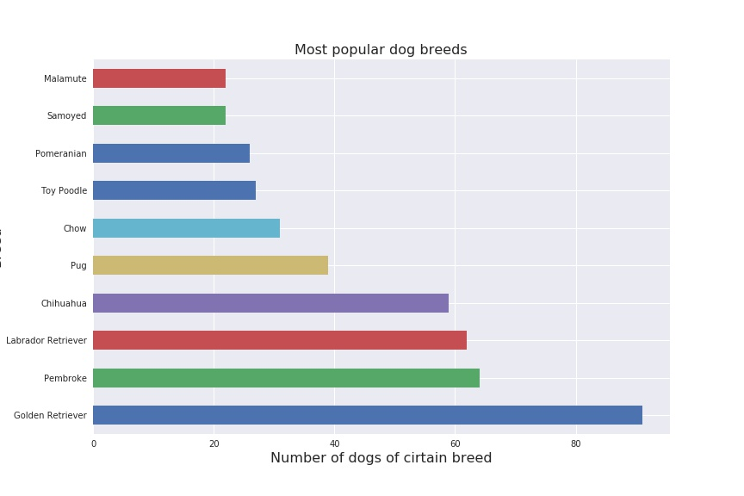

Most of dogs are classified in the 'Pupper' stage: "A pupper is a small doggo, usually younger. Can be equally, if not more mature, than most doggos. A doggo that is inexperienced, unfamiliar, or in any way unprepared for the responsibilities associated with being a doggo."

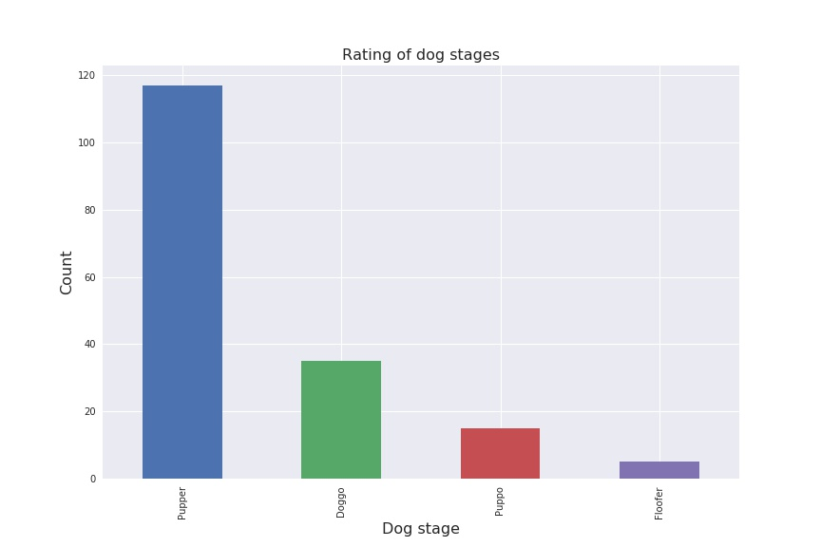

The most retweeted tweets get more likes. It is not wondering. The more people see the tweet the more is the probability that user will like the tweet

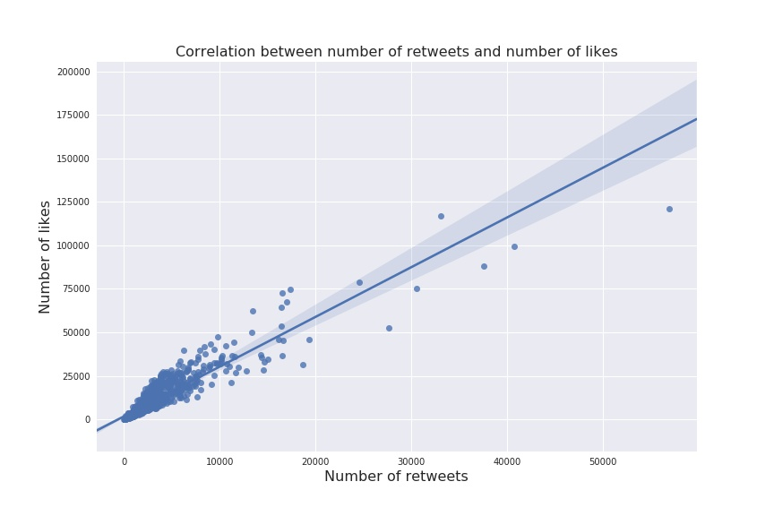

By the way, the posted pictures of dogs were mixed with pictures of other object and fed through the neural net with a goal to predict, whether or not the shown picture is a picture of a dog. The results of predictions are shown below.

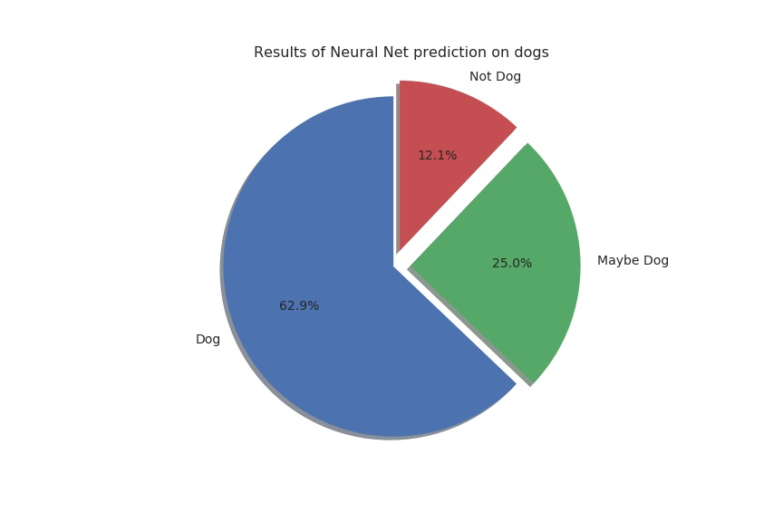

We see that in most cases the neural net was confident in prediction of a dog and its breed

