Facility Advisor - Electrical Team Meeting Notes
Project: Universal Plastic Shredder V2.0
Date: 01/09/26
Time: 04:00 PM - 05:00 PM
Location / Call Link: In-person

Attendees
- Electrical Team:
  - Bao Nguyen
  - Fearghus Tyler
  - Yaqoub Rabiah
  - Fox Kang

- Faculty Advisor:
  - Jonathan Bird

Meeting Purpose
- Determine meeting schedule between all parties including Mechanical Team, Faculty Advisor, and Electrical team
- Assign members task and responsibilities

Mechanical/Electrical/faculty scheduling Discussion
- Mechanical Team Availability
  - TBD
- Faculty Advisor Availability
  - Fridays 12:30 to 01:00
- Electrical Team Availability(Electrical Team)
  - 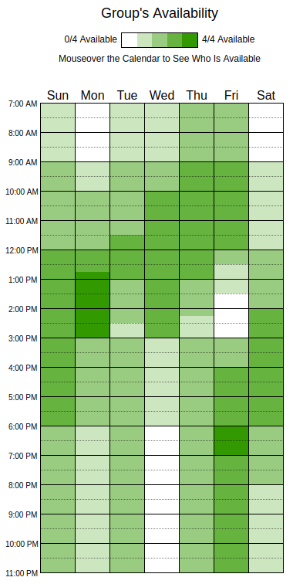
  - Mondays from 1-3
  - All day Friday

- Weekly meeting times with Faculty advisor that we agreed on
  - Fridays 12:30PM - 01:00PM

Figure out what we need to do by Next Friday
- Bao Nguyen:
  - Determine what information should be shown on the screen
  - Compare and research HMI options (work with Yaqoub)
    - Siemens HMI(From Fearghus)
    - Automation direct
    - ESP32 based HMI
  - Decide what telemetry we want(Group)
    - Current
    - Voltage
    - Fault bits
    - Fault pictures
    - RPM
    - Buzzers?
  - Extra time?
    - HMI screen layout
    - Research HMI to VFD connection
- Fearghus Tyler:
  - Create a basic bill of materials (BOM)
  - Work with Mechanical teams to figure out motor power and torque needs
  - Source motors, make matrix of motor options
    - Cost
    - Power
    - Features
    - Torque
    - Rate them etc
  - New questions: 120VAC or industrial power?

- Yaqoub Rabiah
  - Preliminary research on how VFD measures current and be programmed and connected to HMI
  - Work on ideas for jam detection and current limiting.
  - VFD matrix compare and research options
    - Ed may have free VFDs( From Bao)
    - Automation direct VFD (Similar to Power lab)
    - Cost
    - Power
    - Features
    - Current and rpm telemetry
    - Any other info we want?
    - What protocol does it use?

- Fox Kang:
  - Look into ways to detect a human hand inside the machine.
    - Capacitive safety sensors like saw stop?
    - Thermal?
    - Switches?
  - Research Capacitive safety sensor

- Team
  - Make a matrix of options
    - like find a bunch of motors and find what you want, cost power, features, and rate them a total them
    - Types of HMI
    - Switches, sensors
    - VFDs
  - Contact Mechanical team
  - Finish by next friday meeting 12:30-1:00

Issues / Risks Identified
- Choosing between a cheaper ESP32 display and a more expensive industrial HMI.
- Making sure safety systems are reliable.
- Cost of VFD
- Cost of Sensors
- Cost of motors 3 phase? Brushless, AC, DC?
- Connecting the VFD, HMI, and safety sensors correctly.

Decisions Made
- Weekly advisor meetings will be every Friday from 12:30 PM to 1:00 PM.
- Motors, HMI, VFD, Sensors will be chosen using a scoring matrix.
- Safety design will happen at the same time as controls and interface design.

Next Meeting
- Date: Friday, 16th
- Time: 12:30-1:00
- Focus:
  - Review motor comparison table
  - Review HMI comparison table
  - Review VFD comparison table
  - Review Sensors comparison table
  - Discuss early safety ideas

Notes / Other Comments
- Continue VFD research
- Figure out power and control voltages
- Set up and organize GitHub
- Look into Siemens display with physical buttons
- Define interface standards
- Explore magnetic failsafe ideas
- Research VFD current limiting
- Look into SawStop-like safety ideas
- Decide if a different VFD approach is needed
- Work on a new VFD?

