Tab 1

Sponsor - Electrical Team Meeting Notes
Project: Universal Plastic Shredder V2.0
Date: 01/16/26
Time: 11:00 AM - 11:30 PM
Location / Call Link: Microsoft Teams

Power and System Constraints
- System will use standard 120 VAC power
- 3 HP motor is borderline for 120 V
- Power availability may limit final motor selection

Mechanical Team Status
- ME team is having difficulty sourcing:
  - Sprocket
  - Bearings (unusual sizes)
- Chain drive is being considered for shaft coupling
- Gearbox likely required between motor and shafts

Motor and Torque Targets
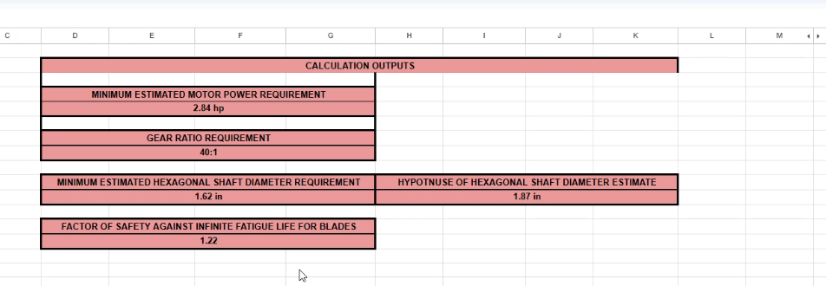
- Minimum motor power identified: 0.79 HP
- Desired motor power: 3 HP
- Target torque range: 450–500 Nm
- Proposed gear ratio: 60:1
  - Corresponds to approximately 1.89 HP requirement

Safety Considerations
- Add deadman’s switch
- Discussed possible advanced safety concepts:
  - Deadman-style control
  - SawStop-style safety (conceptual only)
- Safety approach still under discussion

Mechanical Design Details (from Bridget)
- Shaft diameter: 1¾ inches
- Shaft and tooth clearance area: 6” × 9”
- Tooth engagement area: ~7 inches
Teeth are offset by 0.7 inches
- Maximum torque: 450–500 Nm

Electrical Team (ECE) Action Items
- Create a preliminary BOM for review
- Support ME team with component sourcing
- Evaluate feasibility of Siemens HMI
- Account for 120 V power limitation in electrical design

Schedule / Administrative
- Next meeting will include:
  - Manager
  - HR representative
- Purpose: progress report
- Emphasis on delivering BOM as soon as possible

Notes / Open Questions
- Final definition of “deadman’s switch” needed
- Confirm whether Siemens HMI fits project scope and budget
- 120V power
- 1 ¾” thick shafts
- 6” by 9” area around shafts and teeth
- Chain drives for the shafts?
- Gearbox with motor
- 7” area for teeth
- Teeth are offset by .7”
- We (ECE) need to make a BOM for Bridget
- Next meeting is with manager & HR rep for a progress report
- 120V socket for power (3 HP is pushing it)
- Sooner we get the BOM the better
- Deadman’s switch safety? Whatever that is.
- Maybe SawStop safety?
- Max torque: 450-500 Nm
- 60:1 gear ratio for 1.89 HP
- Siemens HMI?

