PSU ECE Capstone Team Contract

Contact Information

Team Members
Team Member Name | Phone | Email
Bao Nguyen | 408-659-9355 | baon@pdx.edu
*Fearghus Tyler* | 503-969-0723 | fearghus@pdx.edu
Fox Kang | 503-519-4281 | foxkang@pdx.edu
Yaqoub Rabiah | 503-816-9361 | yrabiah@pdx.edu
If you have a project coordinator or leader, please mark them with an asterix (*).

Industry sponsor
Organization and Name | Phone | Email
Ichor Systems,  Bridget Lannigan | 503-783-2117 | blannigan@ichorsystems.com

Faculty Advisor
Name | Phone | Email
Jonathan Bird | 503-725-9059 | bird@pdx.edu

Project Objective
The objective of the electrical team for the Universal Plastic Shredder V2.0 (aka Shreddar) is to design safe and robust electrical control systems in conjunction with the mechanical team. The system will support an industrial-grade shredder capable of processing industrial plastic materials such as PVC, Polypropylene, and LDPE into approximately 1-inch pieces. The electrical system will be designed in accordance with NFPA 70 (NEC), with electrical enclosures selected to meet NEMA requirements appropriate for the operating environment.”

Electrical work will include VFD-based motor control, an emergency stop, safety interlocks, overload or jam protection, and telemetry such as motor current, lockout indicators, voltage, and fault status. If the minimum viable product (MVP) is achieved early, the team will explore, develop, and implement open-source capacitive touchbased hand or body detection and thermal sensing safety mechanisms to enhance operator protection beyond typical industrial solutions.

The electrical system will be developed within a target budget of $1,000 (subject to change) and delivered as an integrated control solution that operates reliably with the mechanical shredder developed by the mechanical engineering team.

Member Skills, Strengths, and Areas of Practice
This table should be derived from your team canvas and team discussions, and then used throughout the project in determining task ownership, team processes and helping each other develop skills. We don’t like “weakness”. The weak will be executed. As much as “areas where one needs practice”.
Teammate Name | Key areas of strength to leverage in the project | Key areas of practice and development in the project
Bao Nguyen | Strong with 3D printing/Modeling  Experience with PCB cutting and soldering  Comfortable building hardware | Basic Programming/coding  Combining telemetry data with an ESP32
Fox Kang | Experience with PCB designing  Experience with welding and assembling circuits | Basic Programming
Yaqoub Rabiah | Experience with embedded systems and programming  Experience in circuit design and organization | PCB cutting, designing, and soldering
Fearghus Tyler | Professional experience in industrial shredders and manufacturing. | VFD programming, ladder logic, circuit design

Meetings

Team Meetings
- Frequency: Weekly
- Proposed days and times: Mondays 1 PM - 3 PM, Fridays after 3:00 PM class
- Platform: In person, Microsoft teams, discord
- Expectations: Come prepared with progress updates and questions
- Agenda:Scrum
  - Status updates from each team member
  - Coordination with mechanical team needs
  - Identify issues, risks, and next steps
- Prep: Review assigned tasks and bring progress updates or questions
- Attendance: Expected at all meetings unless communicated in advance
- Participation: Active involvement in discussion and decision-making
- Note-taking (minutes): Notes recorded and shared after each meeting
- Other expectations: Communicate respectfully, meet deadlines, and follow agreed-upon team processes

Team meeting with Industry Sponsor (Faculty Advisor invited)
- Frequency: Weekly/ bi-weekly
- Proposed days and times: Fridays, 11:00 AM - 11:30 AM, Office Hours
- Platform: Teams
- Expectations: Communicate respectfully, meet deadlines, and follow agreed-upon team processes

Team meeting with Faculty Advisor
- Frequency: Weekly/Bi-weekly
- Proposed days and times: Fridays 12:30-1:00 PM
- Platform: In person.
- Expectations: Arrive with assigned task update, necessary questions and prepare to give a brief explanation of our goals until the next meeting.

Communications

Preferred Method of Communication
List your communication tools and if there is anything important about how you use them
- Discord: Primary tool for day-to-day team communication and quick updates
- Email: Used for formal communication and messages involving faculty or the sponsor
- Microsoft Teams: Used for scheduled meetings, calls, and shared documents

Information Architecture
GitHub will be used for version control of code, documentation, and technical files related to the electrical system. Issues and milestones will be used to track tasks and deadlines. Google Drive will be used for shared documents such as reports, meeting notes, drafts, and reference materials. Folder structure and access permissions will be maintained by the project coordinator to ensure consistency and version control.

Team Working Agreements and Expectations

Guiding principles of how we work together
Are there any thoughts or values that guide how your group works together?
Professionalism is important to our group, as well as cohesive communication.

How we make decisions
How does your group make decisions?
Decisions are made by majority vote. For any specific section of the project, the team member primarily responsible for that section is given priority. Their vote counts as two points for that section, while each other team member’s vote counts as one point.

Approach to conflict
If a problem or disagreement comes up, we will talk about it as a team in a respectful way. If we cannot solve the issue on our own, we will ask the Faculty Advisor for help. If needed, the issue may be taken to the Capstone Coordinator.

How we will hold each other accountable
We will check progress during weekly meetings using Scrum-style updates. Each team member is responsible for completing their assigned tasks and giving updates. If someone is falling behind, the team will talk about it and help fix the issue. If the problem continues, it will be brought to the Faculty Advisor.

How we will give and receive feedback
- We will give and receive feedback regularly to help the team improve. Feedback will be shared in a respectful and supportive way. We will focus on actions and completed work, not personal traits. When giving feedback, we will use specific examples and explain how the situation affects the team or project. We will also listen to the other person’s perspective and work together to find a solution. If needed, we will create a clear plan to help each other stay on track and meet expectations.

Team Contract Signatures
By typing in your name, you agree:
- I participated in formulating the standards, roles, and procedures as stated in this contract.
- I understand that I am obligated to abide by these terms and conditions.
- I understand that if I do not abide by these terms and conditions, I will suffer the consequences as stated in this contract.

Team Member Name
Fearghus Tyler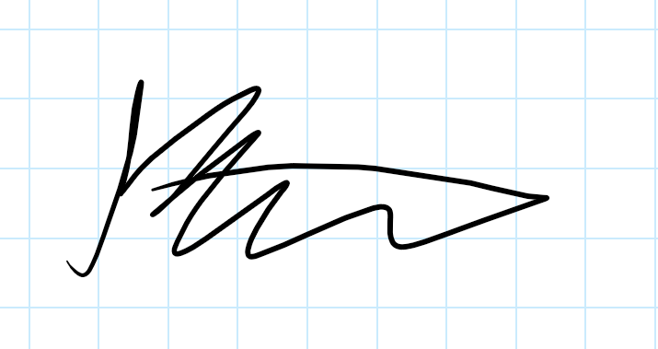
Bao Nguyen
Yaqoub Rabiah 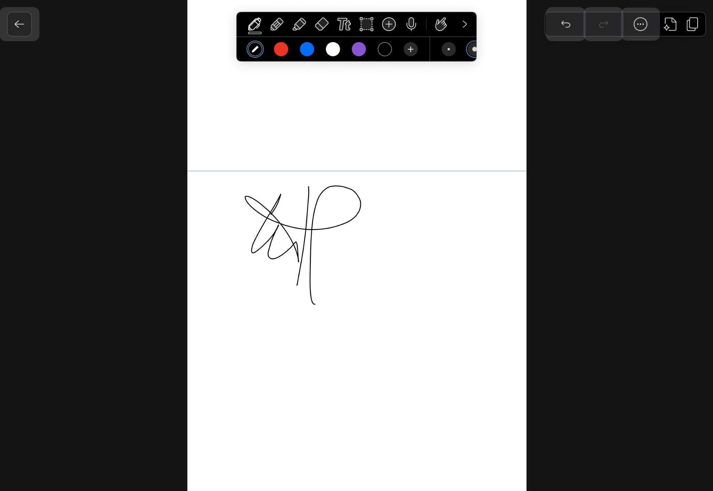
Fox Kang