A+ Computer Science If Else If – MOUSE BUTTON TESTER Lab Value - 100

Lab Goal : This lab was designed to teach you more else if statements.
Lab Description : Write a program that will test to see which mouse button was pressed. If the left mouse button is pressed, draw a rectangle at that location. If the right mouse button is pressed, draw a circle at that location. Feel free to change the colors, sizes, and shapes however you want.
The Java docs on MouseEvent will prove very useful for this lab.

MouseEvent methods
getX() – gets X position
getY() – gets Y position
getButton() – gets button #

MouseEvent fields
BUTTON1
BUTTON2
BUTTON3

Files Needed ::
MouseButtonTester.java
MouseButtonTesterRunner.java

Sample Data :
lots of mouse clicks

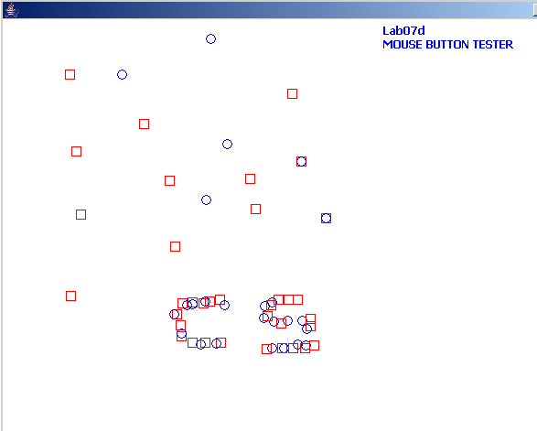
Sample Output :

