A+ Computer Science ROCK – PAPER - SCISSORS Lab Value - 100

Lab Goal : This lab was designed to teach you how to design and use classes, instantiate objects, use GUI Components, use if statements, and multiple selection statements ( switch case / if else if ).

Lab Description : Write a program in Java to allow the play of the game Rock-Paper-Scissors. Each time a button is pressed, a game of Rock-Paper-Scissors will be played. You may use a variant of this game, but you must have at least 3 different symbols in the game. You will receive extra credit if you use more than 3 symbols.

Part One :: Use the Player.java file to create the player. Complete the Player constructors, set methods, get methods, and the toString. Use PlayerRunner.java to test your Player class.

Part Two :: Use the Computer.java file to create the computer player. Complete the Computer constructors, methods, and the toString. Use ComputerRunner.java to test your Computer class.

Part Three :: Use the RockPaperScissorsRunner.java to complete the project. Each time a button is pressed, set the choice for the player based on that button. Then, compare the player choice to the computer choice using the computer’s didIWin() method. Display the results of the game. Add in scoring to show how many games each player has won. Use fonts to make the text appear in color and in a different font style.

BONUS :: Add in sound to this lab using MP3s ( Javazoom - JLayer ).
Change the background color of the JTextArea and the Font style and color ( JTextArea ).

Files Needed ::
Player.java
PlayerRunner.java
Computer.java
ComputerRunner.java
RockPaperScissorsRunner.java

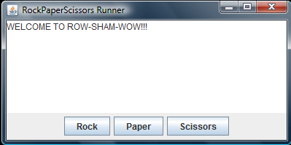
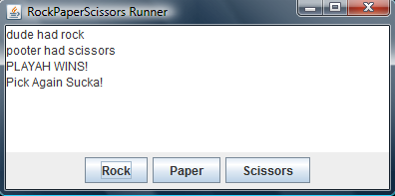
Sample Output :

