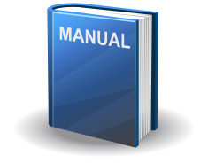
Crossover Assignment Solution’s
Deployment Manual
Author: Blasius Cosa
Position: Cloud Chief Architect - $100K

- Introduction

The deployment instructions covers two approaches:
- Deploy using AWS CLI tool
- Deploy using AWS Console
The approach using CLI is faster and requires less manual steps to be deployed. However, if for some reason this method cannot be used it is also provided a method using AWS Console.

- Deploy using AWS CLI tool

To deploy MyBB solution using CLI tool you need to have it installed and configured in your system. If you don’t have it installed you can install it following the steps in the following links:

http://docs.aws.amazon.com/cli/latest/userguide/installing.html

To configure it should be enough to execute the following commands:

$ aws configure --profile user2
AWS Access Key ID [None]: <your-access-key>
AWS Secret Access Key [None]: <your-secret-access-key>
Default region name [None]: us-east-1
Default output format [None]: text

If you need more information about configuring the tool you can refer to the following link:

http://docs.aws.amazon.com/cli/latest/userguide/cli-chap-getting-started.html

After the tool is installed and configured you must go to the mybb-aws-deployment/Code folder and type the following commands:

$ aws ec2 create-key-pair --key-name mybb-key --query “KeyMaterial” --output text > ./mybb-key.pem

$ aws cloudformation create-stack --stack-name MyBBStack --template-body file://MyBB_Cloudformation_Stack.json --cli-input-json file://MyBB_Cloudformation_Parameters.json

If everything is correct you will see an output similar to:
{
"StackId": "arn:aws:cloudformation:us-east-1:374279810406:stack/MyBBStack/adb0f240-d619-11e6-8b5f-503aca4a5835"
}

You can follow the progress of stack deployment through AWS Console or using the following command:

$ aws cloudformation describe-stacks --stack-name MyBBStack

- Deploy using AWS Console

To deploy using AWS console execute the following steps:

- Login at the console for with your AWS account (https://console.aws.amazon.com/console/home)
- Click on “Services” and search for EC2 and select it;
- On the left panel select Security Groups;
- Click on “Create Security Group”;
- Fill the informations (
- Click on “Services” and search for Cloudformation and select it;
- Click the button “Create Stack”;
- Clock the button “Choose file” under “Upload a template to Amazon S3” radiobutton.
- On the file browser window, navigate to mybb-aws-deployment/Code, select the “MyBB_Cloudformation_Stack.json” file, click “Open” and then the “Next” button;
- On the next screen fill the parameters with the respective values like in the following figure:

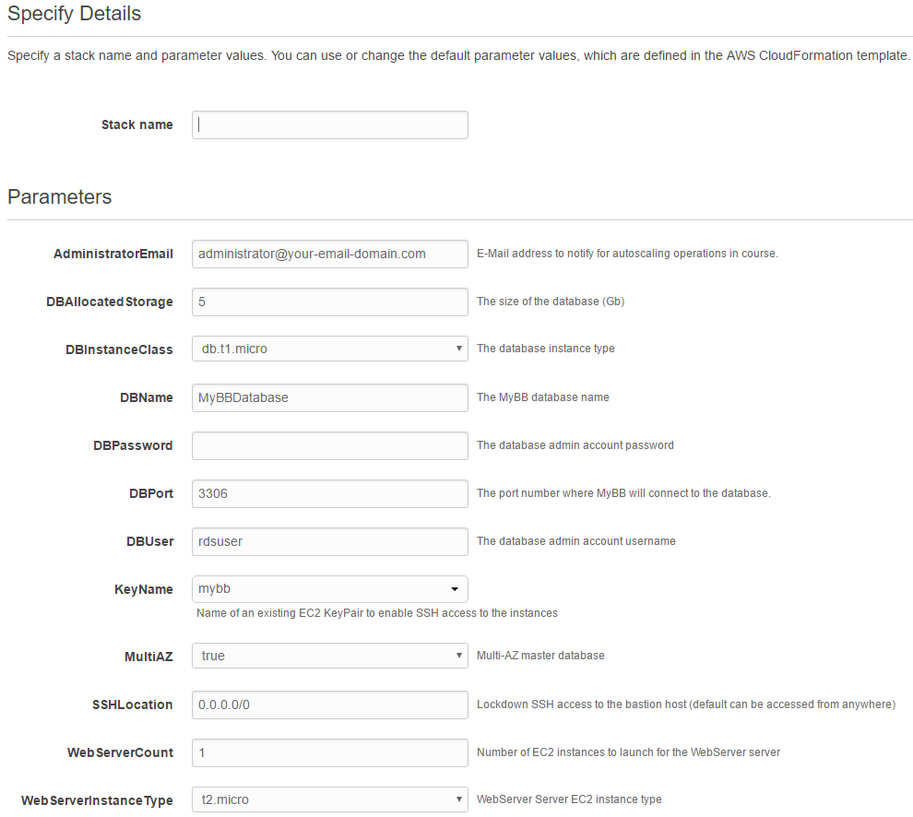

- Click next button;
- Confirm the default options for Tags and Permissions and click next Button;
- Review the information and click “Create” button.

- Deploy using AWS Console
After deployment finishes you should see “Deployment Complete” message like the following figure:

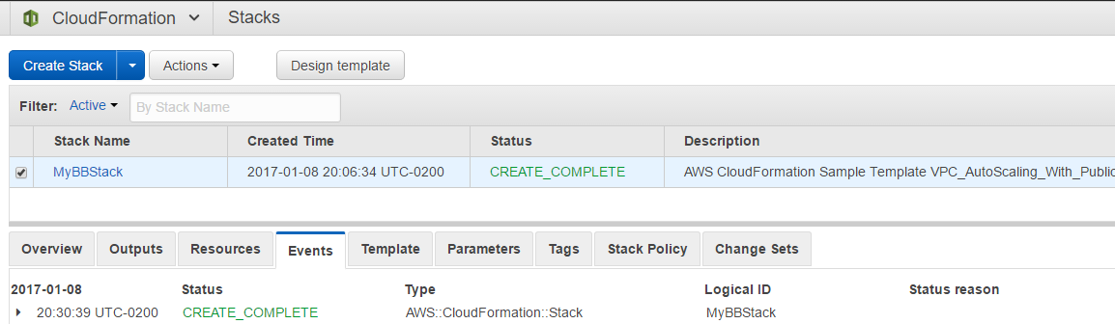

- Source code files in Code directory
There are some files in the source code that are automatically download from github and used during automated installation and configuration of MyBB. Below it is provided a brief explanation on those files:

- deploy-mybb.sh and dependencies

This script executes several steps to install and configure MyBB application using dependencies included. First it extract the content of mybb_0917.zip that contains MyBB installation files to the apache server directory. Then it executes SED to replace variables in config.php and settings.php configuration files. Finally it initializes MyBB database importing a empty schema prepared in mybb.sql file.

- Mybb_0917.zip, config.php, settings.php and mybb.sql: As explained above those are configuration file dependencies of deploy-mybb.sh script used to install and configure MyBB application.

- MyBB_Cloudformation_Parameters.json: Cloudformation parameter files used as input for the cloudformation script. It is used as parameter when deploying cloudformation script with AWS command line tool.

- MyBB_Cloudformation_Stack.json: Cloudformation script containing the specification of the resources to be deployed on AWS. It depends on deploy-mybb.sh and dependencies. Cloudformation script configures an autoscaling launch configuration that downloads deploy-mybb.sh and the other files to the EC2 machine that should be configured.

