Crossover Assignment Solution’s Architeture:
Automated Deployment of MyBB at AWS (Amazon Web Services)
Author: Blasius Cosa
Position: Cloud Chief Architect - $100K

- Requirements
The assignment requirements aimed to deploy the MyBB forum application to AWS cloud IaaS using cloudformation scripts. The deployed solution is required to be secure, high available, scalable and monitorable.
For MyBB forum application database it is required to use RDS (Relational Database Service).
- Solution’s Architecture

  - Overview

The solution was divided in 2 tiers: Webserver-tier and Database-tier.
On the webserver tier it the MyBB application was deployed on apache server installed on EC2 instances inside an autoscaling group with a autoscaling CPU policy configured to ensure scalability. These webservers received requests in port 80 from the public elastic load balancer that was exposed to internet. The load balancer is CrossZoned, that is, it distributes the incoming requests between webservers deployed among two different availability zones to ensure high availability. The autoscaling activities or errors are automatically notified thorugh a SNS topic to a configurable administrator email. Two cloudwatch alarms monitors low and high CPU thresholds.
On the database tier a MySQL RDS instance was deployed within a subnet group for supporting the Multi-AZ feature and also improves high availability feature of the architecture.
A router is also present on the architecture just to remember that it plays an important role on isolating private subnets from public internet and exposing public subnets to the internet.
Security Groups are not represented in the overview diagram so it can be better visualized on Security session where a detailed diagram is presented containing security groups.
The overview of the solution’s architecture is presented on the following diagram:
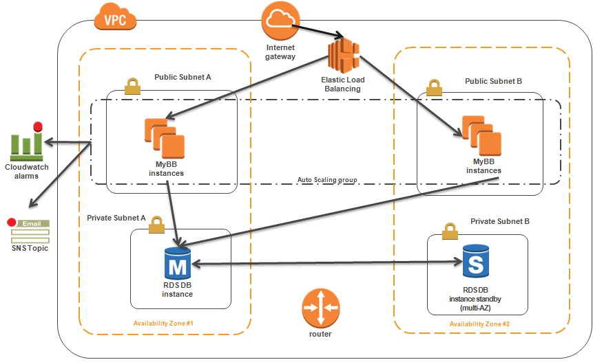

  - Security

The solution’s architecture focused basically on security groups and subnets to prevent unauthorized access to the deployed resources.
The public subnets had a routing rules configured so that it could be able accessed from the Internet Gateway. The private subnets had routing rules denying any access from internet.
Network ACLs was also added, but we do not rely on them to deny access to the resources. If we want even more control and restriction to the subnets we can configure them. They are being set to allow every connections.
The security groups was divided in 3:

- PublicElasticLoadBalancerSecurityGroup
- WebServerSecurityGroup
- DBEC2SecurityGroup

The PublicElasticLoadBalancerSecurityGroup was configured to allow incoming connections on port 80 (HTTP) from the InternetGateway, so that users from internet could access the webservers inside the VPC.
The WebSeverSecurityGroup was configured to accept incoming connections from the Public Load Balancer security group on port 80 (HTTP) and incoming connections from Internet on port 22 (SSH). The SSH connection from internet can be restricted by the CIDRIp mask and even a parameter for configuring this restriction was included on cloudformation script (the default allows any IP from internet). An improvement for this would be to create another security group for a bastion server and accept connections just from the bastion security group. For this exercise we considered okay to proceed with the simpler solution without the bastion server.
The DBEC2SecurityGroup (regular EC2 security group) was configured to accept incoming connections on port 3306 (MySQL) from the MyBB web servers security group. MySQL port was configurable from cloudformation parameters which also is used to configure the security group port.
The diagram that summarizes this is the following:
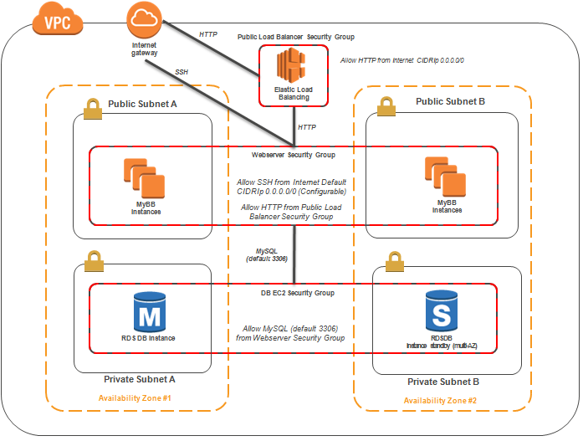

  - Monitoring

We relied on cloudwatch to monitor the deployed application. Two cloudwatch alarms were created already to monitor CPUUtilization and take autosacling actions if certain conditions are satisfied. To demonstrate how cloudwatch is powerfull we also created three other Alarms, but instead take an autoscaling action, these cloudwatch alarms will notifiy the administrator through the SNS Topic already created. One alarm monitors EC2’s network out of MyBB Webservers in the autoscaling group and one other alarm monitors RDS’s FreeStorage for the master instance.
These metrics were choosen just to illustrate the usage of cloudwatch for monitoring. If necessary, even other custom metrics can be published to cloudwatch so that we can take automatic actions over certain criterias.

  - High Availability

The High Availability was implemented for both WEB and Database tiers considering one unique region. It may be possible to improve the architecture to consider multiple regions, but the automation efforts to do this on a brand new account would be high and then it was decided to take the simple unique region approach for the purposes on this exercise.
On the Web tier, the high availability was achieved using an autoscaling group specifying two different availability zones. Also, the Elastic Load Balancer was configured to be “CrossZone”, taking into account the two different availability zones. With this configuration, any problem in one of the availability zones would make possible to the application to keep functioning with the other availability zone.
For the database a similar reasoning was done and a Multi-AZ MySQL RDS was instantiated using a DB Subnet Group specifying the same two regions that was used for the Webtier. This makes a synchronized copy of the master database that stays idle. If some problem occours on the master RDS instance’s availability zone, AWS RDS automatically promotes the idle instance in the other availability zone to primary RDS and application can keep working with it.
The Multi-AZ feature was parameterized with a cloudformation parameter giving an option to deploy the solution without Multi-AZ database.

  - Scalability
The Scalability was achieved through configuration of the autoscaling group and its launch configurations. Two autoscaling policies was configured: One increases 1 more instance if CPU Utilization is more than 80% for 5 minutes. The other removes one instance from the autoscaling group if CPU Utilization falls below 40% for more than 10 minutes. The higher period for the removal of an instance over adding them was configured because once the instances are running it charges for one whole hour. Then you don’t need to worry about removing them fast and if the instances are there you can take the advantage of responding immediately to following increasing on the demand while they are not removed.
Autoscaling Launch Configuration (MyBBWebServerLaunchConfig) was also a huge part of the work. For each EC2 instance provisioned a series of automation steps take place to download, install and configure MyBB Webserver and Database. The launch configuration consists of the following steps:

- Installs necessary MyBB linux packages dependencies (httpd, php, php-mysql, php-gd);
- Installs mysql package to be able to configure MySQL RDS schema afterwards;
- Downloads all necessary files for installation;
- Executes deploy-mybb.sh script;
  - Downloads mybb zip with source;
  - Replace variables that should be configured on config.php and settings.php;
  - Import MySQL dump file with empty MyBB schema to RDS;
  - Sets ownership and file permissions;
  - Remove “install” directory;
- Enable htppd (apache) service;
- Signals success for installation;

The script is also provided in zip file with all other sources used for this configuration.
The following diagram depicts in a high level the process (other resources were removed for simplification):
