Testing Document: Web Address Book
Date: 11-15-2016
Testing conditions: These tests were ran in WebStorm IDE version 2016.2.4.

Web Address Book: Testing 11-15-2016
Testing at this stage was to make sure that the HTML, CSS, and Javascript are working together to build the Web Address Book.
Test 1: Contact Name Links Work
Open the Web Address Book and run in the WebStorm IDE environment loading the page in a web browser. Select each contact individually.
The page should be displayed on as follows:
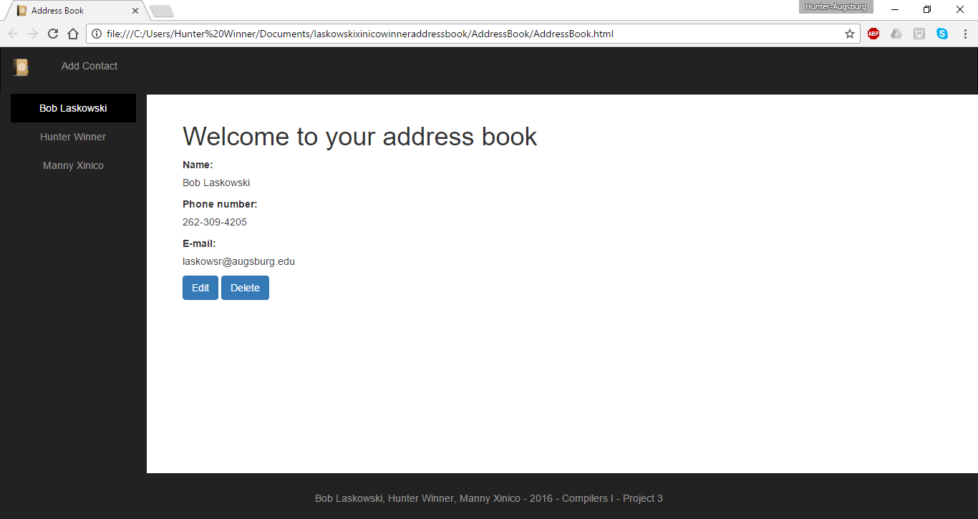
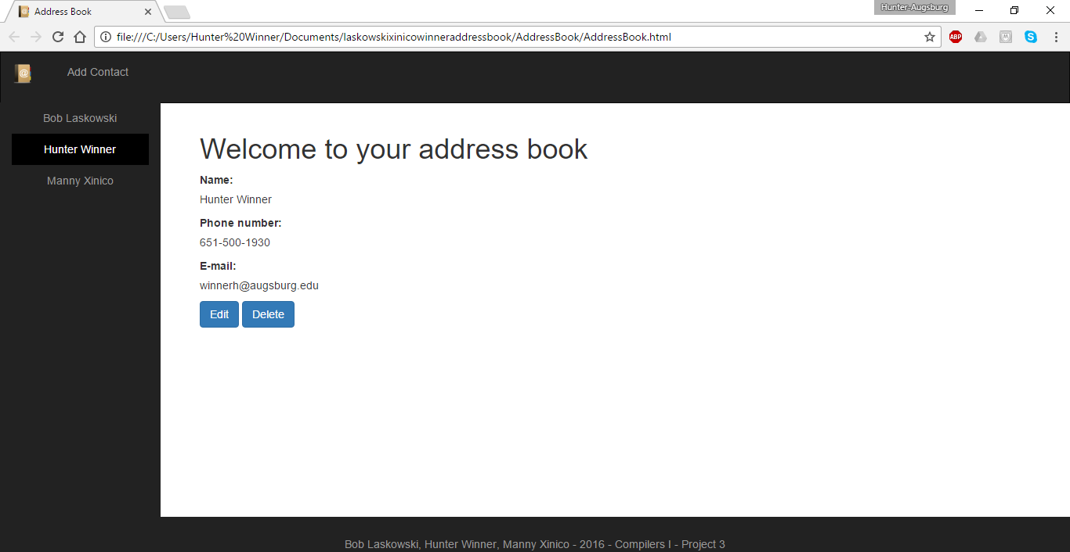

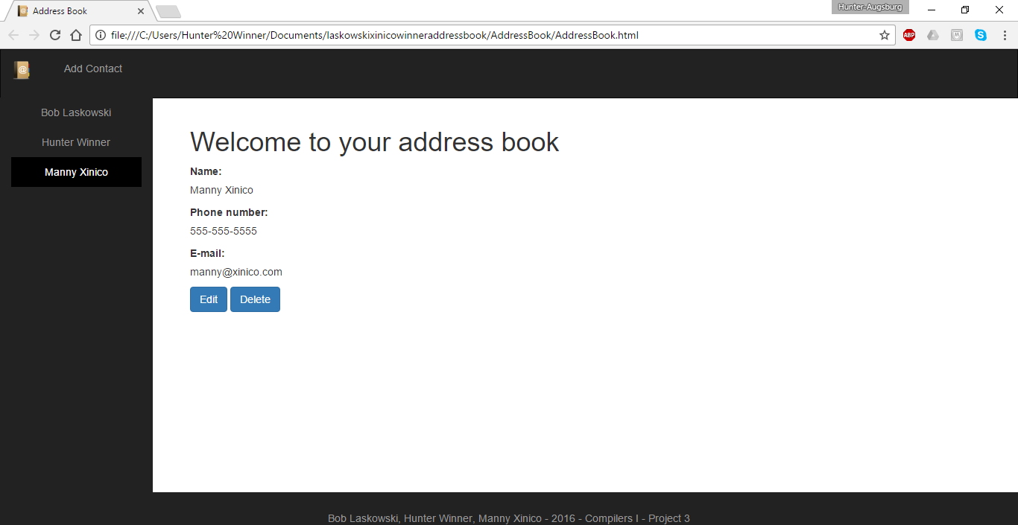
The results above show that all three contacts display in the web page with their corresponding information.

Test 2: Edit and Delete Contact:
Open the Web Address Book and run in the WebStorm IDE environment loading the page in a web browser. Select a contact, the select edit and then delete.The page should be displayed on as follows:
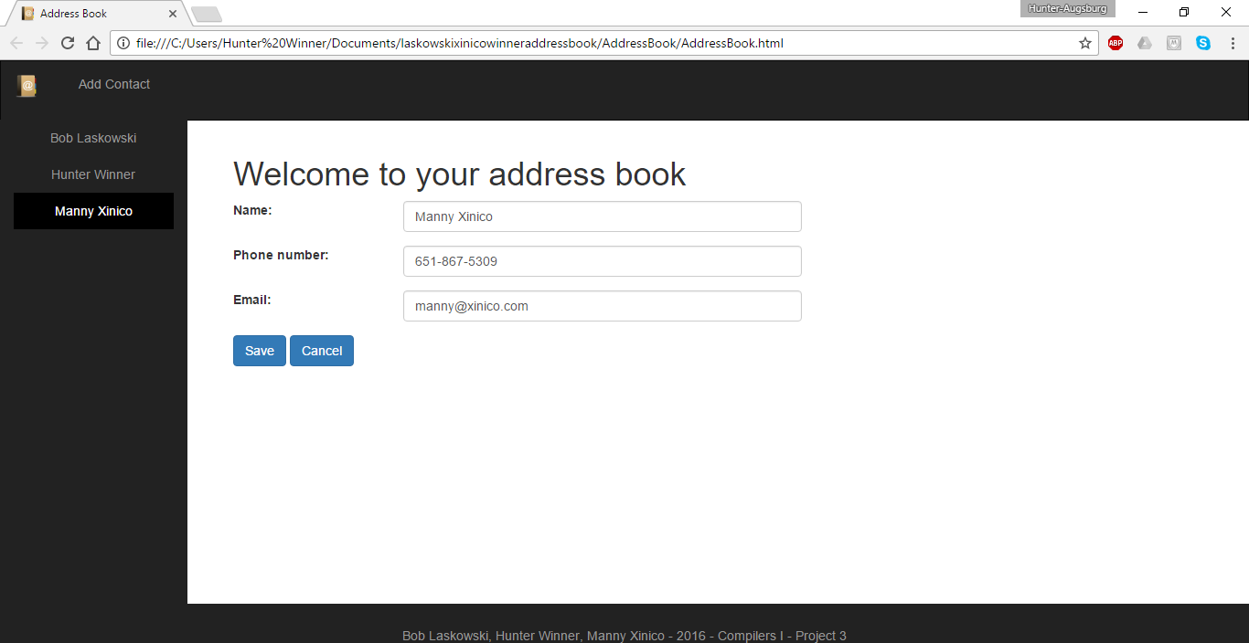
Editing contact.

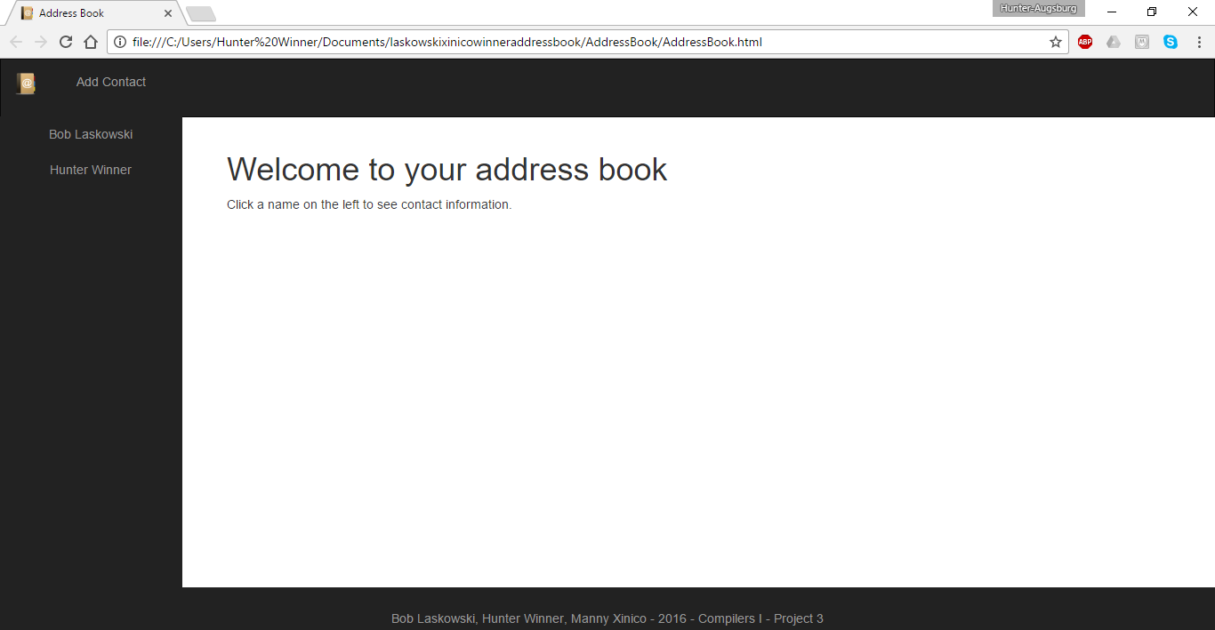
Deleted contact.

Test 3: Home Logo Link Works
Open the Web Address Book and run in the WebStorm IDE environment loading the page in a web browser. Select a contact, then select the logo in upper left corner.
The page should be displayed on as follows:
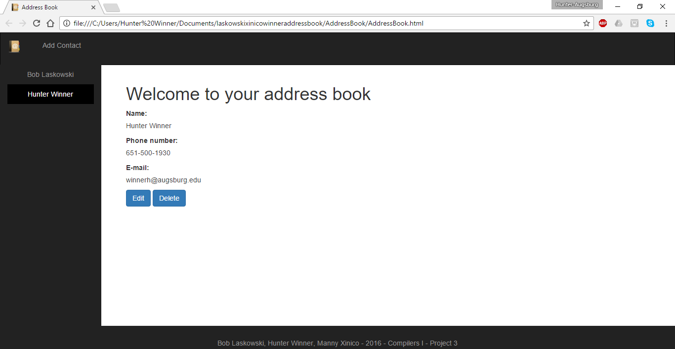
Contact selected.

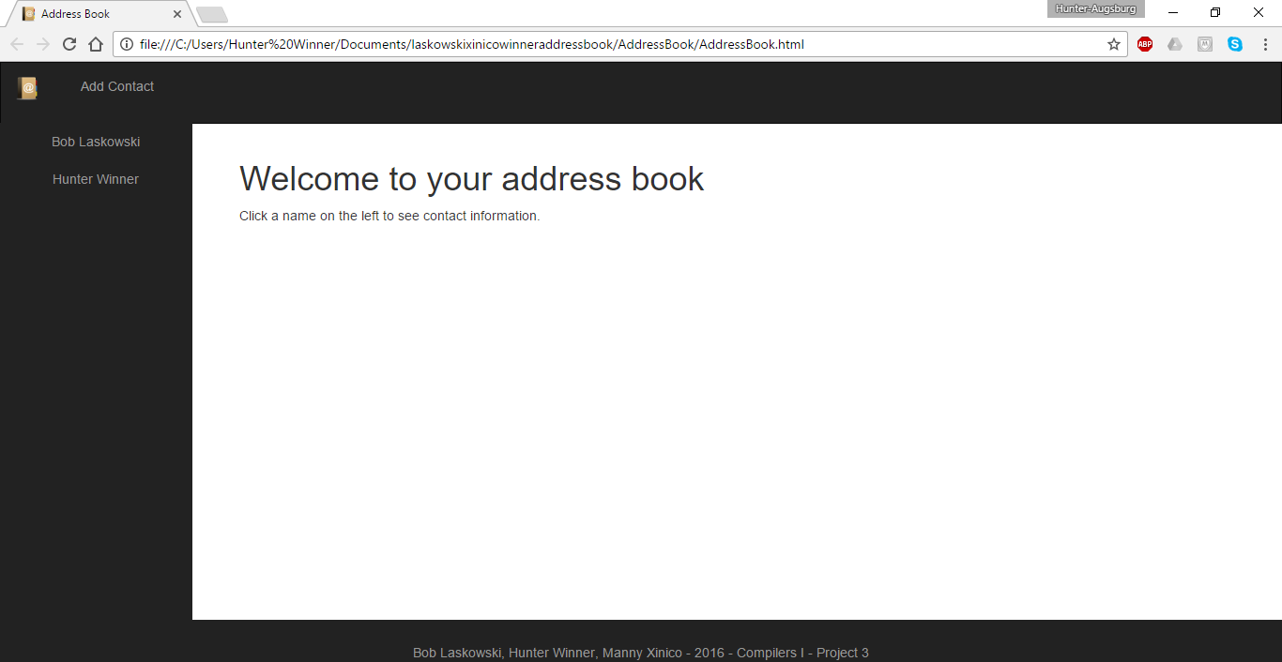
Home logo link selected.

Testing Results:

At the current time all functionality of the Web Address Book is working properly. The program displays all contacts stored in the array with their corresponding information, allows users to edit a contact and save the information, as well as delete a contact that they select, and there is a link to clear the right side to return to user prompt. All the results display properly in the HTML web page.

