INTRODUCTION
------------
The Web Address Book is a web based application for tracking contact information input by a user.

This program displays a list of names on the left side of the screen; the user is prompted to choose a name of a contact to view. Upon click the program displays the information that is stored corresponding to the contact that was selected by the user.

The Web Address Book also allows for the contact information stored by the program to be altered by the user and stores the edits back to the data structure that it pulls the contact data from. The program will have 4 contacts hard coded into it when it starts. The user will be able to view, edit, add or delete contacts.

The program consists of 3 different portions of code: HTML, which organizes the webpage that displays the address book, CSS, which handles the formatting aspects not related to page placement and JavaScript, which handles the data manipulation. The JavaScript manages the array of contacts and the corresponding displayed names on the main page as well as the editing capability of the program. Editing is set up by the HTML and CSS, but carried out by the JavaScript logic of the program.

For purposes of simplicity the program only edits contacts in the array, and would ideally store the data back, but since normal web pages don't have access to local hard disks the data will be allowed to be edited but will not be stored back to the file at this time. This means that changes made will be lost between sessions.

Design
------------
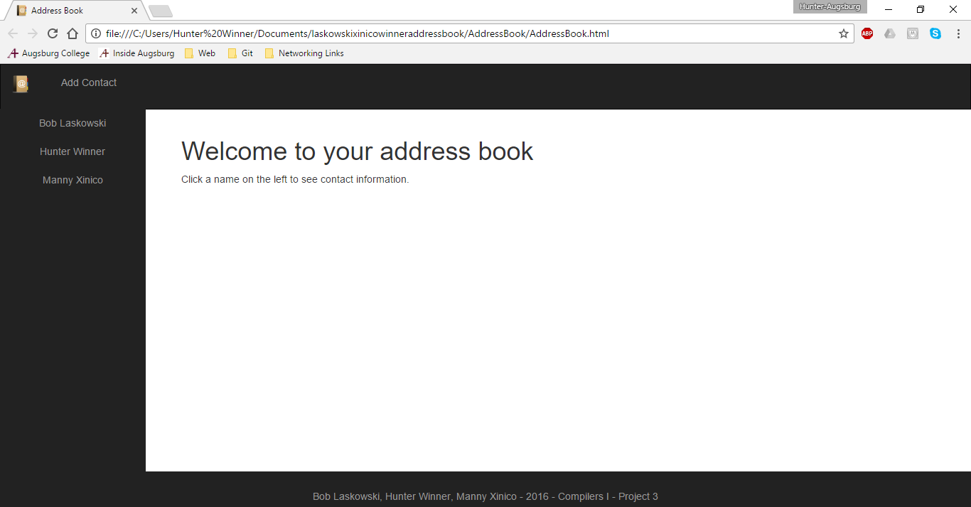
The Web Address Book is designed to store contact data that is accessible by selecting a name from the left side of the screen, this displays the contact information on the right side corresponding with the selected contact. The contacts are also editable, making changes to the source data to end up storing the contact edits. Below in Figure 1 is the home page design of how the page functions with the left side containing the index of contact information, and the right holds the display area for the contact information, and prompts users to select a contact from the left.
Figure 1
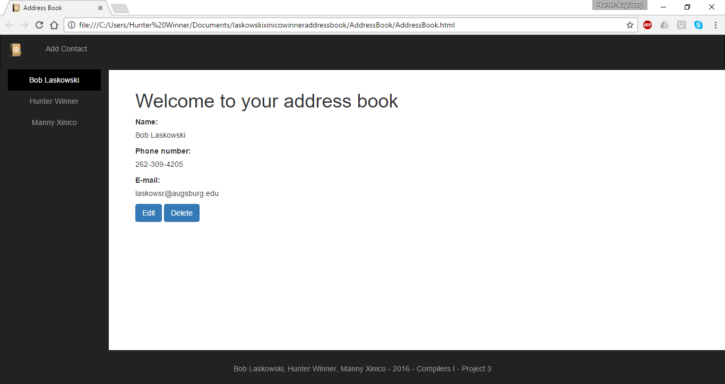
The image below in Figure 2 is a diagram of what the page looks like once a contact has been selected by the user, and the corresponding information is displayed.

Figure 2

The Web Address Book also allows for contacts to be added, edited and deleted. As seen in figure 4 the contacts can be edited by the user and will update the data displayed in the HTML.
Figure 3
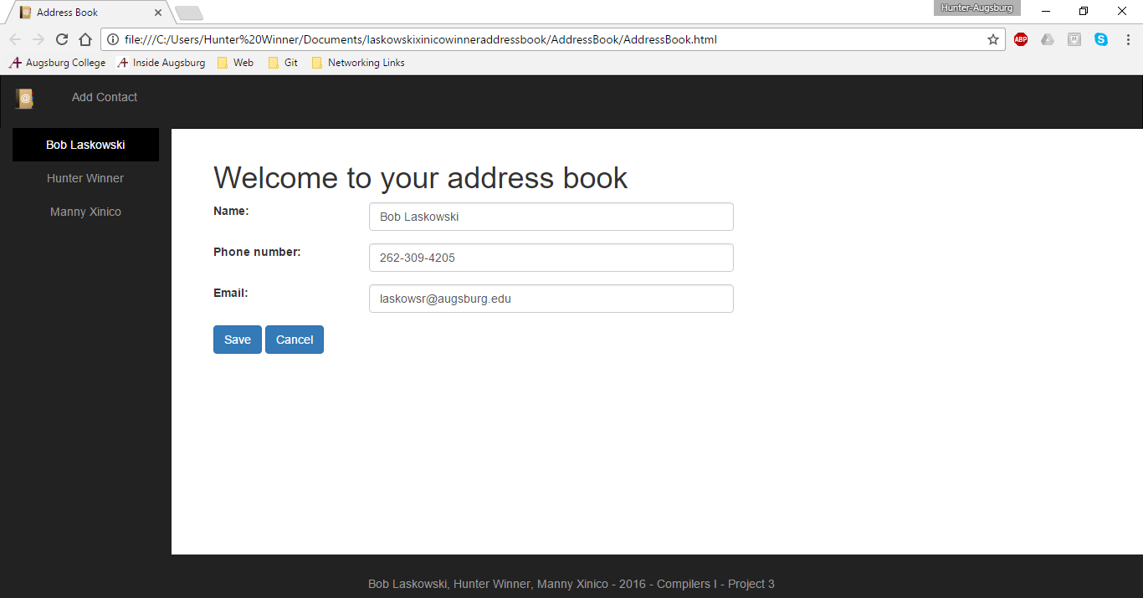
The user can also add contacts that aren’t originally part of the array and save them for display in the HTML page. This is shown in figure 5.
Figure 4

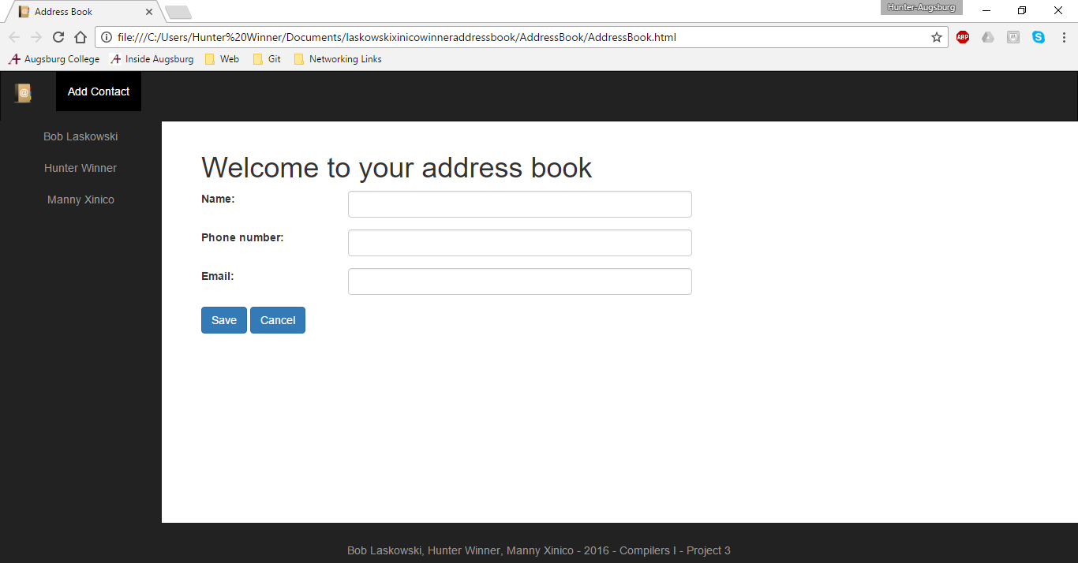
The user can also delete contacts. When the delete button, as seen in Figure 2, is clicked, a prompt asks the user if they are sure they would like to delete the contact. If they say yes, the contact is removed from the array in JavaScript and no longer shown on the left hand side of the screen. This can be seen in Figure 5.

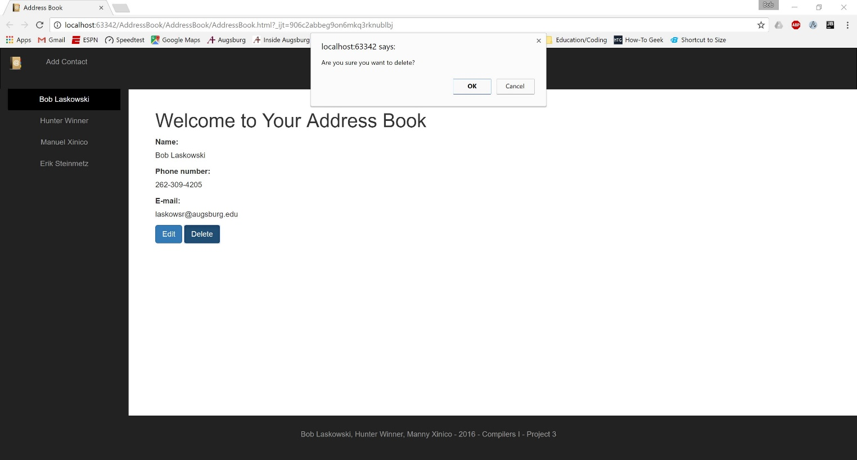
Figure 5

Layout--CSS & HTML
------------------

The layout of the page shown above is completely designed with the HTML and CSS. There is one HTML file named AddressBook.html and one CSS file named AddressBook.css. The application also makes use of the BootStrap framework. The BootStrap style sheets are referenced externally and not included in the files.

Inside of AddressBook.html the page is divided into two columns, one for the contacts and one for the displayed information. At the start of the program, the left column contains the unordered list of the contact names and the right displays a prompt for the user to select a name.

The style.css file handles the things such as margins, font style, color, background color, etc.

Functionality--JavaScript
-------------------------

There is one file titled JSAddressBook.js that handles all the manipulation and data storage for the web page. Instead of having links clicked on the screen navigate to different HTML pages, the JavaScript will manipulate the AddressBook.html page to display different information. The process of changing what is displayed is completed with using divs one with the prompt and another that displays the contact information and editing options. The div that is selected displays, but when another is chosen it hides those that are not needed.

At the start the JavaScript file contains an array of contact objects. The contact object is defined in the JavaScript file, outlining the parameters that make up a contact. These parameters are: name, phone, email, and open. Open is the parameter that allows the editing function to make changes to the selected contact. This array is used to populate the left hand column of the HTML page at load time. When users edit contacts they will be manipulating this array. The JavaScript will then in turn change what the HTML page displays.

In addition to defining a contact object, the JavaScript file has the following methods: pageLoad, home, contactOpen, save, edit, and delete. The pageLoad method is called when the webpage is first loaded to populate the contacts on the left hand side of the page. The home method takes the user back to the home page prompt. The contactOpen method handles what happens when one of the contacts is clicked. It updates the right hand side of the page with the appropriate contact information. The save method allows the user to save the changes they have made to the array and updates the HTML that is displayed in the web page. The edit method allows the user to edit the currently selected contact. The add method allows users to insert values to the end of the array and display the information on the end of the contact array. Finally, the delete method removes the selected contact from the array and updates the HTML display. The contactOpen, save, edit, add, and delete all manipulate the data found in the contact array for display or changes and updates the HTML that is displayed on the web page.

A contact is required to have a name. The application can store a maximum of 15 contacts. E-mails and phone numbers must be in an appropriate format or blank. The program will alert you if the e-mail or phone number is in an invalid format. Regular expressions are used to validate the input.

The basic class diagram for the project can be seen below in Figure 6.

Figure 6

Revision Log
------------

11-4-2016 - Initial SDD outline, basic design images and outline. –-HDW
11-6-2016 – Minor corrections to intro, added to layout and functionality section - RJL, MRX
11-15-2016 – Updated images to reflect web address book, added information about the program and design—HDW
11-15-2016 – Updated figure 6 and added figure 5 - RJL
11-17-2016 – Updated Figure 6 with Contact constructor and added details in JavaScript about max # of contacts and input validation - RJL

