UE24CS341A - Software Engineering
Mini Project
SOFTWARE REQUIREMENTS SPECIFICATION
(SRS)

SMART EXPENSE & BUDGET MANAGEMENT APPLICATION

Project | Smart Expense & Budget Management Application
Version | 1.0
Authors | BHU VIGNA REDDY A T  BIJJALA SAI VISHNU ROHIT  BLASON RAJ  BOLLAVARAM SANTOSH KUMAR
Date | 04-09-2026
Status | Draft for Review / Submission

Revision History
Version | Date | Author(s) | Change Summary | Approval
1.0 | 04-09-2026 | Project Team | Initial SRS for Smart Expense & Budget Management Application | Pending

Approvals
Role | Name | Signature / Email | Date
Course Coordinator / Faculty
Project Guide / Reviewer

Table of Contents
1. Introduction
2. Overall Description
3. External Interface Requirements
4. System Features (Detailed)
5. Non-Functional Requirements (Detailed)
5.1 Security
6. Quality Attributes & Acceptance Tests
7. System Models and UML Use-Case Diagrams
8. Requirements Traceability Matrix (RTM)

1. Introduction

1.1 Purpose
This Software Requirements Specification (SRS) defines the functional and non-functional requirements for the Smart Expense & Budget Management Application. The system is intended to help users record income and expenses, organize transactions into categories, create budgets, monitor spending, receive alerts, and analyze financial activity through dashboards and reports.

1.2 Scope
The application provides personal expense tracking and budget management through a web-based interface. The scope includes user authentication, income and expense recording, category management, budget planning, dashboards, analytics, alerts, reports, and administrative controls. The system does not provide banking transactions, payment processing, lending, investment execution, or direct access to bank accounts unless such integrations are added in a future version.

1.3 Audience
- End Users who manage personal income, expenses, and budgets.
- Administrators who manage users, categories, system rules, and operational information.
- Developers and Test Engineers responsible for implementation and verification.
- Project evaluators, faculty members, and stakeholders reviewing the project requirements.

1.4 Definitions and Acronyms
Term | Meaning
SRS | Software Requirements Specification
UI | User Interface
API | Application Programming Interface
CRUD | Create, Read, Update, and Delete
NFR | Non-Functional Requirement
FR | Functional Requirement
RTM | Requirements Traceability Matrix
Budget Alert | A notification generated when spending approaches or exceeds a budget limit

2. Overall Description

2.1 Product Perspective
The Smart Expense & Budget Management Application is a management application that centralizes personal financial records in a single system. A typical implementation may use a Python/Django backend, a database for persistent storage, and a JavaScript-enabled web interface. The application presents users with a dashboard for tracking spending patterns and budget performance.

2.2 Major Product Functions
- User registration, login, logout, and password management.
- Income and expense recording with date, amount, category, and description.
- Transaction update and deletion.
- Custom category management.
- Monthly and category-wise budget creation.
- Dashboard summaries and visual spending analytics.
- Budget threshold and overspending alerts.
- Search and filtering of transaction history.
- Monthly and custom-period report generation.
- Report export in supported formats.
- Administrative user and system management.
- Audit logging and secure backup support.

2.3 User Roles and Characteristics
- User: Uses the application to manage personal transactions and budgets; requires basic web and financial literacy.
- Administrator: Manages users, configuration data, notifications, and operational monitoring.
- Developer/Maintainer: Maintains the application, database, deployment, and security updates.

2.4 Operating Environment
- Client: Modern desktop or mobile web browser.
- Server: Python runtime with Django framework or an equivalent web application stack.
- Database: Relational database such as MySQL or PostgreSQL.
- Network: HTTPS-based communication over the Internet or institutional network.
- Optional services: Email or notification service for alerts.

2.5 Constraints
- Each user shall access only their own financial data unless granted administrator privileges.
- The application shall use secure authenticated sessions.
- The database schema shall maintain referential integrity between users, categories, transactions, and budgets.
- Technology choices and deployment configuration shall comply with the academic project environment.
- External banking or payment integrations are outside the current project scope.

2.6 Assumptions and Dependencies
- Users provide correct transaction information.
- An active network connection is available for the web application.
- The selected database service is available and properly configured.
- Notification delivery depends on the configured email or alert service.

3. External Interface Requirements

3.1 User Interfaces
- Login and registration pages for authentication.
- Dashboard displaying total income, total expenses, current balance, budget status, and recent transactions.
- Transaction forms for adding and editing income and expenses.
- Budget management screens for creating and monitoring limits.
- Analytics and reporting pages using tables and charts.
- Administrative screens for authorized administrators.

3.2 Hardware Interfaces
No specialized hardware is required. The system shall operate on standard computing devices such as desktops, laptops, tablets, and smartphones capable of running a modern web browser.

3.3 Software Interfaces
- Backend framework: Python/Django application services.
- Database management system: MySQL or PostgreSQL.
- Frontend technologies: HTML, CSS, and JavaScript.
- Optional REST/JSON APIs for client-server communication.
- Optional email/notification service for budget alerts.

3.4 Communications Interfaces
All production client-server communication shall use HTTPS. Application APIs shall use structured request and response formats such as JSON where applicable. Session and authentication mechanisms shall protect access to user-specific resources.

4. System Features (Detailed)
Each requirement includes an identifier, priority, acceptance criterion, and dependency where relevant. IDs follow SEB-F-###.
Req ID | Requirement | Requirement (shall...) | Type | Priority | Acceptance Criteria / Test Case | Dependencies
SEB-F-001 | User Registration | The system shall allow a new user to register using required identity and account credentials. | Functional | High | AC-SEB-F-001: A valid user record is created and duplicate account identifiers are rejected. Test: TC-AUTH-01 | Database and validation rules
SEB-F-002 | User Authentication | The system shall authenticate registered users before allowing access to personal financial data. | Functional | High | AC-SEB-F-002: Valid credentials create an authenticated session; invalid credentials are rejected. Test: TC-AUTH-02 | Authentication module
SEB-F-003 | Password Protection | The system shall store user passwords using a secure one-way password hashing mechanism. | Functional | High | AC-SEB-F-003: Password values are not stored or displayed in plaintext. Test: TC-SEC-01 | Security framework
SEB-F-004 | Income Recording | The system shall allow users to add income transactions with amount, date, category, and optional description. | Functional | High | AC-SEB-F-004: A valid income transaction appears in the user's transaction history and totals. Test: TC-TXN-01 | Transaction module
SEB-F-005 | Expense Recording | The system shall allow users to add expense transactions with amount, date, category, and optional description. | Functional | High | AC-SEB-F-005: A valid expense is stored and reflected in summaries. Test: TC-TXN-02 | Transaction module
SEB-F-006 | Transaction Update/Delete | The system shall allow users to edit or delete their own transactions. | Functional | High | AC-SEB-F-006: Updated values are reflected correctly; deleted transactions no longer affect totals. Test: TC-TXN-03 | Authorization required
SEB-F-007 | Category Management | The system shall provide predefined or user-defined categories for organizing income and expenses. | Functional | Medium | AC-SEB-F-007: Users can create, view, update, and delete permitted custom categories. Test: TC-CAT-01 | Category module
SEB-F-008 | Budget Creation | The system shall allow users to create budgets for a selected category and time period. | Functional | High | AC-SEB-F-008: A valid budget with a positive limit is saved and displayed. Test: TC-BUD-01 | Budget module
SEB-F-009 | Budget Monitoring | The system shall calculate actual spending against the configured budget limit. | Functional | High | AC-SEB-F-009: Spending progress is updated when relevant expenses are added, edited, or deleted. Test: TC-BUD-02 | Transaction and budget data
SEB-F-010 | Budget Alerts | The system shall notify users when spending reaches a configurable warning threshold or exceeds a budget. | Functional | High | AC-SEB-F-010: A threshold or exceeded condition generates a visible notification. Test: TC-ALT-01 | Notification service
SEB-F-011 | Dashboard Summary | The system shall display total income, total expenses, current balance, recent transactions, and budget status on the dashboard. | Functional | High | AC-SEB-F-011: Dashboard totals match stored transaction data. Test: TC-DASH-01 | Analytics service
SEB-F-012 | Analytics | The system shall provide category-wise and period-wise expense analysis using suitable charts or summaries. | Functional | Medium | AC-SEB-F-012: Selected filters produce correct aggregated values. Test: TC-ANL-01 | Reporting/analytics module
SEB-F-013 | Search and Filter | The system shall allow users to search and filter transactions by date range, category, type, and relevant supported criteria. | Functional | Medium | AC-SEB-F-013: Returned results match the selected filter criteria. Test: TC-SRCH-01 | Database queries
SEB-F-014 | Report Generation | The system shall generate financial reports for a selected month or custom date range. | Functional | High | AC-SEB-F-014: Report totals equal the underlying transaction records. Test: TC-RPT-01 | Reporting module
SEB-F-015 | Report Export | The system shall allow users to export supported reports in at least one portable format. | Functional | Medium | AC-SEB-F-015: Generated export opens successfully and matches selected report data. Test: TC-RPT-02 | Export library
SEB-F-016 | User Data Isolation | The system shall ensure that a standard user cannot access another user's transactions, budgets, or reports. | Functional | High | AC-SEB-F-016: Direct and indirect access attempts to another user's records are denied. Test: TC-SEC-02 | Authorization layer
SEB-F-017 | Administrative User Management | The system shall allow authorized administrators to view and manage user accounts according to configured permissions. | Functional | Medium | AC-SEB-F-017: Authorized actions succeed; standard users cannot access administration functions. Test: TC-ADM-01 | Role-based access control
SEB-F-018 | Audit Logging | The system shall record significant security and administrative events with timestamps. | Functional | Medium | AC-SEB-F-018: Test actions create retrievable audit entries without exposing sensitive values. Test: TC-AUD-01 | Logging subsystem

5. Non-Functional Requirements (Detailed)
NFRs are measurable and shall be verified through defined test activities. IDs follow SEB-NF-###.
Req ID | Category | Requirement | Priority | Acceptance Criteria / Measurement
SEB-NF-001 | Performance | The system shall complete standard dashboard and transaction operations within 3 seconds for at least 90% of requests under normal academic deployment load. | High | 90th percentile response time ≤ 3 seconds. Test: TC-PERF-01
SEB-NF-002 | Availability / Reliability | The application shall recover gracefully from transient failures and preserve committed transaction data. | High | No committed transaction data is lost during controlled restart testing. Test: TC-REL-01
SEB-NF-003 | Usability | The system shall provide a clear navigation structure and validation messages for invalid form input. | Medium | Representative users complete core add-expense and budget tasks without critical UI ambiguity. Test: TC-UX-01
SEB-NF-004 | Maintainability | The application shall use modular separation between presentation, business logic, and data access components. | Medium | Code review confirms modular organization and documented configuration. Test: TC-MNT-01
SEB-NF-005 | Compatibility | The system shall support current versions of major modern browsers used in the project environment. | Medium | Core functions pass compatibility tests in at least Chrome and Firefox or equivalent approved browsers. Test: TC-COMP-01
SEB-NF-006 | Data Integrity | The system shall validate numeric amounts, dates, ownership relationships, and required fields before persistence. | High | Invalid or inconsistent data is rejected and valid data maintains referential integrity. Test: TC-DATA-01

5.1 Security

5.1.1 Security Objectives
Objective ID | Security Objective | Verification Focus
SEB-SO-001 | Confidentiality and Privacy: Protect users' financial information from unauthorized access or disclosure. | Authorization tests, encrypted transport, and secure data handling review.
SEB-SO-002 | Integrity and Accountability: Prevent unauthorized modification of financial records and maintain auditable security and administrative actions. | Input validation, access-control tests, and audit-log verification.

5.1.2 Security Requirements
Req ID | Requirement (shall...) | Type | Priority | Acceptance Criteria / Test Case
SEB-SR-001 | The system shall enforce HTTPS for production network communication. | Security | High | TC-SEC-03: HTTP access is redirected or rejected according to deployment policy.
SEB-SR-002 | The system shall hash passwords using an approved framework-supported secure password hashing mechanism. | Security | High | TC-SEC-01: Password storage inspection confirms no plaintext passwords.
SEB-SR-003 | The system shall enforce authentication and authorization checks for protected user and administrator resources. | Security | High | TC-SEC-02: Unauthorized requests are denied.
SEB-SR-004 | The system shall validate and sanitize user-controlled input to reduce injection and common input-based attacks. | Security | High | TC-SEC-04: Malformed and malicious test inputs do not alter unintended data or execution.
SEB-SR-005 | The system shall avoid logging passwords, authentication secrets, or other sensitive credentials in application logs. | Security | High | TC-SEC-05: Log inspection confirms sensitive values are absent.

6. Quality Attributes & Acceptance Tests

6.1 Quality Attributes
- Correctness: Financial totals, balances, and budget calculations must match validated transaction data.
- Performance: Core user actions should meet the response-time target defined in SEB-NF-001.
- Reliability: Committed data must remain consistent across normal application restarts.
- Security: Protected resources must enforce authentication, authorization, secure password storage, and safe input handling.
- Usability: Users should be able to perform core expense and budget tasks through clear workflows.

6.2 Acceptance Exit Criteria
- All high-priority functional requirements are implemented and verified.
- All mandatory security requirements pass their defined tests.
- No critical or high-severity defects remain open for core workflows.
- Non-functional acceptance targets are met or approved deviations are documented.
- The RTM shows coverage from requirements to modules and test cases.

6.3 Acceptance Test Suites
- Authentication and authorization tests.
- Transaction CRUD and calculation tests.
- Category and budget management tests.
- Dashboard and analytics verification.
- Alerts and notification tests.
- Reporting and export tests.
- Performance, compatibility, data integrity, and security tests.

7. System Models and UML Use-Case Diagrams

7.1 UML Use-Case Diagram: User Functions
This diagram summarizes the primary functions available to an authenticated standard user.
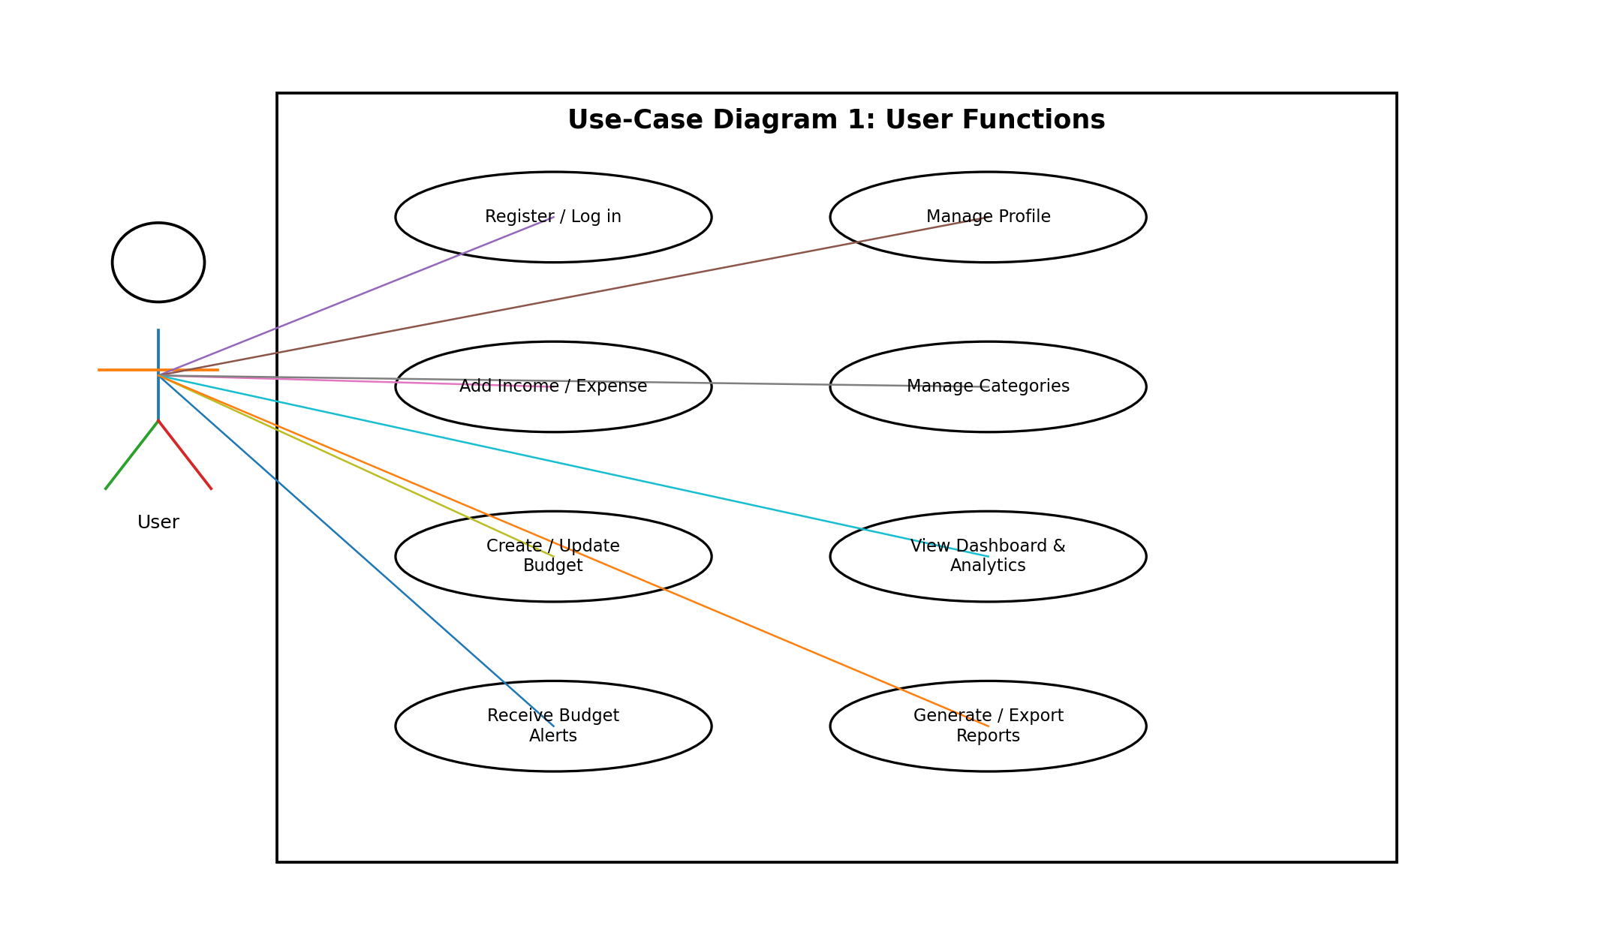

7.2 UML Use-Case Diagram: Administrator Functions
This diagram summarizes administrative functions that require elevated authorization.
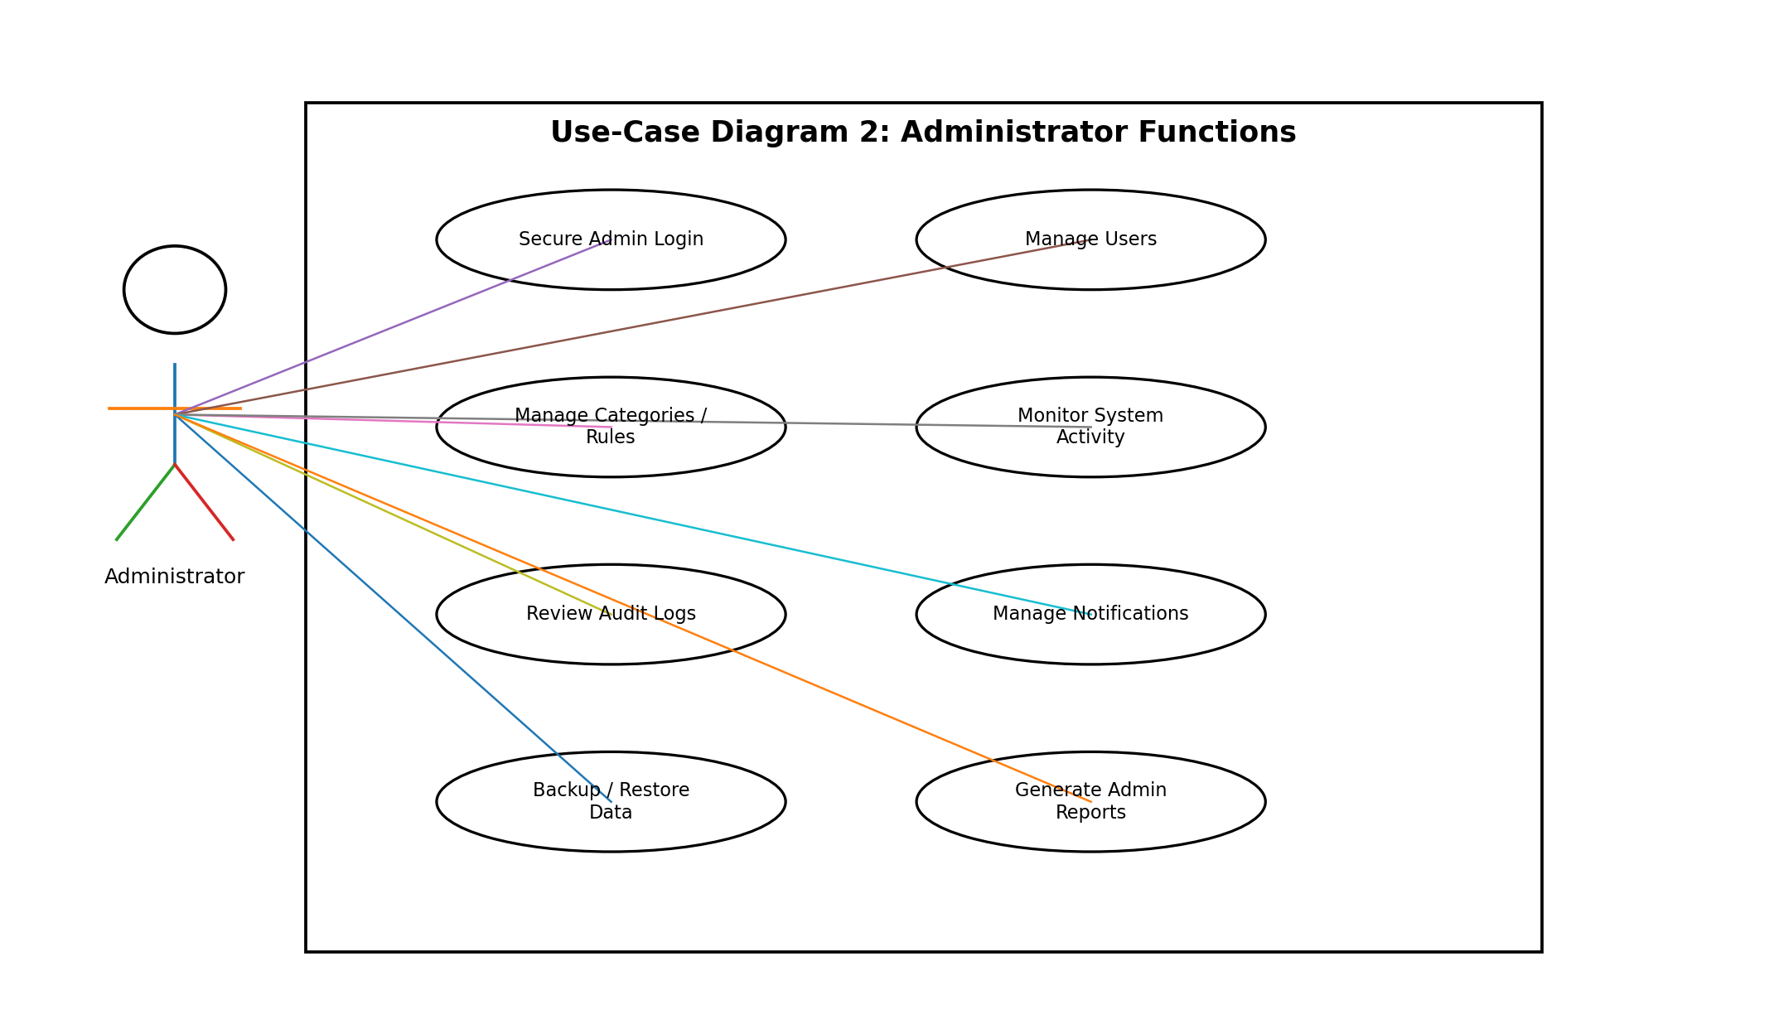

8. Requirements Traceability Matrix (RTM)
Req ID | Requirement Short | Section Ref | Module | Test Case(s) | Status (N/P/A) | Comments
SEB-F-001 | User Registration | Section 4 | Authentication Module | TC-AUTH-01 | N | Initial SRS
SEB-F-002 | User Authentication | Section 4 | Authentication Module | TC-AUTH-02 | N | Initial SRS
SEB-F-003 | Password Protection | Section 4 | Authentication Module | TC-SEC-01 | N | Initial SRS
SEB-F-004 | Income Recording | Section 4 | Transaction Module | TC-TXN-01 | N | Initial SRS
SEB-F-005 | Expense Recording | Section 4 | Transaction Module | TC-TXN-02 | N | Initial SRS
SEB-F-006 | Transaction Update/Delete | Section 4 | Transaction Module | TC-TXN-03 | N | Initial SRS
SEB-F-007 | Category Management | Section 4 | Category Module | TC-CAT-01 | N | Initial SRS
SEB-F-008 | Budget Creation | Section 4 | Budget Module | TC-BUD-01 | N | Initial SRS
SEB-F-009 | Budget Monitoring | Section 4 | Budget Module | TC-BUD-02 | N | Initial SRS
SEB-F-010 | Budget Alerts | Section 4 | Notification Module | TC-ALT-01 | N | Initial SRS
SEB-F-011 | Dashboard Summary | Section 4 | Dashboard Module | TC-DASH-01 | N | Initial SRS
SEB-F-012 | Analytics | Section 4 | Analytics Module | TC-ANL-01 | N | Initial SRS
SEB-F-013 | Search and Filter | Section 4 | Transaction Module | TC-SRCH-01 | N | Initial SRS
SEB-F-014 | Report Generation | Section 4 | Reporting Module | TC-RPT-01 | N | Initial SRS
SEB-F-015 | Report Export | Section 4 | Reporting Module | TC-RPT-02 | N | Initial SRS
SEB-F-016 | User Data Isolation | Section 4 | Authorization Layer | TC-SEC-02 | N | Initial SRS
SEB-F-017 | Administrative User Management | Section 4 | Admin Module | TC-ADM-01 | N | Initial SRS
SEB-F-018 | Audit Logging | Section 4 | Audit Module | TC-AUD-01 | N | Initial SRS
SEB-NF-001 | Performance | Section 5 | Cross-cutting | TC-PERF-01 | N | Initial SRS
SEB-NF-002 | Availability / Reliability | Section 5 | Cross-cutting | TC-REL-01 | N | Initial SRS
SEB-NF-003 | Usability | Section 5 | Cross-cutting | TC-UX-01 | N | Initial SRS
SEB-NF-004 | Maintainability | Section 5 | Cross-cutting | TC-MNT-01 | N | Initial SRS
SEB-NF-005 | Compatibility | Section 5 | Cross-cutting | TC-COMP-01 | N | Initial SRS
SEB-NF-006 | Data Integrity | Section 5 | Cross-cutting | TC-DATA-01 | N | Initial SRS
SEB-SR-001 | The system shall enforce HTTPS for production... | Section 5.1 | Security Layer | TC-SEC-03 | N | Initial SRS
SEB-SR-002 | The system shall hash passwords using an appr... | Section 5.1 | Security Layer | TC-SEC-01 | N | Initial SRS
SEB-SR-003 | The system shall enforce authentication and a... | Section 5.1 | Security Layer | TC-SEC-02 | N | Initial SRS
SEB-SR-004 | The system shall validate and sanitize user-c... | Section 5.1 | Security Layer | TC-SEC-04 | N | Initial SRS
SEB-SR-005 | The system shall avoid logging passwords, aut... | Section 5.1 | Security Layer | TC-SEC-05 | N | Initial SRS

