# NATIONAL INSTITUTE OF TECHNOLOGY SIKKIM



**CONTROL SYSTEM LABORATORY II**

NAME :- VIKRAM KUMAR

ROLL NO:- B190095EE

SUBJECT:- CONTROL SYSTEM LAB- (II)

SUBJECT CODE:-EE16203

SUBMITTED TO :- DR. KUNTAL MONDAL

SUBMITTED BY:- VIKRAM KUMAR

**EXPERIMENT -3**

**AIM:-** (a) To design the controller using Emulation.

(b) To validate the design with the actual system response**.**

**MATLAB CODE:-**

clear all

clc

num=input('Enter the numerator: ');

den=input('Enter the denominator: ');

T=tf(num,den)

[numd,dend]=bilinear(num,den,0.5);

Z=tf(numd,dend,2)

hold on;

step(T)

stepz(numd,dend)

**OUTPUT:-**

Enter the numerator: [3 4]

Enter the denominator: [5 6 8]

T =

3 s + 4

---------------

5 s^2 + 6 s + 8

Continuous-time transfer function.

Z =

0.3684 z^2 + 0.4211 z + 0.05263

-------------------------------

z^2 + 0.3158 z + 0.3684

Sample time: 2 seconds

Discrete-time transfer function.

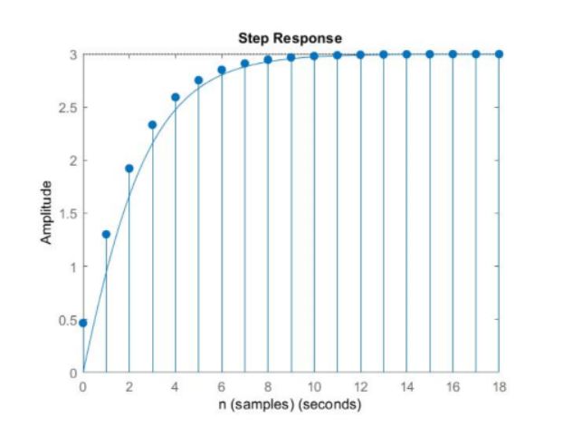

**DISCUSSION:-**

* It is noted that by conversion of analog to digital it does not effect the stability of the system . Hence the system is stable is S domain then it is also stable in Z domain.
* By analysis of the stability of system in digital is much faster than Analog.
* Digital version of the analog controller was derived using bilinear

transformation.