# NATIONAL INSTITUTE OF TECHNOLOGY SIKKIM



**CONTROL SYSTEM LABORATORY II**

NAME :- VIKRAM KUMAR

ROLL NO:- B190095EE

SUBJECT:- CONTROL SYSTEM LAB- (II)

SUBJECT CODE:-EE16203

SUBMITTED TO :- DR. KUNTAL MONDAL

SUBMITTED BY:- VIKRAM KUMAR

**EXPERIMENT -6**

**AIM:-** (a) Draw the transfer characteristics of different types of nonlinear elements.

(b) Determine the amplitude and frequency of the limit cycle.

**MATLAB CODE:-**

**(a)**

clc

clear all

z=[];

p=[-1 -1 -1];

k=3;

G=zpk(z,p,k) %transfer function

[Gm,Pm,Wcg,Wcp] = margin(G);

[mag,phase] = bode(G,Wcg);

A=(mag*4)/pi; %amplitude of the limit cycle

figure(1)

nyquist(G)

figure(2)

syms x

y=piecewise(x<0,-1,x>0,1);%rellay non-linearity

fplot(y);

xlabel('Input')

ylabel('Output')

figure(3)

t = 0:0.01:10;

u = A*sin(Wcg*t); %input signal

y = (4/pi)*sin(Wcg*t); %output signal

hold on

plot(t,u);

plot(t,y);

xlabel('t')

ylabel('u,y')

**(b)**

clc

clear all

z=[];

p=[-1 -2 -3];

k=120;

G=zpk(z,p,k)

[Gm,Pm,Wcg,Wcp] = margin(G);

[mag,phase] = bode(G,Wcg);

Wcg %frequecy of the limit cycle

if mag<=1 %amplitude of limit cycle

A=mag;

else

A=1/mag;

end

syms x

y=piecewise(x<-1,-1,-1<x<1,x,x>1,1);%saturation non-linearity

figure(1)

fplot(y);

xlabel('Input')

ylabel('Output')

syms a

figure(2)

Na=piecewise(a<=1,1,a>1,1/a); %gain characteristics of

saturation non-linearity

fplot(Na)

xlabel('A')

ylabel('N(A)')

**PLOTS FOR SYSTEM 1** 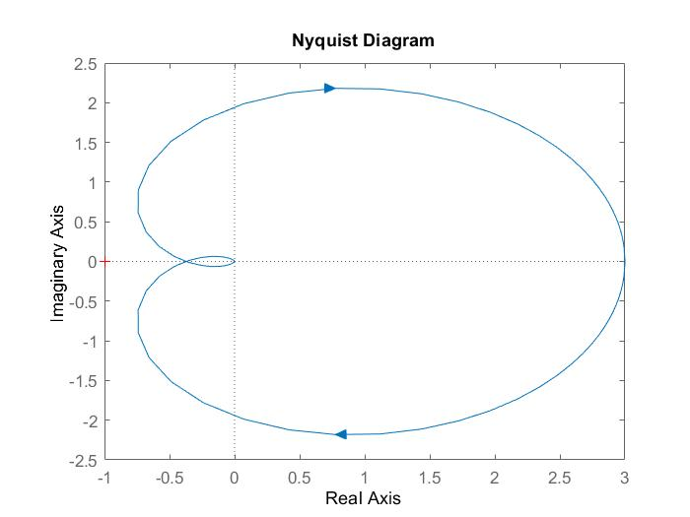

**Fig 1 Nyquist plot**

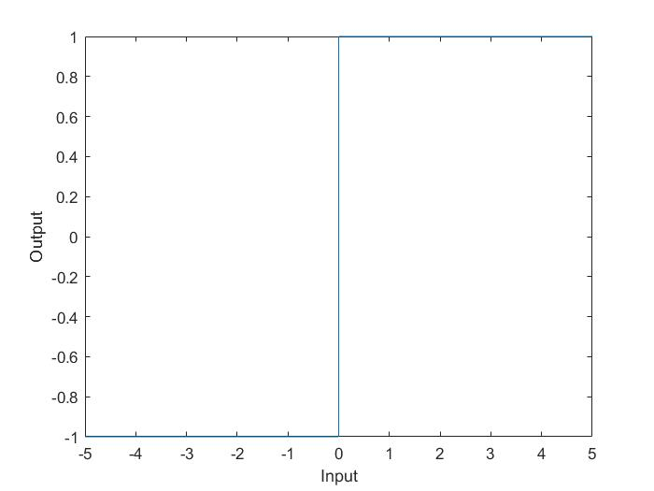

**Fig 2 Transfer characteristics of relay**

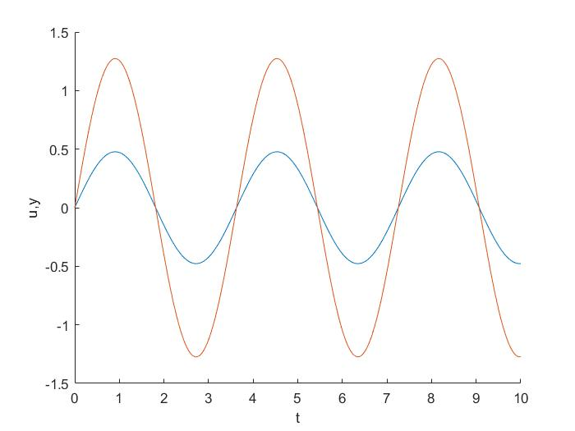

**Fig 3 Input and output of describing function**

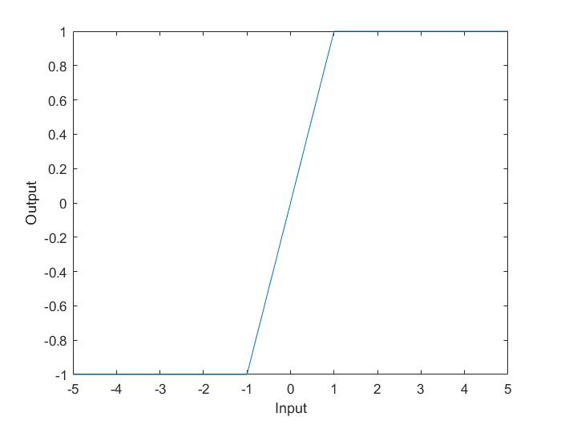 **Fig 4 Transfer Characteristics of saturation nonlinearity**

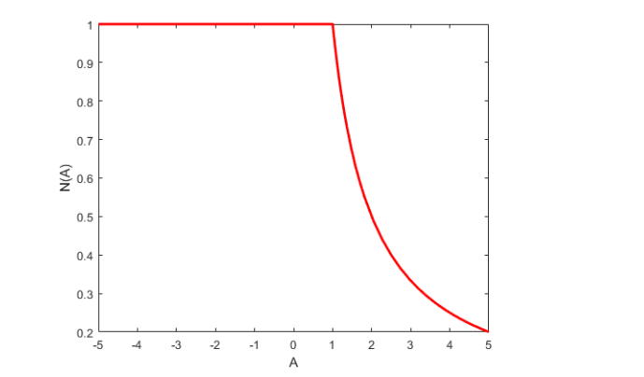

**Fig 5 Describing function characteristics**

**OUTPUT:-**

G = 3

-------

(s+1)^3

Continuous-time zero/pole/gain model.

A = 0.4774

Wcg = 1.7322

G = 120

-----------------

(s+1) (s+2) (s+3)

Continuous-time zero/pole/gain model.

Warning:

The closed-loop system is unstable.

A = 0.5000

Wcg = 3.3166

**DISCUSSION:-**

It is noted that an unstable or marginally stable linear system can be made stable and resistant to noise or disturbance using a non-linear element which is implemented using describing function method. The system used is of low pass nature and the non-linear component is time invariant and its characteristics is symmetric with respect to origin.