NATIONAL INSTITUTE OF TECHNOLOGY SIKKIM



CONTROL SYSTEM LABORATORY II

NAME :- VIKRAM KUMAR
ROLL NO:- B190095EE
SUBJECT:- CONTROL SYSTEM LAB- (II)
SUBJECT CODE:-EE16203

SUBMITTED TO :- DR. KUNTAL MONDAL
SUBMITTED BY:- VIKRAM KUMAR

EXPERIMENT -5

AIM:- (a) draw the positive definite function, directional derivative and negative definite function.
(b) Determine of different types of stability.

PROBLEM -1
System:-
dx1=x2
dx2=-x1-x2

MATLAB CODE:-

clc;
clear all;
syms x1 x2;
V=((3/2)*x1^2+x2^2+x1*x2) %Lyapunov Candidate fn %pdf
[X1, X2]=meshgrid(-10:0.1:10,-10:0.1:10);
Z=(X1.^2+X2.^2+X1*X2);
figure
meshc(X1, X2, Z)
xlabel('x1')
ylabel('x2')
zlabel('V(x1,x2)')
hold on

%System
dx1=x2;
dx2=-x1-x2;

%plot of vector field
[x, y]= meshgrid(-10:0.4:10, -10:0.4:10);
px=y;
py=-y-x;
quiver(x,y,px,py,1);
grid on
xlabel('x1');ylabel('x2');
hold on

%Animated Solution
f=@(t,P)[P(2)-P(1)*(P(1)^2+P(2)^2);-P(2)-P(1)*(P(1)^2+P(2)^2)];
tspan = [0 100];
x0=[-10 -10];%IC
%Sol=Solution
[t,Sol]=ode45(f,tspan,x0);
for k=1:1:50
plot(Sol(k,1),Sol(k,2),'r*');
plot3(Sol(k,1),Sol(k,2),subs(V,{x1,x2},{Sol(k,1),Sol(k,2)}),'k*');
pause(0.8);
grid on
xlabel('x1');ylabel('x2');
title('Analysis of Lyapunov Direct method');
end

%Evaluating Vdot
dx1=x2;
dx2=-x1-x2;
dx=[dx1; dx2];
V=((3/2)*x1^2+x2^2+x1*x2); %Lyapunov Candidate fn %pdf
dV_dx=jacobian(V,[x1,x2]);
dV_dt=dV_dx*dx
disp('Directional derivative');
dV_dt=simplify(dV_dt) % Directional derivative

%Definiteness of Vdot
[X1, X2]=meshgrid(-10:0.2:10,-10:0.2:10);
Z=subs(dV_dt,{x1 x2},{X1 X2});
Z=-(X1.^2 + X2.^2);
figure(2)
meshc(X1, X2, Z)
xlabel('x1')
ylabel('x2')
zlabel('dV/dt')
title('Definiteness of dV/dt')

OUTPUT:- 1

V =

(3*x1^2)/2 + x1*x2 + x2^2

dV_dt =

x2*(3*x1 + x2) - (x1 + x2)*(x1 + 2*x2)

Directional derivative

dV_dt =

- x1^2 - x2^2

PROBLEM 2
System
dx1=x2-x1(x1^2+x2^2)
dx2=-x1-x2(x1^2+x2^2)

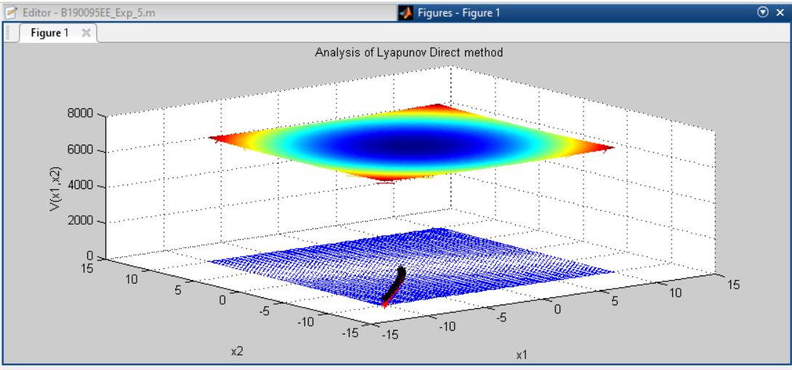
OUTPUT:- 2
dV_dt =

-(x1^2 + x2^2)^2
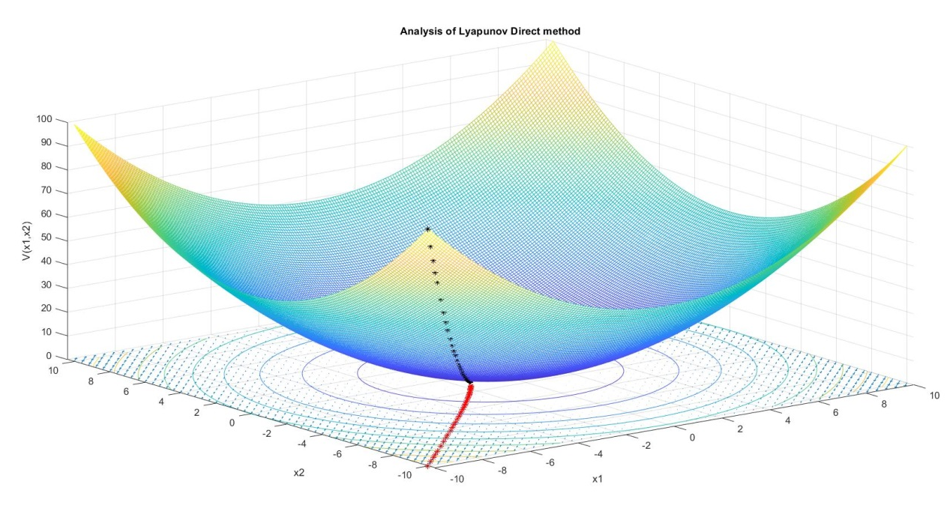

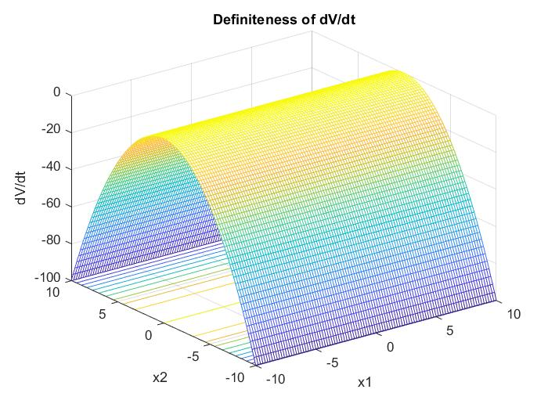

DISCUSSION:-

- After analysing the graph we get to know that Lyapunov is one of the good method for analysis of the stability of the system it is applicable both linear as well as non-linear system.
- In Lyapunov we are not using any differential equation here analysis is simply decided by Lyapunov function which is already taken as PDF.
- In the first example I have taken PDF Lyapunov function which is radially unbounded and directional derivative is NDF .
- In the second example , I have taken PDF Lyapunov function which is radially unbounded and directional derivative is NDF.
- Hence for both example we can say that system is stable in the sense of Lyapunov.

