Simple OBJ Editor - by Francisco Romano
For this project I decided to make a simple 3D ".obj" file loader to display and test my libraries from my previous assigments. Basically this programs reads multiple files and allow them to be saved as one file.
Opening/Saving a file:
To open a file simply go to the top menu of the window, click file -> open, and select the obj file to read.
To save your current scene go again to the top menu, click file->save as, and select where you want to save the file.
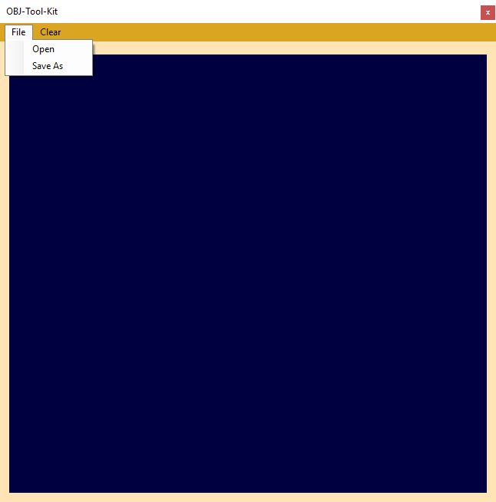

Clearing the current workspace:
If you no longer like the current scene click "clear" in the top menu to erase the current scene on screen
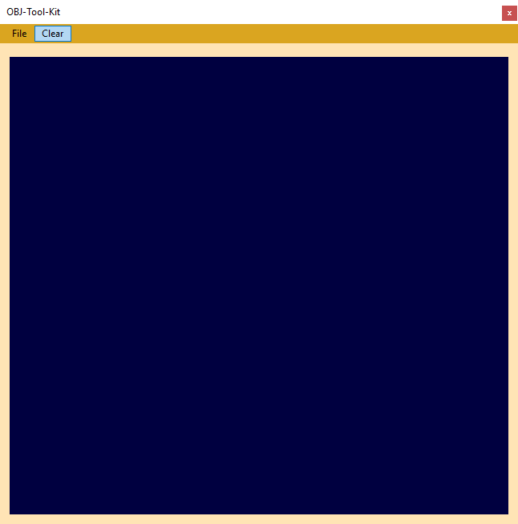
Moving around the editor
To move your camera around the editor you do:
WASD >> move camera forwards or right.
NUMPAD 8,4,2,6 >> turn camera around Y and Right axis.

