URL : <http://guns.periscopic.com/?year=2013>

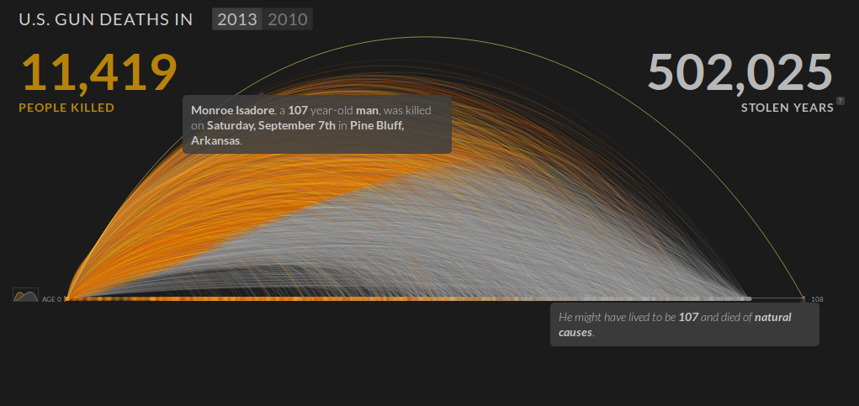

The system visualizes the crowdsourced data of deaths by gun shooting on two dimensional graphic plane. The animation on the graph drawing shows the order of incidents. The X-axis represents the number of years that the victim might have live, if he or she was not killed by the gun shooting. It also shows the number of people killed and number of stolen years as the high level view. When mouse pointer hovers on a curve, it shows victim’s name, age, gender, date and location in a pop-up bubble. It also displays age prediction that the victim might have lived and cause of death in a different bubble. The orange part of the curve tells the age when the victim was killed and the white part is the predicted life span of the victim.

The view of the data on the graph can be changed by clicking the button on the left hand side and it will display the number of victims vs. age graph. Furthermore, the data can be filtered by sex, age group, region and time using the check boxes in the bottom. The filtered data is shown on top part of the x-axis and the rest is displayed on the bottom part of the x-axis.

This visualization system handled multi-dimensional data effectively on two dimensional graphic plane. Data contains more than 5 fields: time, name, age, gender, location, potential lifespan, potential cause of death, etc. Visualizing high dimensional data on two dimensional plane is not an easy job but the system handled it by using animation, user interaction, colors, overlapping graphs and flipping graphs while maintaining the numerical representation of the visualized data. The most noticeable elements of the visualization is the graph drawing animation. It is not the most important part but it shows the order of incidents occurred in the time frame. Interaction of the system is fast and easy to understand. Buttons, graph legends and filtering functions are very intuitive. First time user will not need much time to get familiar with the system and retrieve the information from the system.

In addition, the system helps in stimulating the thoughts of the user. The color coded areas under the curves tell the differences right away. Matching color code on the legends also tell you the numerical representation of the data and differences between them. The webpage also provides the link to download the data, if a user needs more details on this. I do not see any essential information missing in this visualization system and every element of the system carries useful information effectively.

Even though this visualization seems to be a perfect system, the white region in the graph, formed by the predicted life spans, looks like a bell curve and causes misunderstanding at least for me. I’d use a straight line to prevent this kind of misperceptions.