Title: Visual Verification of Space Weather Ensemble Simulations

Authors: Alexander Bock, Asher Pembroke, M. Leila Mays

This visualization system helps analysts to understand Coronal mass ejections (CME) created by the Sun. The CMEs influence the space weather. Analysts need to actively monitor the CME occurrences and their behaviors like velocity, arrival time and impact because they can damage spacecraft and power grids on the Earth. Manually selected parameters in the current system introduced errors in the data processing and visualization pipelines. In addition the available data sources are noisy and uncertain. Verification and inspection processes against the ground-truth data is needed to mitigate the errors and uncertainty.

This paper introduces three step workflow to help analysts understand the parameters. The first step, Glyph-based visualization provides access to ground-truth values. It also allows filtering of parameters that the analyst needs to inspect. The user can compare simulation results with ground-truth data in this step. The second step, Graph plotting, extract speed of the CME from simulations and compare them with speed derived from the satellite images. The final step, Volumetric rendering combines simulation results and data gathered for the satellites and produces the final visualization for the analysts.

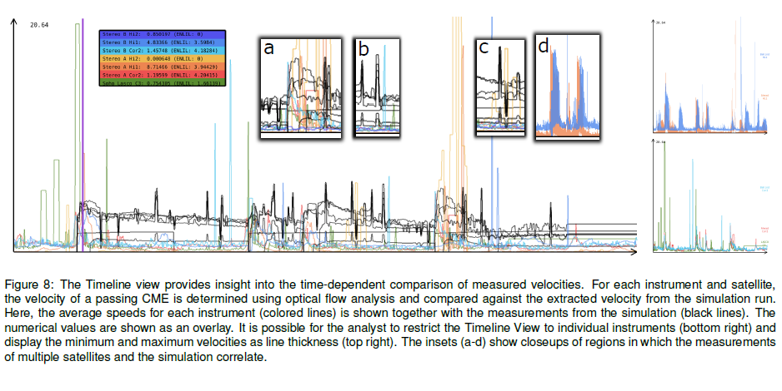

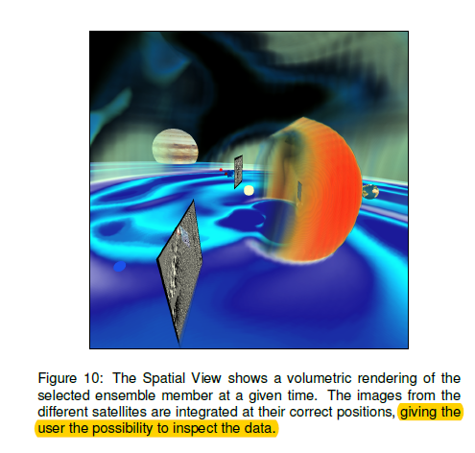

The visualization consists of two major views: the timeline view and the spatial view. The time line view provides time-dependent comparison of measured velocities. The spatial view shows a snapshot of volumetric rendering (the 3rd step) at a given time. In the time line view, it uses color lines to show the average speeds for each instrument. According to the diagram, the visualization is missing time scale on x-axis and speed on y-axis. It is easier to compare since the curves are plotted on the same graph, but user cannot tell their numerical values by looking at only the graph. It is also missing label on the small graphs popping up on top of the main one. Scale, label and the unit of measurements are important elements of the visualization. In addition, the numerical value, 20.64, doesn’t make sense without mentioning its unit of measurement and it creates misperceptions on the data that the system is visualizing. The popup graphs on top of the main graph do not convey any information if you are not a domain expert. In the second part, the spatial view, labels are missing

The system covers all major requirements like providing user with the possibility to compare simulation data with ground-truth data, and visualization the simulation data in three dimensional view, but it has some minor issues that make the system ineffective. I’d suggest to fix the above issues on the visualization system in order to make it more efficient and user friendly.