This is in response to Sheng’s email on 29 Oct about how we will be evaluated for the class, and that we should keep a log. This is my log. There are many like it, but this one is mine…

I am using Word format so that I can embed images in this log… I will update the log from the top, so that the oldest material is at the bottom.

2 Nov 2014: HW4 completed, with Wayne Fang’s cooperation. We verified the control of each other’s LEDs with our switches.

Also the team (Wayne, Zihui, Sudheendra, and I) converged on a final project, which will involve an mbed w/ BLE interface, two sensors, and a hexadecimal display (the latter is shown in the image from 29 Oct). Zihui will write an iDevice app that uses Bluetooth to read the two sensors’ data, and also provide a touch-movable slider that controls the numbers shown on the display (ox00 – 0xFF). We are all ordering the same parts so we each can replicate the project for debugging or whatever.

29 Oct 2014: So far I have completed homeworks hw1, hw2, and hw3. While working on hw3, just for fun I put together some things that I have on hand:
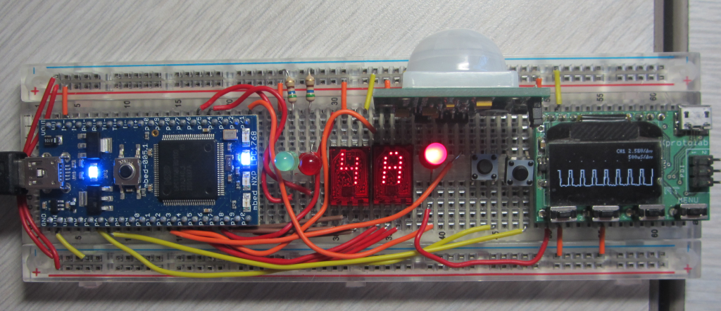

The displays are old HP 5082-7304 5x7 LED matrix displays, with built-in BCD decode logic. Initially I drove those displays using a 16x4 lookup array of the BCD codes for digits 0-9 and alpha A-F, but I came across a much more elegant way to do it,using the bitwise AND operator. This code just causes the displays to count from 00 to FF:

DigitalOut one28(p20), sixty4(p19), thirty2(p18), sixteen(p17);
DigitalOut eight(p16), four(p15), two(p14), one(p13);
DigitalOut myled1(LED1), myled2(LED2), myled3(LED3), myled4(LED4);

for(unsigned int i = 0; i < 256; i++)
{
one28 = myled4 = i & 128;
sixty4 = myled3 = i & 64;
thirty2 = myled2 = i & 32;
sixteen = myled1 = i & 16;
eight = i & 8;
four = i & 4;
two = i & 2;
one = i & 1;
}

The mbed’s built-in LEDs show the most significant digit’s BCD code.

The white device at the top of the image above is a Parallax PIR (passive infra-red) sensor. I’ve coded it so that when the PIR detects movement, the counting stops, and the red and green LEDs to the left of the displays blink back and forth until the PIR resets (after no movement for about 4 seconds). After that, the counter resets to 00 and starts counting again.

In addition, I have a red LED to the right of the displays that is driven by an mbed PWM output; it’s using “i” to control the apparent brightness of the LED, which gets progressively brighter between i= 0 and 128, and then dims back down from i=129->256.

Finally, I have a Gabotronics Xprotolab “tiny oscilloscope” on the right hand of the board; in the image it shows the current pulse width of the PWM output. It can also show the PWM frequency, which is 2000Hz (based on a period setting of 500us).

Complete code:

#include "mbed.h"

DigitalIn inputOne(p12); // PIR input
DigitalIn switch1(p5), switch2(p6); // switches for upcoming hw4
DigitalOut one28(p20), sixty4(p19), thirty2(p18), sixteen(p17); // HP BCD (MSD)
DigitalOut eight(p16), four(p15), two(p14), one(p13); // HP BCD (LSD)
DigitalOut myled1(LED1), myled2(LED2), myled3(LED3), myled4(LED4);
DigitalOut red(p25), green(p26);
DigitalOut rate(p11); // for monitoring loop frequency
PwmOut myPwm(p21);

int main()
{
myPwm.period_us(500);

while(1)
{
for(unsigned int i = 0; i < 256; i++)
{
if(inputOne || switch1 || switch2) // If PIR detects movement
{ // or either button is pressed
for(unsigned int j = 0; j < 4; j++) // alternately flash LEDs
{
red = 0;
green = 1;
wait(0.09);
green = 0;
red = 1;
wait(0.09);
}
red = green = 0;
break; // And then reset counter and
} // start counting again

if(i < 128) // Gradually brighten PWM LED
myPwm = i * 0.004; // based on “i”
else // Then, gradually dim it
myPwm = 1 - (i * 0.004);

one28 = myled4 = i & 128; // generate BCD codes to drive
sixty4 = myled3 = i & 64; // HP displays
thirty2 = myled2 = i & 32;
sixteen = myled1 = i & 16;
eight = i & 8;
four = i & 4;
two = i & 2;
one = i & 1;
rate = !rate; // output to monitor outer "for" loop frequency
wait(0.063); // 0.063 results in approx. 1 second MSD counting
}
}
}

28 Oct 2014: Today I got the Bluetooth BLE board that I recently ordered from Adafruit working with my Arduino, with the idea of possibly using it with my mbed for the final class project. However, Adafruit’s board does not have a hardware-native UART capability, so they implemented support libraries which of course will not work with the mbed, and we would have to write our own mbed versions. But, Zihui pointed us at a “Red Bear Labs” BLE board that has basic TX/RX pins, which would be far easier to work with.

Adafruit board: http://www.adafruit.com/product/1697
Red Bear Labs board: http://www.makershed.com/products/ble-mini-bluetooth-4-0-interface

The example mbed code for the Red Bear board is dead simple:

#include "mbed.h"
#include "ble_mini.h" // see below
Serial pc(USBTX, USBRX); // tx, rx
Serial device(p13,p14);
DigitalOut myled1(LED1);
DigitalOut myled2(LED2);
DigitalOut myled3(LED3);
DigitalOut myled4(LED4);

char buf[10];

int main() {
int i=0;
//set mbed baud rate the same as BLE mini baud rate
device.baud(57600);
//simple polling demonstrate serial communication
while(1) {
if(device.readable()) {
buf[i]=device.getc();
if(buf[i]==ON_INTERNEL_LED1)myled1=1;
if(buf[i]==OFF_INTERNEL_LED1)myled1=0;

if(buf[i]==ON_INTERNEL_LED2)myled2=1;
if(buf[i]==OFF_INTERNEL_LED2)myled2=0;

if(buf[i]==ON_INTERNEL_LED3)myled3=1;
if(buf[i]==OFF_INTERNEL_LED3)myled3=0;

if(buf[i]==ON_INTERNEL_LED4)myled4=1;
if(buf[i]==OFF_INTERNEL_LED4)myled4=0;

i++;
}

if(i==10)i=0;
wait(0.1);
}
}

The “ble_mini.h” is not a support library per-se; it just defines some LED control codes:

#define ON_INTERNEL_LED1 0x01
#define OFF_INTERNEL_LED1 0x02
#define ON_INTERNEL_LED2 0x03
#define OFF_INTERNEL_LED2 0x04
#define ON_INTERNEL_LED3 0x05
#define OFF_INTERNEL_LED3 0x06
#define ON_INTERNEL_LED4 0x07
#define OFF_INTERNEL_LED4 0x08

That all said, for our final project we may end up not using BLE at all; this remains to be determined (we might do Ethernet/web instead).

.end document.

