**TECHNICAL ANALYSIS STOCK SCREENER-1**

## LOW LEVEL DESIGN

**Overview of TA Screener:**

Technical Analysis Stock Screener mainly displays the list of stocks to gives choices of stock User can choses and project display all past data and calculated averages on the basis of data display.

It gives recommendations based on the averages calculated between the latest 10 days Stock records average to the latest 50 days average Stock record based on this difference between averages It provides recommendations like Buy, Sell or Hold.

.

**Data Flow Diagram:**

**Level 0:**

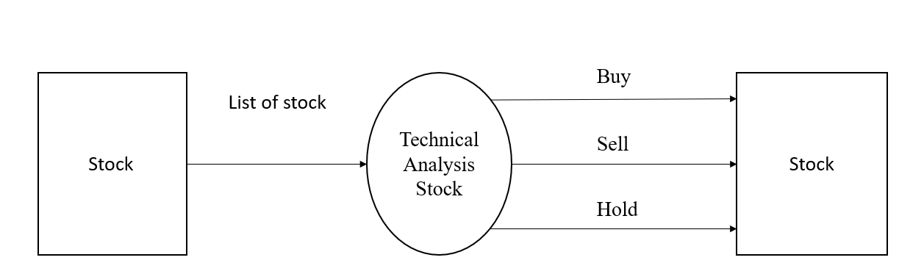

**Level 1:**

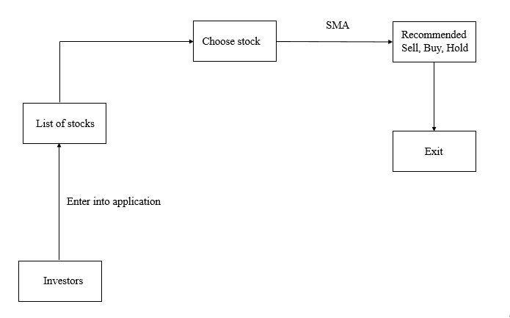

**Investor:** A person or organization that puts money into financial schemes, property with the expectation of achieving a profit.

**Stock:** A stock, also known as [equity](https://www.investopedia.com/terms/e/equity.asp#:~:text=Equity%20represents%20the%20value%20that,debts%20associated%20with%20that%20asset.), is a security that represents the ownership of a fraction of the issuing corporation. Units of stock are called "[shares](https://www.investopedia.com/terms/s/shares.asp#:~:text=Shares%20are%20units%20of%20equity,in%20a%20distribution%20of%20profits.)" which entitles the owner to a proportion of the corporation's [assets](https://www.investopedia.com/terms/c/core-assets.asp) and profits equal to how much stock they own.

**Technical Analysis Stock Screener:** Technical analysis is purely based on mathematical calculations, called the “technical indicators” that take into account the trading volume, stock price, and the speed of price movement as key variables. The main aim of these indicators, as mentioned above, is to suggest to you the probable price of the stocks in the near future.

**Procedure flow:**

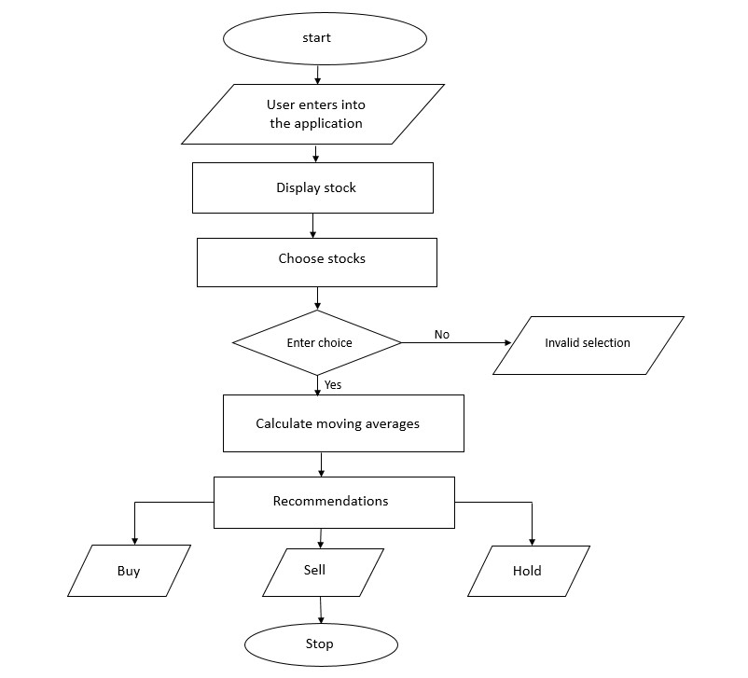

**Sequence flow:**

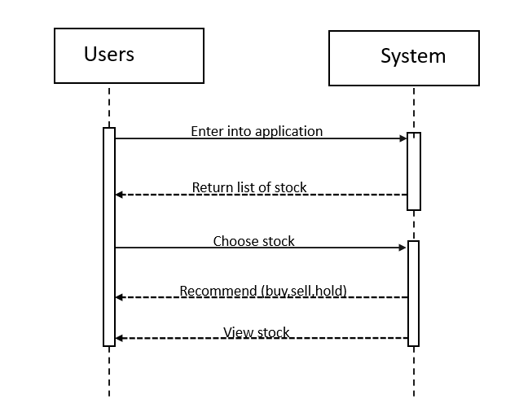

**moving Average**: In Technical analysis, moving average also plays a great role. As observing all the lines for closing prices, opening prices, highs and lows can become confusing at times, moving averages can show you the price trend clearly as averages of these prices can be plotted simply on the graph without a mess. You can track the averages daily and it will be easy for you to understand the price movement. You can either use a simple moving average or exponential moving averages, depending on the type of security you are analysing.

**Simple moving Average:** A simple moving average chart is calculated taking all the closing prices for a given period and then summing them up and dividing by the number of stock prices used. For example, you can calculate a 20-day SMA. Then you will be adding all the 20 closing prices for fifteen days and then divide the same by 20 the number derived is the SMA for the 20-day moving average of the stock.

**Recommendations**: Based on this difference between averages It provides recommendations like Buy, Sell or Hold.

.