

**TECHNICAL ANALYSIS SCREENER 1**

**Software Requirement Specification (SRS) Document**

**Sprint Implementation**

**Project Timeline: 07-12-2022 to 12-12-2022**

**INDEX**

1. Introduction

1.1 Purpose ------------------------------- 3

1.2 Intended audience ------------------------------- 3

1.3 Intended use ------------------------------- 3

1.4 Scope ------------------------------- 4

2. Overall description ------------------------------- 4

2.1 Assumptions and dependency ------------------------------- 4

3. System feature and requirements ------------------------------- 5

3.1 Functionality ------------------------------- 6

3.1.1 SelectChoice ------------------------------- 6

3.1.2 LoadStockData ------------------------------ 6

3.1.3 ShowMovingAverages --------------------------------6

3.1.4 FreeLinkedList --------------------------------6

3.15 PrintStockList ---------------------------------6

3.2 System requirement -------------------------------- 7

3.2.1 Tools to be used -------------------------------- 7

3.3 System feature ------------------------------- 7

4. Data Flow Diagram --------------------------------7

4.1 DFD level 0 ------------------------------ 8

4.2 DFD level 1 ------------------------------ 8

### **1.Introduction: -**

Technical analysis is a trading tool employed to evaluate securities and identify trading opportunities by analyzing statistics gathered from trading activity, such as price movement and volume.Technical analysts focus on price charts on price trends and various analytical tools to measure a security’s strengths and weaknesses.

The target of technical analysts is to predict the future stock market behavior using past price performance where they like to use 18 behavioral economics and quantitative analysis. Mostly used technical analysis forms are the price chart patterns and the technical indicators.

**1.1 Purpose**: **-** The main purpose of Simple moving average is to show the trend of a stock/security in a smoothed manner with a single line with less apparent volatility. It’s gives recommendations to the Stock Holders like Buy, Sell or Hold the stock by the past moving averages.

Moving Averages are some of the oldest technical indicators and still remain some of the most useful indicators for market analysis using the technical analysis approach. In simple terms moving average is the average price of the security at a specified point in time. This project is to create for Time Saving, Easily Accessible for customer while doing Technical Analysis Stock Screener and moving average tries to exhibit a trend in the prices.

**1.2 Intended Audience: -**

This document is intended to be read by investor.

* 1. **Intended Use: -**
* Development Team
* Investor

There is no such specific audience, one who want to invest in stock market can access it.

* 1. **Scope: -**

Scope of Technical Analysis Technical Analysis is commonly and widely used by Equity traders, Forex traders, Commodity traders around the globe to**predict the market for short term as well as long term.** The charts, indicators are the main tools of technical analysis, and these help the traders to understand the price movement pattern, the trend in the market.

In this project we have analyzed static data but in real time stock market the price changes in every millisecond hence the decision made at current situation may not valid at next instant So it can be solved by analyzing the algorithm with real time data.We are using one year data for all sticks but when new data is used in this model its accuracy may vary.

**2. Overall Description: -**

The technical indicator is used to predict the trends in the stock prices and the timing of the reversal. A simple moving average is an arithmetic moving average calculated by adding the closing price of the security for a month of time periods and then dividing this total by the number of time periods. A simple moving average line is projected over the price chart and when the simple moving average line went below the share price line it was an indicator that the share price would rise. A simple moving average smooths out volatility, and makes it easier to view the price trend of a security. Pointing up simple moving average indicates the increasing price and pointing down indicates the decreasing price of a security. The longer moving average time period makes the simple moving average smoother and this smoothness increases with the length of time period. And the shorter moving average causes the volatile simple moving average but the reading is so close to source data

**2.1 Assumptions and Dependency: -**

* System should have Ubuntu Linux installed.
* System should have either 4GB or more RAM.
* The service is used preferably on a desktop or laptop.

**3.System Features and Requirements: -**

**3.1 Functionality: -**

* + 1. **TA SCREENER-1_01->: void selectChoice()** :- This function display

list of stocks and user need to select one stock from list.If user select invalid choice then it display invalid selection.

* + 1. **TA SCRNEER-1_02-> void loadStockData()** :- This function will load the files of stocks in the application.When user select anyone stock from list then that file get load from this function.
    2. **TA SCRNEER-1_03-> void showMovingAverages()** :-This function calculate averages of the past stocks and show recommendation that which stock we need to buy ,sell or hold.
    3. **TA SCRNEER-1_04-> void freeLinkedList()** :-This function will deallocated all the dynamic memory which is allocated in program.
    4. **TA SCRNEER-1_05-> void printStockList()** :-This function will print all data of stocks.

**3.2 System Requirements: -**

### **3.2.1. Tools to be used:**

1. Language: C
2. Tools: Valgrind ,CTags, MakeFile
3. Complier: gcc
4. Linux Environment

### **3.3 System Features: -**

### **Supportability:** The system is easy to use.

* **Design Constraints:** The system is built using only C language.
* **Usability:**  A simple moving average line is projected over the price chart and when the simple moving average line went below the share price line it was an indicator that the share price would rise. A simple moving average smooths out volatility, and makes it easier to view the price trend of a security. Pointing up simple moving average indicates the increasing price and pointing down indicates the decreasing price of a security.
* **Reliability & Availability:** The system is available 24/7 that is whenever the user would like to use the system, they can use it up to its functionalities.

### **Performance:** The system will work on the user’s terminal**.**

**4. Data Flow Diagram**

**4.1 DFD level 0**

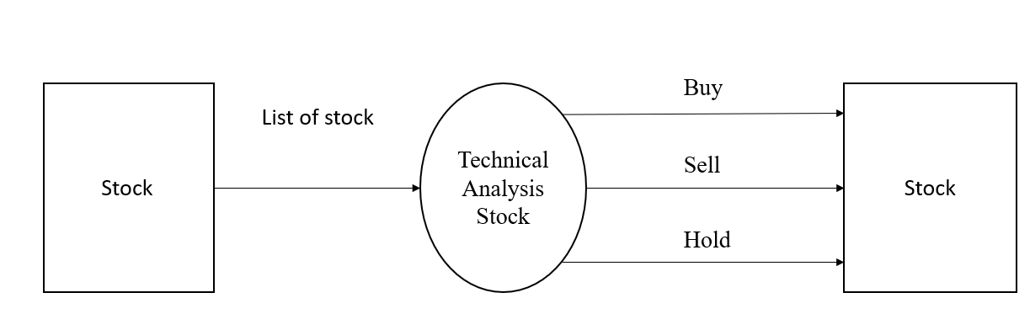

**4.2 DFD level 1**

