Technical Report
for
license plate detection

Prepared by
Group Name: 13
Arinda Johnson | 22/U/5032/EVE | arindaj33@gmail.com
Zirimabagabo Anslem | 22/U/7076 | zbagagabo@gmail.com
Mukisa Don Joseph | 22/U/6365 | donmukisajoseph@gmail.com

Mentor: | Mr Paddy Asiimwe
Course: | CSC 1304 Practical Skills Development
Date: | 21-08-2023

Contents
Contents ii
Abstract iii
1 Introduction (max. 2 pages) 1
1.1 User Challenge 1
1.2 Project Goals 1
1.3 Functional Requirements 1
2 Project Results (max. 3 pages) 2
2.1 Product Design 2
2.2 Product Functionality and Screenshots 2
3 Limitations and Next Steps (max. 1 page) 3
3.1 Limitations 3
3.2 Next Steps 3
References 3
4 Appendix A – Project Work plan 4
Appendix B – Contribution by Team Members 5

Abstract
This technical report presents the development and implementation of a license plate recognition embedded system designed to detect and identify license plates on automobiles. The project addresses the growing need for efficient and accurate license plate recognition systems in various applications, including traffic management, security, and automated toll collection.
The report begins by outlining the problem statement, highlighting the challenges and requirements associated with license plate recognition, including variations in plate design, lighting conditions, and vehicle speeds. It then details the solution that has been built to address these challenges.
The solution consists of a hardware and software integration, leveraging computer vision algorithms and machine learning techniques. The hardware component includes a specialized camera system for capturing license plate images and a processing unit for real-time analysis. The software component involves image preprocessing, character segmentation, and optical character recognition (OCR) techniques to extract and identify the license plate characters accurately.
Throughout the report, we discuss the design choices, implementation details, and performance evaluations of the embedded system. The accuracy, speed, and robustness of the system are assessed through extensive testing in various real-world scenarios. Additionally, the report touches upon potential future enhancements and applications for the license plate recognition embedded system.
In conclusion, this project presents a comprehensive solution to the challenge of license plate recognition in real-world environments. The embedded system showcases promising results and opens up opportunities for integration into a wide range of applications where reliable license plate detection and identification are essential.

Introduction

User Challenge
In today's fast-paced world, the efficient management of traffic and the maintenance of security have become paramount concerns. One of the key challenges in addressing these concerns is the need for accurate and rapid license plate recognition. License plate recognition (LPR) systems play a crucial role in various applications, such as law enforcement, automated toll collection, parking management, and traffic monitoring. The user challenge we aim to address with this project is the development of a robust and versatile license plate recognition embedded system capable of accurately detecting and identifying license plates on automobiles under diverse environmental conditions. This challenge is of utmost importance as it directly contributes to improving security, traffic management, and overall efficiency in various sectors.

Project Goals
The primary goal of this project is to design, develop, and implement a highly reliable license plate recognition embedded system that can operate efficiently in real-world scenarios. Our system aims to address the user challenge mentioned above by providing the following:
- Accuracy: Achieve high accuracy in license plate detection and character recognition, even under challenging conditions such as low lighting, varying plate designs, and fast-moving vehicles.
- Speed: Process license plate information in real-time to support applications like traffic monitoring, access control, and toll collection.
- Versatility: Adapt to a wide range of environmental conditions and vehicle types to ensure applicability in diverse use cases.
- Scalability: Design a system architecture that allows for easy scalability to accommodate increasing demands in terms of camera inputs and recognition tasks.
- Innovativeness: Implement cutting-edge computer vision and machine learning techniques to enhance the system's adaptability and recognition accuracy.

Functional Requirements

Camera System
- Image Capture: The system shall capture high-resolution images of vehicles and their license plates using specialized cameras.
- Image Preprocessing: Implement image preprocessing techniques to enhance image quality by reducing noise, adjusting contrast, and improving overall clarity.
- Real-time Operation: Ensure real-time image acquisition and preprocessing to support immediate analysis.

License Plate Detection
- Plate Localization: Develop algorithms for accurately localizing license plates within captured images.
- Variability Handling: Handle variations in plate size, orientation, and lighting conditions.
- Multiple Plates: Detect and handle cases where multiple license plates are present in a single image.

Character Recognition
- Optical Character Recognition (OCR): Implement OCR algorithms to extract and identify individual characters from the detected license plates.
- Character Segmentation: Develop techniques for accurate character segmentation, especially in cases of tightly spaced characters or distorted plates.
User Interface
- Configuration: Provide a user-friendly interface for system configuration, including camera settings, recognition thresholds, and database integration.
- Monitoring: Display real-time recognition results and system health status.

Project Results

Product Design
The figure below represents the system architectural design of our project
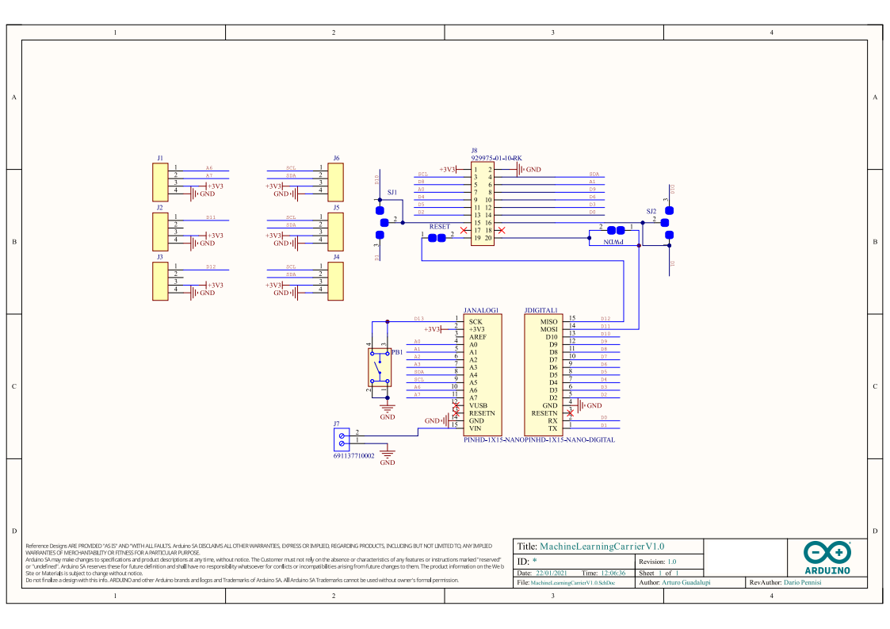

Product Functionality and Screenshots
The embedded system will feature object detection and segmentation techniques to precisely locate and extract number plates from complex backgrounds and varying lighting conditions. The captured number plates will undergo character recognition using optical character recognition (OCR) algorithms to extract the alphanumeric information effectively. Additionally, the system will incorporate data verification techniques to ensure the accuracy and integrity of the captured number plate information such as character recognition confidence scoring.
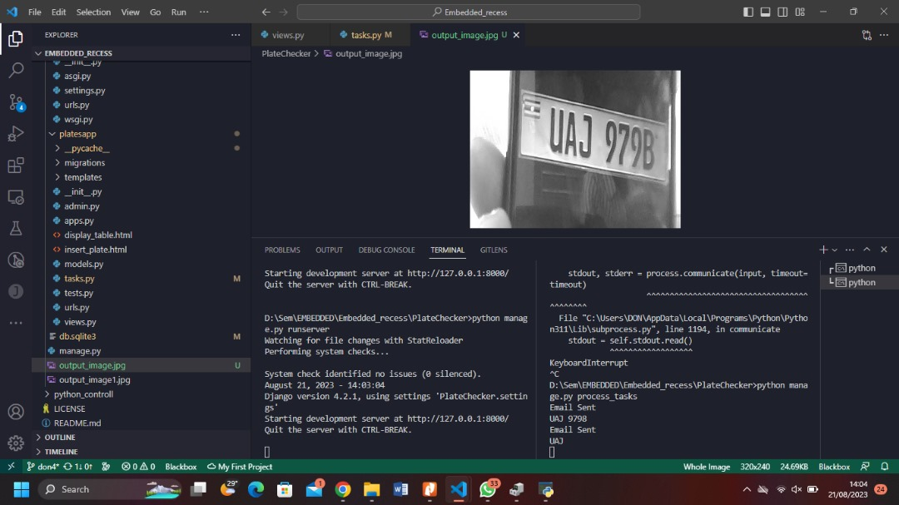

To enable efficient tracking and investigation, the system will integrate with a centralized database or law enforcement systems, providing east communication and information exchange. It will support rapid matching and retrieval of vehicle records based on the captured number plate data, incorporating advanced search algorithms and efficient mechanisms to optimize performance. The system will store relevant metadata, including date, time, and location of the vehicle sightings, to assist law enforcement agencies in building comprehensive case histories and generating insights for investigative purposes.
enforcement agencies in building comprehensive case histories and generating insights for investigative purposes.
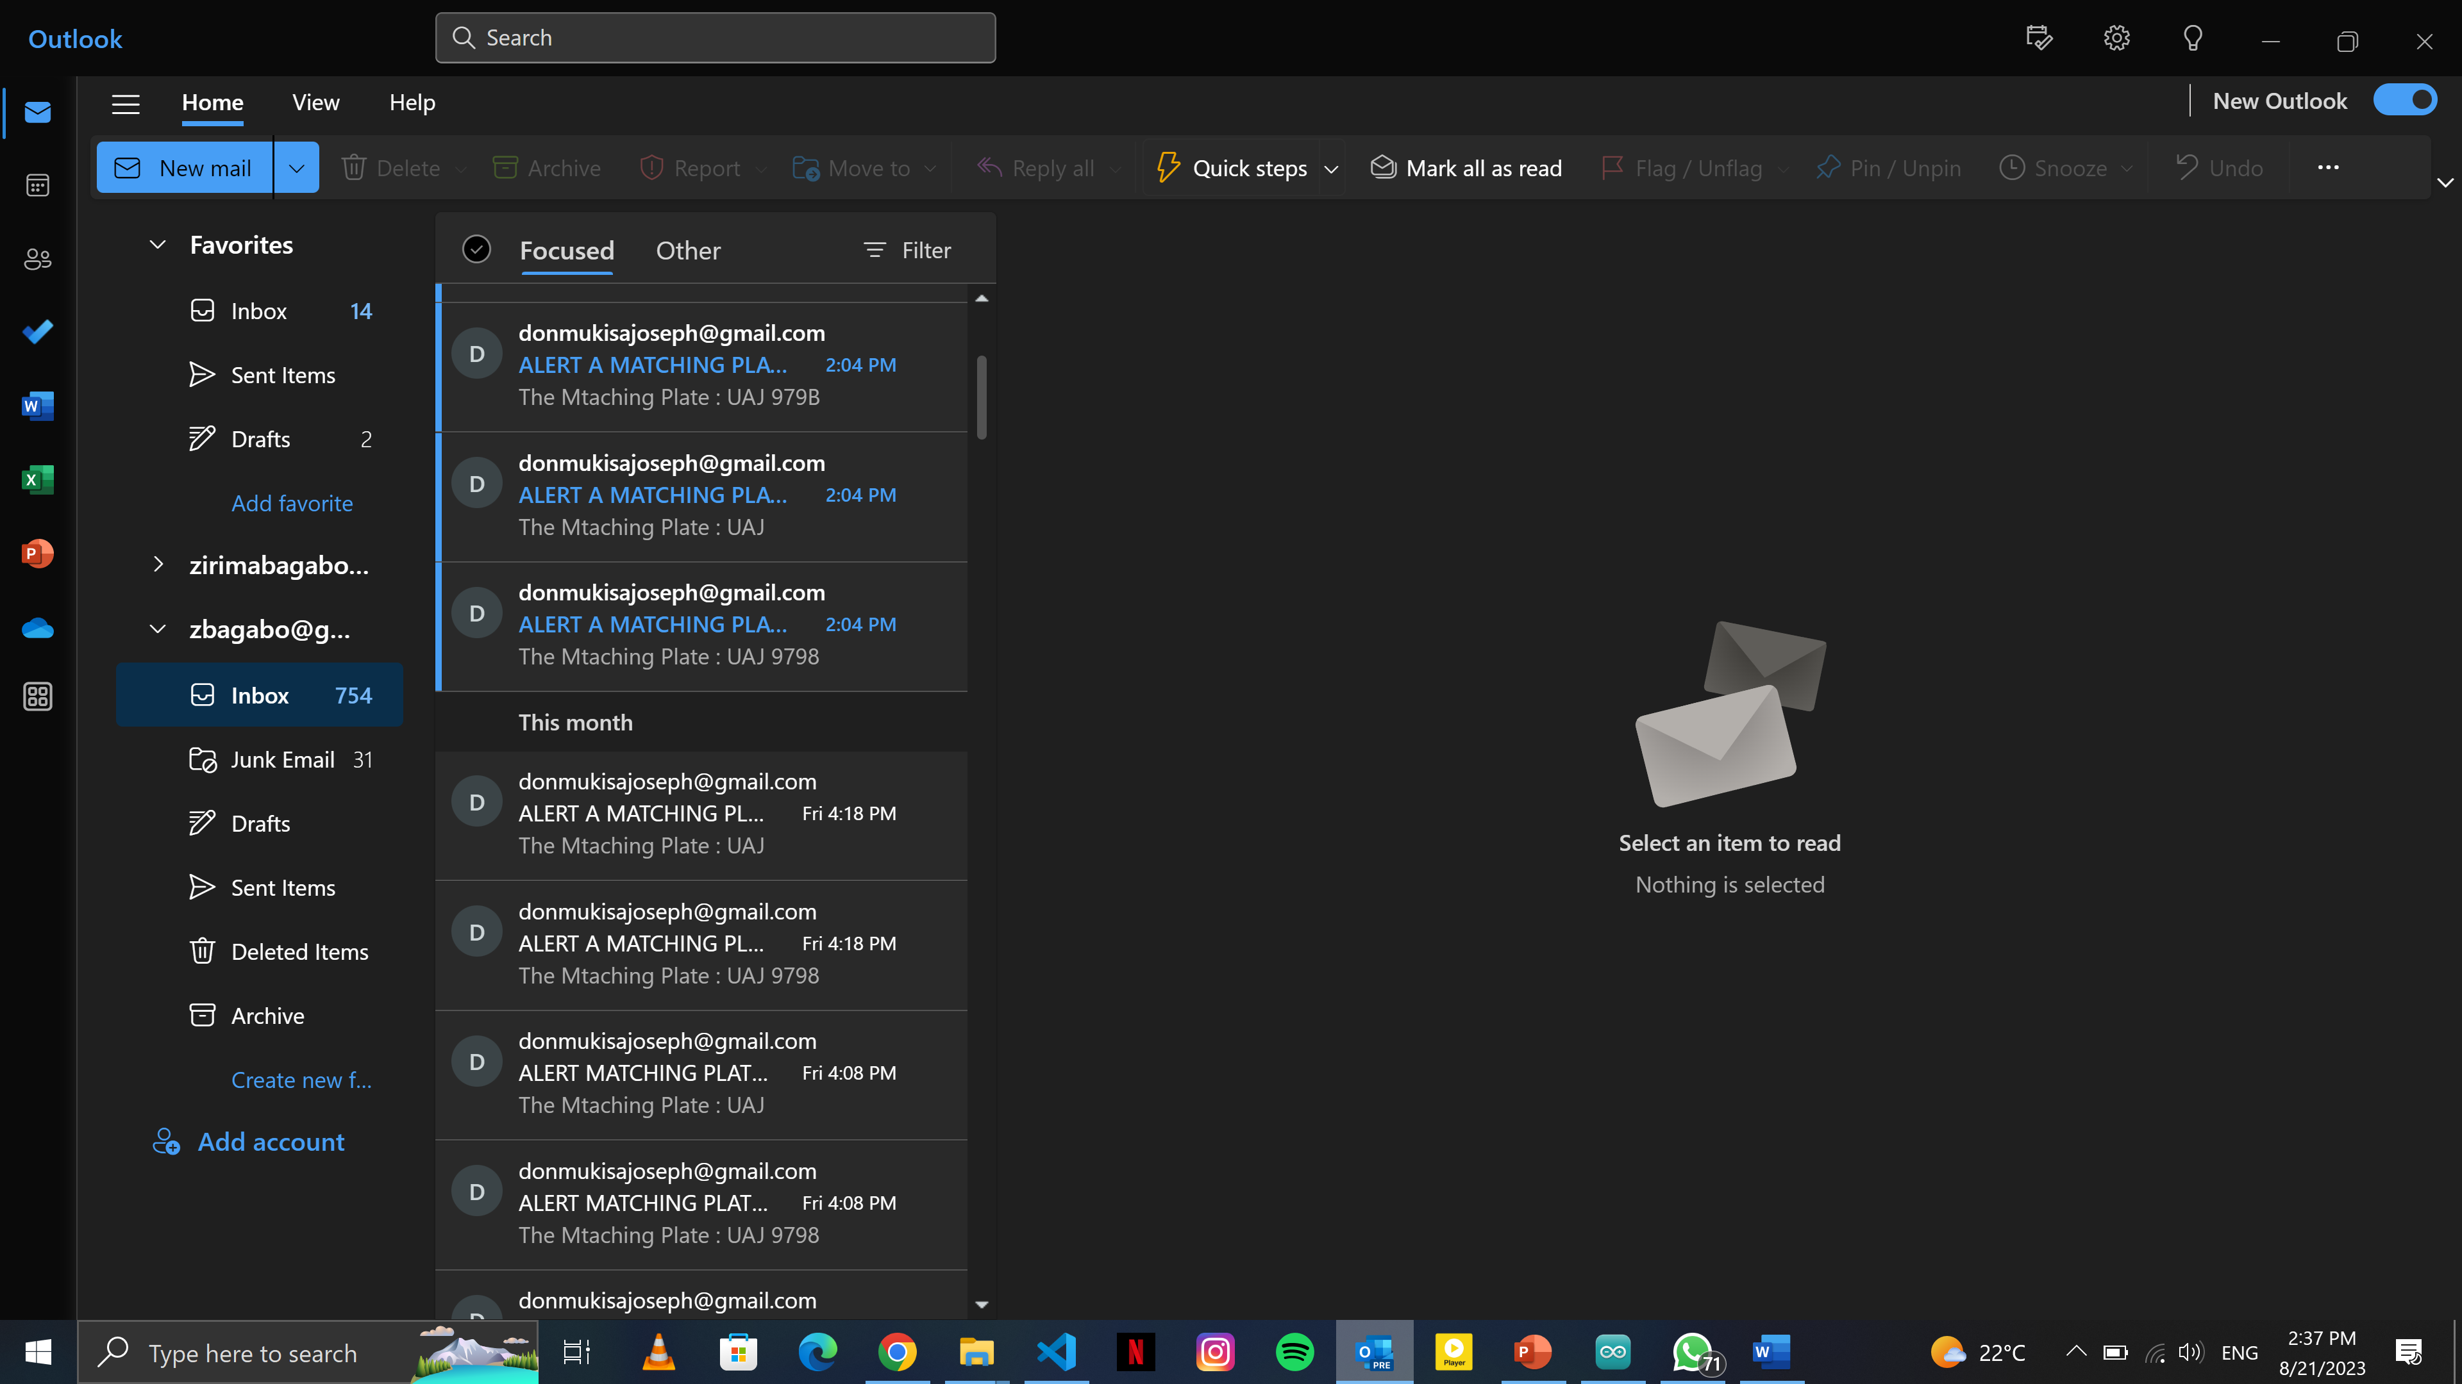

Project website and repository
Project website: https://anslemhunco.github.io
Project repository: https://github.com/blaxpyda/Embedded_recess.git

Limitations and Next Steps
While our license plate recognition embedded system has achieved significant success in accurately detecting and identifying license plates in various scenarios, it is essential to acknowledge certain limitations

Limitations
- Environmental Variability: Our system performs well under diverse lighting conditions and plate designs, but extreme variations, such as very low-light environments or heavily obscured plates, can still pose challenges. Future improvements should focus on enhancing performance in these extreme cases.
- Recognition Accuracy: While the system achieves high accuracy, occasional recognition errors may still occur, especially when dealing with damaged plates or non-standard character fonts. Further advancements in machine learning algorithms and training data diversity can mitigate this issue.
- Processing Speed: While our system is designed for real-time processing, there is room for optimization to handle exceptionally high traffic volumes, especially in urban areas with heavy vehicle congestion. Improvements in parallel processing and hardware acceleration could address this limitation.

Next Steps
To address these limitations and continue to enhance our license plate recognition embedded system, we have identified several next steps beyond the current phase:
- Advanced Machine Learning: Further research into advanced machine learning techniques, such as deep learning and neural networks, can improve recognition accuracy, particularly for challenging cases like damaged plates or non-standard fonts.
- Integration with IoT: Explore the integration of Internet of Things (IoT) devices, such as sensors and connected cameras, to enhance real-time data gathering and processing capabilities.
- Cloud-Based Processing: Consider the possibility of offloading some processing tasks to cloud-based services for improved scalability and real-time performance in high-traffic areas.

References
https://cloud.google.com/vision
https://viso.ai/computer-vision/automatic-number-plate-recognition-anpr/
https://www.section.io/engineering-education/license-plate-detection-and-recognition-using-opencv-and-pytesseract/

Appendix A – Project Work plan
Week 1: Project Planning and Research
- Define the project goals and objectives.
- Conduct focused research on embedded systems, specifically related to your project.
- Create a concise project plan outlining the key tasks, milestones, and deliverables.
Week 2: System Design and Specification
- Identify the requirements and specifications for your embedded system.
- Design the overall system architecture, focusing on essential hardware and software components.
- Select the necessary components and tools, considering time constraints.
Week 3: Hardware Development
- Begin developing the core hardware for your embedded system.
- Prioritize key hardware components required for basic functionality.
- Test and debug the hardware components to ensure proper functionality.
Week 4: Software Development and Integration
- Set up the development environment and necessary software tools.
- Write and test the firmware or software for your embedded system, focusing on essential features.
- Integrate the software with the hardware components and perform initial testing.
Week 5: Testing, Optimization, and Documentation
- Conduct thorough testing to ensure the system functions as intended.
- Identify and fix any critical bugs or issues discovered during testing.
- Optimize the performance of the embedded system, focusing on key areas.
- Create documentation, including system specifications, hardware and software design details, and user manuals.

Appendix B – Contribution by Team Members

No. | Team Member | Contribution
1. | Arinda Johnson | Project documentation  Implemented code running on Arduino board  Contributed to C++ code
2. | Zirimabagabo Anslem | Implemented and integrated Google vision API for Detection and recognition  Contributed to python code  Contributed to C++ code
3 | Mukisa Don Joseph | Integrated the ANPR system to Django and concurrent scheduling(running of tasks) in the system  Configured communication between the Board and PC  Contributed to python code  Contributed to C++ code

