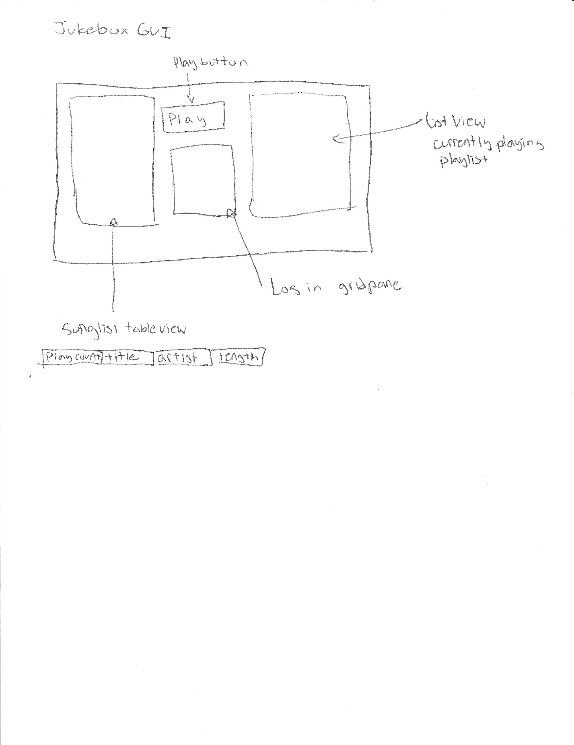Tasks:

Fix Playlist FIFO -Braxton

Complete GUI -Allen

TableView-Allen

ListView-Braxton