**CSc 335 Analysis and Design Artifacts for Final Project**

*Each team member completes this form SOLO, renames it with their last name, places it into the Eclipse project, then pushes the project to Github*

**1. Team Name:**  __________KimLazar__________

**3. Team Members**: ______Allen Kim____________ __________Braxton Lazar_________

___________________________

**4. Candidate Objects or Class Hierarchies**

List the most important objects, or an inheritance hierarchy name, and the single responsibility of each.

|  |  |
| --- | --- |
| **Candidate Object** | **Single Responsibility in 1 or 2 sentences** |
| JukeBox | Hold the song catalog , card reader, plays song. |
| Song | Contains title, artist, and duration. also well as mp3 file. |
| Card Reader | Takes a students ID and verifies it. |
| Song Catalog | Hold a list of all songs in the JukeBox and how many times a song is played a day. |
| Student ID | Contains ID number as well as password. |
| JukeBoxAccount | List of the student ids as well as student plays each day.  . |
| Student | Logs in and Chooses song |
|  |  |
|  |  |
|  |  |

**5. Sequence Diagram 1:** Your team UML Sequence Diagram should show the most important scenario you can think of. Your sequence diagram should show most of your objects from above and how they communicate with each other.

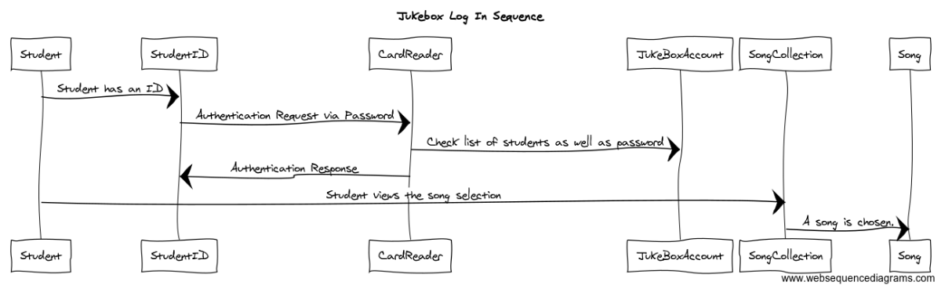

**6. Sequence Diagram 2:** Your team UML Sequence Diagram should show the seconf most important scenario you can think of. Your sequence diagram should show most of your objects from above and how they communicate with each other.

