Incremental Commit & Decommit Implemenation

1. Summary
This milestone successfully implements Incremental Commit and Incremental decommit capabilities for the Blazar Hydra payment protocol, enabling dynamic liquidity management in live Hydra Heads without requiring head closure. This represents a significant advancement is Layer 2 scalability for Cardano-based payment systems.
Key achievements:
- Implemented incremental commit handler for adding funds to open heads
- Implemented incremental decommit handler for withdrawing funds from open heads
- Added REST API endpoints (‘/incremental-commit, /incremental-decommit’)
- Enhanced Hydra node communication layer with decommit support
- Validated on-chain validator compatibility (no changes required)
- Comprehensive error handling and event-driven architecture
Impact:
- Users can add funds to active payment channels without waiting for daily head closure.
- Merchants can withdraw earnings immediately without interrupting service.
- System eliminates the limitation of once-daily deposits, enabling true continuous operation.

2. Background
2.1 The Problem Statment

The original Blazar Hydra System operated in a daily cycle model:
- Users deposit funds to L1 smart contract
- Admin opens head once per day, committing all pending deposites
- Users transact within the head
- Head closes at the end f day, funds are fanned out
- Process repeats next day
Limitations:

- Users joining mid-day must wait ~12 – 24 hours for funds to be available
- Merchants cannot withdraw earnings until daily closure
- System downtime during head opening/closing transitions
- Poor user experience for time-sensitive payments
2.2 The Solution
Hydra Protocol specification introduced support for Incremental Commit/Decommit.

3. Technical Architecture
Incremental Commit is processed through the Hydra Commit script. A participant submits a new Commit transaction to Cardano L1, Hydra observes this event, and integrates the newly committed UTXOs into the active micro-ledger. A new snapshot is generated, and participants sign it to confirm the updated ledger state.

3.1 Transaction Flow
1. Participant selects UTXO on Cardano.
2. Participant submits CommitTx.
3. Hydra node observes CommitTx via the on-chain observer.
4. Hydra injects new UTXO into the local ledger.
5. Snapshot N+1 is created and signed.
6. Ledger state becomes updated and deterministic across all nodes.

3.2 Security Considerations
Incremental Commit inherits the security model of Hydra: all commits must comply with the Commit validator script; signatures ensure state agreement; and consensus requires all participants to validate the new snapshot. No participant can introduce invalid funds.

4. Incremental Commit Implementation
Since incremental commit is not a trivial extension of initial commit, this stage required a deep understanding. The architecture for incremental commit defines exactly how the system accepts new UTXOs during a live Hydra Head session, integrates them into the micro-ledger, and preserves consensus and safety across all participants. This section shows what is added and updated for Incremental Commit.
4.1 Off-Chain Handlers
For incremental commit, incremental-commit script is created. The purpose is to allow user to add more funds to an OPEN Hydra Head without closing it
Incremental-Commit Flow:
1. Validates head is in RUNNING (OPEN) status
2. Builds deposit the transactions to L1 smart contract
3. Submits transaction to L1
4. Builds commit transaction blueprint
5. Sends commit to Hydra node via HTTP API (‘/commit’)
6. Waits for ‘committed’ event confirmation
For incremental decommit, incremental-decommit script is created. The purpose is to allow users/merchants to withdraw funds from OPEN Hydra Head without closing it.
Incremental-Decommit Flow:
1. Validates headis in RUNNING (OPEN) status
2. Fetches L2 snapshot from Hydra node
3. Validates ownership of funds UTXO
4. Builds withdrawal transaction (reuses existing withdrawMerchant logic)
5. Sends decommit to Hydra node via HTTP API (‘/decommit’)
4.2 API Layer Integration
New routes:
Two endpoints and schema are added in routes file for incremental-commit/decommit.
- ‘/incremental-commit’
- ‘/incremental-decommit’
Request Schemas:
Zod script is updated to show the Incremental commit and decommit schema.
4.3 Hydra Node Communication Layer
Hydra file is updated for handler definition.
- Added decommit() method to send decommit requests to Hydra node
- Enhanced sendCommit() to support both initial and incremental commits
- Added DecommitInvalid to error tags for proper handling
- Event listeners now handle DecommitFinmalized events
4.4 Type System Updates
IncrementalCommitSchema/IncremetalDecommitSchema is added in type file.
- Compile-time validation of request/response shapes
- Auto-completion is IDEs
- Runtime validation via Zod schemas
- Consistent types across API, handlers, and database layers

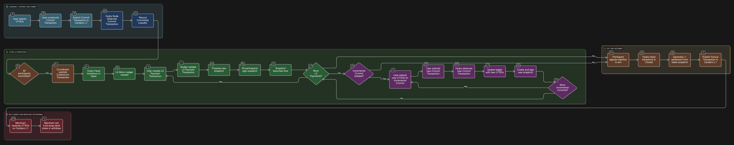5. Diagram

