Guide for Midnight Medical Project
1. Introduction
Production Name: Midnight Medical Record
This is a medical management app based on the Midnight Network to safely store your child's personal & medical data and manage various tasks such as vaccinations.
2. Step By Step Guide
2.1 Create the new child
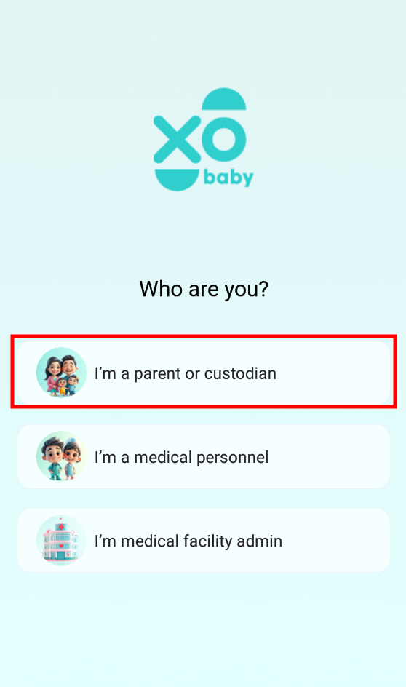- Click the “I am a parent or custodian” button - Users (parents) should select the role in the first screen of the app. There is the 3 roles in app – Parent, Doctor and Admin role. Parent can create their child’s data.
- Next Step is to Register/login part. Here user can create their account (Name, Mail and Password).
- Click the “add first child” button - after login app, you can see the dashboard page. It is maybe empty screen. Here users create their child’s account and register the child’s data.
- Input child’s first name, click “Next” button.
- Input child’s last name, click “Next” button.
- Select the child’s gender – Male or Female, click “Next” button.
- Select the child’s birth date, click “Next” button.
- Select the child’s blood type, click “Next” button.
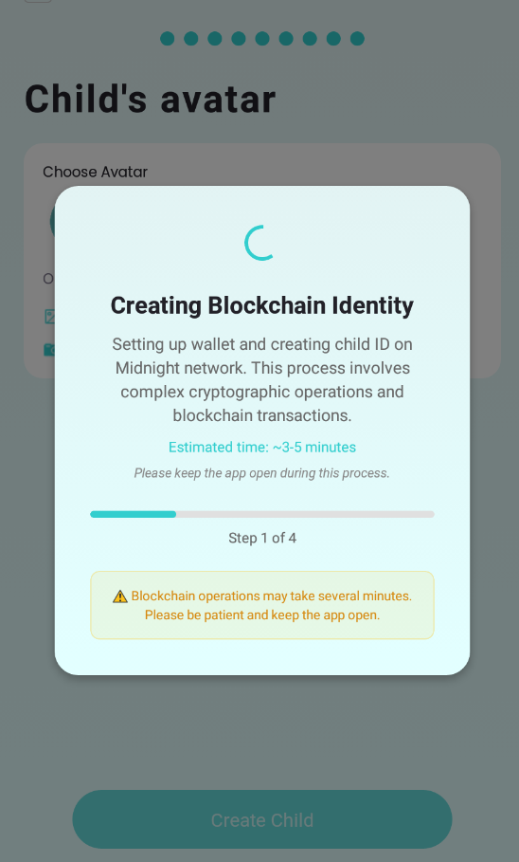- Select the child’s ethnicity, click “Next” button.
- Select the child’s location, click “Next” button.
- Input the child’s congenital anomalies, click “Next” button.
- Select the child’s avatar, click “Create Child” button.
You can see the process that child’s data is stored and it takes some time. After few minutes, you can see the success message and children dashboard.
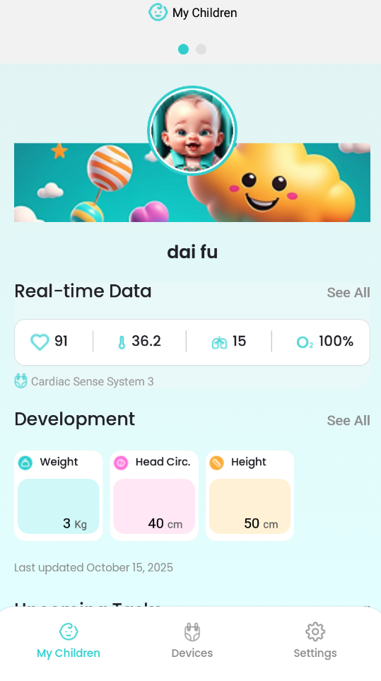

2.2 Children dashboard
This is the dashboard to show the child’s data and manage the some tasks such as Doctor Diagnosis, Vaccination and so on.
There are the 3 tabs on the bottom of interface – My Children, Devices and Settings.
- My Children: This is the main page to show and manage the child’s data and some schedule. - Devices: This is the tab to manage the device connection. If you connect the device, you can see the child’s real-time data that is received using sensor.
- Settings: This is the tab to show the user data and manage the user’s account.
2.2.1 My Children Page
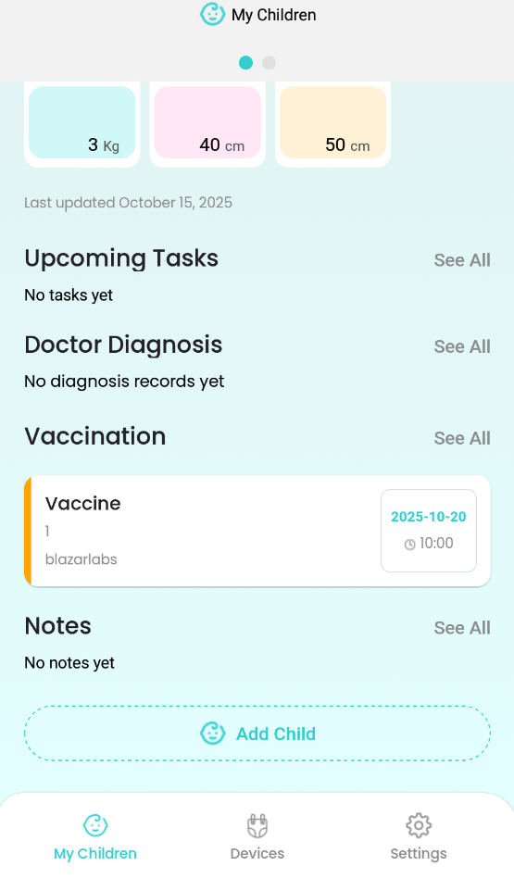Here is the main page to show the child’s data and manage the some schedule.
- Real-time data: This shows the child’s medical real-time data such as heart rate, temperature, oxygen and so on. You can see the data if you connect the device on the bottom – Devices tab.
- Development: This is the part to manage the child’s weight, height and head circumference. You can input the child’s weight, height and head circumference according to date and show the chart.
- Upcoming Tasks: This is the part to manage the task. You can manage the Date, Time, Name and Description.
- Doctor Diagnosis: This is the part to manage the doctor diagnosis. You can manage the Date, Time, Doctor Name, Diagnosis, Location and Notes.
- Vaccination: This is the part to manage the Vaccination schedule. You can create the schedule using some data such as Date, Time, Vaccine Name, Dose Number, Administered By, Location and Notes.
- Notes: This is the part to manage the task. You can manage the Date, Description and Category.

