BGECore

For Blender 2.76

Introduction

What's BGECore?
You can think of BGECore as a framework for Blender Game Engine. BGECore provides you with the tools to make great games in BGE. It adds functionality to BGE through Python and makes coding typically complex setups easy.

Why a framework and not a library?
The lack of a standard in BGE makes impossible writing a library that could work with any design a developer could think of. That's why in order to provide new functionality BGECore requires of a strong standard that every BGECore user must follow. It may look like a restriction to you now, but the more you use BGECore the more you'll realize how much important is to follow BGECore Design.

The most basic rules
1. No logic bricks or game properties are allowed, all the game is done in Python.
2. Your project must follow the standard BGECore directory organization, including the launcher.
3. There must be one and only one GUI scene, all scenes can have only one scene Behavior.

Python API
There is no way you're gonna do something without the API. BGECore and BGE apis can be generated with Sphinx, but online versions can also be found in the following links.
BGE API: http://www.blender.org/api/250PythonDoc/
BGECore API: http://bgecore.royalwebhosting.net/

License
Copyright © Robert Planas Jimenez, 2015
Free for non-comercial use. Contact elmeunick9@gmail.com for a license. Open Source.
Table of contents
Introduction 2
What's BGECore? 2
Why a framework and not a library? 2
The most basic rules 2
Python API 2
License 2
Directory organization 4
The “constant.py” file 4
The main blend file 5
Launching and distributing your game 6
How it works 6
The launcher 6
Final touches 7
The main loop 8
One ring to rule them all 9
Special cases 9
The making of Space Invaders 10
Appendix 11
FLables: Creating custom fonts 11

Directory organization
All file names and directory names are lowercase separated by underscores and singular. The following is an example of a blender game organization design. Bold are mandatory for any game and are explained in more detail in the following pages.

- engine/ | Here we put blenderplayer and all it's required files (*.dll, python, etc...)
- data/ | Blend files, python packages, and other miscellaneous light files.
- core/ | The core library of BGECore.
- script/ | Scripts for a specific game. Your game is basically coded here.
- __init__.py | This file is used by python to make a package.
- constant.py | It contains constants that you will use all across your game.
- gui.py | The GUI scene behavior and its elements are found here.
- behavior/ | All behaviors not being part of the GUI are here.
- control.py | This file should contain an API accessible from any point in the game.
- gui/ | We put here textures, fonts and other files related to the GUI
- quest/ | Almost all games have quests, they can be coded here.
- dialog/ | Almost all games have dialogs, they can be coded here.
- intro.xml | We could have a dialog system based on xml or csv files.
- game.blend | Your main blend file.
- config.txt | This file contains generic configurations of your game.
- MyGame.exe | The game launcher. It's different for Linux and MacOS.
- readme.txt | A readme file is always welcome.

The “constant.py” file
Constants in BGECore are defined using UPPERCASE. If you see a variable witted like that you know it is a constant and you shouldn't modify it. A basic constant.py file should look like:
VERSION = “0.2”

CORE_SCENE_GUI = “GUI”
CORE_DEBUG_PRINT = True
CORE_DEBUG_VERBOSE = True

GAME_DEBUG = False

Constants prefixed with “CORE” are used from inside BGECore and therefore should not be deleted. In this case CORE_SCENE_GUI is used to know the name of the GUI scene, whilst CORE_DEBUG_PRINT and CORE_DEBUG_VERBOSE are used by the functions debug() and verbose() from core.utils. BGECore uses those to display warnings when something is not setup correctly but the game can still continue. You can also use them in your game.

You can define your own constants. For example GAME_DEBUG may be used for a game to generate different versions of itself, one for testing purposes (that jumps directly to the place you want to test or provides developers only tools inside the game), and another for the final product (with the company logo at the start at the game and a cool menu).
The VERSION constant is a string containing the version of your game. It is also a user-defined constant and can be removed if you prefer to use some other version control system.

The main blend file
The main blend file needs to have a minimum setup to work with BGECore, since it is not trivial a template file ready to use is provided at examples/empty-project.blend

For better understanding of the template file here is a list of some of the things that your main blend file must have.
- A scene for the GUI which name coincides with constant.CORE_SCENE_GUI. By default “GUI”.
- All object names must be CamelCase starting with a capital letter. Acronyms, if used as a prefix, can be witted in uppercase, e.j. GUICamera or GUIScreen.
- Objects that will potentially be duplicated must be enumerated in the standard blender way, e.j. GUICamera.000.
- Cameras in the GUI scene should be orthographic, have a rotation of (0,0,0) and a position on the Z axis of 10. It's also recommended to have an orthographic scale of 16.
- The main camera of the GUI scene “GUICamera.000” or “GUICamera” must have the following logic bricks:
  - ALWAYS (pulse_mode = True) → PYTHON (module = “main.loop”)
- All other scenes should have the following logic brick in their main camera:
  - ALWAYS → PYTHON(module = “main.autoStart”)
- 2D Filter actuators may be attached to a Python controller as the documentation specifies.
- No more logic bricks are allowed in any object of any scene.
- A GUIScreen object in a hidden layer of the GUI scene. (for media.showScreen())
- A main.py file should be packed inside the blend, it must not be modified. The content of that file can be found in the template.

Launching and distributing your game
First thing to do is duplicate the template folder and rename it with the name of your game. That's your game from now on, you will be modifying the template until it looks exactly as you want. (You can use examples/empty-project for an empty template). Since this is an empty, but ready to distribute game, you can launch it using the launcher.exe, or the equivalent in your OS. You can, of course, change the name of the launcher with the one of your game.

How it works
The contents in the data directory are your game, and that is just data, no binaries or executable are included there. Of course you can run your game opening your main blend file with blender, but how to run it without blender? How players should launch the game? That is with blenderplayer. Blenderplayer is like a mini blender just for games. It includes all the necessary to run BGE but not all the functionalities of blender. For example it doesn't have interface (you can't modify or watch blend files with it). To run a game with blenderplayer you first must specify which blend file to run. That can be done using a command line argument or attaching the blend file at the end of the blenderplayer executable (and therefore converting it into GPL3). The last one is the traditional method of publishing BGE games, done using some of the official addons that Blender provides. BGECore tough uses the first, the reason? It's better. A launcher has been specially made for BGECore games, it allows you to execute blenderplayer with the appropriate command line given a configuration file. This way not addon or workaround is needed, everything is ready since the moment you downloaded BGECore.

A complete discussion on the subject can be found on the following link:
http://blenderartists.org/forum/showthread.php?340504-Build-Game-Addon

The launcher
The launcher builds and source code can be found at tools/Simple Launcher. It is licensed with Simplified BSD License, allowing it to be used and modified in any project. Not the same license as BGECore. The launcher first looks for a configuration file config.txt in the same directory, then searches for blenderplayer and executes it with the blend file specified also on the configuration file. Other arguments can also be provided in the configuration file. By default the launcher first looks for blenderplayer in a specified path, if it's not found there, it searches some default paths on the system. This last option allows to execute BGECore games without providing a blenderplayer if Blender is installed in a default path of the system. If no blenderplayer is found a message shows up to inform the player that he should install Blender in order to play the game.

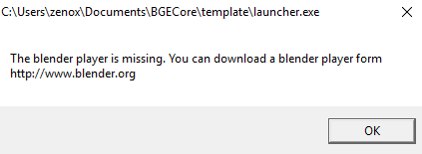
BGECore comes with the “engine” folder empty. That's because its contents will change depending on which operating system and blender version you are using or you want to publish your game to. For example if you want to publish your game for Windows you will put a copy of Blender for windows in there. For other operating systems you can just download their version of Blender and put that in the engine folder.

However, now you have a folder containing all Blender inside, it should be around 200mb which is a lot for just the game engine. If you don't want to distribute Blender together with your game you can just delete the parts of it that the game will not be using. The following scheme shows in bold the parts that are required for BGE (blenderplayer), in cursive those parts that may or may not be needed and in default those who can be deleted. This scheme is for Windows, other OS can differ.
- 2.76/
  - datafiles/
  - python/
    - bin/
    - lib/
  - scripts/
- blender.exe
- blender-app.exe
- blenderplayer.exe
- *.txt
- *.dll

Final touches
Most common ways of distributing your game are in a compressed file (“zip”, “rar”, “7z”) or with an installer. Notice that installers only work on Windows. To make an installer you can use applications like the ones in this link: http://www.techsupportalert.com/content/best-free-setup-builder.htm

In Windows you also have the possibility to change the icon of your game, for that, have a look at Resource HackerTM

Note: Blenderplayer and Blender are being merged recently, this makes newer versions of BGE bigger. e.j. BGE 2.56 Win64 → 55mb vs. BGE 2.76 Win64 → 83mb

The main loop
As you probably know all games have a main loop. Usually that loop is implemented in the game engine and then it calls scripts, events and so on. BGE does the same with Logic Bricks, but it lets them handle the Python modules instead of doing so directly. BGECore however, handles the main loop differently. In the following scheme you can see how BGECore handles the main loop.

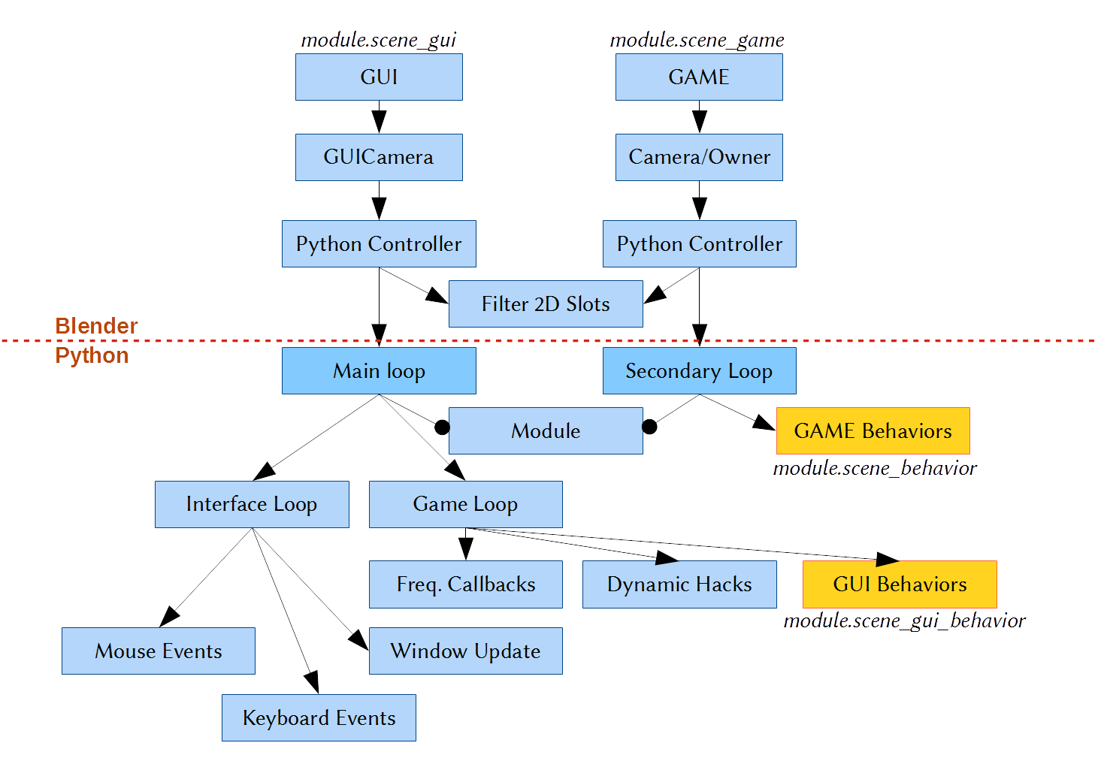
Each frame all starts with two scenes, the GUI and the GAME. Scenes share the same namespace, that's why the prefix GUI is added to most of the elements of the GUI. The main element in each scene is the only one were logic bricks or properties are allowed, on the GUI that's “GUICamera” or “GUICamera.000” if multiple cameras are used (most common case). On the GAME that would be also the main camera if any, if not then the main object. If no objects are present on the active layer an empty. The object that executes logic bricks is called the “owner” and can be accessed using: bge.logic.getCurrentController().owner.

While the main loop is necessary for BGECore in order to work, and must be run at every logic tick no matter what, the secondary loop is not. That means that you don't need to have the GAME scene loaded all the time. It also means that you can change a GAME scene with another on runtime, like if they were levels. And since the main loop is always a must, if you try to start the game from a scene that's not the GUI it will automatically restart from the GUI scene. Therefore pressing P always starts the game from the GUI scene no matter in which scene the view-port is on.
Notice that on a GUI scene behavior the function logic.getCurrentScene() returns module.scene_gui and on a GAME scene behavior the same function returns module.scene_game. In any case is recommended to use self.scene instead. The same happens with logic.getCurrentController() and other methods of the BGE API. For example the method bge.render.drawLine(…) will render a line on the GUI scene if called from a GUI behavior, a widget callback, or a frequency callback (sequencer) and on the GAME scene if called from the GAME behavior or an event of that behavior.

Special cases
What if you want to draw a line when clicking over a button. TODO...

One ring to rule them all
About the control.py file or module and its relation with quests and commands.

The making of Space Invaders
Introduction.

Appendix

FLables: Creating custom fonts
The font objects used by Labels on BGECore must follow some rules:
- They must be in a hidden/inactive layer of the GUI scene.
- Their name must be prefixed with “Font.”, e.j. “Font.Hobo”
- The mesh, the material, and the texture must have the same name than the object.
- They must have a “Text” property that represents the displaying text.
- The material must have “Backface Culling” disabled.

To create a new font you can just duplicate the “Font.Hobo” object and change its texture to the texture of your font. For a better explanation of how Dynamic Texts are created in BGE check this video: https://www.youtube.com/watch?v=GKO4jfAHtjk

Sometimes, after a modification, a font object stops working and all texts display “@@@...”, in such cases restarting blender usually fixes the problem.

Some useful tools, not part of BGECore, are also provided with it. One of these is JBFT, an application that will help you to create font textures from font files. Path: “tools/Font Generator/jbft.jar”. It's recommended to create textures with a resolution of 1024×1024.

A font texture can also be modified to create some cool effects, check this tutorial: http://www.blendenzo.com/tutColoredText.html

Note: Alignment of Labels are done using bge.logic.NewLib which can be bugged in some versions of Blender prior to 2.76

