**Java JDBC**

Java JDBC is a java API to connect and execute query with the database. JDBC API uses jdbc drivers to connect with the database.

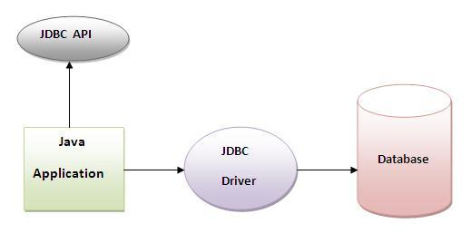

**Why use JDBC**

Before JDBC, ODBC API was the database API to connect and execute query with the database. But, ODBC API uses ODBC driver which is written in C language (i.e. platform dependent and unsecured). That is why Java has defined its own API (JDBC API) that uses JDBC drivers (written in Java language).

**What is API**

API (Application programming interface) is a document that contains description of all the features of a product or software. It represents classes and interfaces that software programs can follow to communicate with each other. An API can be created for applications, libraries, operating systems, etc

**JDBC Driver**

|  |
| --- |
| JDBC Driver is a software component that enables java application to interact with the database.There are 4 types of JDBC drivers:   1. JDBC-ODBC bridge driver 2. Native-API driver (partially java driver) 3. Network Protocol driver (fully java driver) 4. Thin driver (fully java driver) |

**1) JDBC-ODBC bridge driver**

|  |
| --- |
| The JDBC-ODBC bridge driver uses ODBC driver to connect to the database. The JDBC-ODBC bridge driver converts JDBC method calls into the ODBC function calls. This is now discouraged because of thin driver. |

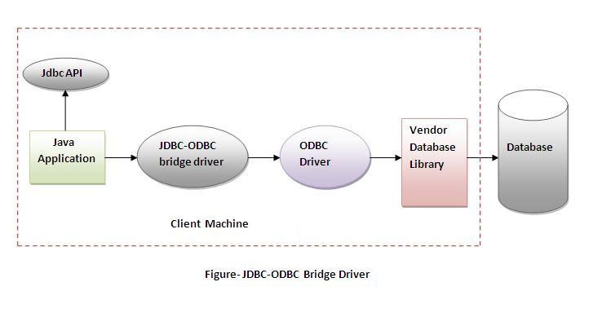

**Advantages:**

* easy to use.
* can be easily connected to any database.

**Disadvantages:**

* Performance degraded because JDBC method call is converted into the ODBC function calls.
* The ODBC driver needs to be installed on the client machine.

**2) Native-API driver**

|  |
| --- |
| The Native API driver uses the client-side libraries of the database. The driver converts JDBC method calls into native calls of the database API. It is not written entirely in java. |

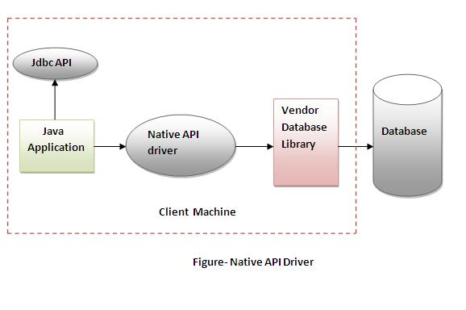

**Advantage:**

* performance upgraded than JDBC-ODBC bridge driver.

**Disadvantage:**

* The Native driver needs to be installed on the each client machine.
* The Vendor client library needs to be installed on client machine.

**3) Network Protocol driver**

The Network Protocol driver uses middleware (application server) that converts JDBC calls directly or indirectly into the vendor-specific database protocol. It is fully written in java.

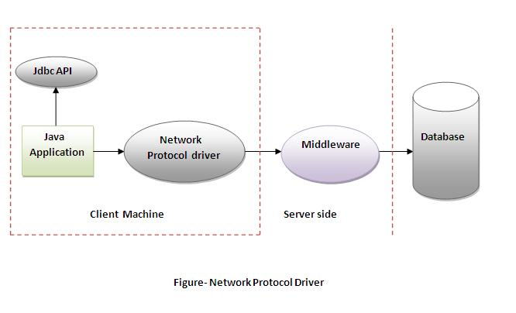

**Advantage:**

* No client side library is required because of application server that can perform many tasks like auditing, load balancing, logging etc.

**Disadvantages:**

* Network support is required on client machine.
* Requires database-specific coding to be done in the middle tier.
* Maintenance of Network Protocol driver becomes costly because it requires database-specific coding to be done in the middle tier.

**4) Thin driver**

|  |
| --- |
| The thin driver converts JDBC calls directly into the vendor-specific database protocol. That is why it is known as thin driver. It is fully written in Java language. |

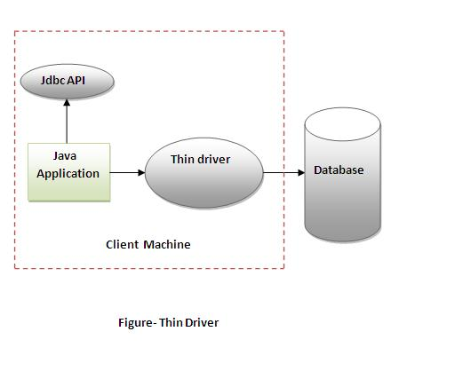

**Advantage:**

* Better performance than all other drivers.
* No software is required at client side or server side.

**Disadvantage:**

* Drivers depends on the Database.

**5 Steps to connect to the database in java**

|  |
| --- |
|  |

* Register the driver class
* Creating connection
* Creating statement
* Executing queries

Closing connection

**1) Register the driver class**

|  |
| --- |
| The forName() method of Class class is used to register the driver class. This method is used to dynamically load the driver class. |

**Syntax of forName() method**

1. public static void forName(String className)throws ClassNotFoundException

**Example to register the OracleDriver class**

1. Class.forName("oracle.jdbc.driver.OracleDriver");

**2) Create the connection object**

|  |
| --- |
| The getConnection() method of DriverManager class is used to establish connection with the database. |

**Syntax of getConnection() method**

1. 1) public static Connection getConnection(String url)throws SQLException
2. 2) public static Connection getConnection(String url,String name,String password)
3. throws SQLException

**Example to establish connection with the Oracle database**

1. Connection con=DriverManager.getConnection(
2. "jdbc:oracle:thin:@localhost:1521:xe","system","password");

**3) Create the Statement object**

|  |
| --- |
| The createStatement() method of Connection interface is used to create statement. The object of statement is responsible to execute queries with the database. |

**Syntax of createStatement() method**

1. public Statement createStatement()throws SQLException

**Example to create the statement object**

1. Statement stmt=con.createStatement();

**4) Execute the query**

|  |
| --- |
| The executeQuery() method of Statement interface is used to execute queries to the database. This method returns the object of ResultSet that can be used to get all the records of a table. |

**Syntax of executeQuery() method**

1. public ResultSet executeQuery(String sql)throws SQLException

**Example to execute query**

1. ResultSet rs=stmt.executeQuery("select * from emp");
3. while(rs.next()){
4. System.out.println(rs.getInt(1)+" "+rs.getString(2));
5. }

**5) Close the connection object**

|  |
| --- |
| By closing connection object statement and ResultSet will be closed automatically. The close() method of Connection interface is used to close the connection. |

**Syntax of close() method**

1. public void close()throws SQLException

**Example to close connection**

1. con.close();

**Example to connect to the Oracle database**

|  |
| --- |
| For connecting java application with the oracle database, you need to follow 5 steps to perform database connectivity. In this example we are using Oracle10g as the database. So we need to know following informations for the oracle database:   1. **Driver class:** The driver class for the oracle database is **oracle.jdbc.driver.OracleDriver**. 2. **Connection URL:** The connection URL for the oracle10G database is **jdbc:oracle:thin:@localhost:1521:xe** where jdbc is the API, oracle is the database, thin is the driver, localhost is the server name on which oracle is running, we may also use IP address, 1521 is the port number and XE is the Oracle service name. You may get all these informations from the tnsnames.ora file. 3. **Username:** The default username for the oracle database is **system**. 4. **Password:** Password is given by the user at the time of installing the oracle database. |

|  |
| --- |
| Let's first create a table in oracle database. |

1. create table emp(id number(10),name varchar2(40),age number(3));

**Example to Connect Java Application with Oracle database**

In this example, system is the username and oracle is the password of the Oracle database.

1. import java.sql.*;
2. class OracleCon{
3. public static void main(String args[]){
4. try{
5. //step1 load the driver class
6. Class.forName("oracle.jdbc.driver.OracleDriver");
8. //step2 create  the connection object
9. Connection con=DriverManager.getConnection(
10. "jdbc:oracle:thin:@localhost:1521:xe","system","oracle");
12. //step3 create the statement object
13. Statement stmt=con.createStatement();
15. //step4 execute query
16. ResultSet rs=stmt.executeQuery("select * from emp");
17. while(rs.next())
18. System.out.println(rs.getInt(1)+"  "+rs.getString(2)+"  "+rs.getString(3));
20. //step5 close the connection object
21. con.close();
23. }catch(Exception e){ System.out.println(e);}
25. }
26. }

[download this example](http://www.javatpoint.com/src/jdbc/OracleCon.zip)

The above example will fetch all the records of emp table.

To connect java application with the Oracle database ojdbc14.jar file is required to be loaded.

[download the jar file ojdbc14.jar](http://www.javatpoint.com/src/jdbc/ojdbc14.jar)

**Two ways to load the jar file:**

1. paste the ojdbc14.jar file in jre/lib/ext folder
2. set classpath

**1) paste the ojdbc14.jar file in JRE/lib/ext folder:**

|  |
| --- |
| Firstly, search the ojdbc14.jar file then go to JRE/lib/ext folder and paste the jar file here. |

**2) setclasspath:**

|  |
| --- |
| There are two ways to set the classpath:   * temporary * permanent |

**How to set the temporary classpath:**

|  |
| --- |
| Firstly, search the ojdbc14.jar file then open command prompt and write: |

1. C:>set classpath=c:\folder\ojdbc14.jar;.;

**How to set the permanent classpath:**

|  |
| --- |
| Go to environment variable then click on new tab. In variable name write **classpath** and in variable value paste the path to ojdbc14.jar by appending ojdbc14.jar;.; as C:\oraclexe\app\oracle\product\10.2.0\server\jdbc\lib\ojdbc14.jar;.; |
|  |

**Example to connect to the mysql database**

For connecting java application with the mysql database, you need to follow 5 steps to perform database connectivity.

In this example we are using MySql as the database. So we need to know following informations for the mysql database:

1. **Driver class:** The driver class for the mysql database is **com.mysql.jdbc.Driver**.
2. **Connection URL:** The connection URL for the mysql database is **jdbc:mysql://localhost:3306/sonoo** where jdbc is the API, mysql is the database, localhost is the server name on which mysql is running, we may also use IP address, 3306 is the port number and sonoo is the database name. We may use any database, in such case, you need to replace the sonoo with your database name.
3. **Username:** The default username for the mysql database is **root**.
4. **Password:** Password is given by the user at the time of installing the mysql database. In this example, we are going to use root as the password.

Let's first create a table in the mysql database, but before creating table, we need to create database first.

1. create database sonoo;
2. use sonoo;
3. create table emp(id int(10),name varchar(40),age int(3));

**Example to Connect Java Application with mysql database**

In this example, sonoo is the database name, root is the username and password.

1. import java.sql.*;
2. class MysqlCon{
3. public static void main(String args[]){
4. try{
5. Class.forName("com.mysql.jdbc.Driver");
6. Connection con=DriverManager.getConnection(
7. "jdbc:mysql://localhost:3306/sonoo","root","root");
8. //here sonoo is database name, root is username and password
9. Statement stmt=con.createStatement();
10. ResultSet rs=stmt.executeQuery("select * from emp");
11. while(rs.next())
12. System.out.println(rs.getInt(1)+"  "+rs.getString(2)+"  "+rs.getString(3));
13. con.close();
14. }catch(Exception e){ System.out.println(e);}
15. }
16. }

[download this example](http://www.javatpoint.com/src/jdbc/MysqlCon.zip)

The above example will fetch all the records of emp table.

To connect java application with the mysql database mysqlconnector.jar file is required to be loaded.

[download the jar file mysql-connector.jar](http://www.javatpoint.com/src/jdbc/mysql-connector.jar)

**Two ways to load the jar file:**

1. paste the mysqlconnector.jar file in jre/lib/ext folder
2. set classpath

**1) paste the mysqlconnector.jar file in JRE/lib/ext folder:**

|  |
| --- |
| Download the mysqlconnector.jar file. Go to jre/lib/ext folder and paste the jar file here. |

**2) setclasspath:**

|  |
| --- |
| There are two ways to set the classpath:   * temporary * permament |

**How to set the temporary classpath**

|  |
| --- |
| open comman prompt and write: |

1. C:>set classpath=c:\folder\mysql-connector-java-5.0.8-bin.jar;.;

**How to set the permanent classpath**

Go to environment variable then click on new tab. In variable name write **classpath** and in variable value paste the path to the mysqlconnector.jar file by appending mysqlconnector.jar;.; as C:\folder\mysql-connector-java-5.0.8-bin.jar;.;

**Connectivity with Access without DSN**

There are two ways to connect java application with the access database.

1. Without DSN (Data Source Name)
2. With DSN

Java is mostly used with Oracle, mysql, or DB2 database. So you can learn this topic only for knowledge.

**Example to Connect Java Application with access without DSN**

In this example, we are going to connect the java program with the access database. In such case, we have created the login table in the access database. There is only one column in the table named name. Let's get all the name of the login table.

1. import java.sql.*;
2. class Test{
3. public static void main(String ar[]){
4. try{
5. String database="student.mdb";//Here database exists in the current directory
7. String url="jdbc:odbc:Driver={Microsoft Access Driver (*.mdb)};
8. DBQ=" + database + ";DriverID=22;READONLY=true";
10. Class.forName("sun.jdbc.odbc.JdbcOdbcDriver");
11. Connection c=DriverManager.getConnection(url);
12. Statement st=c.createStatement();
13. ResultSet rs=st.executeQuery("select * from login");
15. while(rs.next()){
16. System.out.println(rs.getString(1));
17. }
19. }catch(Exception ee){System.out.println(ee);}
21. }}

**Example to Connect Java Application with access with DSN**

Connectivity with type1 driver is not considered good. To connect java application with type1 driver, create DSN first, here we are assuming your dsn name is mydsn.

1. import java.sql.*;
2. class Test{
3. public static void main(String ar[]){
4. try{
5. String url="jdbc:odbc:mydsn";
6. Class.forName("sun.jdbc.odbc.JdbcOdbcDriver");
7. Connection c=DriverManager.getConnection(url);
8. Statement st=c.createStatement();
9. ResultSet rs=st.executeQuery("select * from login");
11. while(rs.next()){
12. System.out.println(rs.getString(1));
13. }
15. }catch(Exception ee){System.out.println(ee);}
17. }}

# DriverManager class

The DriverManager class acts as an interface between user and drivers. It keeps track of the drivers that are available and handles establishing a connection between a database and the appropriate driver. The DriverManager class maintains a list of Driver classes that have registered themselves by calling the method DriverManager.registerDriver().

### Commonly used methods of DriverManager class:

|  |  |
| --- | --- |
| 1) public static void registerDriver(Driver driver): | is used to register the given driver with DriverManager. |
| 2) public static void deregisterDriver(Driver driver): | is used to deregister the given driver (drop the driver from the list) with DriverManager. |
| 3) public static Connection getConnection(String url): | is used to establish the connection with the specified url. |
| 4) public static Connection getConnection(String url,StringuserName,String password): | is used to establish the connection with the specified url, username and password. |

# Connection interface

A Connection is the session between java application and database. The Connection interface is a factory of Statement, PreparedStatement, and DatabaseMetaData i.e. object of Connection can be used to get the object of Statement and DatabaseMetaData. The Connection interface provide many methods for transaction management like commit(), rollback() etc.

#### By default, connection commits the changes after executing queries.

### Commonly used methods of Connection interface:

|  |
| --- |
| **1) public Statement createStatement():** creates a statement object that can be used to execute SQL queries. |
| **2) public Statement createStatement(intresultSetType,intresultSetConcurrency):** Creates a Statement object that will generate ResultSet objects with the given type and concurrency. |
| **3) public void setAutoCommit(boolean status):** is used to set the commit status.By default it is true. |
| **4) public void commit():** saves the changes made since the previous commit/rollback permanent. |
| **5) public void rollback():** Drops all changes made since the previous commit/rollback. |
| **6) public void close():** closes the connection and Releases a JDBC resources immediately. |

**Statement interface**

The **Statement interface** provides methods to execute queries with the database. The statement interface is a factory of ResultSet i.e. it provides factory method to get the object of ResultSet.

**Commonly used methods of Statement interface:**

The important methods of Statement interface are as follows:

|  |
| --- |
| **1) publicResultSetexecuteQuery(String sql):** is used to execute SELECT query. It returns the object of ResultSet. |
| **2) public intexecuteUpdate(String sql):** is used to execute specified query, it may be create, drop, insert, update, delete etc. |
| **3) publicboolean execute(String sql):** is used to execute queries that may return multiple results. |
| **4) publicint[] executeBatch():** is used to execute batch of commands. |

**Example of Statement interface**

Let’s see the simple example of Statement interface to insert, update and delete the record.

1. import java.sql.*;
2. class FetchRecord{
3. public static void main(String args[])throws Exception{
4. Class.forName("oracle.jdbc.driver.OracleDriver");
5. Connection con=DriverManager.getConnection("jdbc:oracle:thin:@localhost:1521:xe","system","oracle");
6. Statement stmt=con.createStatement();
8. //stmt.executeUpdate("insert into emp765 values(33,'Irfan',50000)");
9. //int result=stmt.executeUpdate("update emp765 set name='Vimal',salary=10000 where id=33");
10. int result=stmt.executeUpdate("delete from emp765 where id=33");
11. System.out.println(result+" records affected");
12. con.close();
13. }}

# ResultSet interface

The object of ResultSet maintains a cursor pointing to a row of a table. Initially, cursor points to before the first row.

#### By default, ResultSet object can be moved forward only and it is not updatable.

But we can make this object to move forward and backward direction by passing either TYPE_SCROLL_INSENSITIVE or TYPE_SCROLL_SENSITIVE in createStatement(int,int) method as well as we can make this object as updatable by:

1. Statement stmt = con.createStatement(ResultSet.TYPE_SCROLL_INSENSITIVE,
2. ResultSet.CONCUR_UPDATABLE);

### Commonly used methods of ResultSet interface

|  |  |
| --- | --- |
| **1) public boolean next():** | is used to move the cursor to the one row next from the current position. |
| **2) public boolean previous():** | is used to move the cursor to the one row previous from the current position. |
| **3) public boolean first():** | is used to move the cursor to the first row in result set object. |
| **4) public boolean last():** | is used to move the cursor to the last row in result set object. |
| **5) public boolean absolute(int row):** | is used to move the cursor to the specified row number in the ResultSet object. |
| **6) public boolean relative(int row):** | is used to move the cursor to the relative row number in the ResultSet object, it may be positive or negative. |
| **7) public intgetInt(intcolumnIndex):** | is used to return the data of specified column index of the current row as int. |
| **8) public intgetInt(String columnName):** | is used to return the data of specified column name of the current row as int. |
| **9) public String getString(intcolumnIndex):** | is used to return the data of specified column index of the current row as String. |
| **10) public String getString(String columnName):** | is used to return the data of specified column name of the current row as String. |

### Example of Scrollable ResultSet

Let’s see the simple example of ResultSet interface to retrieve the data of 3rd row.

1. import java.sql.*;
2. class FetchRecord{
3. public static void main(String args[])throws Exception{
5. Class.forName("oracle.jdbc.driver.OracleDriver");
6. Connection con=DriverManager.getConnection("jdbc:oracle:thin:@localhost:1521:xe","system","oracle");
7. Statement stmt=con.createStatement(ResultSet.TYPE_SCROLL_SENSITIVE,ResultSet.CONCUR_UPDATABLE);
8. ResultSet rs=stmt.executeQuery("select * from emp765");
10. //getting the record of 3rd row
11. rs.absolute(3);
12. System.out.println(rs.getString(1)+" "+rs.getString(2)+" "+rs.getString(3));
14. con.close();
15. }}

# PreparedStatement interface

The PreparedStatement interface is a subinterface of Statement. It is used to execute parameterized query.

Let's see the example of parameterized query:

1. String sql="insert into emp values(?,?,?)";

As you can see, we are passing parameter (?) for the values. Its value will be set by calling the setter methods of PreparedStatement.

### Why use PreparedStatement?

**Improves performance**: The performance of the application will be faster if you use PreparedStatement interface because query is compiled only once.

#### How to get the instance of PreparedStatement?

The prepareStatement() method of Connection interface is used to return the object of PreparedStatement. Syntax:

1. public PreparedStatement prepareStatement(String query)throws SQLException{}

### Methods of PreparedStatement interface

The important methods of PreparedStatement interface are given below:

|  |  |
| --- | --- |
| **Method** | **Description** |
| public void setInt(intparamIndex, int value) | sets the integer value to the given parameter index. |
| public void setString(intparamIndex, String value) | sets the String value to the given parameter index. |
| public void setFloat(intparamIndex, float value) | sets the float value to the given parameter index. |
| public void setDouble(intparamIndex, double value) | sets the double value to the given parameter index. |
| public intexecuteUpdate() | executes the query. It is used for create, drop, insert, update, delete etc. |
| public ResultSetexecuteQuery() | executes the select query. It returns an instance of ResultSet. |

### Example of PreparedStatement interface that inserts the record

First of all create table as given below:

1. create table emp(id number(10),name varchar2(50));

Now insert records in this table by the code given below:

1. import java.sql.*;
2. class InsertPrepared{
3. public static void main(String args[]){
4. try{
5. Class.forName("oracle.jdbc.driver.OracleDriver");
7. Connection con=DriverManager.getConnection("jdbc:oracle:thin:@localhost:1521:xe","system","oracle");
9. PreparedStatement stmt=con.prepareStatement("insert into Emp values(?,?)");
10. stmt.setInt(1,101);//1 specifies the first parameter in the query
11. stmt.setString(2,"Ratan");
13. int i=stmt.executeUpdate();
14. System.out.println(i+" records inserted");
16. con.close();
18. }catch(Exception e){ System.out.println(e);}
20. }
21. }

### Example of PreparedStatement interface that updates the record

1. PreparedStatement stmt=con.prepareStatement("update emp set name=? where id=?");
2. stmt.setString(1,"Sonoo");//1 specifies the first parameter in the query i.e. name
3. stmt.setInt(2,101);
5. int i=stmt.executeUpdate();
6. System.out.println(i+" records updated");

### Example of PreparedStatement interface that deletes the record

1. PreparedStatement stmt=con.prepareStatement("delete from emp where id=?");
2. stmt.setInt(1,101);
4. int i=stmt.executeUpdate();
5. System.out.println(i+" records deleted");

### Example of PreparedStatement interface that retrieve the records of a table

1. PreparedStatement stmt=con.prepareStatement("select * from emp");
2. ResultSet rs=stmt.executeQuery();
3. while(rs.next()){
4. System.out.println(rs.getInt(1)+" "+rs.getString(2));
5. }

### Example of PreparedStatement to insert records until user press n

1. import java.sql.*;
2. import java.io.*;
3. class RS{
4. public static void main(String args[])throws Exception{
5. Class.forName("oracle.jdbc.driver.OracleDriver");
6. Connection con=DriverManager.getConnection("jdbc:oracle:thin:@localhost:1521:xe","system","oracle");
8. PreparedStatement ps=con.prepareStatement("insert into emp130 values(?,?,?)");
10. BufferedReader br=new BufferedReader(new InputStreamReader(System.in));
12. do{
13. System.out.println("enter id:");
14. int id=Integer.parseInt(br.readLine());
15. System.out.println("enter name:");
16. String name=br.readLine();
17. System.out.println("enter salary:");
18. float salary=Float.parseFloat(br.readLine());
20. ps.setInt(1,id);
21. ps.setString(2,name);
22. ps.setFloat(3,salary);
23. int i=ps.executeUpdate();
24. System.out.println(i+" records affected");
26. System.out.println("Do you want to continue: y/n");
27. String s=br.readLine();
28. if(s.startsWith("n")){
29. break;
30. }
31. }while(true);
33. con.close();
34. }}

Java –cp .;mysql-connector.jar FirstExample.java