**GGR372 Lab 2 Report**

Blaise Calaycay

Feb 1 2017

**Question 1**

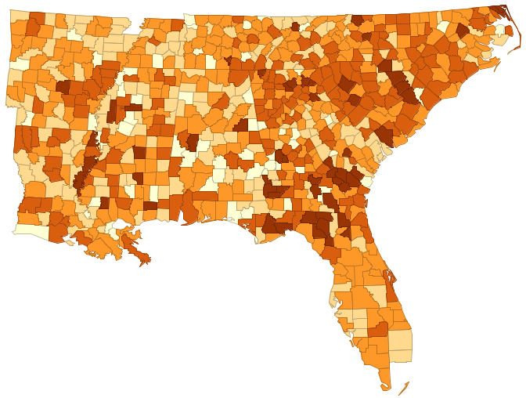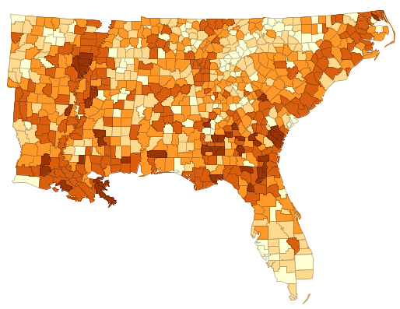I chose to explore the rate of prostate cancer among males (variable name “PROM_RATE”) across the Southeast US. Visually, it seems that in the eastern part of the region (i.e. Florida, Georgia, North Carolina, South Carolina), there is a higher rate of prostate cancer relative to the 20 kinds of cancer in the US Geological Survey dataset. However as we move further west, the rate of prostate cancer goes down.

Image 2. Prostate Cancer rate among males

Image . Cancer rate among males