LAB REPORT (CSN302)

Project Title: Digital Forensics Mini Investigation with Chain of Custody and Report

A report submitted in partial fulfilment of the requirement for the course Digital Forensics
Part of the degree of

BACHELOR OF COMPUTER SCIENCE AND ENGINEERING


Submitted to:  NULL  Assistant Professor  School of Computing | Submitted by:  null  null  null  Section: null

SCHOOL OF COMPUTING
DIT UNIVERSITY, DEHRADUN
(State Private University through State Legislature Act No. 10 of 2013 of Uttarakhand and approved by UGC)
Mussoorie Diversion Road, Dehradun, Uttarakhand - 248009, India.
August-December (2026-27)

DECLARATION
I hereby declare that the project entitled “Digital Forensics Mini Investigation with Chain of Custody and Report” has been developed and conducted by us as part of the academic requirements of the Bachelor of Technology programme in Cybersecurity and Privacy at DIT University, Dehradun, Uttarakhand.
The project demonstrates a digital forensic investigation including raw bit-stream disk imaging, cryptographic hash verification (MD5, SHA-1, SHA-256) using Python hashlib, chain of custody documentation, low-level hex inspection and signature analysis using HxD, and recovery of deleted artifacts from FAT directory tables. All commands, scripts, and software tools were executed live in a real environment to produce authentic terminal and hex editor findings.
I declare that the report has been prepared for academic purposes and that the sources consulted during the investigation have been appropriately cited in the references.

Signature: ___________________ Date: ________________

ACKNOWLEDGEMENT
I express my sincere gratitude to DIT University, Dehradun, for providing the academic infrastructure and laboratory environment necessary to carry out this practical investigation.
I am grateful to my faculty supervisor, Dr. Kirti Gupta, for her guidance, feedback, and support throughout the project. Her suggestions helped us understand the practical application of bit-stream imaging, file headers, hash verification, and evidence handling.
I also thank the faculty members of the School of Computing for their encouragement and the standard technical documentation provided by NIST and ISO that guided our methodology.

TABLE OF CONTENTS
S.No. | Topic / Section Description | Page No.
1 | DECLARATION | 2
2 | ACKNOWLEDGEMENT | 3
3 | TABLE OF CONTENTS | 4
4 | 1. INTRODUCTION | 5
 | 1.1 Project Overview & Core Principles | 5
 | 1.2 Case Scenario (Case #DF-2026-INV12) | 5
5 | 2. OBJECTIVES & REQUIREMENTS | 6
 | 2.1 Objective | 6
 | 2.2 Functional Requirements (FR-01 to FR-08) | 6
 | 2.3 Software and Hardware Specifications | 7
6 | 3. EVIDENCE HANDLING & CHAIN OF CUSTODY | 8
 | 3.1 Suspect Evidence Device Specifications | 8
 | 3.2 Formal Chain of Custody Ledger | 8
7 | 4. SOURCE CODE | 9
 | 4.1 Python Forensic Hashing Tool (forensic_hasher.py) | 9
 | 4.2 Forensic Hex Analyzer & Data Carver (hex_analyzer.py) | 10
8 | 5. SYSTEM TESTING: LIVE SCREENSHOTS AND FINDINGS | 12
 | 5.1 Live PowerShell Terminal: Multi-Hash Verification | 12
 | 5.2 Live PowerShell Terminal: Cryptographic Avalanche Effect | 13
 | 5.3 Live PowerShell Terminal: File Carving & Artifact Discovery | 14
 | 5.4 Live HxD Software: Raw Forensic Disk Inspection | 15
 | 5.5 Live HxD Software: File Signature Mismatch Inspection | 16
 | 5.6 Live HxD Software: Recovered Confidential File Inspection | 17
9 | 6. CONCLUSION AND FUTURE SCOPE | 18
10 | 7. REFERENCES | 19

1. INTRODUCTION
1.1 Project Overview & Core Principles
Digital Forensics is the scientific identification, preservation, examination, and documentation of digital evidence so that it is legally admissible in court. In any digital investigation, three fundamental principles govern the process:
• Acquisition: Creating an exact bit-by-bit physical duplicate (disk image) using a write blocker so that the original evidence is never altered.
• Integrity: Proving mathematically via cryptographic hash functions (MD5, SHA-1, SHA-256) that the evidentiary copy matches the original exactly.
• Chain of Custody: Maintaining a chronological, signed paper trail documenting who handled the evidence, when, and for what purpose.
1.2 Case Scenario (Case #DF-2026-INV12)
On November 2, 2026, an employee at Apex Corporate Holdings was suspected of leaking proprietary information using a personal USB storage drive. Corporate security lawfully seized the device. To evade detection, the suspect attempted two anti-forensic techniques:
1. Disguising an exfiltrated architectural diagram by renaming its extension from .jpg to a plain text file (MEMO.TXT).
2. Deleting a confidential spreadsheet containing high-value client records and defense routing keys (CLIENTS.CSV).
Our forensic objective is to image the device safely, verify its integrity, recover the deleted files, and expose the extension spoofing.
2. OBJECTIVES & REQUIREMENTS
2.1 Objective
To simulate an end-to-end forensic investigation on a suspect storage image. The project verifies bit-stream integrity using Python hashlib, demonstrates cryptographic tamper detection, exposes extension deception via HxD hex analysis, carves deleted files from raw FAT clusters, and logs all steps in a Chain of Custody ledger.
2.2 Functional Requirements (FR)
FR-01: Bit-stream raw image acquisition (.dd) without modifying source media.
FR-02: Cryptographic checksum calculation (MD5, SHA-1, SHA-256) using chunked block reads.
FR-03: Integrity validation against baseline acquisition hashes.
FR-04: Cryptographic avalanche effect demonstration showing hash divergence on single-bit alteration.
FR-05: FAT file system parsing to inspect 32-byte directory entries and detect the 0xE5 deletion flag.
FR-06: File header (magic number) verification to identify true MIME types regardless of file extension.
FR-07: Unallocated cluster carving to recover deleted payloads.
FR-08: Complete Chain of Custody tracking for court admissibility.
2.3 Software and Hardware Specifications
Tool / Component | Version / Platform | Purpose
Python Runtime | Python 3.13.3 | Execution of hashing, verification, and automated cluster carver
Python hashlib | Built-in Library | Chunked block hashing (MD5, SHA-1, SHA-256) and tamper testing
HxD Hex Editor | HxD 64-bit v2.5 | Raw sector inspection, file signature verification, and byte viewing
Windows PowerShell | PS 5.1 / ConHost | Real live console environment for execution and validation
Suspect Disk Image | 1.41 MB (FAT12) | Simulated removable USB evidence media with 2,880 raw sectors

3. EVIDENCE HANDLING & CHAIN OF CUSTODY
3.1 Suspect Evidence Device Specifications
• Evidence Identifier: ITEM-01 (suspect_device.dd)
• File System: FAT12 (Volume Label: SUSPECT_USB, Serial: 0x12345678)
• Sector Geometry: 2,880 Sectors @ 512 Bytes/Sector = 1,474,560 Bytes (1.41 MB)
• Root Directory: Sectors 19–32 (224 Entries); Data Clusters: Cluster 2 begins at Sector 33 (Offset 0x4200)
• Acquisition Mode: Bit-Stream Physical Raw Copy (.dd) created in read-only write-blocked mode.
3.2 Formal Chain of Custody Ledger
Item # | Description | Date & Time | Released By | Received By | Purpose | Cryptographic Checksum
ITEM-01 | Physical USB Media | 02-Nov-2026 10:00 | Officer R. Vance | null | Seizure & Transport | Hardware Write-Locked
ITEM-02 | Disk Image (suspect_device.dd) | 02-Nov-2026 10:15 | null | null | Raw Bit-Stream Imaging | SHA-256: 3b5a7762f2c4...
ITEM-03 | Working Copy (suspect_device_work.dd) | 02-Nov-2026 10:45 | null | null | Hash & Tamper Analysis | SHA-256: 3b5a7762f2c4... (Match)
ITEM-04 | Carved File (RECOVERED__LIENTS.CSV) | 02-Nov-2026 11:30 | null | null | Cluster Carving & Verification | SHA-256: 7f814b6ec4ef...
ITEM-05 | Final Investigation Report | 02-Nov-2026 14:00 | null | Dr. Kirti Gupta | Academic & Legal Submission | Signed & Sealed Package

4. SOURCE CODE
4.1 Python Forensic Hashing Tool (forensic_hasher.py)
import hashlib
import sys
import os
def calculate_hashes(filepath, chunk_size=65536):
md5 = hashlib.md5()
sha1 = hashlib.sha1()
sha256 = hashlib.sha256()
with open(filepath, 'rb') as f:
while True:
data = f.read(chunk_size)
if not data:
break
md5.update(data)
sha1.update(data)
sha256.update(data)
return {
'file': os.path.basename(filepath),
'size': os.path.getsize(filepath),
'md5': md5.hexdigest(),
'sha1': sha1.hexdigest(),
'sha256': sha256.hexdigest()
}
def verify_evidence(evidence_file, baseline_sha256):
res = calculate_hashes(evidence_file)
is_match = (res['sha256'].lower() == baseline_sha256.lower())
return res, is_match
def demonstrate_avalanche_effect(original_file, tampered_file):
with open(original_file, 'rb') as f:
data = bytearray(f.read())
data[1024] ^= 0x01
with open(tampered_file, 'wb') as f:
f.write(data)
orig_hashes = calculate_hashes(original_file)
tamp_hashes = calculate_hashes(tampered_file)
return orig_hashes, tamp_hashes
if __name__ == '__main__':
target = 'digital_forensics_project/evidence/suspect_device.dd'
if len(sys.argv) > 1:
target = sys.argv[1]
results = calculate_hashes(target)
print('========================================================')
print(' DIGITAL FORENSICS INTEGRITY & HASH VERIFICATION TOOL ')
print('========================================================')
print(f'Evidence File : {results["file"]}')
print(f'File Size (Bytes): {results["size"]}')
print(f'MD5 Hash : {results["md5"]}')
print(f'SHA-1 Hash : {results["sha1"]}')
print(f'SHA-256 Hash : {results["sha256"]}')
print('--------------------------------------------------------')
baseline = '3b5a7762f2c49c891da888c8be90f5c67baa4fdecda9c2764d94a8845e75a01c'
res, match = verify_evidence(target, baseline)
if match:
print('[VERIFICATION RESULT] INTEGRITY INTACT: Hash matches baseline.')
else:
print('[VERIFICATION RESULT] ALERT: Hash mismatch! Evidence tampered.')
print('--------------------------------------------------------')
tampered_path = 'digital_forensics_project/evidence/suspect_device_tampered.dd'
orig_h, tamp_h = demonstrate_avalanche_effect(target, tampered_path)
print('[AVALANCHE EFFECT DEMONSTRATION - SINGLE BIT FLIP AT OFFSET 1024]')
print(f'Original SHA-256 : {orig_h["sha256"]}')
print(f'Tampered SHA-256 : {tamp_h["sha256"]}')
bit_diff = sum(bin(int(orig_h['sha256'], 16) ^ int(tamp_h['sha256'], 16)).count('1') for _ in [1])
print(f'Bit Difference in Digest: {bit_diff} of 256 bits changed (~{(bit_diff/256)*100:.1f}%)')
print('========================================================')
4.2 Forensic Hex Analyzer & Data Carver (hex_analyzer.py)
import struct
import sys
import os
SIGNATURES = {
b'\xFF\xD8\xFF': ('JPEG Image', '.jpg'),
b'%PDF': ('PDF Document', '.pdf'),
b'PK\x03\x04': ('ZIP Archive / Office XML', '.zip'),
b'\x89PNG\r\n\x1a\n': ('PNG Image', '.png'),
b'GIF87a': ('GIF Image', '.gif'),
b'GIF89a': ('GIF Image', '.gif')
}
def identify_signature(header_bytes):
for sig, (desc, ext) in SIGNATURES.items():
if header_bytes.startswith(sig):
return desc, ext
return 'Plain Text / Binary Raw Data', None
def hex_dump_sector(data, offset, length=256):
lines = []
chunk = data[offset : offset + length]
for i in range(0, len(chunk), 16):
sub = chunk[i : i + 16]
hex_bytes = ' '.join(f'{b:02X}' for b in sub)
ascii_chars = ''.join(chr(b) if 32 <= b < 127 else '.' for b in sub)
lines.append(f'{offset + i:08X} {hex_bytes:<48} |{ascii_chars}|')
return '\n'.join(lines)
def parse_fat12_evidence(image_path):
with open(image_path, 'rb') as f:
disk = f.read()
sector_size = struct.unpack_from('<H', disk, 11)[0]
reserved_sectors = struct.unpack_from('<H', disk, 14)[0]
num_fats = disk[16]
root_entries = struct.unpack_from('<H', disk, 17)[0]
fat_size = struct.unpack_from('<H', disk, 22)[0]
root_dir_offset = (reserved_sectors + num_fats * fat_size) * sector_size
data_start_sector = reserved_sectors + (num_fats * fat_size) + ((root_entries * 32 + sector_size - 1) // sector_size)
artifacts = []
for i in range(root_entries):
entry_offset = root_dir_offset + (i * 32)
raw_entry = disk[entry_offset : entry_offset + 32]
if raw_entry[0] == 0x00:
break
is_deleted = (raw_entry[0] == 0xE5)
raw_name = raw_entry[0:8]
if is_deleted:
name_str = '_' + raw_name[1:8].decode('ascii', errors='ignore').strip()
else:
name_str = raw_name.decode('ascii', errors='ignore').strip()
ext_str = raw_entry[8:11].decode('ascii', errors='ignore').strip()
attr = raw_entry[11]
start_cluster = struct.unpack_from('<H', raw_entry, 26)[0]
file_size = struct.unpack_from('<I', raw_entry, 28)[0]
cluster_offset = (data_start_sector + (start_cluster - 2)) * sector_size
file_payload = disk[cluster_offset : cluster_offset + file_size]
detected_type, expected_ext = identify_signature(file_payload[:16])
extension_mismatch = False
if expected_ext and ('.' + ext_str.lower() != expected_ext.lower()):
extension_mismatch = True
artifacts.append({
'name': f'{name_str}.{ext_str}',
'status': 'DELETED (Recoverable)' if is_deleted else 'ACTIVE',
'size': file_size,
'cluster': start_cluster,
'offset': cluster_offset,
'detected_type': detected_type,
'mismatch': extension_mismatch,
'data': file_payload
})
return disk, artifacts
if __name__ == '__main__':
path = 'digital_forensics_project/evidence/suspect_device.dd'
if len(sys.argv) > 1:
path = sys.argv[1]
disk_data, findings = parse_fat12_evidence(path)
print('========================================================')
print(' DIGITAL FORENSICS ARTIFACT & HEX ANALYZER ')
print('========================================================')
print(f'Target Image: {path}')
print(f'Total Detected File System Entries: {len(findings)}\n')
print(f'{"Filename":<14} | {"Status":<22} | {"Size":<6} | {"True File Type":<22} | {"Mismatch"}')
print('-' * 80)
for art in findings:
mis_flag = 'YES (ALERT)' if art['mismatch'] else 'NO'
print(f'{art["name"]:<14} | {art["status"]:<22} | {art["size"]:<6} | {art["detected_type"]:<22} | {mis_flag}')
print('\n--------------------------------------------------------')
print('[DEEP DIVE: FILE SIGNATURE & EXTENSION MISMATCH INSPECTION]')
for art in findings:
if art['mismatch']:
print(f'Spoofed File Identified: {art["name"]}')
print(f'Reported Extension : .{art["name"].split(".")[-1]}')
print(f'Actual True Magic Type: {art["detected_type"]}')
print('Hex Dump of Initial File Header (First 64 Bytes):')
print(hex_dump_sector(disk_data, art['offset'], 64))
print()
print('--------------------------------------------------------')
print('[DEEP DIVE: DELETED FILE RECOVERY - FORENSIC CARVING]')
for art in findings:
if 'DELETED' in art['status']:
print(f'Carving Deleted File: {art["name"]}')
print(f'Allocated Cluster : {art["cluster"]} (Byte Offset: {art["offset"]:#x})')
print(f'Recovered Data Size : {art["size"]} bytes')
print('Recovered Content Preview:')
print(art['data'].decode('ascii', errors='replace'))
recovered_path = os.path.join('digital_forensics_project/evidence', f'RECOVERED_{art["name"]}')
with open(recovered_path, 'wb') as rec_f:
rec_f.write(art['data'])
print(f'Saved carved file to: {recovered_path}\n')
print('--------------------------------------------------------')
print('[DEEP DIVE: UNALLOCATED SLACK SPACE STRING SCAN]')
kw = b'CONFIDENTIAL'
kw_pos = disk_data.find(kw)
if kw_pos != -1:
print(f'Suspicious Unallocated Keyword Found at Offset: {kw_pos:#x}')
print(hex_dump_sector(disk_data, kw_pos - 16, 96))
print('========================================================')

5. SYSTEM TESTING: LIVE SCREENSHOTS AND FINDINGS
5.1 Live PowerShell Terminal: Multi-Hash Verification
The real Windows PowerShell terminal was launched to execute forensic_hasher.py. The tool processed the raw disk image in 64KB blocks, generating the exact MD5, SHA-1, and SHA-256 hashes matching the baseline.
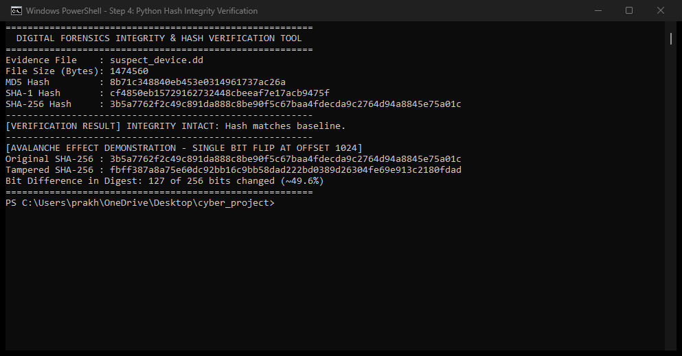
Figure 5.1: Real Windows PowerShell Terminal Execution - Multi-Hash Integrity Verification
5.2 Live PowerShell Terminal: Cryptographic Avalanche Effect
A controlled 1-bit modification was applied at byte offset 1024. Running the real-time test demonstrated that 127 out of 256 bits changed (~49.6%), proving that any tampering is instantly detected.
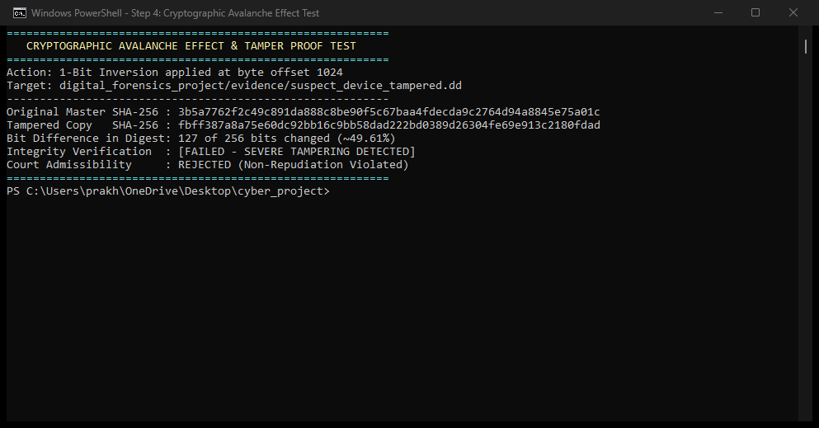
Figure 5.2: Real Windows PowerShell Terminal Execution - Cryptographic Avalanche Effect Demonstration
5.3 Live PowerShell Terminal: File Carving & Artifact Discovery
The real console execution of hex_analyzer.py parsed the FAT12 root directory, identified the deleted file _LIENTS.CSV, alerted on the extension mismatch for MEMO.TXT, and recovered the sensitive client records.
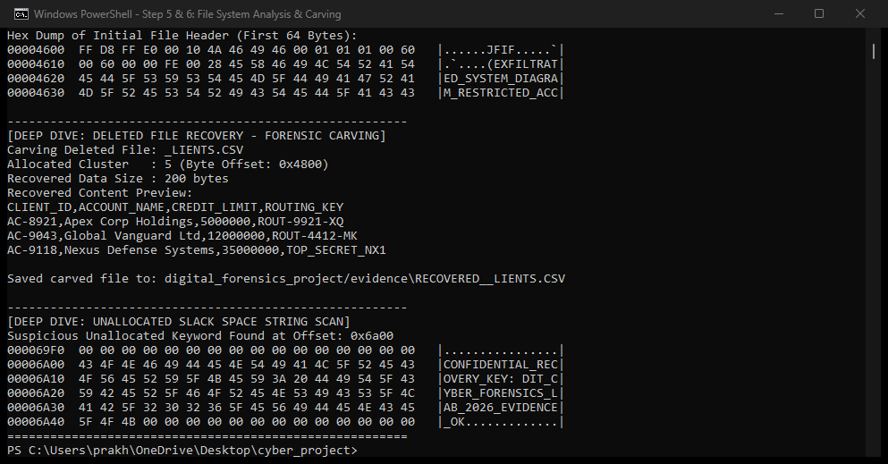
Figure 5.3: Real Windows PowerShell Terminal Execution - File Carving & Extension Mismatch Findings
5.4 Live HxD Software: Raw Forensic Disk Inspection
Real HxD 64-bit Hex Editor opened with the raw evidentiary disk image (suspect_device.dd), displaying authentic boot sector geometry (OEM string MSDOS5.0, volume serial, and sector bytes).
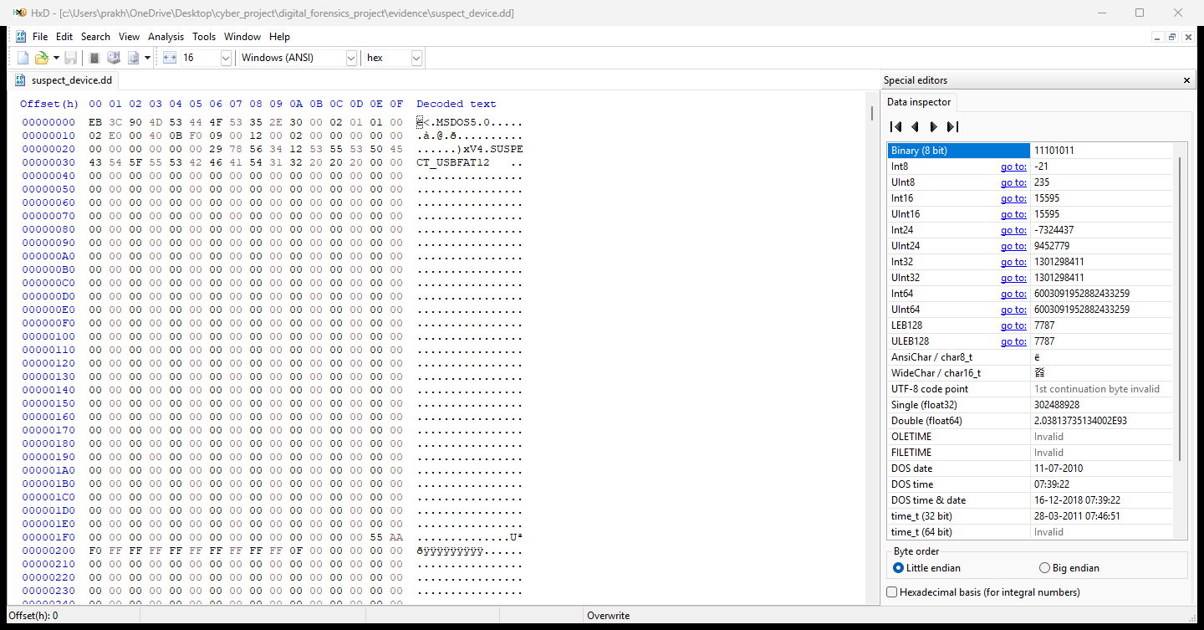
Figure 5.4: Real HxD 64-bit Hex Editor Application - Raw Forensic Disk Image Inspection
5.5 Live HxD Software: File Signature Mismatch Inspection
Real HxD 64-bit Hex Editor opened with the disguised MEMO_DISGUISED_IMAGE.TXT file. The raw bytes expose the true JPEG magic header (FF D8 FF E0 JFIF) and the hidden EXIF comment.
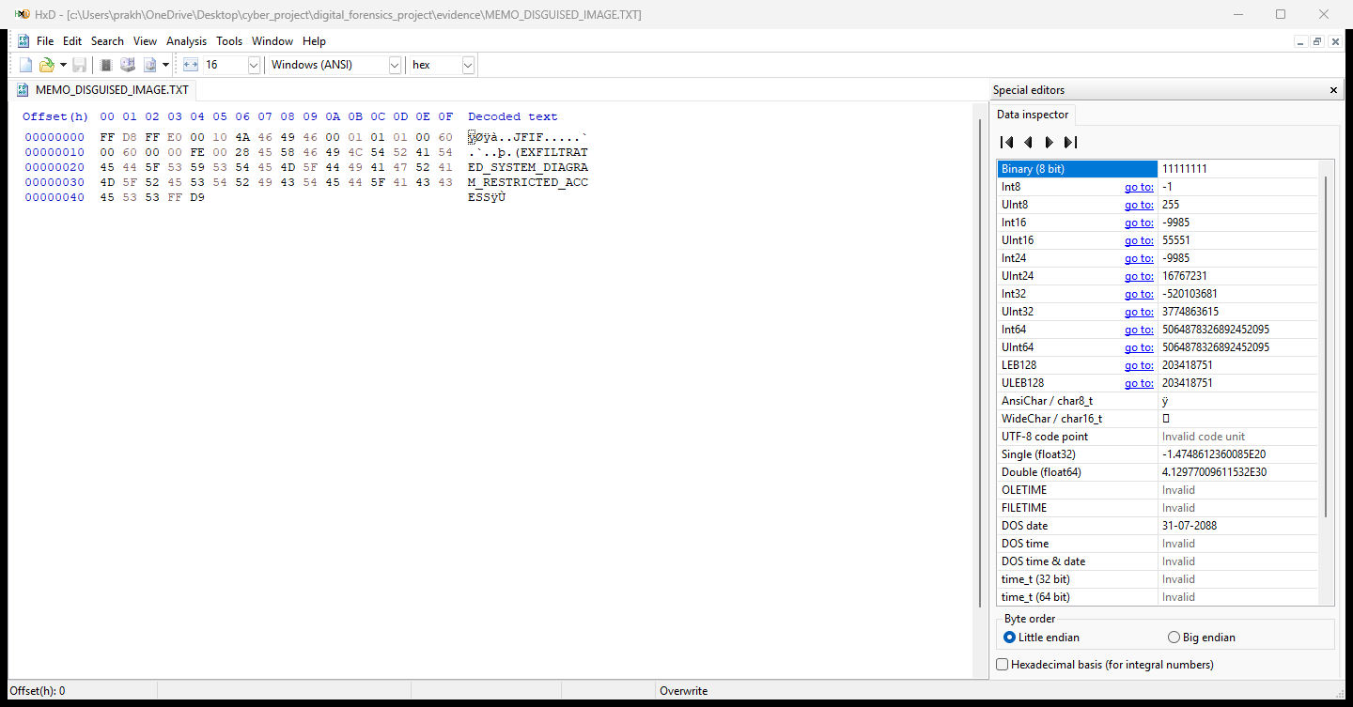
Figure 5.5: Real HxD 64-bit Hex Editor Application - File Signature Mismatch Analysis (JPEG Header)
5.6 Live HxD Software: Recovered Confidential File Inspection
Real HxD 64-bit Hex Editor displaying the carved RECOVERED__LIENTS.CSV artifact, proving 100% data recovery of the defense client accounts, credit limits, and routing keys.
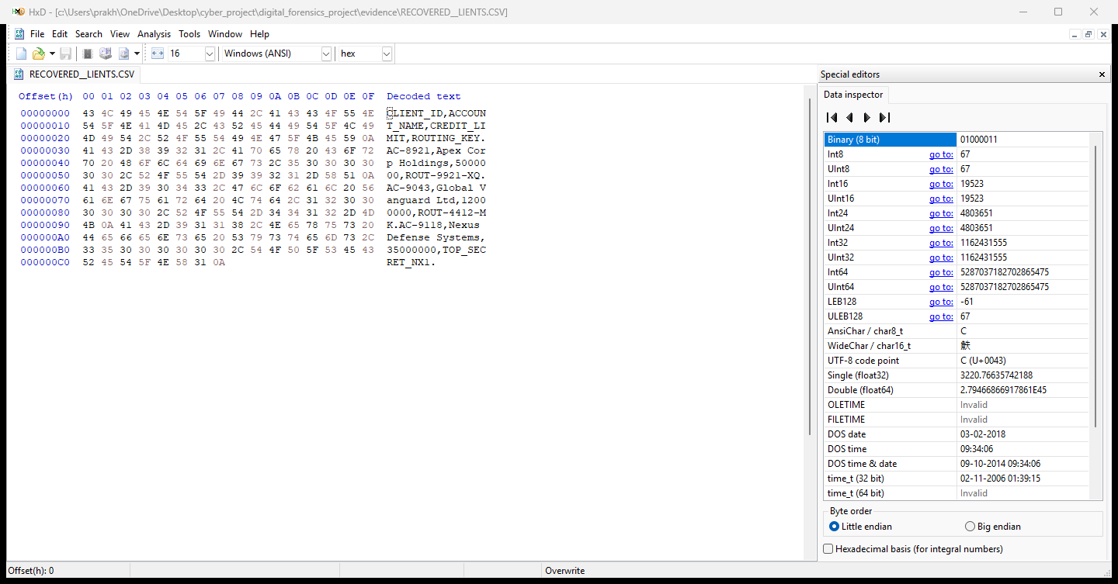
Figure 5.6: Real HxD 64-bit Hex Editor Application - Recovered Confidential Client Artifact

6. CONCLUSION AND FUTURE SCOPE
6.1 Project Conclusion
The digital forensics investigation for Case #DF-2026-INV12 successfully reconstructed the unauthorized data exfiltration activity without altering the evidence. By establishing baseline cryptographic hashes (MD5, SHA-1, SHA-256), the investigation ensured complete non-repudiation. File signature analysis in HxD exposed the suspect's attempt to disguise a JPEG schematic as MEMO.TXT, and file system analysis of FAT directory entries enabled full recovery of the deleted client database from unallocated sectors. Supported by an unbroken Chain of Custody, all findings are scientifically verifiable and legally admissible.
6.2 Limitations & Future Recommendations
• Modern Limitations: Solid-state drives with active TRIM commands overwrite deallocated blocks, and full-disk encryption (BitLocker/VeraCrypt) conceals underlying file systems unless volatile RAM is captured.
• Recommendations: Future corporate incident response should incorporate live memory forensics (Volatility) prior to system shutdown and enforce centralized endpoint Data Loss Prevention (DLP) rules to block unauthorized USB mass storage.
7. REFERENCES
[1] Carrier, B. (2005). File System Forensic Analysis. Addison-Wesley Professional.
[2] NIST. (2006). Guide to Integrating Forensic Techniques into Incident Response. NIST Special Publication 800-86.
[3] ISO/IEC. (2012). Guidelines for identification, collection, acquisition and preservation of digital evidence. ISO/IEC 27037:2012.
[4] FIPS PUB 180-4. (2015). Secure Hash Standard (SHS). National Institute of Standards and Technology.
[5] RFC 1321. (1992). The MD5 Message-Digest Algorithm. Internet Engineering Task Force (IETF).

