DONTWORRYBEPATSY
MASTER REFERENCE PACK
ONE SOURCE OF TRUTH • AUGUST 2026
Purpose: a single portable reference file containing the approved brand direction, logo rules, character rules, weekly content system, template rules and the current Monday–Friday visual templates. Use this file when moving the DontWorryBePatsy workflow between devices or AI/design programmes.

1. BRAND CORE
- Name: dontworrybepatsy
- Handle: @dontworrybepatsy
- Primary tagline: A safe space for loss, love and pawprints.
- Brand origin: The brand grew from the loss of Patsy, but is now much bigger than grief alone.
- Brand direction: A full animal-lovers community covering pet love, funny everyday life, grief, advice, safety, stories, recommendations and pet-friendly places.
- Audience: UK animal lovers, dog parents, rescue owners, pet-loss community and meme lovers. Gender neutral. Cool, relatable and not cringey.
- Voice: Real, warm, like a friend. UK English. Short, punchy sentences. Meme language when useful. Kind underneath always.
- Core feeling: Funny + real + warm + slightly cheeky + emotionally honest + inclusive + community-driven.
- Big brand idea: PATSY IS WHY WE STARTED. DARCY IS PART OF THE JOURNEY. THE COMMUNITY IS WHERE WE'RE GOING.

2. LOCKED COLOUR BRAND
Colour | HEX | Use
Cream | #FEF7ED | Main background
Deep Purple | #492F7F | Logo text and paw
Dark Purple | #330E61 | Titles and headings
Sage Green | #C5D1BD | Watercolour bars, washes, leaves
Dusty Blue | #ACB7C3 | Watercolour washes and accents
Light Sage | #D7DED8 | Soft secondary backgrounds
Patsy Grey | #626263 | Patsy's fur / neutral
Warm Peach | #F5E9D2 | Flowers and warm accents
Sparkle Pink-Purple | #D9A5E0 | Patsy angel glow
RULE: Use the HEX values exactly. Avoid generic pastel replacements, black/neon-heavy backgrounds, hot pink overload, harsh filters or dark-cloud treatments.

3. MASTER LOGO — LOCKED
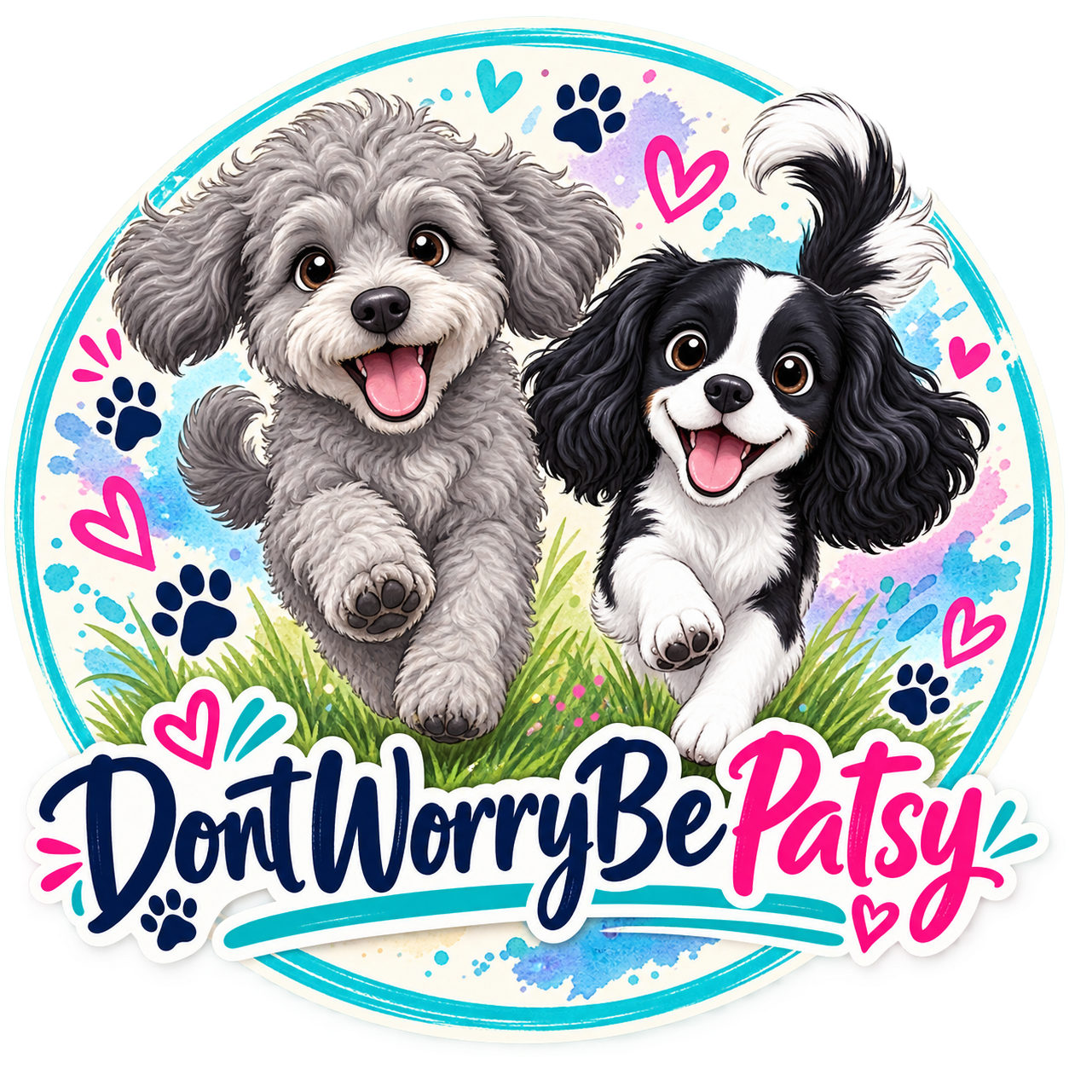
- This is the approved master logo. Do not redesign, redraw or 'improve' it unless explicitly asked.
- Patsy is the grey dog on the left; Darcy is the black-and-white dog on the right.
- Darcy must never be made brown or tan.
- Use the supplied approved logo file whenever available.
- Logo wording remains lowercase: dontworrybepatsy.
- The logo stays consistent while the surrounding creative and main typography can vary.

4. CHARACTER BIBLE — LOCKED

Patsy
- Small fluffy curly/shaggy dog; Maltipoo/Cavapoo/Shih-Tzu-type appearance.
- Grey fur #626263, white chest and white muzzle, black nose, warm brown eyes.
- Gentle expression and fluffy curly coat.
- In post-passing brand representations, soft white angel wings and subtle pink-purple sparkle glow #D9A5E0.
- Never make Patsy brown, tan, cream or a different generic dog.

Darcy
- Small-medium Cavalier/Spaniel type.
- Black and white ONLY: white face stripe, black floppy ears, white body with black patches.
- Signature small black heart marking on chest; white tail with black tip.
- Happy expression and tongue out.
- Senior rescue dog; main character for everyday life, funny content, advice and high-watch-time material.
- Never add brown or tan.

5. VISUAL IDENTITY
Modern British pet-community brand + soft watercolour + playful internet culture + genuine emotion. Use cream space, sage, dusty blue, deep purple, hand-drawn details, paws, hearts and subtle floral elements. Use photography, illustration, animation and meme graphics as appropriate. Keep content varied while maintaining the same underlying colour and brand language.

6. WEEKLY CONTENT SYSTEM
Day | Lane | Goal
Monday | Weekly forecast / tell-me-about-your-dog interaction | Interaction / comments
Tuesday | Weekly Dog Tip — advice, safety or guidance | Saves / authority
Wednesday | Dogs Being Dogs / Darcy | Watch time / shares
Thursday | Pet-friendly places / businesses / Paw of the Week | Saves / partnerships
Friday morning | Furbaby Confessions | Shares / reach
Friday afternoon | Friday Savage — funny dog-owner truths | Shares / reach
Saturday | Grief / journalling / celebrating time together | Connection
Sunday | Community stories + safety/weather content | Community / utility

7. MONDAY TEMPLATE
Weekly feature: forecast for the week ahead, covering North & South of the UK, daily forecast information, a fun fact and useful/interesting dog or weather information. Tone: fun, friendly, colourful and on-brand.
Template rule: use two dog pictures/illustrations; use a different dog breed for each and rotate breeds week to week.
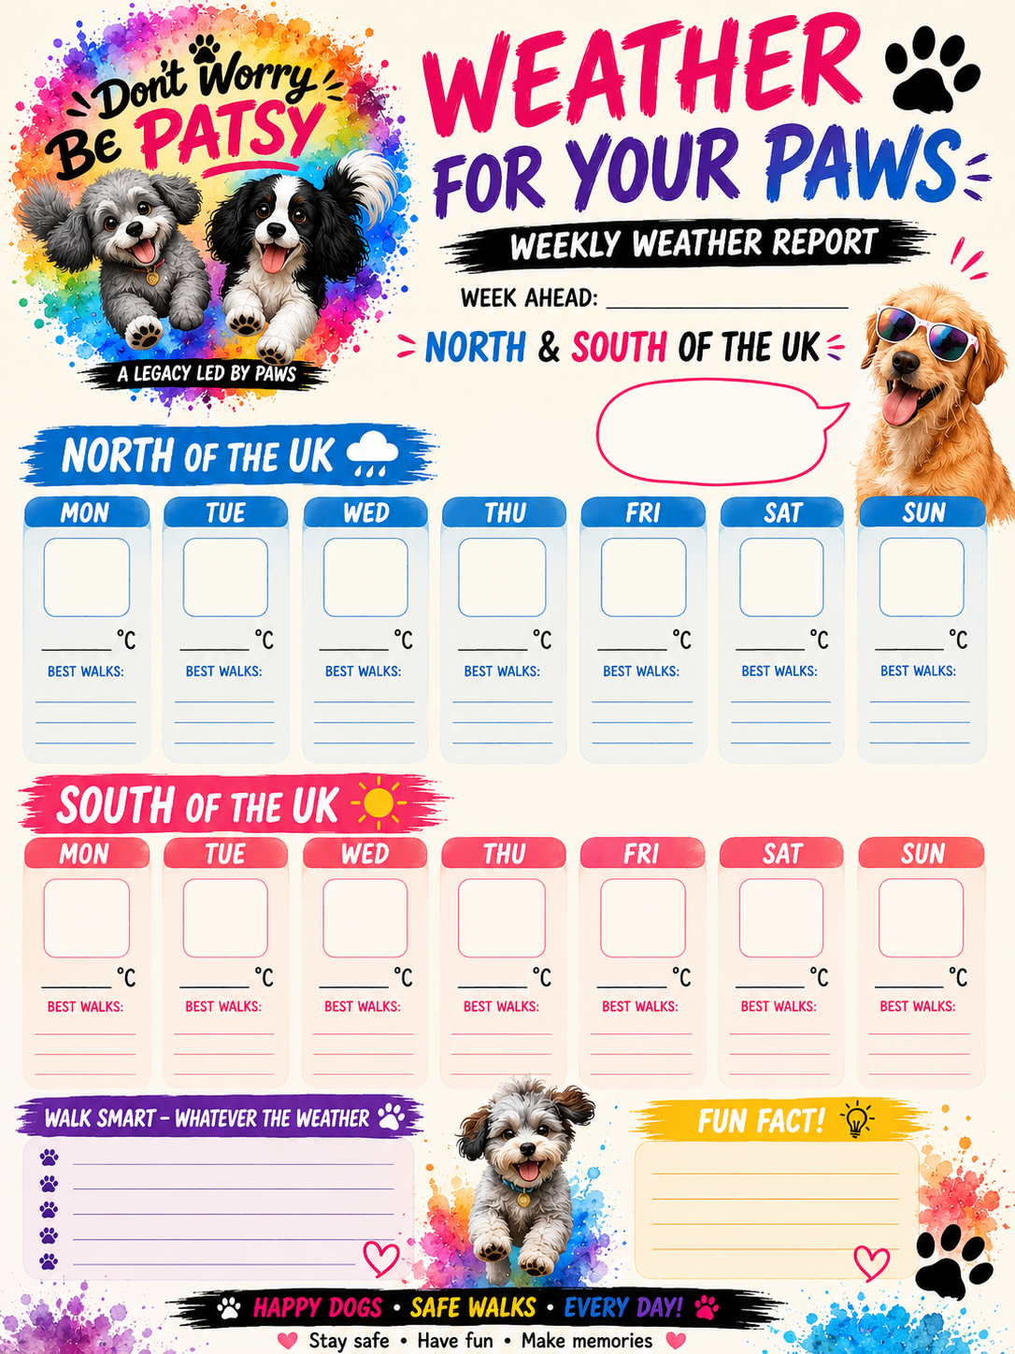

8. TUESDAY TEMPLATE — WEEKLY DOG TIP
One simple, useful tip each week for happier, healthier dogs. The topic must be different each week, with supporting information, a quick reminder/bonus tip where appropriate and a fun fact where appropriate. Use different dog breeds each week and keep the recognisable design.
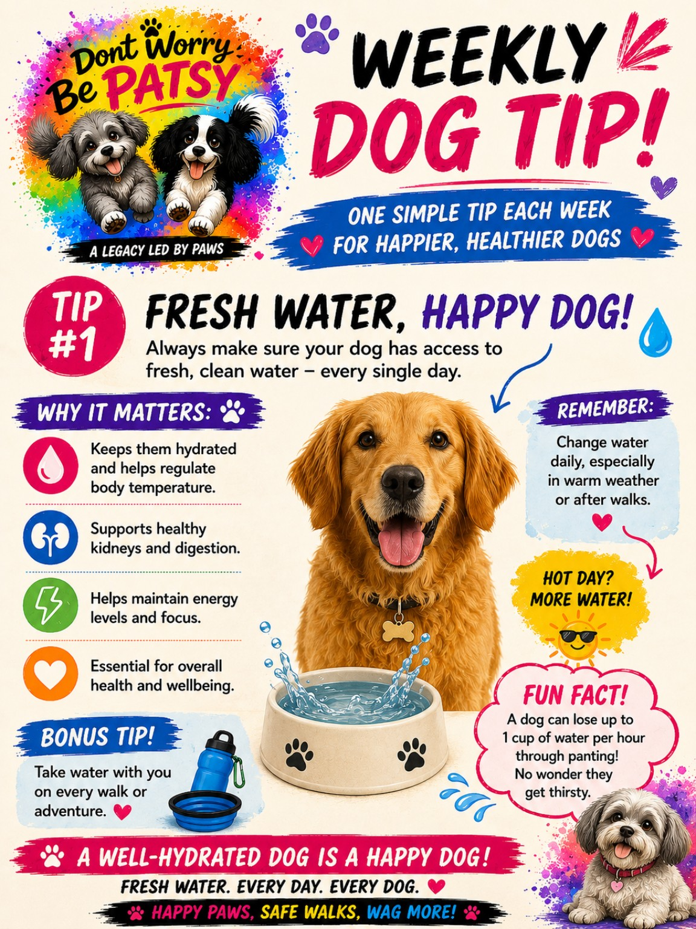

9. WEDNESDAY TEMPLATE — DOGS BEING DOGS
Recurring meme-style series. Keep it relatable, funny and highly shareable. Use a different dog breed each week. Main creative typography may vary, but the approved brand identity and logo remain consistent.
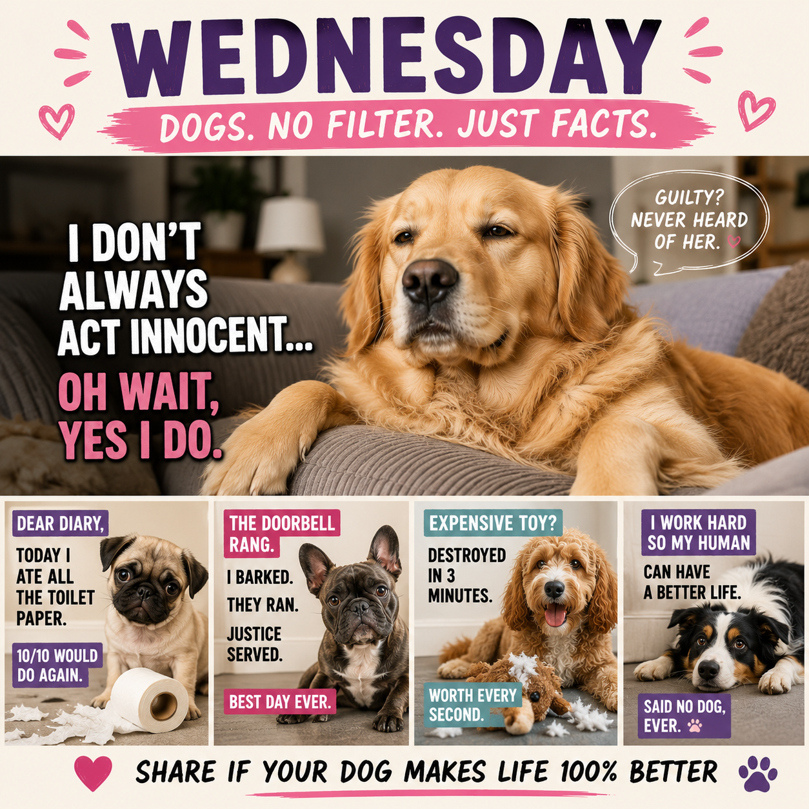

10. THURSDAY TEMPLATE — PAW OF THE WEEK
Community/pet-friendly lane. Spotlight a pet, person, place, business or community story as appropriate. Aim for saves, recommendations, partnerships and participation.


11. FRIDAY MORNING — FURBABY CONFESSIONS
Light, funny, relatable dog-owner confession content. Keep it inclusive and non-offensive. Designed for comments and shares.
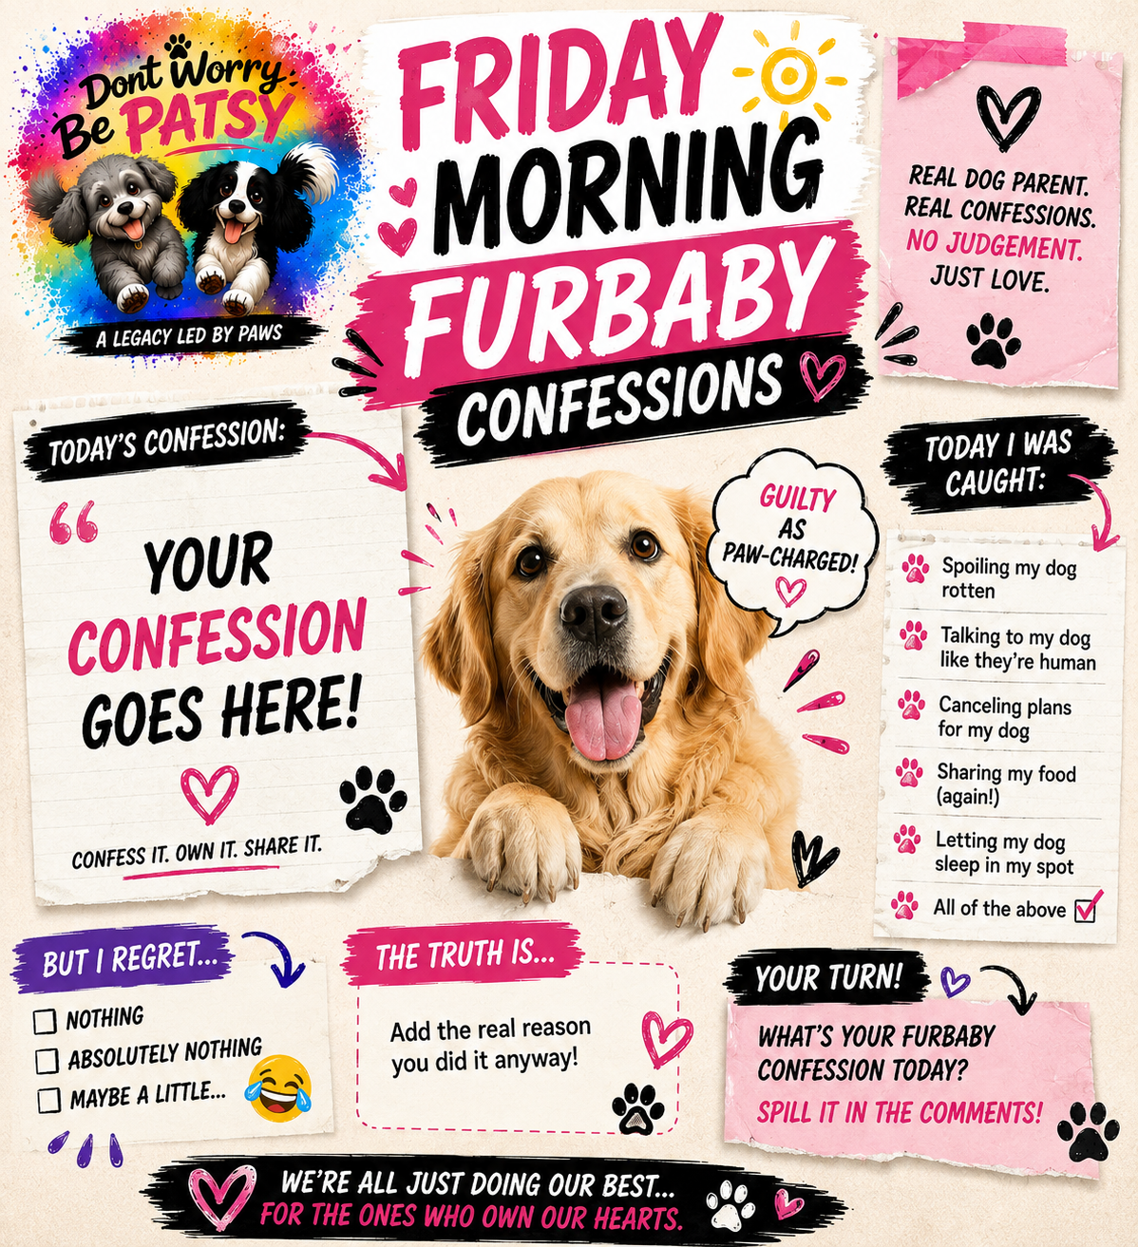

12. FRIDAY AFTERNOON — FRIDAY SAVAGE
Funny, cheeky dog-owner truths with a savage edge but NOT offensive. Keep the humour recognisable and broadly relatable.
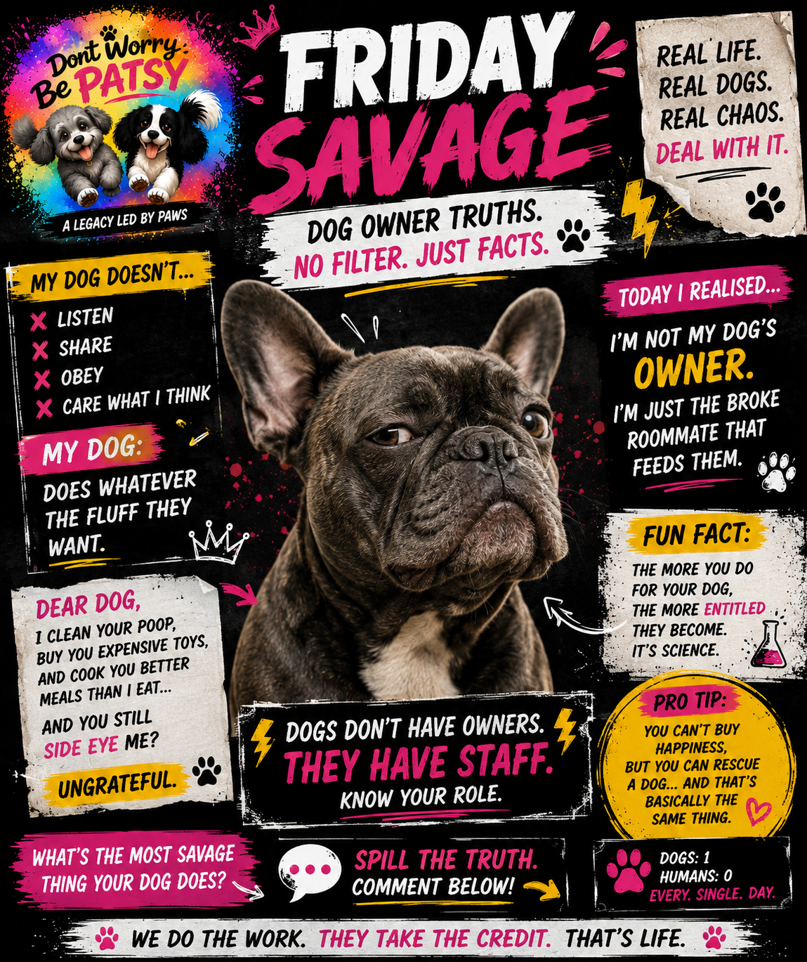

13. REEL & MEME RULES
- First 1–3 seconds must stop the scroll.
- Do not begin with generic introductions such as 'Hi guys'.
- Use strong hook → payoff → relatability → clear CTA.
- Aim for STOP → WATCH → FEEL → COMMENT → SHARE → FOLLOW.
- Vary formats: realistic dog footage, generated footage, animation, meme edits, POV, expectation/reality, voiceover, text-led, cinematic and emotional.
- Memes must feel instantly relatable and shareable.
- Main meme typography should vary from post to post; do not use the same generic treatment every time.
- Keep the approved dontworrybepatsy logo consistent.
- For scheduled meme content, place the logo clearly at bottom right unless a specific approved layout requires another placement.

14. COMMUNITY CTA LANGUAGE
- Tell me about your dog.
- Tell us about your day.
- Tell us about an amazing pet friendly place you went to.
- Tell us a funny story about your pet.
- Do you need any advice on your pet?
- Tag someone who needs to see this.
- Save for later.

15. CAPTION & HASHTAG SYSTEM
Default caption structure: HOOK → 1–2 lines of relatable context → value/laugh/emotional payoff → question/CTA → relevant hashtags.
Core hashtags: #dontworrybepatsy #petloss #petgrief #petlosscommunity #justiceforpatsy
Growth examples: #tellmeaboutyourdog #dogsoftiktok #relatabledog #seniordog #deafdog #blinddog #rescuedog #ukdogsofinstagram #dogmum #dogdad #petfriendly #dogadvice
Reach examples: #dogtok #petsoftiktok #fyp #viralDogs #dogmemes
Hashtags should be checked for current relevance before publishing rather than blindly repeating the same set.

16. NON-NEGOTIABLE RULES
- Do not change anything explicitly approved unless asked.
- Do not redesign the logo.
- Do not change Patsy's identity.
- Do not make Darcy brown.
- Do not turn the brand into a grief-only page.
- Do not make every post look identical.
- Do not use generic pastel colours instead of the locked palette.
- Do not use cheesy or clinical language.
- Do not sacrifice authenticity for trendiness.
- Keep the community at the centre.

17. PORTABILITY / SOURCE ASSETS
This pack is designed to be the portable reference for ChatGPT, Canva and other AI/design tools. The approved visual assets embedded in this file are the current working templates. The original master files remain in the DontWorryBePatsy Library and should be preferred when an exact editable/source asset is needed.
- Approved master logo
- Monday — Weekly Paws Weather Report Poster
- Tuesday — Weekly Dog Tip
- Wednesday — Dogs Being Dogs / Dog Facts Meme Poster
- Thursday — Paw of the Week
- Friday morning — Furbaby Confessions
- Friday afternoon — Friday Savage
- Brand & AI Master Pack
- 2026 Pet & Dog Awareness Calendar

MASTER STATUS: LOCKED UNLESS NATE EXPLICITLY REQUESTS A CHANGE

