PATSY — MASTER APP SPECIFICATION
Rainbow Workspace • Charcoal UI • Moving AI Companion • Owner-Controlled
MASTER SOURCE OF TRUTH. This document consolidates the Patsy app requirements established so far. Use it as the hand-off specification for continued development. The supplied screenshot is the visual reference for the intended Rainbow setup and Patsy's appearance.
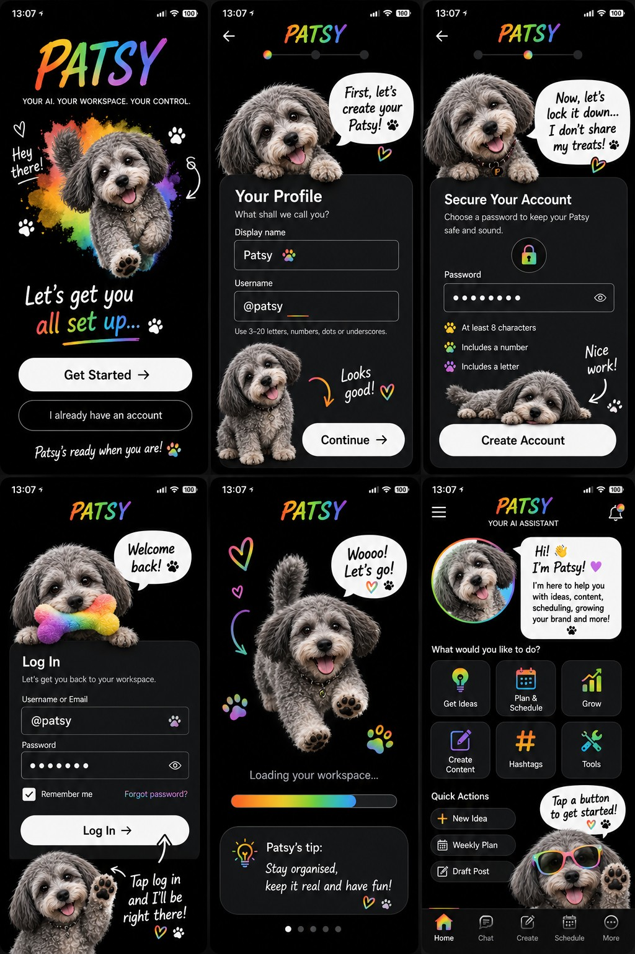
APPROVED VISUAL REFERENCE — Rainbow onboarding/login/home direction

1. Core identity and purpose
- Patsy is the AI assistant/search experience itself — not merely a logo, mascot, or decorative dog.
- A user should be able to ask Patsy questions naturally, in the same conversational way they would ask an AI assistant.
- Patsy should guide, explain, suggest, search, create, organise and help the user work without taking control away from them.
- The app is intended to grow toward an ambitious all-in-one AI + creative workspace, aiming to get as close as realistically possible to polished tools such as Canva/Snapchat over time.
- Patsy must remain recognisable as the approved grey/shaggy dog character shown in the reference material. Do not substitute the pink/black brand logo for Patsy's character.

2. Visual design — NON-NEGOTIABLE
- Primary background: deep black / near-black.
- Primary surfaces: dark charcoal cards and panels.
- Charcoal should be the main UI surface colour rather than plain white screens.
- Rainbow is a core theme/accent system throughout the app.
- Rainbow accents should move through warm and cool hues (orange/yellow/green/cyan/blue/purple/pink) rather than using a single accent colour.
- Use white/light text for high contrast on dark surfaces.
- Use rainbow gradients for progress bars, active states, highlights, borders/glows and selected controls where appropriate.
- Use pink/magenta as a supporting Patsy/brand accent, with black, white and charcoal remaining the foundation.
- The supplied six-screen reference is the target direction for onboarding, account setup, login, loading and home.
- Do not revert to the earlier plain white/striped prototype appearance.

3. Patsy character and animation
- Patsy must be an active on-screen AI companion whenever she is displayed, not a static image.
- She should move around the available area naturally and purposefully.
- She should be able to move/paw toward, point at, or draw attention to the control she is explaining.
- She should change position based on the current screen/context rather than always occupying one fixed spot.
- Use multiple approved poses/expressions: happy, excited, thinking, pointing, concerned/warning, encouraging, sleepy/resting and celebratory.
- Her mouth should animate while she is speaking; ideally use simple lip-sync/talking states rather than a static open-mouth image.
- Face/eye/head expressions should change with the conversation and action.
- Animation should feel continuous and alive while she is on screen, while avoiding distracting or excessive motion.
- Patsy should visibly react to buttons, successful actions, errors and waiting/loading states.
- The character should point toward the next action when guiding a user.
- Where a full real-time animation system is not yet available, build the architecture so animated assets/states can be added without redesigning the app.

4. Onboarding
- Opening identity: PATSY with the tagline 'YOUR AI. YOUR WORKSPACE. YOUR CONTROL.'
- Get Started flow must lead to a working profile/account setup.
- Existing-account flow must lead to a working login.
- Age/experience choices: 16+ Patsy, Under-16 Patsy, and Protected Mode.
- The chosen mode must be stored with the profile and consistently control the relevant experience/safety defaults.
- Patsy should guide setup conversationally and visibly.
- The profile screen should collect a display name and username.
- Username availability validation must be real and must not leave the user stuck on a false/unresolvable validation error.
- Password setup must validate required rules and give clear feedback.
- Continue/Create Account buttons must actually progress when valid information is supplied.

5. Login and account system — MUST WORK
- Login is a release-blocking requirement: the user must be able to get into the app.
- Support username or email plus password.
- Support Remember Me where appropriate.
- Provide password visibility control.
- Provide a real, usable forgotten-password/recovery path when backend support is connected.
- Do not ship a login screen that visually works but has no functional authentication behind it.
- Persist the authenticated session safely and restore it when the user returns, subject to security rules.
- Handle invalid credentials, duplicate usernames, missing fields, offline state and server errors with useful messages.
- Never display or log plaintext passwords.

6. Owner-only tools and profile security
- Owner tools must be built into the owner's profile/role and accessible only to the authorised owner account.
- Do not expose owner controls merely because someone knows a username, can reach a hidden screen, or changes a local flag.
- Owner privileges must be enforced by the authentication/authorisation layer, not only by hiding UI buttons.
- Separate normal user permissions from owner permissions.
- Protect owner actions with server-side/secure checks wherever a backend exists.
- Use secure session/token handling and prevent privilege escalation.
- Record security-sensitive owner actions where appropriate for auditing.
- Never hard-code a secret owner password or API key into the shipped Android app.
- Owner-only features can include administration, configuration, diagnostics, AI/provider configuration, moderation/safety controls and app-management functions.
- If an owner tool cannot safely be implemented yet, keep it disabled rather than pretending the security is complete.

7. Profiles
- Each user needs an independent profile.
- Profile data should include display name, username, experience/age mode and relevant preferences.
- Patsy should use the user's profile to personalise the workspace without exposing private information.
- Owner profile is a special secured role, distinct from ordinary profiles.
- Profile switching/selection must never grant owner privileges.
- Provide sensible privacy controls for profile visibility and shared content.

8. Patsy AI / AI Search
- Patsy is the primary AI search/conversation entry point.
- Users should be able to type natural-language requests rather than navigating only through preset commands.
- Patsy should answer questions, search the internet when enabled/available, explain results and help turn answers into actions.
- Show clear states for thinking/loading, successful response, no connection, provider failure and unavailable capability.
- AI provider/API credentials must never be embedded as plaintext secrets in the Android client.
- The architecture should support a secure backend/proxy for AI calls and web search.
- AI responses should respect the selected safety/experience mode.
- Patsy must not claim she performed an action if it did not actually happen.
- Patsy should ask for confirmation before consequential or irreversible actions where appropriate.
- Patsy should not silently change approved user decisions or project settings.

9. Internet connection and external services
- Provide a real network layer with clear online/offline status.
- AI requests and web search should go through secure network services.
- Handle timeouts, no connection, rate limits and service outages gracefully.
- Do not freeze the UI while waiting for network responses.
- Cache safe non-sensitive data where useful, but never cache secrets or private credentials insecurely.
- Separate UI logic from API/service logic so providers can be changed later.
- Use HTTPS/TLS for network communication.

10. Home / main workspace
- Main navigation direction: Home, Chat, Create, Schedule and More.
- Home should prominently feature Patsy as the active AI assistant.
- Include quick actions such as Get Ideas, Plan & Schedule, Grow, Create Content, Hashtags and Tools.
- Patsy should provide contextual guidance and point toward relevant controls.
- Use charcoal cards with rainbow active states and clean white typography.
- Notifications and account access should be easy to reach without clutter.

11. Creation Studio — HIGH SPEC
- Creation Studio is a major part of the app, not a simple placeholder page.
- It should aim toward a full creative workspace comparable in direction to modern design/content apps.
- Include an editor/canvas area.
- Include image creation/generation capability when a connected image-generation service is available.
- Include 10-second video creation/generation capability when a connected video-generation service is available.
- Include import/upload of user media.
- Include crop, resize, rotate, positioning and basic transform controls.
- Include brightness, contrast, saturation, exposure and similar adjustment controls.
- Include filters/effects.
- Include text, stickers, shapes and overlays.
- Include layering/order controls.
- Include undo/redo and reset adjustments.
- Include preview and export/save.
- Include a Patsy assistant area along the bottom where the user can type what they want to create/change.
- Patsy should understand natural requests such as 'make this brighter', 'remove the background', 'make it more colourful', 'turn this into a Reel', or 'make a 10 second video'.
- Patsy should explain unavailable generation capabilities rather than presenting fake results.
- Design the editor so additional AI tools can be added without rebuilding the whole screen.

12. DMs / Messenger
- Provide direct/private messaging functionality.
- Support conversation lists, individual conversations, message sending and basic message states.
- Protect private conversations with authenticated access and appropriate privacy controls.
- Do not expose private messages through public feeds or search unless the user explicitly shares them.

13. Social/content workspace
- Support content planning and drafting as the product grows.
- Provide schedule/planning surfaces.
- Support reusable drafts and safe repurposing workflows.
- Keep creation, scheduling and social features distinct from owner administration.
- Any publishing/integration action must clearly show what account/service it will affect.

14. Safety and age modes
- 16+ mode: full intended experience within applicable safety rules.
- Under-16 mode: protected younger experience with stronger restrictions and safer defaults.
- Protected Mode: safer defaults when age is uncertain.
- Safety rules must be enforced consistently across chat, search, creation, DMs and other AI-powered areas.
- Do not rely on a label alone; the selected mode must actually affect behaviour.
- Block or appropriately handle unsafe, illegal, exploitative, sexual, violent or otherwise disallowed requests according to the applicable safety policy.
- Provide respectful refusal/redirection rather than exposing internal safety logic.
- Protect children/young users from inappropriate discovery, messaging and generated content.
- Minimise personal-data collection and provide clear privacy behaviour.

15. Privacy and data protection
- Collect only data needed for the feature.
- Protect credentials, sessions, private messages and user-generated content.
- Use secure storage for tokens/secrets available to the app.
- Do not put API keys, passwords or privileged credentials in source control or APK resources.
- Provide account deletion/data-management pathways when the backend supports them.
- Clearly distinguish local-only data from cloud-synchronised data.
- Avoid sending unnecessary profile/private data to AI providers.

16. Reliability / release quality
- The app must compile cleanly before being considered ready.
- No unresolved references, missing imports, invalid Compose parameters, syntax errors or placeholder implementations should remain in the release build.
- Test every onboarding button, back button, login path, account creation path and major navigation destination.
- Test on the target Android device as well as an emulator where possible.
- Test offline and poor-network states.
- Test fresh install, first run, logout, relaunch and returning-user flows.
- Do not call a build 'finished' simply because the UI screenshots look correct.

17. Visual details from the supplied reference
- Black full-screen background.
- Large PATSY heading/wordmark at the top.
- Small uppercase tagline below the title.
- Patsy character positioned prominently under the header.
- Charcoal rounded information panels.
- White/light primary typography.
- Rainbow gradient progress/active accents.
- Rounded white/light primary action buttons with dark text.
- Rainbow-coloured labels/highlights for the experience modes.
- Speech bubbles and paw motifs used as functional guidance, not merely decoration.
- The overall feeling should be friendly, premium, playful, modern and energetic.

18. Functional acceptance checklist
- Fresh install opens correctly.
- User can choose an experience mode.
- User can create a profile with a genuinely available username.
- Account creation succeeds.
- User can log out.
- User can log back in with the created credentials.
- Returning session works safely.
- Patsy responds to a user message through the connected AI service.
- Patsy can perform/search through the intended web/AI pathway when connected.
- Patsy visibly animates, changes expression and points/guides where appropriate.
- Home navigation works.
- Chat works.
- Creation Studio opens.
- Creation Studio has working editing controls rather than decorative buttons.
- AI image generation path works when the image provider is configured.
- 10-second video generation path works when the video provider is configured.
- DMs work when the messaging backend is configured.
- Owner tools are inaccessible to ordinary accounts even if they attempt direct navigation.
- Age-mode restrictions are enforced.
- Offline/error states are handled.
- Release build has zero compilation errors.

19. Important development rule
DO NOT downgrade the design back to the old prototype. The black/charcoal Rainbow Workspace direction, the real Patsy character, active animation, functional authentication, owner-only security, AI Search and high-spec Creation Studio are core requirements.

20. Handoff note
This file is intended to be handed to the next development session/assistant as the consolidated requirements document. The next developer should first make the current project compile and make authentication/navigation genuinely functional, then implement the Rainbow visual system and animated Patsy architecture, followed by the AI/search and Creation Studio service integrations.

