CBSE CLASS XII CHEMISTRY BOARD EXAMINATION
COMPLETE STEP-BY-STEP SOLVED PAPER

SECTION A (16 MARKS)
Select and write the most appropriate option for each of the following questions (Q.1 – Q.16), carrying 1 mark each:
Q1. Which of the following liquid pairs shows a negative deviation from Raoult's law?
Correct Option: (c) Acetone + Chloroform
Explanation: In a mixture of acetone and chloroform, the intermolecular attractive forces between acetone (A) and chloroform (B) are stronger than the pure component attractions (A-A and B-B) because the hydrogen atom of chloroform forms a strong hydrogen bond with the carbonyl oxygen of acetone (Cl3C-H...O=C(CH3)2). This lowers the overall vapor pressure of the solution compared to that predicted by Raoult's law.
Q2. The value of Henry's Law constant (K_H):
Correct Option: (a) increases with increase in temperature.
Explanation: Henry's Law is p = K_H * x. The solubility of a gas in a liquid is an exothermic process. According to Le Chatelier's Principle, as temperature increases, the solubility (x) of the gas decreases for a given pressure (p). Since x = p / K_H, a decrease in x requires an increase in the Henry's law constant (K_H).
Q3. An isotonic solution has the same:
Correct Option: (b) Osmotic pressure
Explanation: Isotonic solutions are defined as solutions having the same osmotic pressure at a given temperature. If two solutions are separated by a semipermeable membrane, no net osmosis occurs between them.
Q4. The SI unit of molar conductivity (Lambda_m) is:
Correct Option: (b) S m^2 mol^-1
Explanation: Molar conductivity is Lambda_m = kappa / C. In SI units, conductivity (kappa) is S m^-1 and concentration (C) is mol m^-3. Thus, Lambda_m = S m^-1 / mol m^-3 = S m^2 mol^-1. (Note: S cm^2 mol^-1 is a common practical unit, but S m^2 mol^-1 is the official SI unit).
Q5. How many Coulombs of electricity are required for the reduction of 1 mole of MnO4^- to Mn^2+?
Correct Option: (c) 4,82,500 C
Explanation: The balanced half-reaction is MnO4^- + 8H^+ + 5e^- -> Mn^2+ + 4H2O. Here, Mn undergoes a change in oxidation state from +7 to +2. This requires 5 moles of electrons. Total charge required Q = n * F = 5 * 96,500 C = 4,82,500 C.
Q6. The cell constant of a conductivity cell:
Correct Option: (d) remains constant for a given cell.
Explanation: The cell constant (G*) is given by G* = l / A, where l is the distance between the electrodes and A is the area of the electrodes. Since these are fixed physical dimensions of a given cell, the cell constant is constant regardless of electrolyte type, concentration, or temperature.
Q7. The half-life period (t_1/2) of a first-order reaction is independent of:
Correct Option: (b) Initial concentration of reactant
Explanation: For a first-order reaction, t_1/2 = 0.693 / k. Since the expression does not contain any initial concentration term [A]_0, the half-life is completely independent of the initial concentration.
Q8. If the concentration of a reactant is increased by a factor of 4 and the rate of reaction increases by a factor of 2, the order of reaction is:
Correct Option: (c) 0.5
Explanation: Rate = k[A]^n. If concentration is multiplied by 4, new rate = k(4[A])^n = 4^n * Rate. Since new rate is 2 * Rate, we have 4^n = 2, which gives n = 0.5.
Q9. According to Arrhenius equation, the slope of the plot of ln k vs 1/T is equal to:
Correct Option: (a) -E_a / R
Explanation: The Arrhenius equation is k = A * e^(-E_a/RT). Taking natural log on both sides gives ln k = ln A - (E_a / R)*(1/T). This represents a straight line (y = mx + c) where the slope m = -E_a / R.
Q10. Which of the following alkyl halides undergoes S_N1 reaction fastest?
Correct Option: (c) (CH3)_3C-Br
Explanation: S_N1 reactions proceed via a carbocation intermediate. Tertiary alkyl halides form tertiary carbocations which are highly stabilized by hyperconjugation and +I effects of three methyl groups. Between (CH3)_3C-Br and (CH3)_3C-Cl, bromide is a better leaving group than chloride because C-Br bond is weaker and bromide is a weaker base.
Q11. Finkelstein reaction is used for the preparation of:
Correct Option: (b) Alkyl iodides
Explanation: Finkelstein reaction is a halogen exchange reaction where an alkyl chloride or bromide is reacted with sodium iodide (NaI) in dry acetone to yield an alkyl iodide: R-Cl + NaI -> R-I + NaCl.
Q12. Chlorobenzene reacts with metallic sodium in dry ether to give diphenyl. This reaction is known as:
Correct Option: (b) Fittig reaction
Explanation: The reaction of two molecules of aryl halides with sodium in dry ether to form a diphenyl (diaryl) is known as the Fittig reaction.
Q13. Assertion (A): Elevation in boiling point is a colligative property.
Reason (R): Elevation in boiling point depends on the nature of the solute particles.
Correct Option: (c) (A) is true, but (R) is false.
Explanation: Elevation in boiling point is a colligative property because it depends only on the number of solute particles. However, Reason (R) is false because colligative properties are independent of the nature of the solute particles.
Q14. Assertion (A): Conductivity of an electrolytic solution decreases with decrease in concentration.
Reason (R): The number of ions per unit volume decreases on dilution.
Correct Option: (a) Both (A) and (R) are true, and (R) is the correct explanation of (A).
Explanation: Conductivity is the conductance of a unit volume of solution. On dilution (decreasing concentration), the number of ions per unit volume decreases, and hence conductivity decreases.
Q15. Assertion (A): Molecularity of a reaction can be zero or fractional.
Reason (R): Molecularity is the number of reacting species taking part in an elementary step.
Correct Option: (d) (A) is false, but (R) is true.
Explanation: Molecularity cannot be zero or fractional because it represents the actual number of atoms, ions, or molecules colliding in an elementary reaction. Reason (R) is the correct definition of molecularity.
Q16. Assertion (A): Haloarenes are less reactive towards nucleophilic substitution than haloalkanes.
Reason (R): In haloarenes, C-X bond acquires partial double bond character due to resonance.
Correct Option: (a) Both (A) and (R) are true, and (R) is the correct explanation of (A).
Explanation: Haloarenes are less reactive because the lone pair of electrons on halogen undergoes conjugation with the benzene ring, giving the C-X bond a partial double bond character which makes it harder to break.

SECTION B (10 MARKS)
Very Short Answer Type Questions carrying 2 marks each:
Q17. State Raoult's Law for a solution of non-volatile solute. How is the molecular mass of a solute determined using relative lowering of vapor pressure?
Raoult's Law: For a solution of non-volatile solute, the relative lowering of vapor pressure of the solvent is equal to the mole fraction of the solute in the solution. Mathematically:
(p1° - p1) / p1° = x2
where p1° is vapor pressure of pure solvent, p1 is vapor pressure of solution, and x2 is mole fraction of solute.
Determination of Molecular Mass (M2):
Let w2 and M2 be the mass and molar mass of solute, and w1 and M1 be the mass and molar mass of solvent. Since mole fraction x2 = n2 / (n1 + n2), for a dilute solution n2 << n1, so x2 = n2 / n1 = (w2/M2) / (w1/M1) = (w2 * M1) / (w1 * M2).
Substituting this in Raoult's Law gives:
(p1° - p1) / p1° = (w2 * M1) / (w1 * M2)
Rearranging for M2:
M2 = (w2 * M1 * p1°) / [w1 * (p1° - p1)]
Q18. Calculate the degree of dissociation (alpha) of 0.00241 M acetic acid if its molar conductivity (Lambda_m) is 39.05 S cm^2 mol^-1. Given: Lambda°(H^+) = 349.6 S cm^2 mol^-1 and Lambda°(CH3COO^-) = 40.9 S cm^2 mol^-1.
Solution:
1. Find limiting molar conductivity (Lambda°_m) of acetic acid:
Lambda°_m(CH3COOH) = Lambda°(H^+) + Lambda°(CH3COO^-) = 349.6 + 40.9 = 390.5 S cm^2 mol^-1
2. Find degree of dissociation (alpha):
alpha = Lambda_m / Lambda°_m = 39.05 / 390.5 = 0.1
Answer: The degree of dissociation (alpha) is 0.1 (or 10%).
Q19. A first-order reaction has a rate constant of 1.15 * 10^-3 s^-1. How long will 5.0 g of this reactant take to reduce to 3.0 g?
Solution:
For first order reaction, t = (2.303 / k) * log10([A]_0 / [A])
Given k = 1.15 * 10^-3 s^-1, [A]_0 = 5.0 g, [A] = 3.0 g
t = (2.303 / (1.15 * 10^-3)) * log10(5.0 / 3.0)
t = (2.303 / (1.15 * 10^-3)) * log10(1.6667)
t = (2.303 / (1.15 * 10^-3)) * 0.2218
t = 0.5109 / (1.15 * 10^-3) = 444.3 seconds.
Answer: It will take 444.3 seconds (or ~7.4 minutes).
Q20. Give chemical tests to distinguish between: (a) Chlorobenzene and Benzyl chloride, (b) Chloroform and Carbon tetrachloride.
(a) Chlorobenzene and Benzyl chloride:
Heat each with aq. NaOH solution, acidify with dilute HNO3, and add AgNO3 solution. Benzyl chloride undergoes hydrolysis readily and forms a curdy white precipitate of silver chloride (AgCl) soluble in NH4OH. Chlorobenzene does not undergo hydrolysis under these conditions and hence does not form a precipitate.
(b) Chloroform and Carbon tetrachloride:
Warm each compound with aniline (C6H5NH2) and alcoholic KOH (Carbylamine Test). Chloroform reacts to produce phenyl isocyanide (C6H5NC) which has an extremely offensive, foul smell. Carbon tetrachloride does not undergo this reaction and gives no foul smell.
Q21. What happens when: (a) n-butyl chloride is treated with alcoholic KOH? (b) Methyl chloride is treated with KCN?
OR Explain why the dipole moment of chlorobenzene is lower than that of cyclohexyl chloride.
Main Questions:
(a) n-butyl chloride with alcoholic KOH undergoes beta-elimination to yield 1-butene:
CH3CH2CH2CH2Cl + KOH(alc) -> CH3CH2CH=CH2 + KCl + H2O
(b) Methyl chloride with KCN undergoes nucleophilic substitution to yield methyl cyanide:
CH3Cl + KCN -> CH3CN + KCl
OR Option:
The dipole moment of chlorobenzene (~1.69 D) is lower than that of cyclohexyl chloride (~2.0 D) due to:
1. Hybridization: In chlorobenzene, chlorine is attached to an sp2 carbon (more electronegative, pulls electron density back, reducing bond polarity). In cyclohexyl chloride, chlorine is attached to an sp3 carbon (less electronegative).
2. Resonance: In chlorobenzene, resonance between chlorine's lone pair and the benzene ring gives C-Cl bond partial double bond character, shortening the bond. Since dipole moment is a product of charge and distance, the shorter bond and smaller charge separation yield a lower dipole moment.

SECTION C (21 MARKS)
Short Answer Type Questions carrying 3 marks each:
Q22. A solution prepared by dissolving 1.25 g of an unknown non-volatile solute in 99.0 g of acetone has a boiling point of 56.38 °C. The boiling point of pure acetone is 56.05 °C. Calculate the molar mass of the solute. (K_b for acetone = 1.72 K kg mol^-1).
Solution:
Elevation in boiling point Delta T_b = T_b - T_b° = 56.38 - 56.05 = 0.33 °C (or 0.33 K).
Using the formula Delta T_b = K_b * (w2 * 1000) / (M2 * w1):
M2 = (K_b * w2 * 1000) / (Delta T_b * w1)
M2 = (1.72 * 1.25 * 1000) / (0.33 * 99.0) = 2150 / 32.67 = 65.81 g mol^-1.
Answer: The molar mass of the solute is 65.81 g mol^-1.
Q23. Explain the following terms with suitable examples: (a) Abnormal molar mass, (b) Van't Hoff factor (i), (c) Azeotropes.
(a) Abnormal molar mass: When the experimental molar mass of a solute determined from colligative properties is higher or lower than its normal value, it is called abnormal molar mass. This happens due to association or dissociation of particles in solution. E.g., NaCl in water dissociates, yielding a measured molar mass of ~29.25 g/mol (half of 58.5 g/mol).
(b) Van't Hoff factor (i): It is the ratio of experimental value of a colligative property to the calculated theoretical value. i = Normal molar mass / Abnormal molar mass. E.g., for complete dissociation of KCl, i = 2; for complete dimerization of benzoic acid in benzene, i = 0.5.
(c) Azeotropes: Binary mixtures having the same composition in liquid and vapor phases and boiling at a constant temperature. E.g., minimum boiling azeotrope: 95% ethanol + 5% water; maximum boiling azeotrope: 68% nitric acid + 32% water.
Q24. The resistance of a conductivity cell filled with 0.1 mol L^-1 KCl solution is 100 Ohm. If the resistance of the same cell filled with 0.02 mol L^-1 KCl solution is 520 Ohm, calculate the conductivity and molar conductivity of 0.02 mol L^-1 KCl solution. (Conductivity of 0.1 mol L^-1 KCl solution is 1.29 S/m).
Solution:
1. Find Cell Constant (G*):
G* = kappa_1 * R_1 = 1.29 S m^-1 * 100 Ohm = 129 m^-1 (or 1.29 cm^-1).
2. Find Conductivity (kappa_2) of 0.02 M KCl:
kappa_2 = G* / R_2 = 129 m^-1 / 520 Ohm = 0.248 S m^-1 (or 2.48 * 10^-3 S cm^-1).
3. Find Molar Conductivity (Lambda_m):
Concentration C = 0.02 mol L^-1 = 20 mol m^-3.
Lambda_m (SI) = kappa_2 / C = 0.248 S m^-1 / 20 mol m^-3 = 0.0124 S m^2 mol^-1.
In common units: Lambda_m = (1000 * kappa_2_cm) / C_M = (1000 * 2.48 * 10^-3) / 0.02 = 124 S cm^2 mol^-1.
Answer: Conductivity = 0.248 S/m, Molar Conductivity = 124 S cm^2 mol^-1.
Q25. State Kohlrausch's law of independent migration of ions. Write two applications of Kohlrausch's law in electrochemistry.
Kohlrausch's Law: At infinite dilution, limiting molar conductivity of an electrolyte is equal to the sum of the individual contributions of its constituent anions and cations: Lambda°_m = v+ * lambda°_+ + v- * lambda°_-.
Applications:
1. Calculation of Lambda°_m for weak electrolytes (e.g. acetic acid) from strong electrolytes:
Lambda°_m(CH3COOH) = Lambda°_m(CH3COONa) + Lambda°_m(HCl) - Lambda°_m(NaCl).
2. Calculation of degree of dissociation (alpha = Lambda_m / Lambda°_m) and dissociation constant (Ka) of weak electrolytes.
Q26. The rate constants of a reaction are 2.0 * 10^-2 s^-1 at 300 K and 8.0 * 10^-2 s^-1 at 320 K. Calculate the activation energy (E_a) of the reaction. [Given: R = 8.314 J K^-1 mol^-1, log 4 = 0.6021]
Solution:
Using Arrhenius equation: log10(k2 / k1) = [E_a / (2.303 * R)] * [(T2 - T1) / (T1 * T2)]
log10(4.0) = [E_a / (2.303 * 8.314)] * [20 / (300 * 320)]
0.6021 = [E_a / 19.147] * [20 / 96000]
E_a = (0.6021 * 19.147 * 96000) / 20 = 55336.8 J mol^-1 = 55.34 kJ mol^-1.
Answer: Activation energy is 55.34 kJ mol^-1.
Q27. Differentiate between S_N1 and S_N2 mechanisms of nucleophilic substitution reactions based on: (a) Kinetics, (b) Stereochemistry, (c) Reactivity order of alkyl halides.
Feature | S_N1 Mechanism | S_N2 Mechanism
Kinetics & Order | First-order kinetics. Rate = k[R-X]. Order = 1. | Second-order kinetics. Rate = k[R-X][Nu^-]. Order = 2.
Stereochemical Outcome | Racemisation (forms 50% d and 50% l enantiomers due to planar carbocation intermediate). | 100% Inversion of configuration (Walden Inversion due to backside attack of nucleophile).
Reactivity Order | 3° > 2° > 1° > CH3X (due to stability of the intermediate carbocation). | CH3X > 1° > 2° > 3° (due to steric hindrance at the reaction center).

Q28. Complete the following chemical equations:
(a) CH3CH2CH=CH2 + HBr -> (in presence of peroxide)
(b) C6H5OH + Zn (dust) -> (with heat)
(c) CH3CH2Br + AgCN ->
OR How will you carry out the following conversions? (a) Propene to Propan-1-ol, (b) Benzene to 4-Bromonitrobenzene, (c) Ethanol to Ethyl fluoride.
Main Equations:
(a) CH3CH2CH=CH2 + HBr -> [peroxide] -> CH3CH2CH2CH2Br (1-Bromobutane) (Anti-Markovnikov addition)
(b) C6H5OH + Zn -> [heat] -> C6H6 (Benzene) + ZnO (Reduction)
(c) CH3CH2Br + AgCN -> CH3CH2NC (Ethyl isocyanide) + AgBr (Nucleophilic substitution via covalent AgCN)
OR Option (Conversions):
(a) Propene to Propan-1-ol: React propene with HBr in peroxide to get 1-bromopropane, then hydrolyze with aqueous KOH:
CH3CH=CH2 + HBr/peroxide -> CH3CH2CH2Br + aq. KOH/heat -> CH3CH2CH2OH
(b) Benzene to 4-Bromonitrobenzene: Brominate benzene with Br2/Fe to get bromobenzene, then nitrate with conc. HNO3 + H2SO4:
C6H6 + Br2/Fe -> C6H5Br + conc. HNO3/H2SO4 -> p-Br-C6H4-NO2 (major, separated from ortho-isomer)
(c) Ethanol to Ethyl fluoride: Chlorinate with SOCl2 to get ethyl chloride, then carry out Swarts reaction with AgF:
CH3CH2OH + SOCl2 -> CH3CH2Cl + AgF/heat -> CH3CH2F

SECTION D (8 MARKS)
Case-Based Questions carrying 4 marks each:
Q29. Case Study 1: Chemical Kinetics & Reaction Rates
(a) Pseudo-first-order reaction: A higher order reaction (e.g. bimolecular) behaving as a first-order reaction due to one reactant being in large excess. E.g., hydrolysis of ethyl acetate: CH3COOC2H5 + H2O(excess) -> CH3COOH + C2H5OH.
(b) Zero-order rate equation & unit of k: Rate = -d[A]/dt = k. Integrated form: [A] = -kt + [A]_0. Unit of k: mol L^-1 s^-1.
(c) Reaction is second order with respect to A (Rate = k[A]^2):
(i) If concentration of A is doubled: Rate' = k(2[A])^2 = 4k[A]^2 = 4 * Rate. (Rate quadruples).
(ii) If concentration of A is halved: Rate'' = k(0.5[A])^2 = 0.25 * Rate. (Rate becomes 1/4th).
Q30. Case Study 2: Organometallic & Polyhalogen Compounds
(a) Anhydrous conditions for Grignard reagents: Grignard reagents (RMgX) are highly polar, strongly basic, and react instantaneously with any proton source (like water) to form alkanes (R-H + Mg(OH)X). Hence dry conditions are required to prevent decomposition.
(b) Friedel-Crafts acetylation of chlorobenzene major product:
IUPAC Name: 4-Chloroacetophenone. Structure: Cl-C6H4-COCH3 (para-position).
(c) Melting points of o-dichlorobenzene vs p-dichlorobenzene: p-dichlorobenzene has a higher melting point because it is highly symmetrical. This symmetry allows its molecules to fit tightly in the crystal lattice, leading to stronger intermolecular forces that require more thermal energy to break compared to the asymmetrical ortho-isomer.

SECTION E (25 MARKS)
Long Answer Type Questions carrying 5 marks each:
Q31. (a) Define Osmotic Pressure. Why is it preferred for determining the molar mass of macromolecules like proteins and polymers? (Give 3 reasons) (b) Calculate the osmotic pressure of a solution prepared by dissolving 25 mg of K2SO4 in 2 L of water at 25 °C, assuming it to be completely dissociated. (R = 0.0821 L atm K^-1 mol^-1, Molar mass of K2SO4 = 174 g mol^-1).
(a) Osmotic pressure is the excess hydrostatic pressure applied to a solution to prevent the flow of solvent into it through a semipermeable membrane. It is preferred for macromolecules because:
1. The pressure has a large, easily measurable value even for very dilute solutions of polymers.
2. Measurements are done at room temperature (preventing thermal denaturation of proteins).
3. It uses molarity which is easy to prepare rather than molality.
(b) Osmotic pressure Pi = i * C * R * T = i * (w2 / (M2 * V)) * R * T
K2SO4 dissociates as K2SO4 -> 2K^+ + SO4^2-, so i = 3 (for 100% dissociation).
w2 = 25 mg = 0.025 g, V = 2 L, T = 25 °C = 298 K, R = 0.0821 L atm K^-1 mol^-1
Pi = 3 * (0.025 / (174 * 2)) * 0.0821 * 298 = 3 * (0.025 / 348) * 24.4658 = 1.835 / 348 = 0.00527 atm = 5.27 * 10^-3 atm.
OR Option:
(a) Ideal solutions obey Raoult's law strictly at all concentrations and temperatures (Delta_mix H = 0, Delta_mix V = 0, A-B interactions similar to A-A and B-B). Non-ideal solutions do not obey Raoult's law. In positive deviation, A-B attractions are weaker; in negative deviation, they are stronger.
Vapor Pressure-Composition Diagrams for Positive and Negative Deviations:
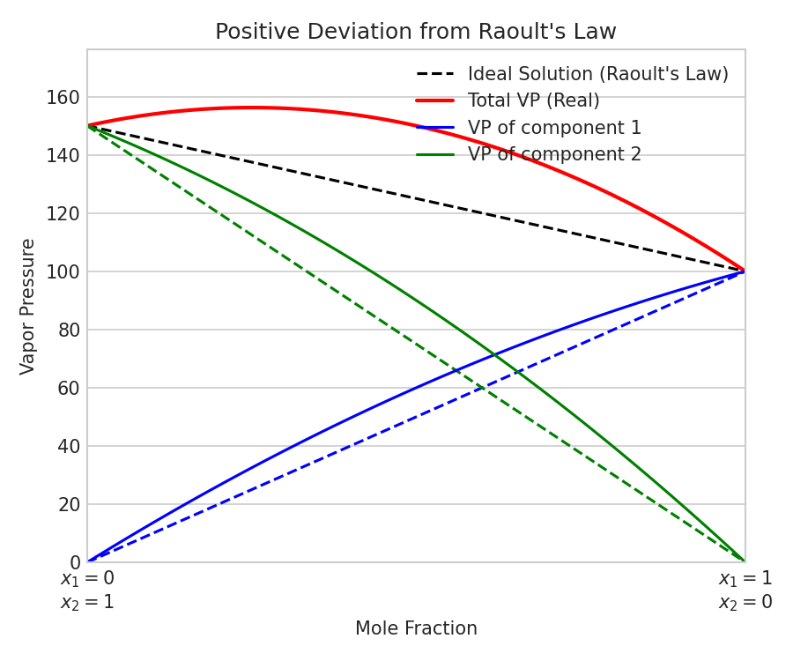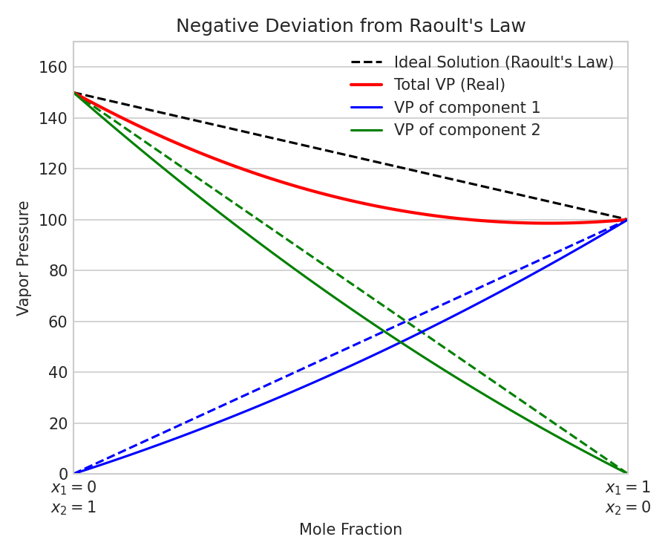
(b) Mass % of aspirin in acetonitrile:
w_solute = 6.5 g, w_solvent = 450 g, w_total = 456.5 g
Mass % = (6.5 / 456.5) * 100 = 1.424%.
Q32. (a) Represent the cell in which the following reaction takes place: Mg(s) + 2Ag^+(0.0001 M) -> Mg^2+(0.130 M) + 2Ag(s). Calculate its cell potential if E°_cell = 3.17 V. (b) Define fuel cell. Write the reactions in a H2-O2 fuel cell.
(a) Cell Representation: Mg(s) | Mg^2+(0.130 M) || Ag^+(0.0001 M) | Ag(s)
Using Nernst Equation (n = 2):
E_cell = E°_cell - (0.0591 / 2) * log10([Mg^2+] / [Ag^+]^2)
E_cell = 3.17 - 0.02955 * log10(0.130 / (10^-4)^2)
E_cell = 3.17 - 0.02955 * log10(0.130 / 10^-8) = 3.17 - 0.02955 * log10(1.3 * 10^7)
E_cell = 3.17 - 0.02955 * (0.1139 + 7) = 3.17 - 0.02955 * 7.1139 = 3.17 - 0.210 = 2.96 V.
(b) Fuel Cell: A galvanic cell designed to directly convert the chemical energy of combustion of fuels (like hydrogen, methane) into electrical energy.
Reactions in H2-O2 fuel cell (alkaline medium):
Anode: 2H2(g) + 4OH^-(aq) -> 4H2O(l) + 4e^-
Cathode: O2(g) + 2H2O(l) + 4e^- -> 4OH^-(aq)
Overall: 2H2(g) + O2(g) -> 2H2O(l)
OR Option:
(a) Faraday's First Law: Mass deposited (w) is proportional to charge passed (Q): w = z * I * t. Faraday's Second Law: When same charge is passed in series, masses deposited are proportional to equivalent weights: w1/w2 = E1/E2.
(b) Ni deposition calculation:
I = 5.0 A, t = 20 min = 1200 s, Q = 5 * 1200 = 6000 C.
Ni^2+ + 2e^- -> Ni. 1 mole of Ni (58.7 g) requires 2 F = 2 * 96500 = 193000 C.
Mass deposited w = (58.7 * 6000) / 193000 = 1.825 g.
Q33. (a) Derive the integrated rate expression for a first-order reaction: k = (2.303/t) * log10([A]_0 / [A]). (b) Show that time for 99.9% completion is 10 times the half-life period.
OR (a) What is collision theory of chemical reactions? Mention two reasons why all molecular collisions do not lead to product formation. (b) Rate quadruples from 293 K to 313 K. Calculate E_a.
Main Questions:
(a) Derivation: For first-order reaction A -> Products: -d[A]/dt = k[A] => d[A]/[A] = -k * dt.
Integrating both sides: ln[A] = -kt + I.
At t = 0, [A] = [A]_0 => I = ln[A]_0. Thus, ln[A] = -kt + ln[A]_0 => kt = ln([A]_0 / [A]).
Converting to base-10 log: kt = 2.303 * log10([A]_0 / [A]) => k = (2.303 / t) * log10([A]_0 / [A]).
(b) Proof: For 99.9% completion, [A] = 0.001[A]_0. t_99.9% = (2.303 / k) * log10([A]_0 / 0.001[A]_0) = (2.303 / k) * log10(1000) = (2.303 / k) * 3 = 6.909 / k.
Half life t_1/2 = 0.693 / k.
Ratio: t_99.9% / t_1/2 = (6.909 / k) / (0.693 / k) = 10 => t_99.9% = 10 * t_1/2.
OR Option:
(a) Collision theory: Reactions occur when molecules collide with correct energy (E >= Ea) and proper orientation. Two reasons for ineffective collisions: 1. Energy barrier (E < Ea), 2. Orientation barrier (molecules do not collide in correct orientation).
(b) Activation energy calculation:
log10(k2 / k1) = [E_a / (2.303 * R)] * [(T2 - T1) / (T1 * T2)]
log10(4.0) = [E_a / (2.303 * 8.314)] * [20 / (293 * 313)]
0.6021 = [E_a / 19.147] * [20 / 91709] => E_a = (0.6021 * 19.147 * 91709) / 20 = 52863 J/mol = 52.86 kJ/mol.
Q34. (a) Account for the observations: (i) Haloarenes less reactive to nucleophilic substitution, (ii) Alkyl halides polar but immiscible in water, (iii) Racemic mixture optically inactive. (b) Identify A, B, C, D of formula C4H9Br/C8H18.
(a) (i) Haloarenes low reactivity: Resonance imparts partial double bond character to C-X; carbon is sp2 hybridized (more electronegative, shorter bond); phenyl cation is highly unstable; electrostatic repulsion from benzene ring.
(ii) Immiscibility in water: The attractive forces formed between alkyl halides and water are weaker than pre-existing hydrogen bonds in pure water, and the energy released is not enough to break these hydrogen bonds.
(iii) Racemic mixture inactivity: Equal amounts of d and l enantiomers cancel each other's optical rotation. This is called external compensation.
(b) Identification:
Since primary alkyl halide A (C4H9Br) gives Wurtz product D (C8H18) different from n-octane (from n-butyl bromide), A must be Isobutyl bromide:
Compound A: Isobutyl bromide, CH3-CH(CH3)-CH2-Br
Compound B (Elimination with alc. KOH): 2-Methylpropene, CH3-C(CH3)=CH2
Compound C (Markovnikov addition of HBr to B): tert-Butyl bromide, CH3-C(CH3)2-Br (isomer of A)
Compound D (Wurtz reaction of A): 2,5-Dimethylhexane, CH3-CH(CH3)-CH2-CH2-CH(CH3)-CH3
Q35. (a) Explain mechanism of S_N2 reaction of methyl bromide with aq. NaOH with energy profile/transition state. (b) Write uses and environmental effects of: (i) Freon-12, (ii) DDT.
(a) S_N2 mechanism: Single-step concerted process. Nucleophile (OH^-) attacks carbon from backside opposite to Br^-. This leads to a pentacoordinated transition state where carbon is sp2 hybridized, partially bonded to OH and Br. Complete Walden inversion occurs on bromide departure:
OH^- + CH3Br -> [HO...CH3...Br]^TS -> HOCH3 + Br^-.
(b) Environmental effects & uses:
(i) Freon-12 (CF2Cl2): Used as refrigerant and aerosol propellant. Environmentally, it diffuses to stratospheric ozone, decomposes to chlorine radicals under UV, depleting ozone layer and letting in UV-B.
(ii) DDT: Used as pesticide. Persistent organic pollutant. Highly stable, bioaccumulates and biomagnifies up the food chain, causing thinning of eggshells and decline in bird populations. Banned in many countries.
S_N2 Potential Energy Profile Diagram:
