Screenshots :: Spring boot microservices example

Spring Eureka Server

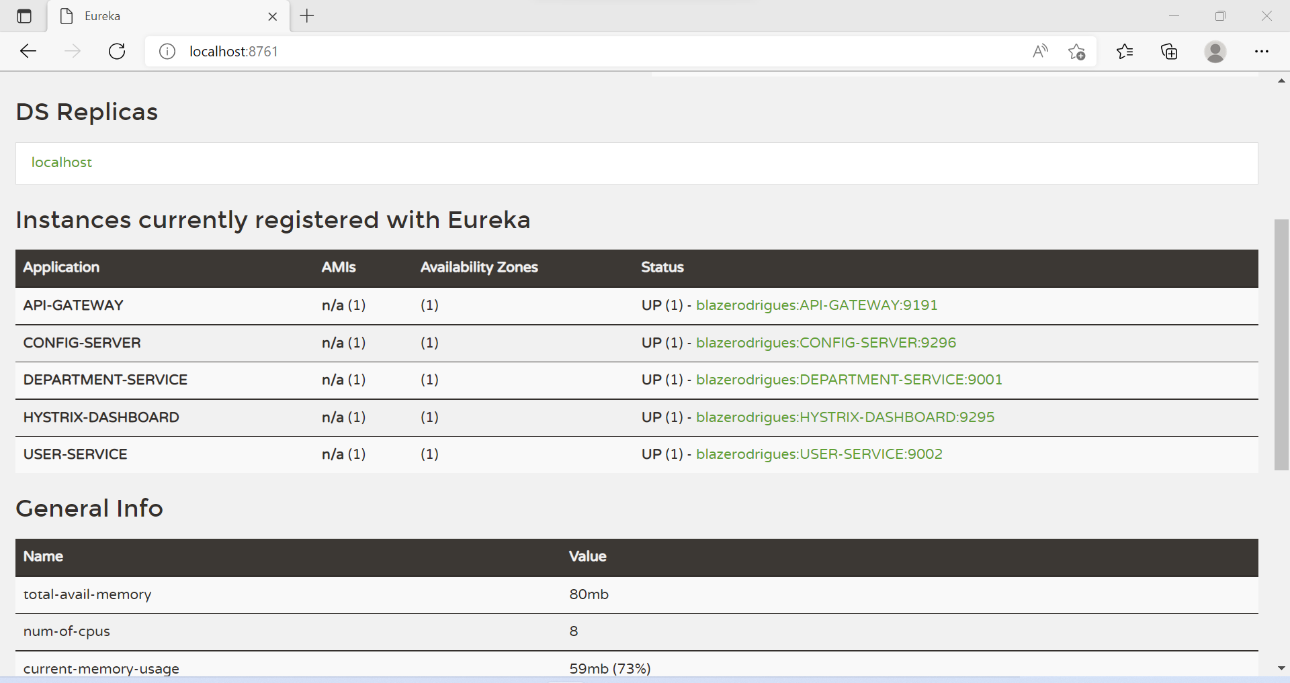

Adding a Department using Department Service

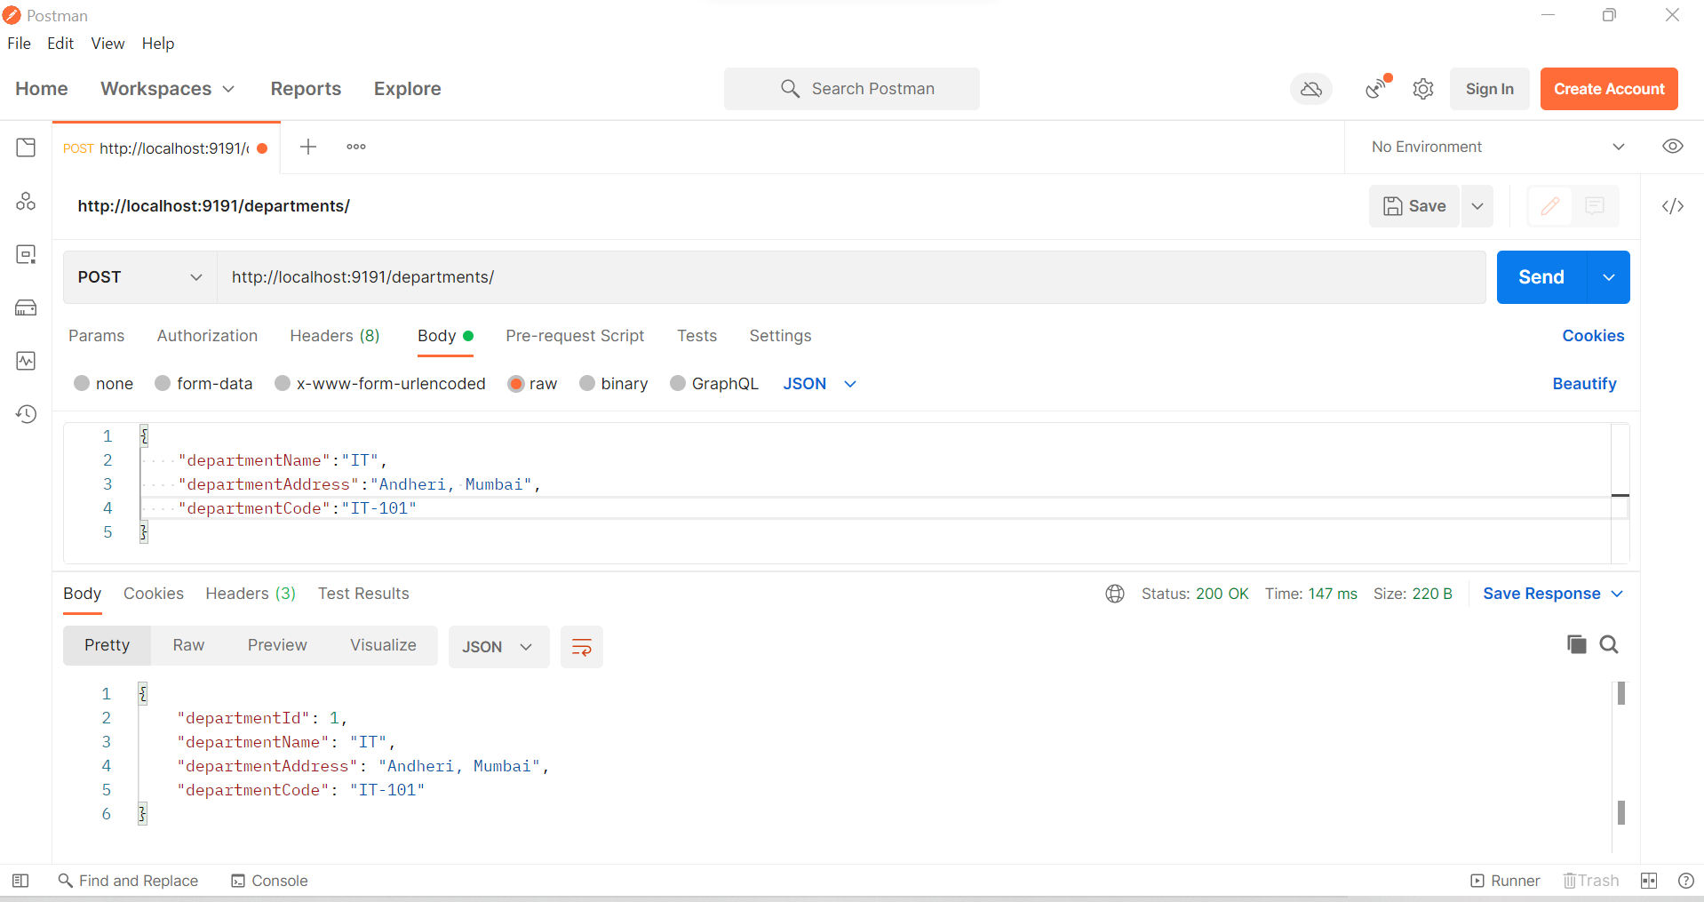

Retrieving a Department using Department Service

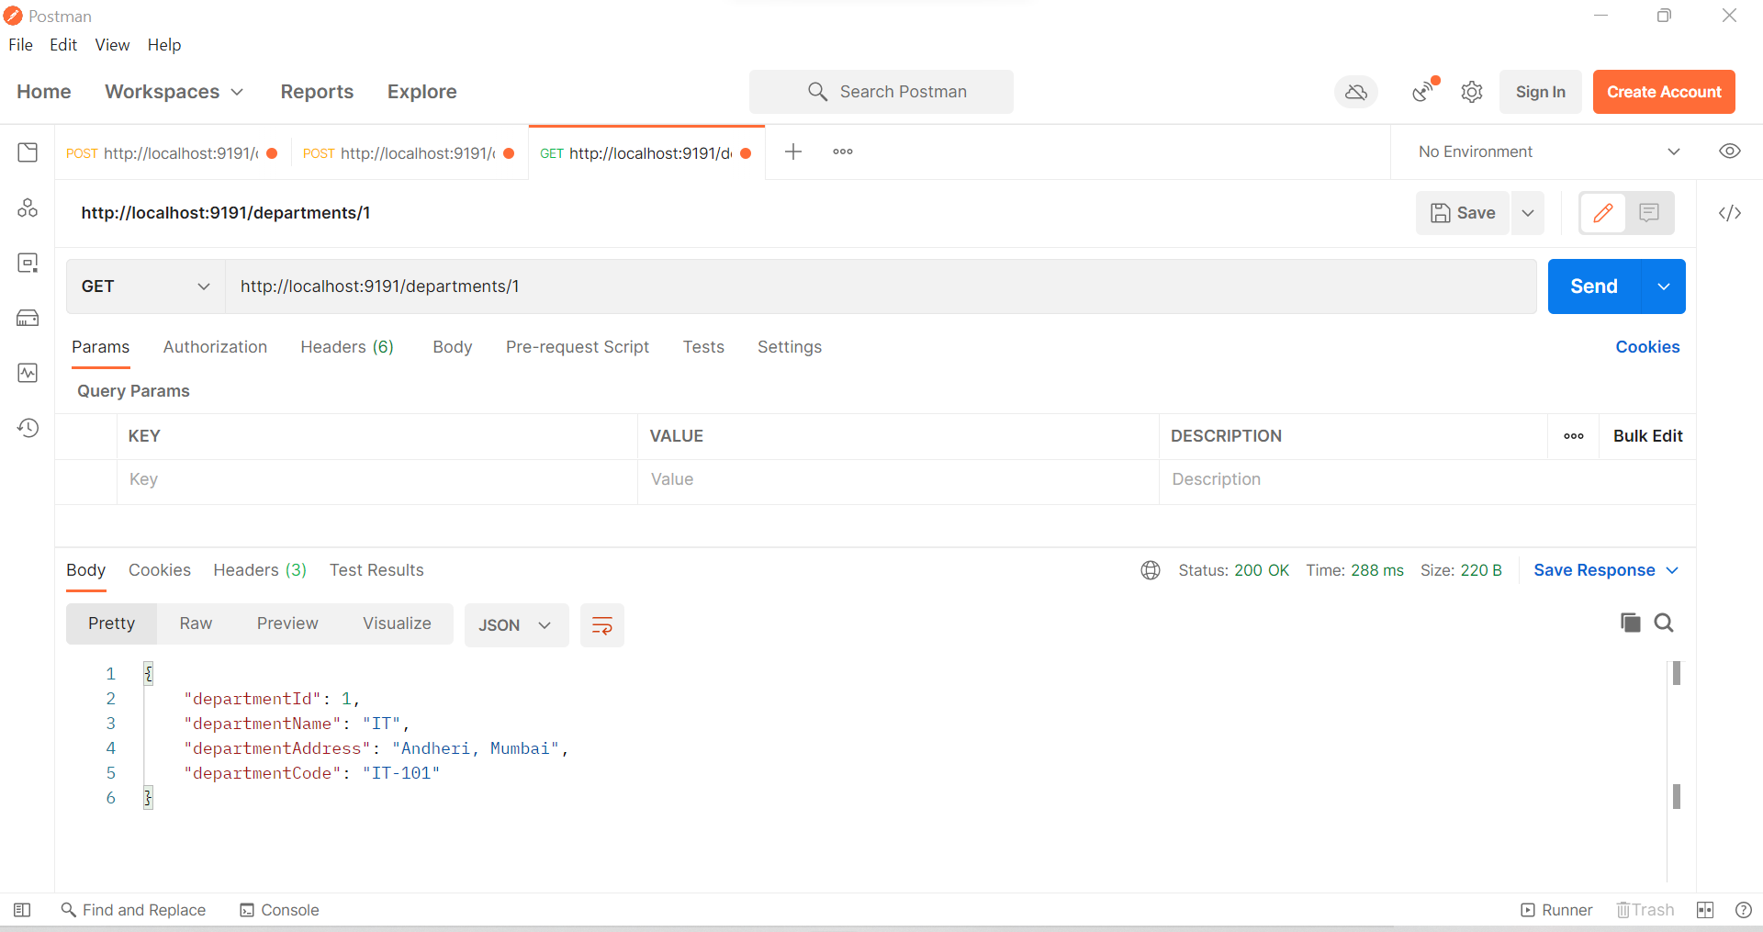

Adding a User using User Service

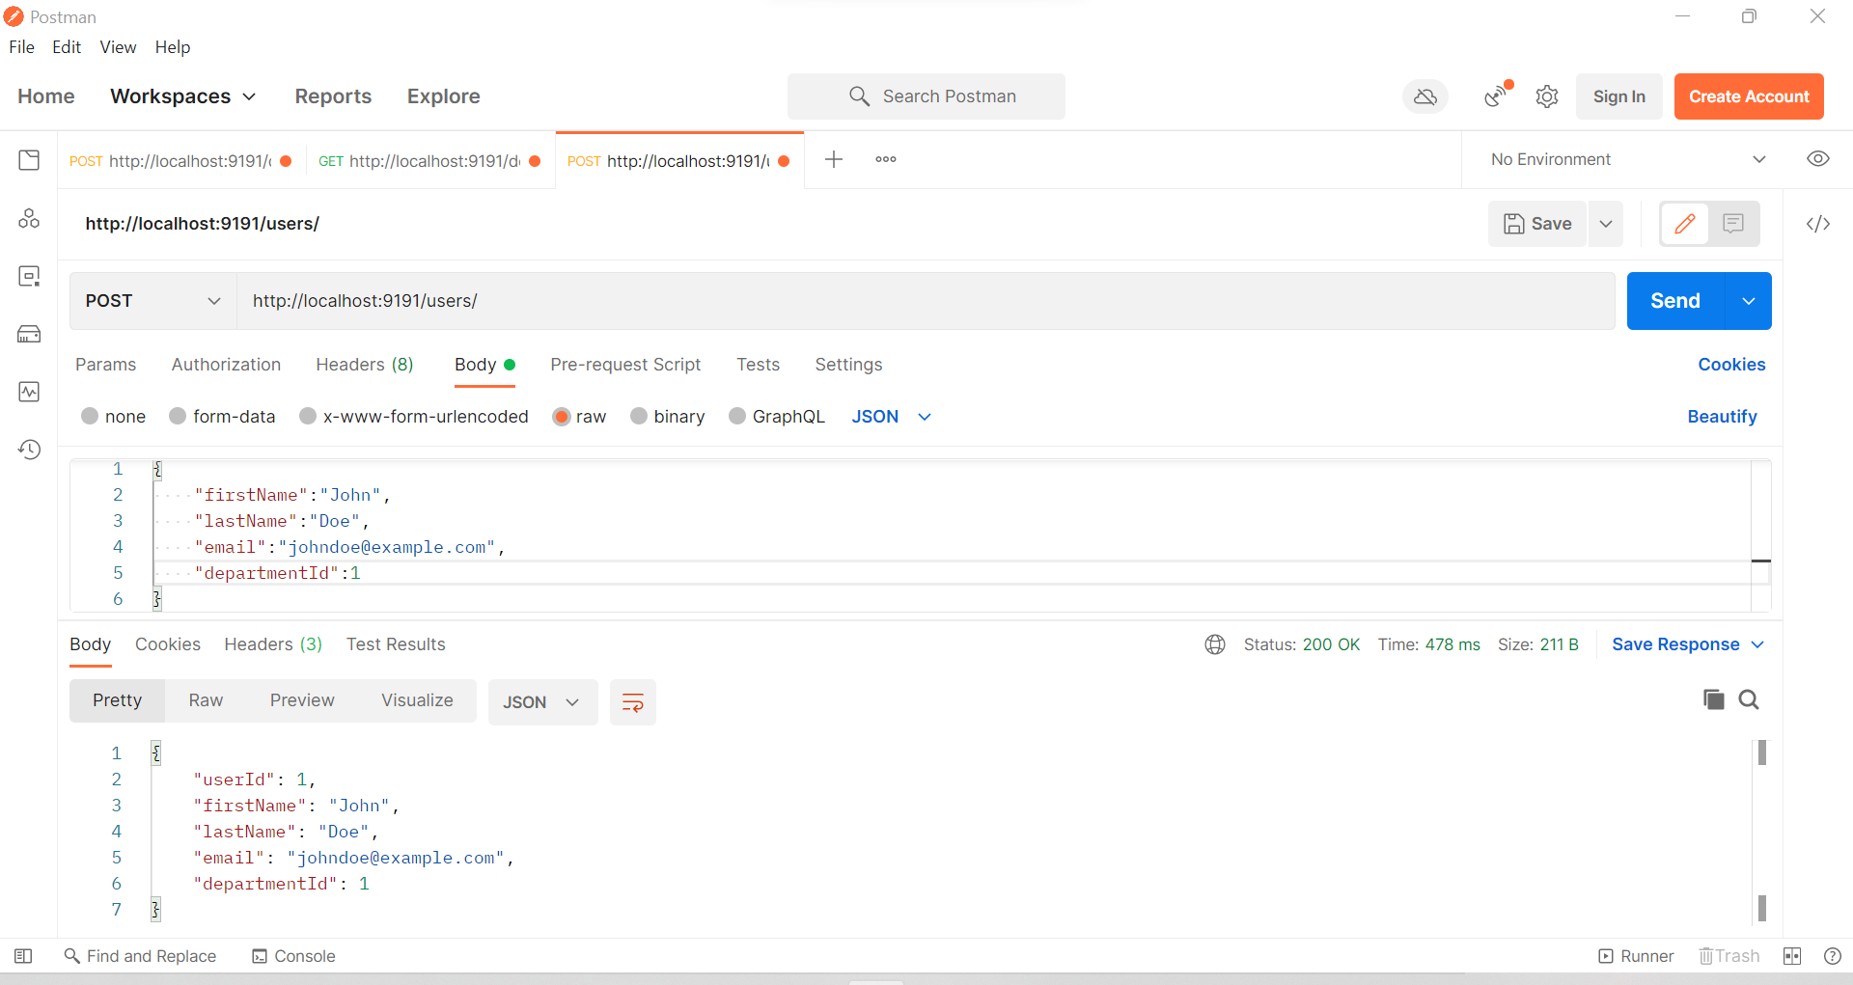

Retrieving a User using User Service (The User’s Department information is also retrieved here)

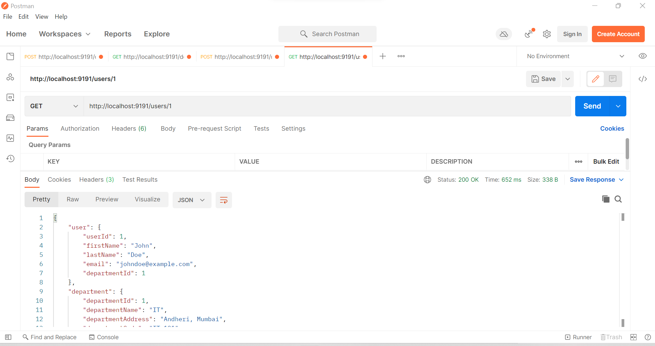

Using Zipkin to trace microservices

