# Part 1

1. 18.26.0.122
2. It stands for canonical name record type. It means that it points to another domain name.
3. 1371
4. First line no IP   
   Second line results in 209.59.119.34 (using @8.8.8.8, my default one gives nothing)
5. It’s used to set the search list to contain the domain, mit.edu. The difference in result is due to the trailing dot in ‘ai.’ With the trailing dot, its an absolute path, and is searched as such. However, without the trailing dot, ‘ai’ is searched within the domain, mit.edu.
6. dig @a.root-servers.net. +norecurse lirone.csail.mit.edu
7. Commands:
   1. dig @a.root-servers.net +norecurse lirone.csail.mit.edu
   2. dig @b.edu-servers.net. +norecurse lirone.csail.mit.edu
   3. dig @usw2.akam.net. +norecurse lirone.csail.mit.edu
   4. dig @auth-ns3.csail.mit.edu. +norecurse lirone.csail.mit.edu

IP address found: 128.52.129.186

1. dig +norecurse www.dmoz.org  
   No. Status was servfail.  
   8msec.
2. 262 msec.
3. 5 msec. Yes, it has served its purpose. No status error this time and IP address was returned successfully without taking very long because IP was cached into the local DNS.

# Part 2

1. Both are UDP.
2. Destination Port for query: 53  
   Source Port for response: 53
3. IP address to which the DNS query was sent: 192.162.2.11. Different.
4. Do query recursively for type A to updatekeepalive.mcafee.com  
   No answers in the query message.
5. 2 answers in the DNS response message.  
   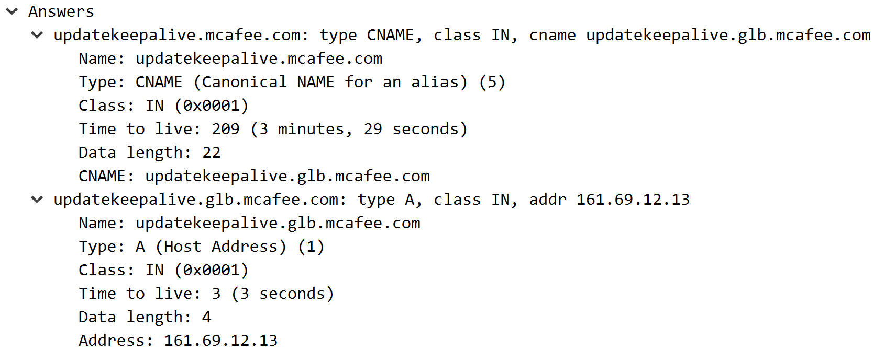
6. Yes, it corresponds to the 2nd answer with the IP address 161.69.12.13