SPRAY IT SOLUTIONS

Gallery photo notes
Prepared for Glenn, Spray It Solutions | Prepared by Systemations
You were right that the photo descriptions on the new gallery page were wrong. They were written from small previews, and some of them guessed badly. They have all been rewritten from the full size photographs, but the one thing we cannot work out from here is what each job actually was.
This document is the quickest way to fix that. Every photograph on the gallery page is below, in the order it appears, with the file name your camera gave it so you can match it against your own photos if you need to. Type your answers straight into the boxes, save, and send it back.
A few things worth knowing before you start:
- You do not have to fill in every box. The job and the building type alone is enough for us to write something accurate.
- If several photographs are the same job, write "same as photo 4" and we will group them on the page.
- If a photograph is not worth keeping, write "remove" and we will take it off. A smaller gallery of strong work beats a bigger one.
- Where we have written a description already, it is only what is visible in the frame. Correct it freely, it is a placeholder, not a claim.
There are 21 photographs, plus a page at the end about the trucks. It should take about twenty minutes.

COMMERCIAL AND INDUSTRIAL
Photo 1 of 21 your file: sunrice-roof-hero
this one came from your old website
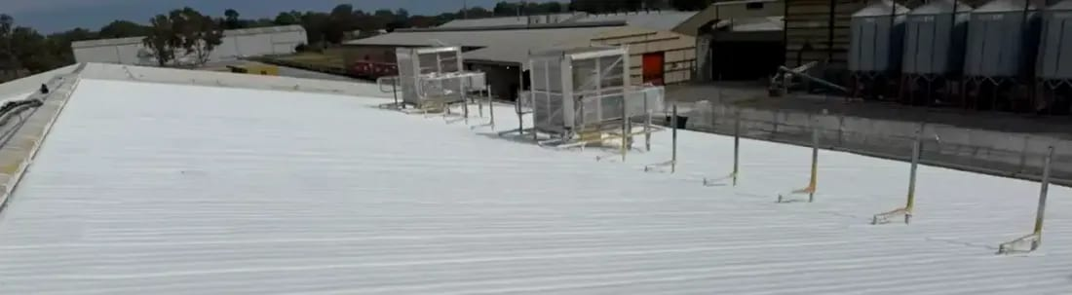
Our description now: Processing plant roof, sprayed around live plant
What was this job?
Suburb or town
What sort of building?
What did we spray, and how thick?
Can we name the client?
Anything else worth saying?

Photo 2 of 21 your file: IMG_2351
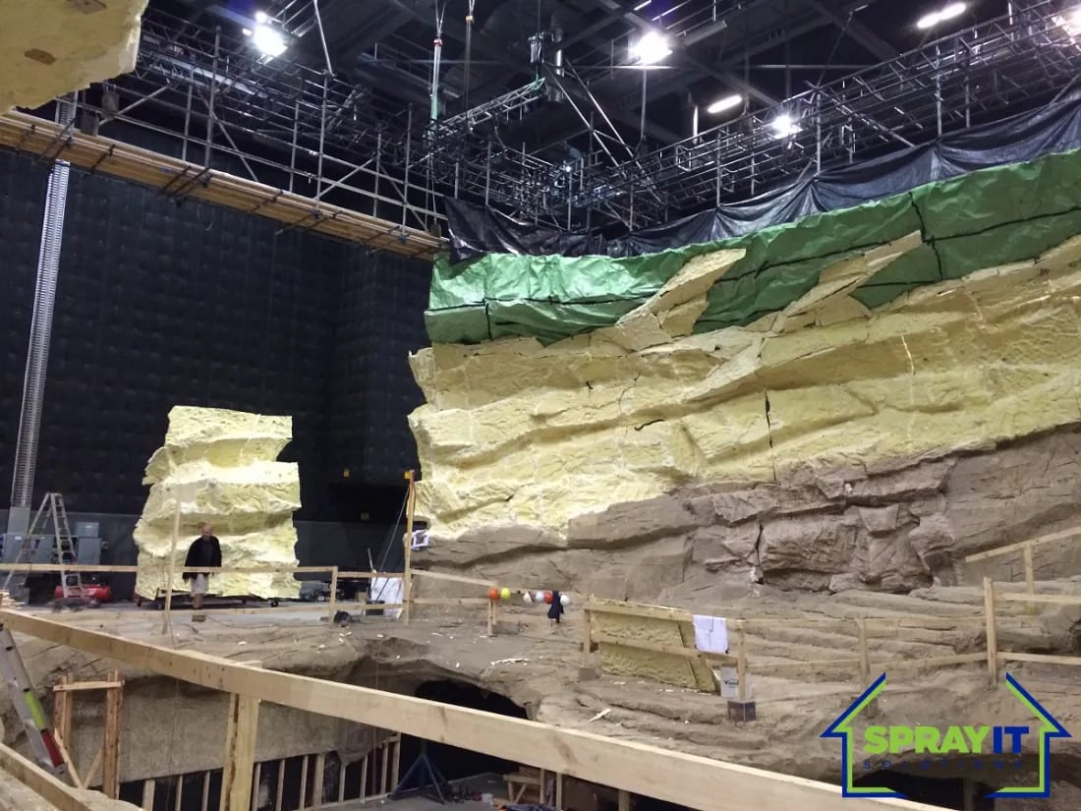
Our description now: Scenic set build, carved from sprayed foam inside a studio
What was this job?
Suburb or town
What sort of building?
What did we spray, and how thick?
Can we name the client?
Anything else worth saying?

Photo 3 of 21 your file: IMG_2353
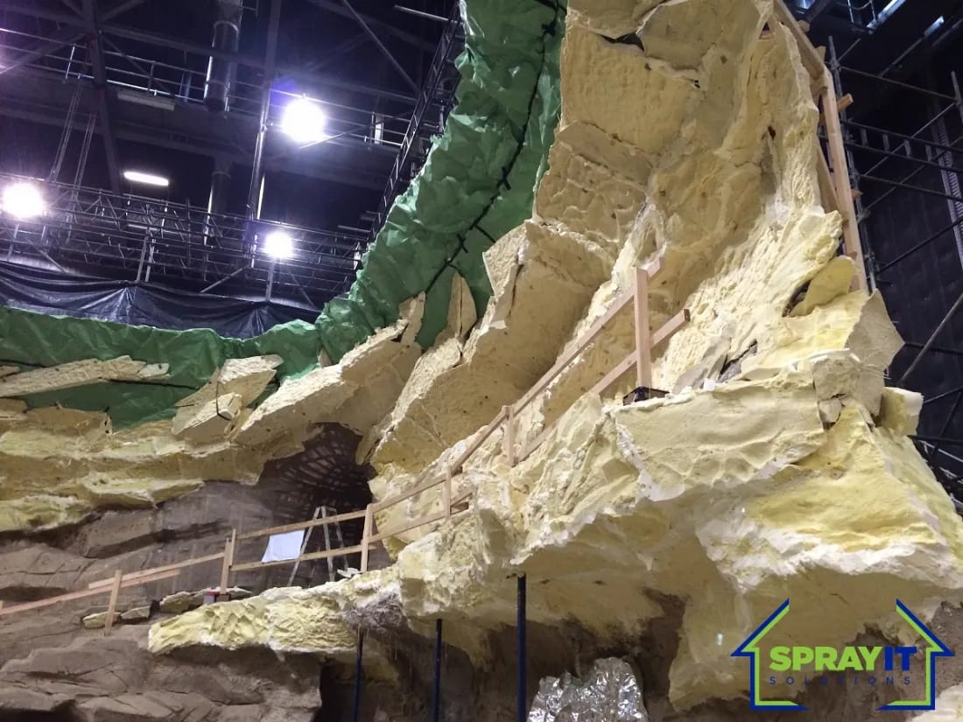
Our description now: The same set, close in on the sculpted profile
What was this job?
Suburb or town
What sort of building?
What did we spray, and how thick?
Can we name the client?
Anything else worth saying?

Photo 4 of 21 your file: IMG_2355
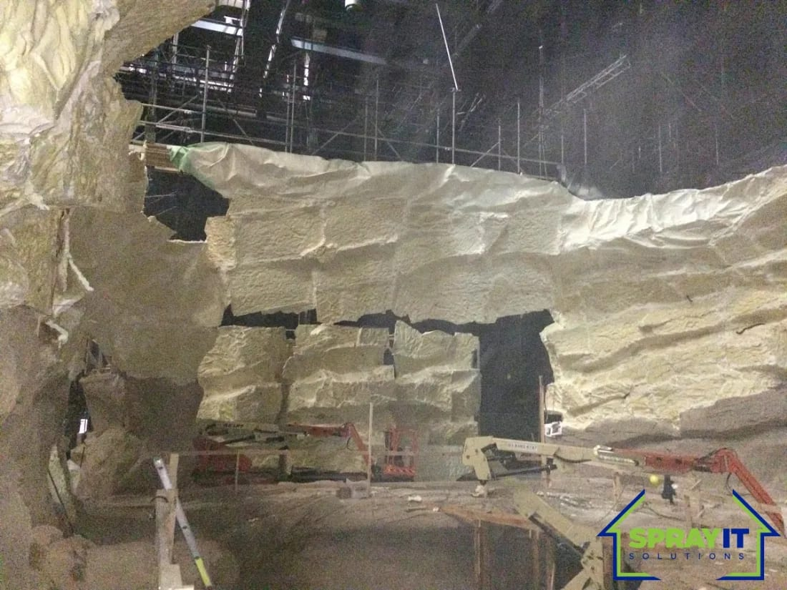
Our description now: A rock wall formed entirely in foam, no other material behind it
What was this job?
Suburb or town
What sort of building?
What did we spray, and how thick?
Can we name the client?
Anything else worth saying?

Photo 5 of 21 your file: IMG_2371
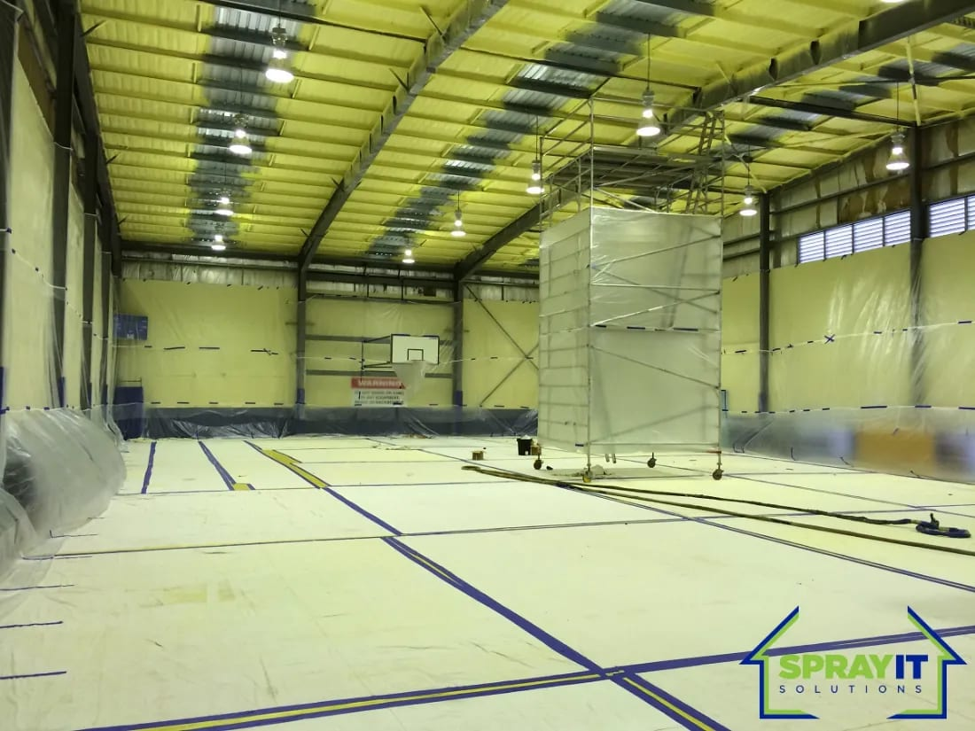
Our description now: Indoor sports hall, walls and roof sealed as one envelope
What was this job?
Suburb or town
What sort of building?
What did we spray, and how thick?
Can we name the client?
Anything else worth saying?

Photo 6 of 21 your file: IMG_2377
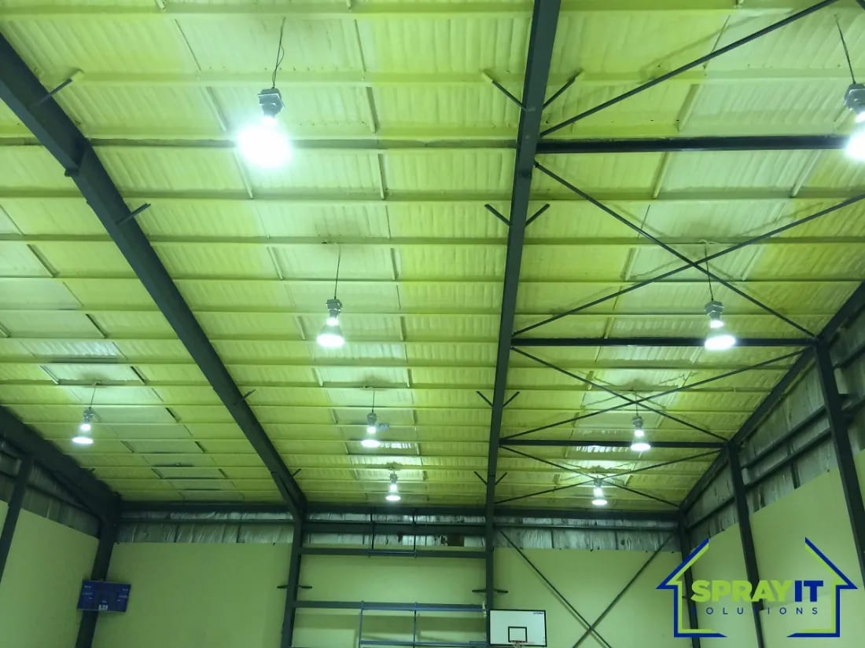
Our description now: The same hall, sprayed between the portal frames
What was this job?
Suburb or town
What sort of building?
What did we spray, and how thick?
Can we name the client?
Anything else worth saying?

Photo 7 of 21 your file: IMG_2710
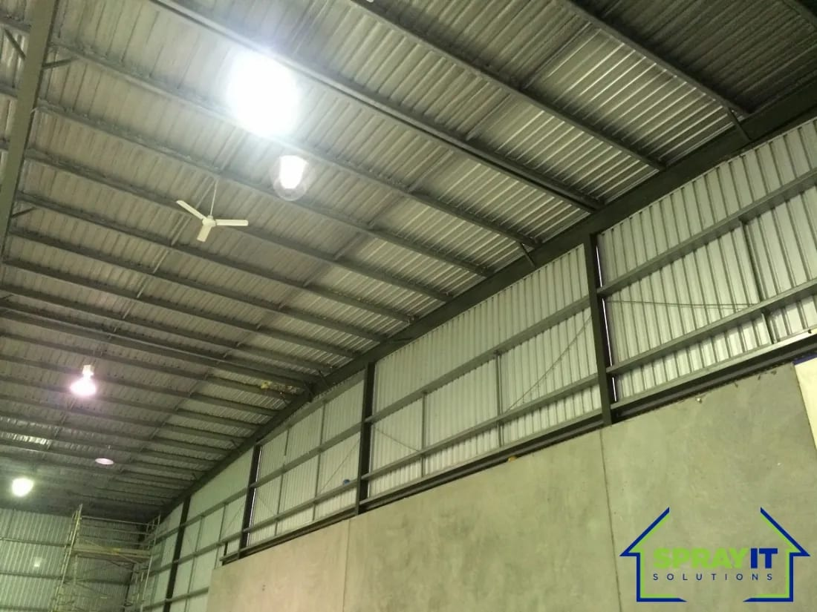
Our description now: Steel-framed shed, roof and upper walls
What was this job?
Suburb or town
What sort of building?
What did we spray, and how thick?
Can we name the client?
Anything else worth saying?

Photo 8 of 21 your file: IMG_2711
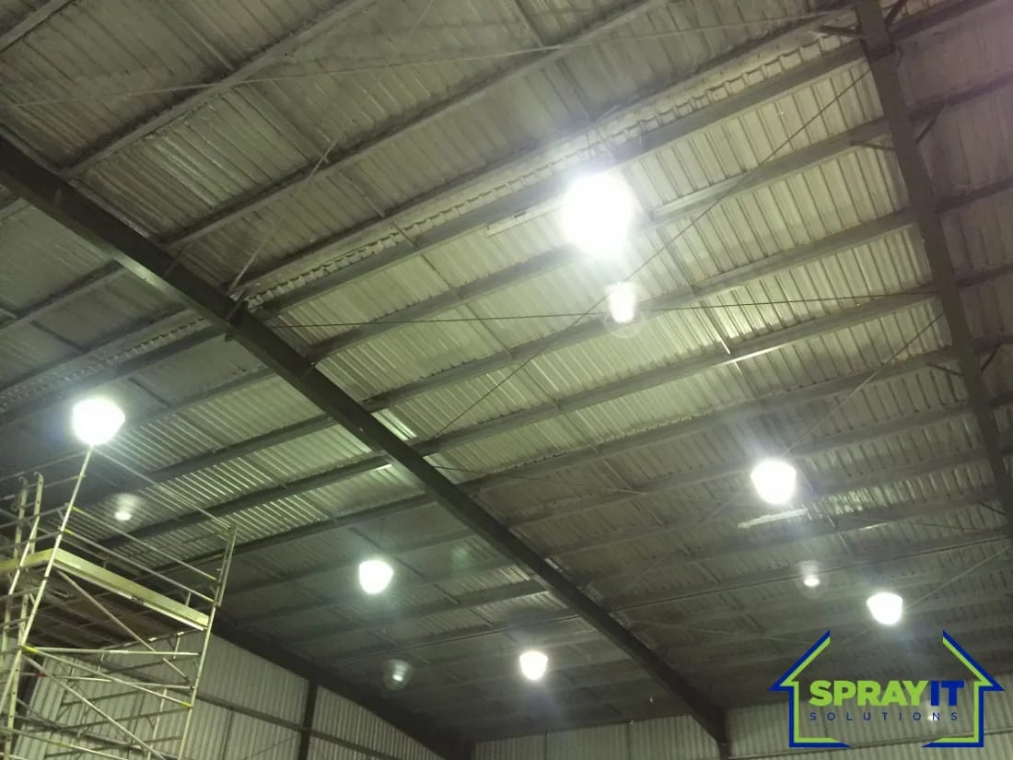
Our description now: Sprayed between purlins across the full span
What was this job?
Suburb or town
What sort of building?
What did we spray, and how thick?
Can we name the client?
Anything else worth saying?

Photo 9 of 21 your file: IMG_1757
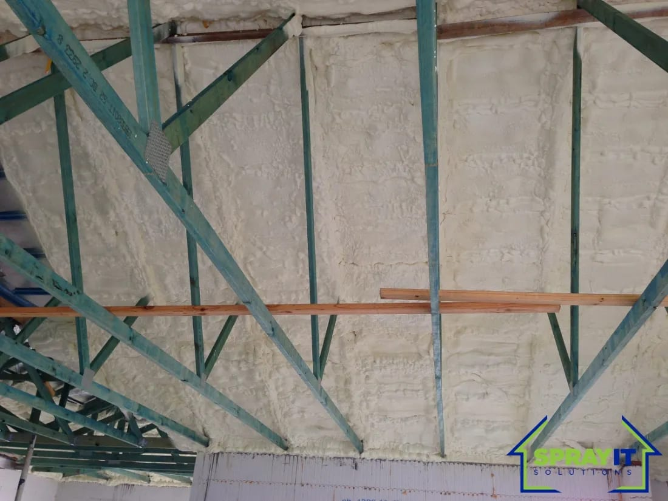
Our description now: Applied behind the trusses, following the roof line
What was this job?
Suburb or town
What sort of building?
What did we spray, and how thick?
Can we name the client?
Anything else worth saying?

Photo 10 of 21 your file: IMG_1328
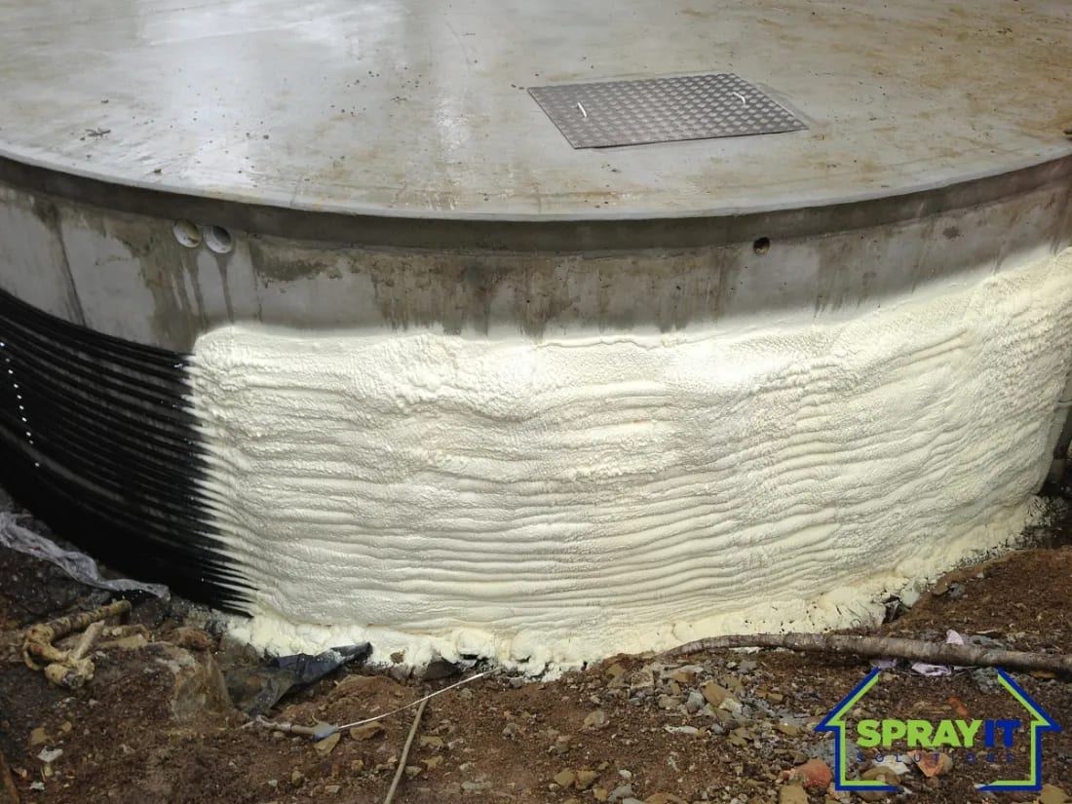
Our description now: Tank base, a curve no cut product follows
What was this job?
Suburb or town
What sort of building?
What did we spray, and how thick?
Can we name the client?
Anything else worth saying?

Photo 11 of 21 your file: IMG_0706
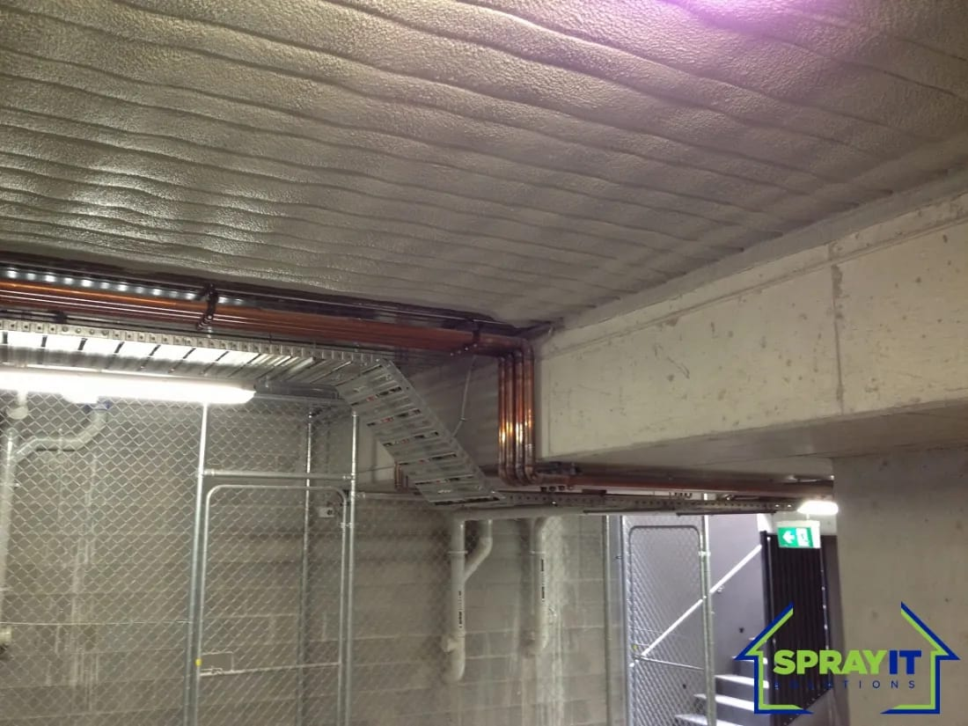
Our description now: Underside of a concrete slab, sprayed around the services
What was this job?
Suburb or town
What sort of building?
What did we spray, and how thick?
Can we name the client?
Anything else worth saying?

Photo 12 of 21 your file: IMG_1297
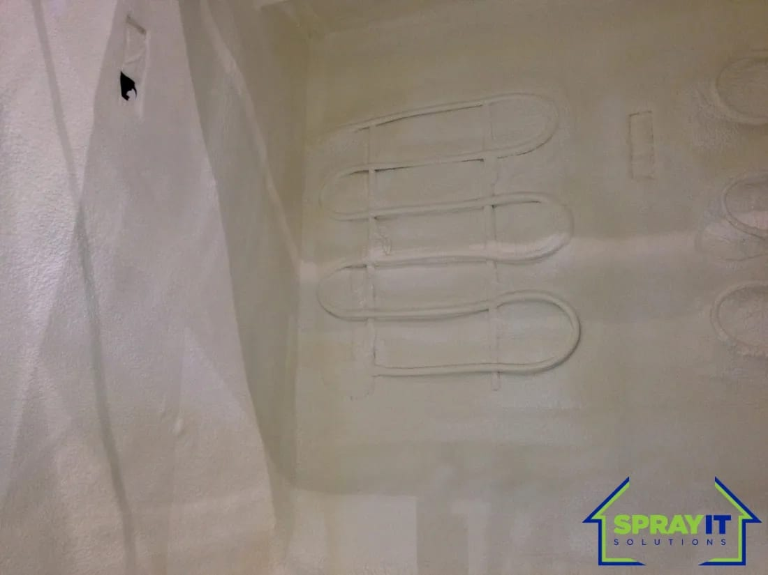
Our description now: Sprayed over pipework, leaving one unbroken face
What was this job?
Suburb or town
What sort of building?
What did we spray, and how thick?
Can we name the client?
Anything else worth saying?

RESIDENTIAL
Photo 13 of 21 your file: IMG_0993
saved here as img-0993-2
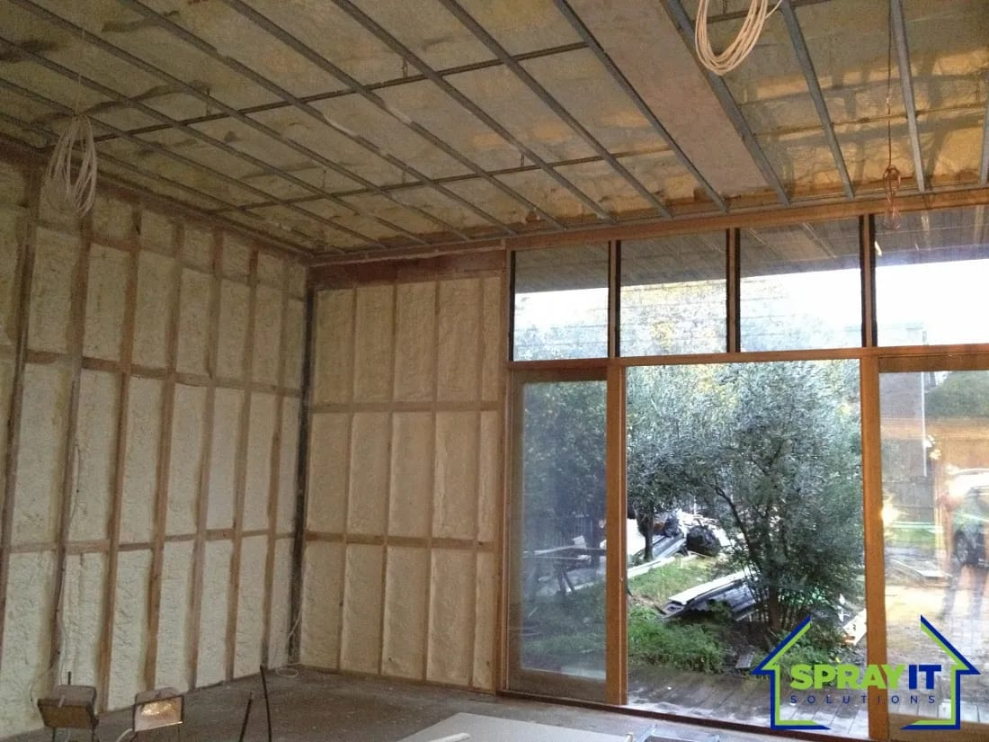
Our description now: Stud walls filled flush to the frame
What was this job?
Suburb or town
What sort of building?
What did we spray, and how thick?
Can we name the client?
Anything else worth saying?

Photo 14 of 21 your file: IMG_2277
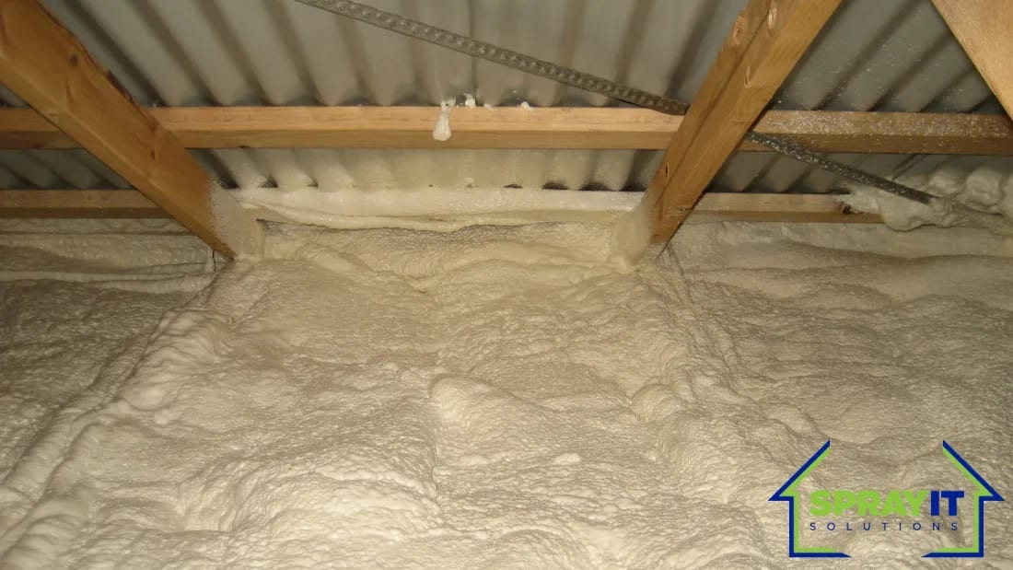
Our description now: Ceiling line, sprayed between the beams
What was this job?
Suburb or town
What sort of building?
What did we spray, and how thick?
Can we name the client?
Anything else worth saying?

Photo 15 of 21 your file: IMG_2792
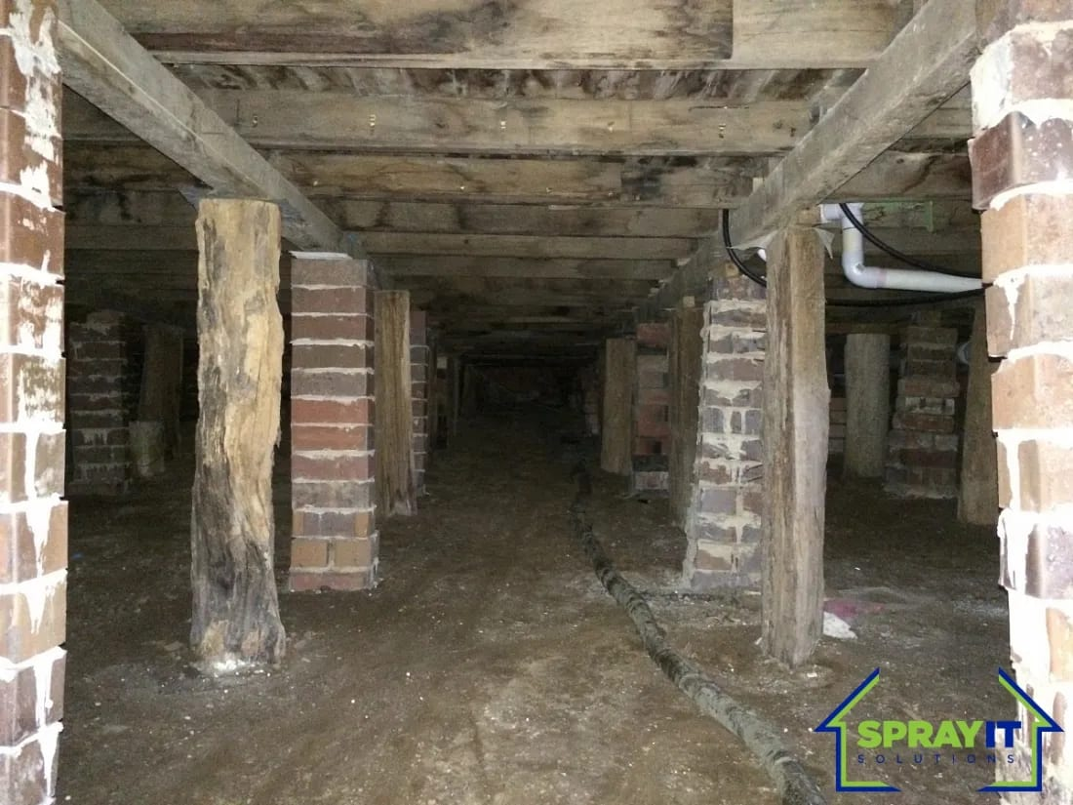
Our description now: Underfloor, sprayed between the piers
What was this job?
Suburb or town
What sort of building?
What did we spray, and how thick?
Can we name the client?
Anything else worth saying?

Photo 16 of 21 your file: PC140546
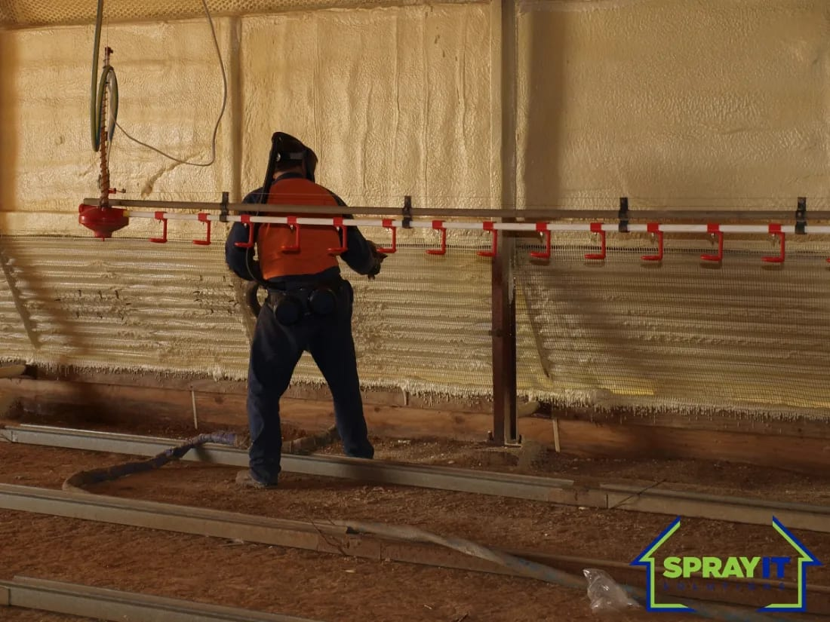
Our description now: Applied by our own crew, in full protective gear
What was this job?
Suburb or town
What sort of building?
What did we spray, and how thick?
Can we name the client?
Anything else worth saying?

Photo 17 of 21 your file: IMG_2419
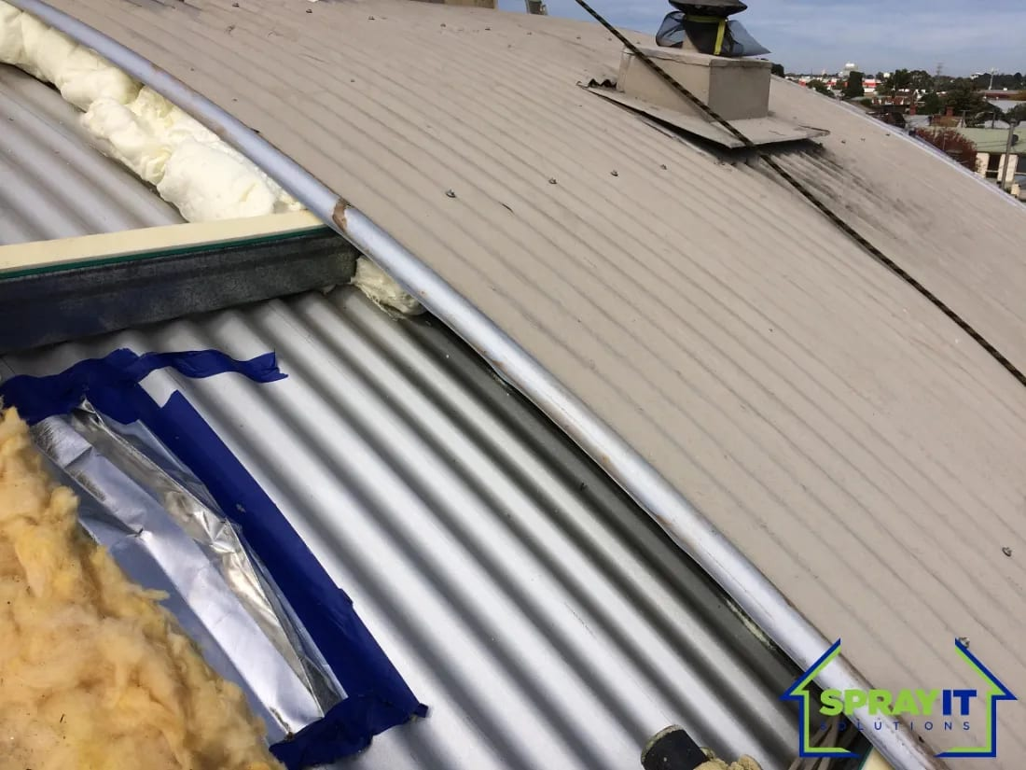
Our description now: Existing batts, exposed where the sheeting came up
What was this job?
Suburb or town
What sort of building?
What did we spray, and how thick?
Can we name the client?
Anything else worth saying?

Photo 18 of 21 your file: IMG_2873
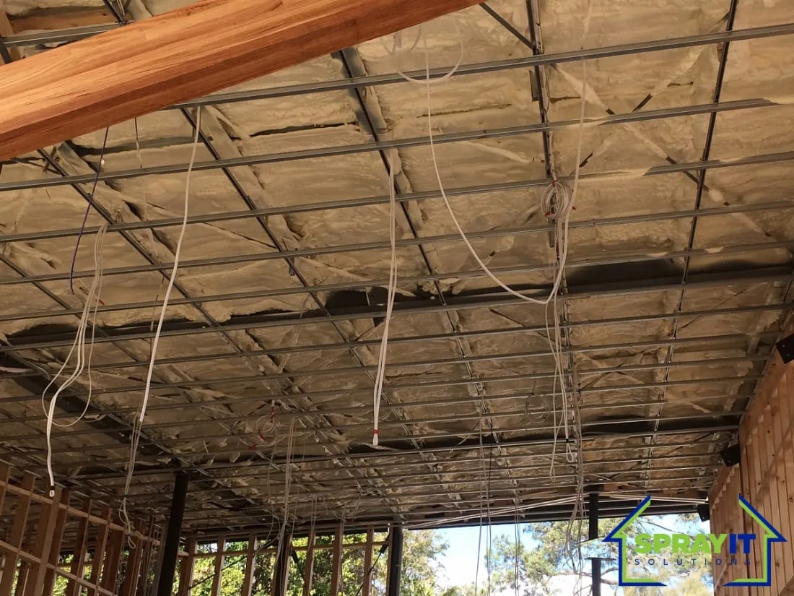
Our description now: An older roof frame, before
What was this job?
Suburb or town
What sort of building?
What did we spray, and how thick?
Can we name the client?
Anything else worth saying?

Photo 19 of 21 your file: IMG_2872
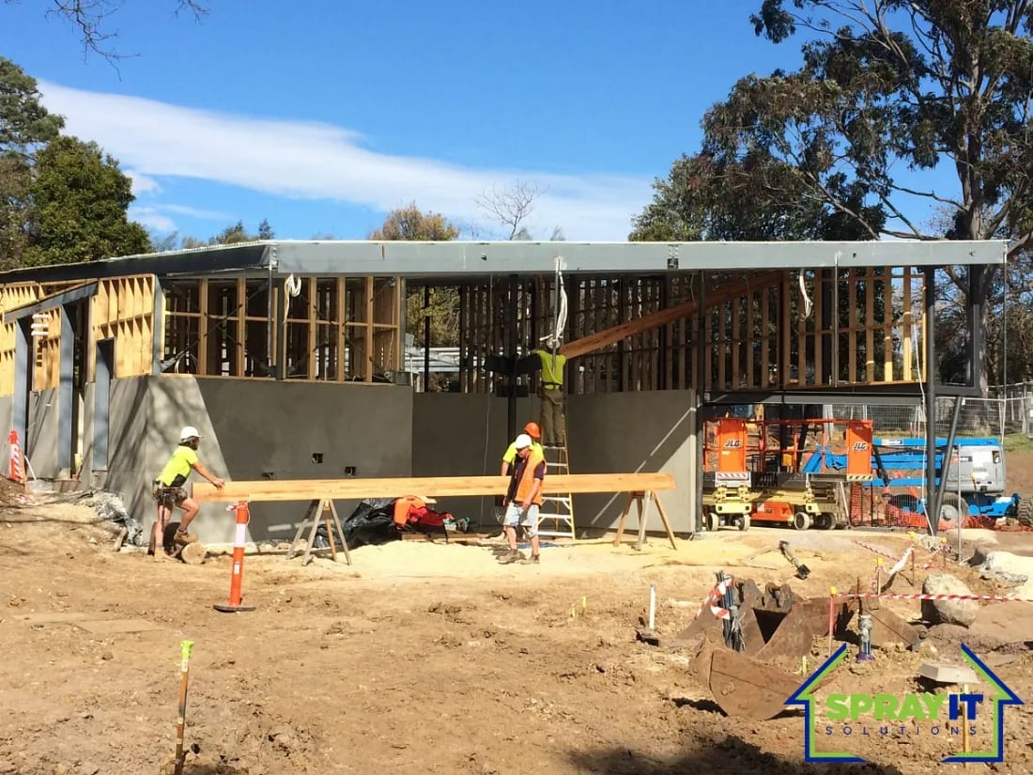
Our description now: New build, before the walls are lined
What was this job?
Suburb or town
What sort of building?
What did we spray, and how thick?
Can we name the client?
Anything else worth saying?

Photo 20 of 21 your file: IMG_2875
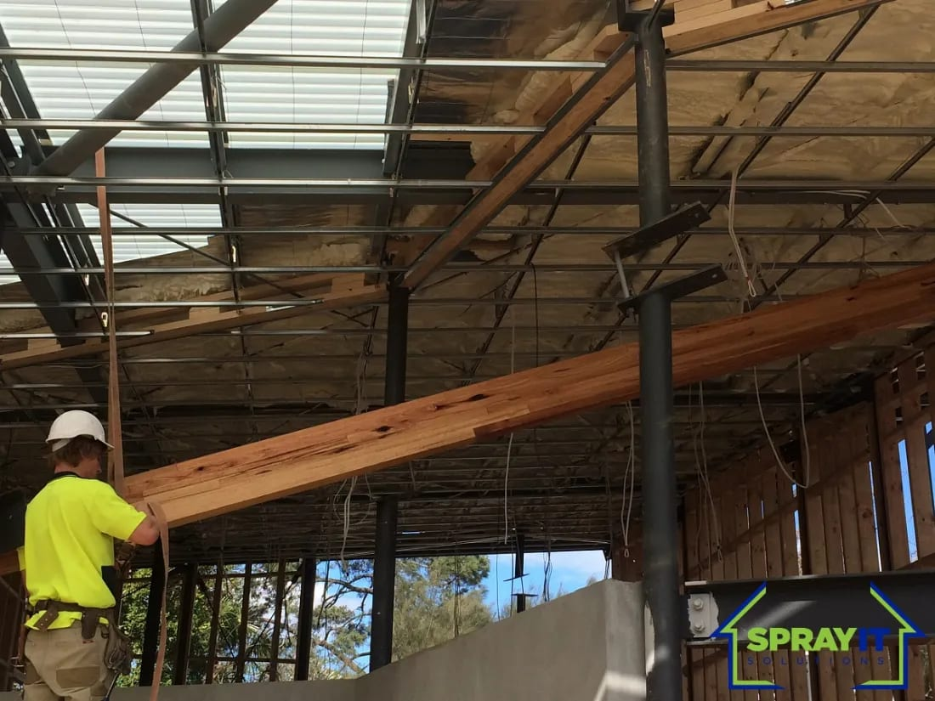
Our description now: Framing going in, ahead of the spray crew
What was this job?
Suburb or town
What sort of building?
What did we spray, and how thick?
Can we name the client?
Anything else worth saying?

Photo 21 of 21 your file: IMG_2877
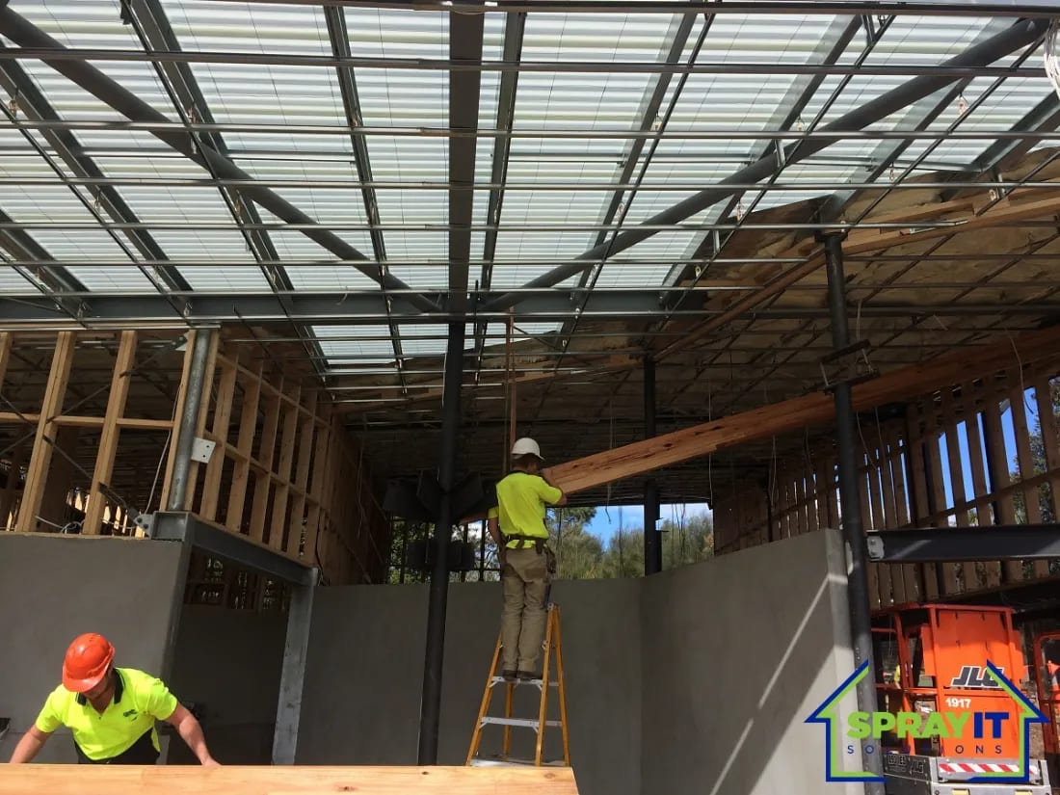
Our description now: On site during the build, not after it
What was this job?
Suburb or town
What sort of building?
What did we spray, and how thick?
Can we name the client?
Anything else worth saying?

THE TRUCKS
You sent us five photographs of the trucks. They are saved and we would like to use them, because a loaded rig is the clearest picture of what the business actually does, but we do not know which truck is which or where they were taken.
The one below is already on the site. It came off your old website.
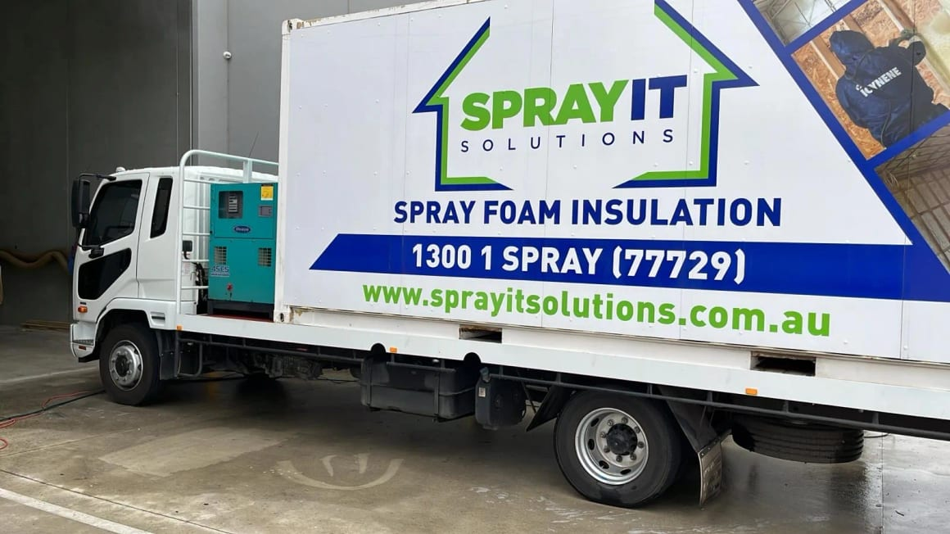
Tell us about the trucks and we will caption the set:
How many trucks are there?
Which one is in this photo?
What is on board?
Anything we should not show?
Anything else worth saying?

If any of the five you sent is a different truck or a particular job, note that here and we will keep them apart.

ANYTHING WE HAVE MISSED
If there is a job you are proud of that is not in these photographs, write it here. Even without a photograph it is useful, because it tells us what sort of work you want the gallery to be selling.
And if you have photographs of any of these on file, send them over. There are five stock photographs on the site standing in for situations we have no picture of: a crew arriving on a residential job, a technician at the reactor, an underfloor crawl space, a cool room wall, and a finished ceiling in an occupied home. Your own photographs would replace all five.

A job we should be showing
Where it was, and what it was
Photos you could send us
Anything else

