Capstone Project - The Battle of Neighborhoods

- PROBLEM DESCRIPTION
Diversity has played a huge role in the modern world and work productivity is essential for organisations to keep up with the ever changing pace in economic development. Companies encourage their workforce to live a healthy lifestyle and since time is of the essence, any individual will try to maximise every minute spent whilst on and off duty.
Diversity plays a huge factor in operating a restaurant. You don't have to be in China to have a Chinese meal or India for an Indian meal or Africa for an African meal. You can literally find a spot to fine dine in Toronto or New York, offering the best intercontinental meal. It is common for people to relocate from one country/city to other across the world for personal reasons however, finding or choosing the best location or neighbourhood can prove challenging at times. Reasons can be of one or more of the following: Job availability, safety and security, housing, social amenities, diversity, and many more.
This is a recommender system for any individual or contractor looking to establish a restaurant for fine dining in a location where its Return on Investment is assured.

- DATA
I would be using unstructured data of the List of postal codes of Canada retrieved from Wikipedia, which is available to download by clicking here. Furthermore, Foursquare will be used to gather the Geolocation of various restaurant in both New York and Canada, for my analysis, although a link for downloading the Geolocation for this capstone project has been provided by Coursera and can be downloaded here.
- MAIN
Foursquare will be used to gather the restaurant locations to analyse in both cities. . Choosing a location for your restaurant is one of just a few keys to profitability. Parking and accessibility can be as crucial to a restaurant's success as great food and service. A restaurant's location influences many aspects of your operation, including the menu and style of the dining room. Factors such as:
- Population Base: Volume of people in the Location
Looking at the 2 City locations- New York and Toronto, both cities are famous but NY has a more pronounced multicultural neighbourhood than Toronto but Toronto is more subtle.
- Visibility: Visibility of the proposed restaurant structure.
Visibility is another factor to consider as patronisers of the restaurant have to see the structure for easy recollection and direction description to strangers has to be relatively straight forward. Both locations meet this criteria.
- Accessibility: Is the restaurant easily accessible?
Accessibility is another factor that can persuade/attract customers. A good accessible restaurant with great menu has a huge selling point.
- Infrastructure: Parking, closest landmark, proximity to other places.
Infrastructure: car park, proximity to other shops, stores, theatre or event centres is definitely a pronounced factor leading to extended opening times for restaurant.
This analysis will be conducted by sampling a select region inside Scarborough, clean and process the data the map each establishment to its current postcodes as seen below:
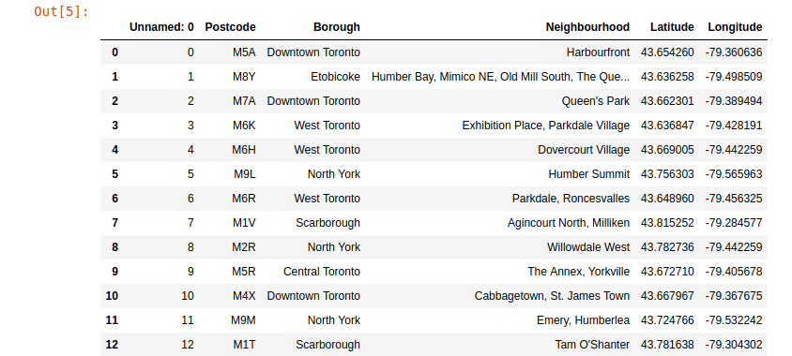

Then using further data science library, the whole area to be sampled was rendered on a map:
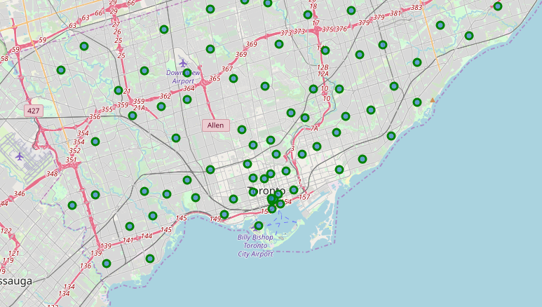
Selected area of Scarborough is also seen below.
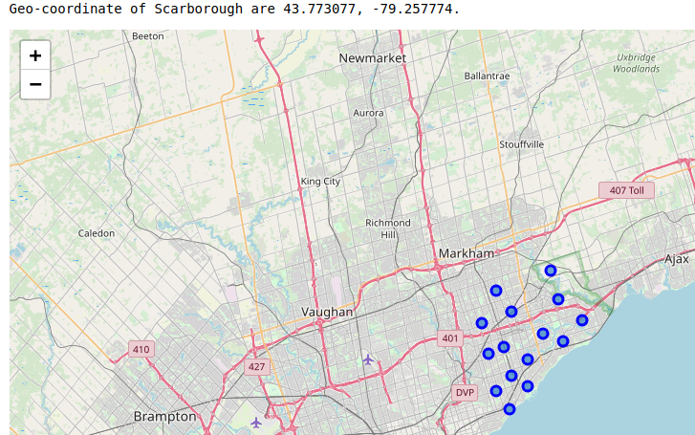

Using Foursquare to extract each venue for every neighbourhood inside the database and displaying the Neighbourhood and its corresponding postal code.
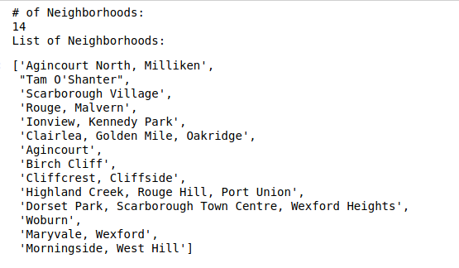

- DECISION
By comparison, both locations offer similar solutions but a closer look at the neighbourhood shows Agincourt, Toronto . Hence, from my analysis, Agincourt, Toronto will be a perfect choice for a restaurant I would recommend by showing centres of each cluster as shown in the datasheet.

