Jacob Blazina
CSCD240
Lab 3: Introduction to Data Types and I/O
- Write a C program (sizeDataTypes.c) that prints the size of short, int, char, double, long and long double using sizeof operator and show that the following guidelines
are true. 4 pts
sizeof(short) < sizeof(int)
2 < 4 == TRUE
sizeof(char) < sizeof(short)
1 < 2 == TRUE
sizeof(long) > sizeof(int)
8 > 4 == TRUE
sizeof(long double) > sizeof(double)
16 > 8 == TRUE
- What will be final values of ‘a’, ‘b’, ‘c’ and ‘size’ in the following code snippet?
int a =3; // finalValue.c 4 pts int b =4; double c = ++a + b++;
int size = sizeof(c/a);

a == 4
b == 5
c == 8.000000
size == 8

- Consider the following program that asks the user for 10 positive integers (grade). Modify the program as follows:
  - The program will be able to read any number of inputs from the keyboard. -1000
will indicate the end of processing. 2 pts
#include <stdio.h> // AverageGrade.c

int main(){ int i = 0; int grade; printf("Please input 10 grades :\n"); while(i < 10) { scanf("%d", &grade);
i ++;
}
return 0;
}
  - As the user keeps on typing integers, the program will keep on summing and averaging the numbers typed so far. For example, in the following screenshot, the user typed 10, so, the sum and average are both 10. Next, the user typed 20, the sum and average were calculated considering the previous input ‘10’. This will continue till the user types -1000. .You need to find the sum and average in double.
4 pts
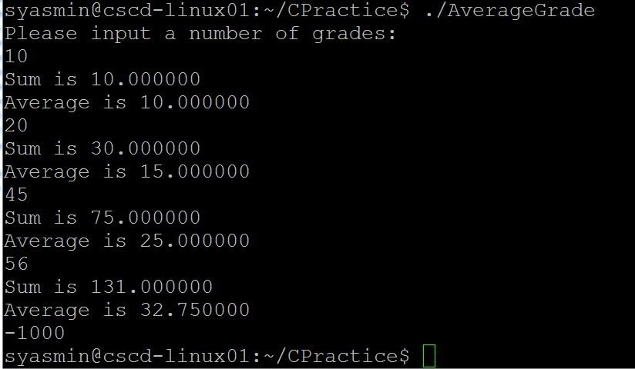
- What is the problem with the following C program? How will you fix it? 4 pts(2+2)
#include <stdio.h> //charBug.c int main( )
{ int c;
char dummy[10];

printf( "Enter a value :"); c = getchar( );

while( c != 'q' && c != 'Q' ) { printf( "You entered: "); putchar( c ); printf("\n");
printf("Enter a value :"); c = getchar();
}
return 0;
}

- What are the differences between ‘gets’ and ‘fgets’ functions. Rewrite the following
code with gets. 4 pts ( 2+2)

gets() is dangerous because you can enter input past the buffer and crash, fgets() is safe because you specify the input size.
#include <stdio.h> //getsFgets.c int main() { char name[100];
printf(“Please enter a name:”); gets( name); printf(“The name you entered is %s”, name); return 0;
}
- Write a C program that reads a sentence from the keyboard until a newline character is met (i.e., ‘Enter’ button from the keyboard is pressed). Next, the user is asked to type any alphabet and the program will count the number of occurrences of that particular alphabet in the sentence. The program will ignore case in alphabets ( i.e., uppercase or lowercase). For example, if the user types “Hello World” and wants to look for the number of occurrences of ‘O’/ ‘o’ in the sentence, the program will generate the following output.
8 pts
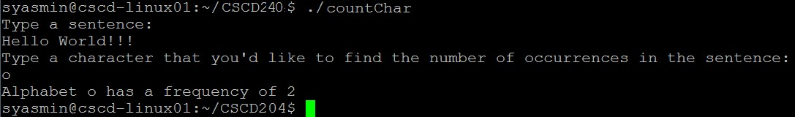
Consider the following C code countChar.c. The comments in code show the steps you need to write to make the code work.
#include <stdio.h>

#define MAXSIZE 100
int main(){ char ch; int i;
char sentence[MAXSIZE]; int alphabetsCount = 0;

printf("Type a sentence: \n");

// write the code that reads a sentence from the keyboard 2pts

printf("Type a character that you'd like to find the number of occurrences in a sentence:\n");

// write the code that reads a character from the keyboard 2 pts
// write the code that counts the number of occurrences of the character in //sentence; 2 pts
// ignore uppercase or lowercase 2 pts printf("Alphabet %c has a frequency %d\n", ch, alphabetsCount); return 0;
}

Submission:
- All answers (whenever you need to write codes) should be submitted as complete C codes named as sizeDataTypes.c (Question 1), finalValues.c (Question 2) AverageGrade.c (Question 3), charBug.c (Question4), getsFgets.c (Question 5) and countChar.c (Question6) respectively.
- Part of Question 5 should be submitted in a PDF file named Lab3.pdf.
- Full submission should contain all C files and pdf file zipped as follows: your last name, first letter of your first name, Lab3.pdf (i.e., YasminSLab3.zip). You should turn in through the EWU Canvas system.
- Submission deadline is Wednesday, January 30, 2019.
- No late submission will be accepted.

