Jacob Blazina
CSCD240 Winter 2019
Due January 16, 2019

Lab 1: Basic Unix Commands

Question 1:
Suppose, you are in your home directory ( i.e., /home/EASTERN/your_user_id).
- What will be printed by pwd after you run the following command?
cd ../../../

It will print ` / ` representing the root directory.

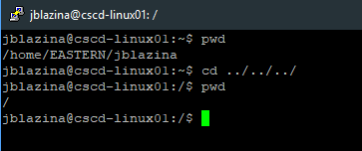

- What command will bring you back to your home directory?

cd ~

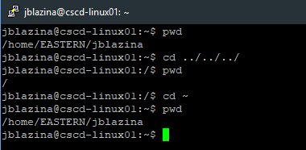

- Under your home directory, create a directory named CSCD240

mkdir CSCD240

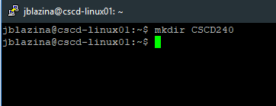

- You want to access the directory named CSCD240 from your home directory. Write
down both the absolute path and relative path for that

Absolute: cd /home/EASTERN/jblazina/CSCD240
Relative: cd CSCD240

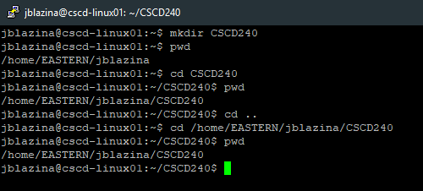

- After running the command in d), what command will you use to figure out your current
working directory?

pwd

( SEE ABOVE SCREENSHOT FROM QUESTION 1.d )

- Create a file named Assignment1 under CSCD240.

touch Assignment1

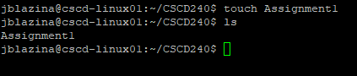

- Create a hard link for the file named Assignment1 in your current directory. You can
choose any name.

ln Assignment1 hardlink

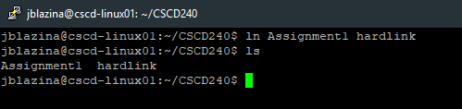

- Suppose you are now in CSCD240 folder. What output will be produced by the following command? Explain.
ls ~ .

It will list all the contents of the home directory and the current directory

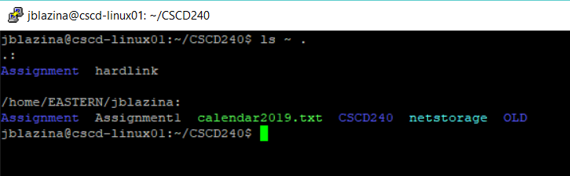

- You need to copy Assignment1 file from your current directory (CSCD240) to your
home directory. What command will you use?

cp Assignment1 ~

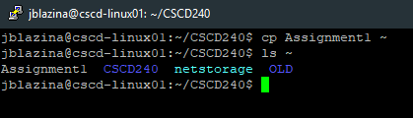

- Create one folder named Assignment under CSCD240. Move the file named Assignment1 from current folder (CSCD240) to Assignment folder. What commands
will you use?

mkdir Assignment
mv Assignment1 Assignment

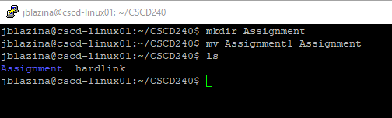

- Copy the Assignment folder from current folder (CSCD240) to your home directory.
What command will you use?

cp -r Assignment ~

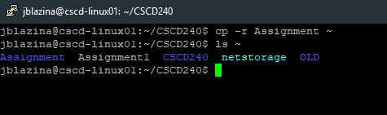

- What is the difference between ‘ls –l’ and ‘ls –al’ commands?

ls -l will show NOT show hidden content, ls -al WILL show hidden content.

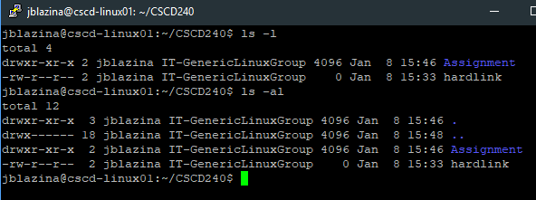

- Make a new command dir that is equivalent to unix command ls –al. Capture the screenshot of the command that can achieve that and the results.

Alias dir=”ls -al”

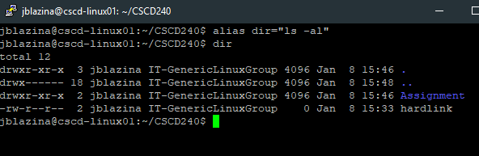

- We’d like to get a warning or prompt information before we delete the subdirectory
Assignment under CSCD240. What command will you use?

rm -i -r Assignment

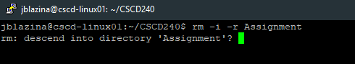

- Use rmdir to delete subdirectory Assignment under CSCD240. Does it delete the
directory? Why or why not?
It does not delete the subdirectory because it is not empty.
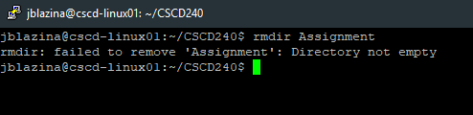

Question 2. Suppose you are in your home directory.
- Create a text file named calendar2019.txt using command cal 2019 > calendar2019.txt. Issue the more command or the less command on calendar2019.txt and capture the screenshot of the output. How to move to the beginning of calendar2019.txt in less?
How to move to the end of calendar2019.txt in less? How to scroll down or up?

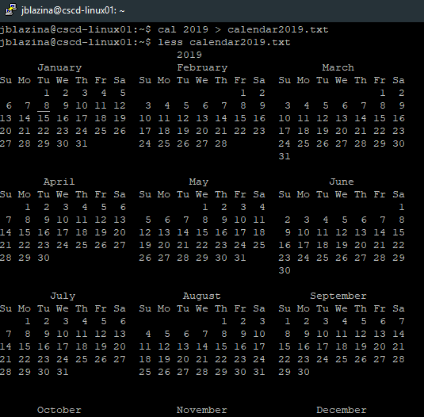
g: Moves to Beginning
G: Moves to End
j: Scroll Down
k: Scroll Up

- Remove read permission from calendar2019.txt for the owner and all permissions for the group. Write down the commands using both symbolic and numeric (octal) values.
Capture the screenshot for the commands and prove that the permission was changed.

Symbolic: chmod u-r calendar2019.txt
chmod g-rwx calendar2019.txt

Octal: chmod 204 calendar2019.txt

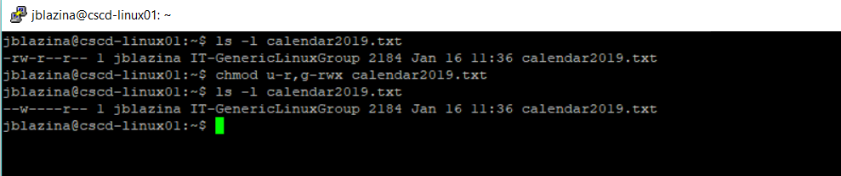

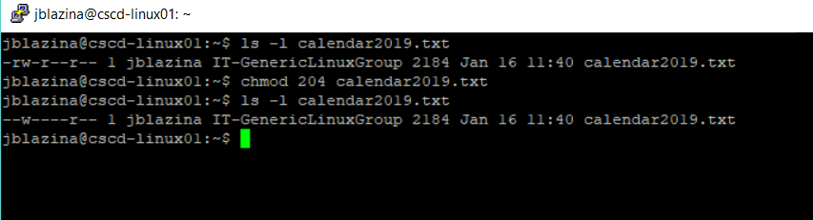

Question 3. Explain the following outputs from a unix command:

-rw-r--r-- 1 syasmin IT-GenericLinuxGroup 3637 Sep 21 2015 file.txt
Explanation: Shows information of a file, this is named file.txt owned by sysasmin that was last modified Sep 21 2018 and is in the IT-GenericLinuxGroup group, with 1 link. Size 3637.
Permissions: User – read/write
Group – read
Others – read

drwx------ 16 syasmin IT-GenericLinuxGroup 4096 Mar 29 2016 CSCD240
Explanation: Shows a directory, this directory is named CSCD240 owned by sysasmin that was last modified Mar 29 2016 and is in the IT-GenericLinuxGroup group, with 16 links. Size 4096.
Permissions: User – read/write/execute
Group – none
Others - none

lrwxrwxrwx 1 syasmin IT-GenericLinuxGroup 15 Nov 21 2015 netstorage -> /mnt/ns-syasmin
Explanation: Shows a symbolic link owned by sysasmin that was last modified Nov 21 2015 and is in the IT-GenericLinuxGroup group, with 1 links. Size 15.
Permissions: User – read/write/execute
Group – read/write/execute
Others – read/write/execute

-rw-r--r-- 2 syasmin IT-GenericLinuxGroup 80 Jan 24 2017 hello.c
Explanation: Shows file information regarding hello.c owned by sysasmin that was last modified Jan 24 2017 and is in the IT-GenericLinuxGroup group, with 2 links. Size 80.
Permissions: User – read/write
Group – read
Global – read

