Jacob Blazina

Lab 4: Playing around with Pointers

- Identify and explain which of the following expressions are valid and which are not valid as shown with an arrow. 5 pts

char c;
char *ptr;
int f;
ptr = &c; This is valid, it will set the char pointer to the memory address of c.
ptr = &f; This is not valid, you will receive a warning about invalid pointer assignment because you are assigning a char pointer to an int value.
ptr = &’#’; This is not valid, # is not a valid variable
ptr = &500; This is not valid, the scalar 500 has no memory address
ptr = &(f+3); This is not valid, cannot increment the memory address of an integer. That is array pointer notation.

- What will be the size of the following pointers? What are their scalar values? Explain with screen shots. 4 pts

int * p; Size is 8 bytes. Scalar value is 4 bytes
double *q; Size is 8 bytes. Scalar size is 8 bytes
char* r; Size is 8 bytes. Scalar size is 1bytes
float* s; Size is 8 bytes. Scalar size is 4 bytes
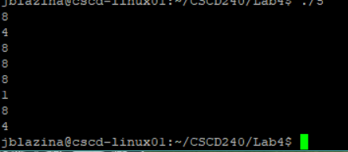

- What is wrong with the following program? Please explain. How will you fix it? 1 pt

#include <stdio.h>
int main(){
int i;
int *ptr = &i;
scanf("%d", &ptr); //change to -> scanf(“%d, ptr);
printf("The value of i is: %d\n", *ptr);
return 0;
}

You cannot use the pointer’s address to input values to. You have to remove the & from ptr in the scanf function for it to work properly.

- What will be the values of the variables in the lines marked with arrows.
NOTE:
Less ambiguous phrasing suggestion. Since she can’t yell at me here.

What will be printed by:
printf(“%d”, c = *p);
printf(“%d”, *p = *p * *p);
printf(“%d”, (*p)++);
printf(“%d”, c = *&a);
int c, a = 10; 4 pts
int *p = &a;
c = *p; c = 10 due to it dereferencing the pointer that is pointing to the memory address of a, which is 10.
*p = *p * *p; the value at the memory address pointed to by p will be multiplied by itself. The new value will be 100 (10*10)
(*p)++; Will print 100, because of the postfix increment.
c = *&a; Sets c to be the dereferenced value at a, so c will now also equal 101.

- Consider the following piece of code. What will be printed by *ptr and ptr after the lines shown with an arrow? Explain with screenshots.

int a[4] = { 8, 3, 5, 6}; 4 pts

int *ptr = a; *ptr will print 8, because it is the first value of the array. ptr will print the memory address of a, which is the same as the memory address of a[0].

ptr ++; *ptr will print 3, because we incremented the pointer by one position. Ptr will print the memory address of a[1].

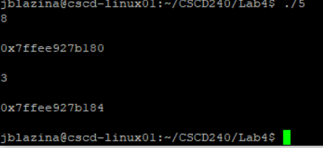
- What is the difference between the following two declarations? 2 pts
char array[] = “Hello World”;
char *array = “Hello World”;
The two declarations are almost the same, a string is just a character array so the second one is a pointer to a character array, while the first one is an explicit declaration of a character array which works the same way. The difference is that the char * declaration makes it immutable while the array[] declaration allows it to be mutable.

Submission:
A pdf file containing answers to the questions and output capture wherever necessary.
Name your file with your last name first letter of your first name Lab4.pdf (ex: yasminsLab4.pdf).

Submission deadline is: 11:59 pm, Monday, February 11. No late submission will be considered.

