Jacob Blazina
CSCD240
Homework 5: All about Files
PART I: Basic File I/O 8 points ( 2 pts each)
Write a Program to create a text file for writing. Use fprintf() to write a simple text message such as “Hello\n” to the file and close it. Now re-open it in read mode and determine the following:
- Whether or not the ‘\n’ character is translated into a line feed sequence. .
Yes, the \n character is translated.
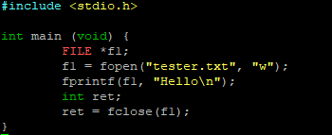
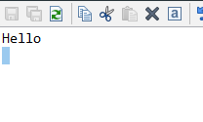
Close the file. Next, open the file in append mode.
- Determine whether the SPI is positioned at the start or end of the file when an existing file is opened in append mode. You can use ftell()/fseek() for that;

SPI is at end of file.
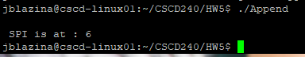

- In append mode, try to use fseek() to move SPI at the beginning. Then write “Goodbye CSCD240\n” in the file. Does it write at the beginning or at the end?

It writes it at the beginning of the file.
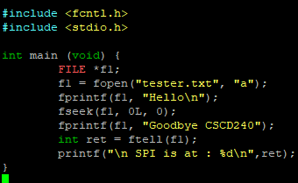

- Whether the operating system permits empty files of zero length to remain in existence after they have been closed.
Yes it seems to permit it
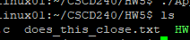
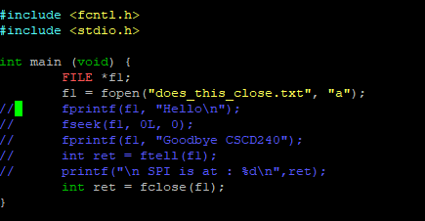

Answer (a) to (d) with code snippets and screenshots in a pdf file named HW5part1.pdf.

PART II: String Match and Empty Line Count in a Text File 8 points (4 + 4)

OUTPUT:
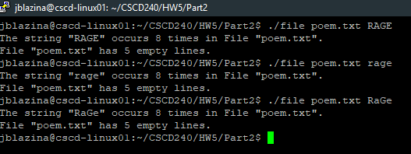

Makefile: For PARTII, you need to use Makefile; split the attached file file.c into three files: (a) header file named fileTest.h and (b) two separate source files: fileTest.c and (c) file.c. fileTest.h will only contain function declaration. For convenience, you can use additional functions. fileTest.c will contain function body. file.c will include the main function only. 4 pts

Submission:
Your final submission will be a zip file that will include the following files: fileTest.h fileTest.c……………….
file.c and
Makefile
HW5part1.pdf
Name your zip file with your last name first letter of your first name HW5.zip (ex:
yasminsHW5.zip).

Submission deadline is: 11:59 pm, Monday, March 18. No late submission will be considered.

