*ST-2*

*Contact List Project*

***DeadLine : 6/Feb/2022 by 6pm***

***Total Marks : 160***

Basic Requirements

* Make a Contact list with fields - (10 Marks)
  + Name
  + Mobile Number
  + Email Id
* Create a input fields with required fields as mentioned above (10 Marks)
* Create new contact should be in separate page and contact should be in separate (20 Marks)

* All should data stored in mongodb (20 Marks)
* It should have Option to Delete contact (10 Marks)
* No two contact should have same email or mobile number (10 Marks)

Bonus Points

* Style the app with your best approach you can use React if you want (20 Marks)
* Add a search-bar to search contact in front end (20 Marks)
* Update contact user can update any of three fields name,mobile no. or email

(20 Marks)

* Write clean code as far as possible should have proper folder structure

(10 Marks)

* Innovation (10 Marks)

Things you need to provide

* A 2-5 min video explaining your code and project (**without video your project won’t be taken you can explain in Hindi/English your choice**)
* GitHub link to your project
* Upload your zip file of your project on Google forms

For Idea you can checkout this Screenshots

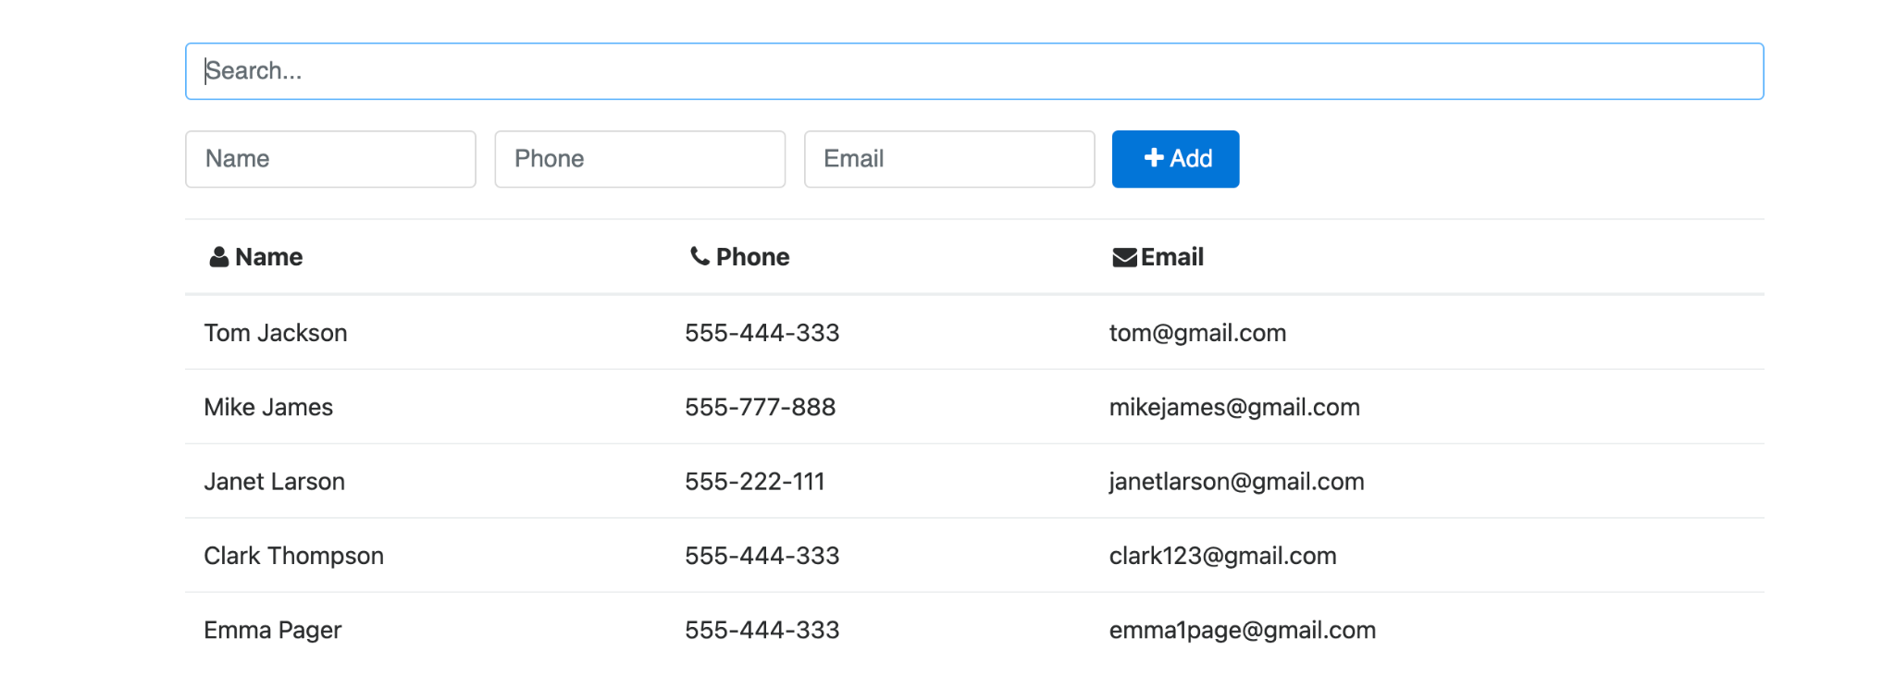

**Add contact should be in separate page else it won't be accepted not on same like this pic it is just to give you an idea**

* Submit your project in this link- https://forms.gle/6ZGqFp579uCfKwhS8