java -Xmx<memory> -cp C:\path\to\MOEA-VELMA.jar;C:\path\to\MOEAFramework-2.6\lib\* org.moeaframework.examples.ga.Velma.runMOEA_nsgaii RandomSeed C:\path\to\CalibratorConfiguration.csvFile PopulationSize NumberOfProcessorsToUse

First, just try up to the runMOEA_nsgaii command.

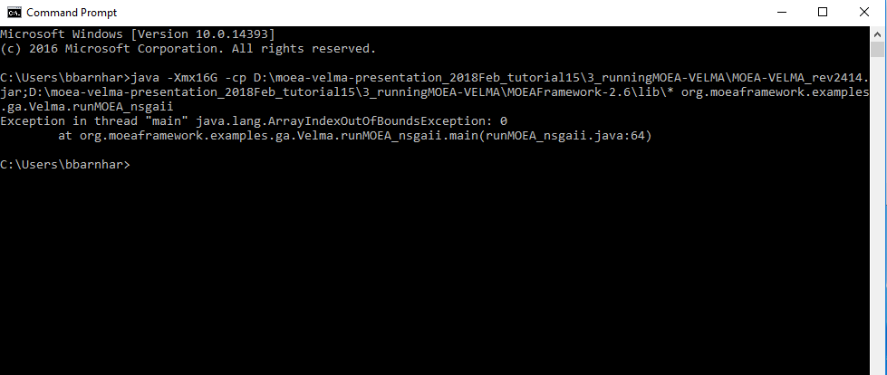

This error is good. All you need to do now is to add the rest of the input parameters, as shown above.

Examples of Other Errors:   
Wrong MOEA name:

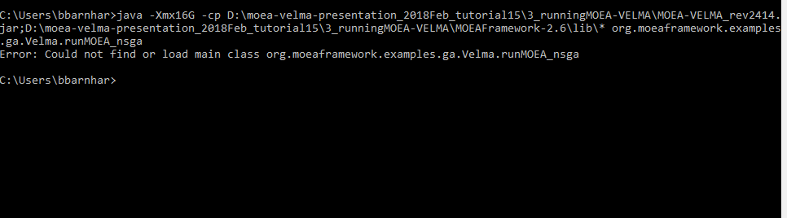

Wrong Path:

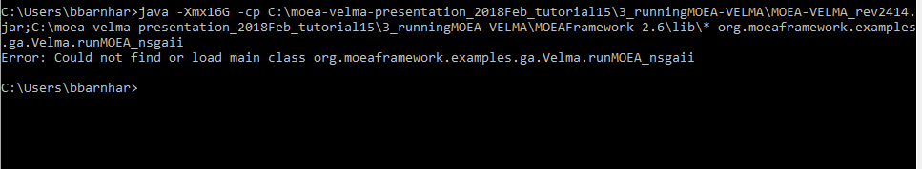

Successful MOEA Run

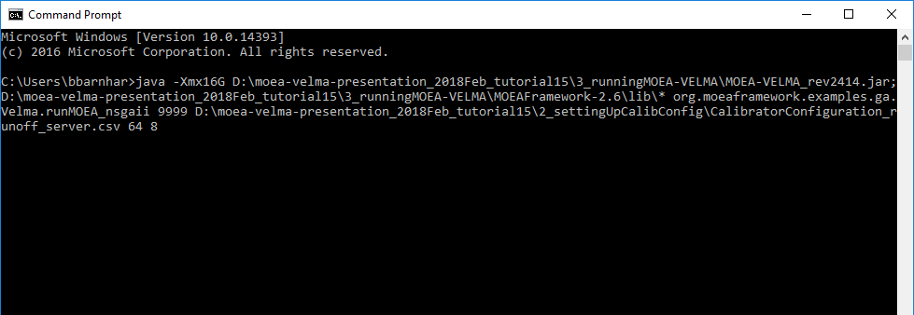

Successful start window:

