Please find attached here the Excel spreadsheet for the market with the 150kgN/ha starting condition. Please note that the best way to regard these results is as the overall baseline condition, with 150kgN/ha as a uniform nitrogen application across all of the grid cells. This results in a total DIN load at end-of-catchment of 492.88 tonnes.

The attached Excel spreadsheet shows this position as the sum of the column titled N150_Nloss (which gives the DIN loss from each grid cell) multiplied by the uniform DIN transport coefficient of 0.73.

Columns towards the left-hand side of the attached Excel spreadsheet show outcomes from running a 'market' with 492.88 tonnes as the overall catchment load cap. The 'market' outcome produces a lower total end-of-catchment DIN load (438.40 tonnes) [calculated as the sum of the (after trading) max_DIN_allow column]. Thus, after 'trading' the initial DIN cap is no longer binding; hence the zero DIN price.

What is happening here is that grid cells on the blue and red soils (see figure below) are already at their GM-maximising N applications (@ 150kgN/ha) so they will chose to retain that position and so don't choose to buy or sell any nitrogen. Whereas grid cells on the green and purple soils can increase their gross margins by reducing their N applications to 120kgN/ha, so they choose to do this with zero inducement i.e. with zero payment. This voluntary revision to N applications reduces the end of catchment DIN load down to 428.40 tonnes.

We also see this. We get 438.40 tonnes as our “No Policy” condition. That is, if the govt agency offers no payments, then the catchment will try to maximize their GM and will choose the best Napp to do so. This results in a total DIN load of 438.40 tonnes to the catchment outlet (assuming a 0.73 transport coefficient).

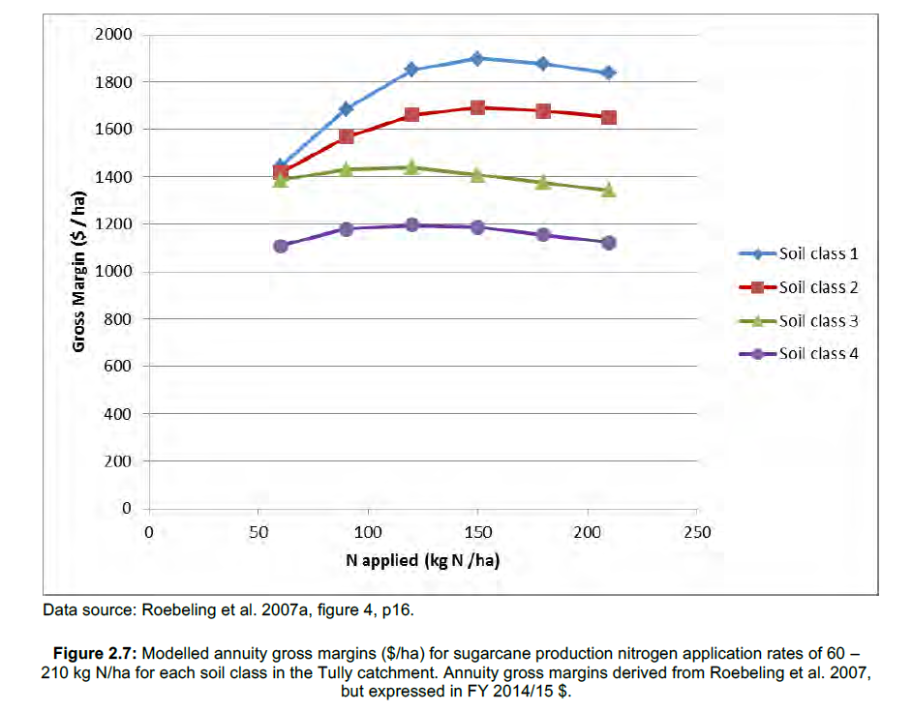

Lin and I have re-run the Tully cap and trade market using the new uniform transport coefficient (0.73). Trading outcomes for initial uniform N-allocations of 120 kgN/ha, 90 kgN/ha and 60 kgN/ha with uniform transport are detailed for each of the 4020 grid cells (decision making units) in the attached Excel files. An Excel spreadsheet for the 150kgN/ha baseline is also attached. The key columns in these spreadsheets are:

 N210_GM, N180_GM, N150_GM, N120_GM, N090_GM, N060_GM:  gross margins for each cell under N_applications of 210, 180, 150, 120, 90 and 60 kgN/ha [relevant before trading)

Napp_rate: Initial nitrogen application rate (kgN/ha) before trading

N_trans: DIN transport coefficient from each cell to the end-of-catchment (receiving waters)

DIN_prices: trading price ($/kg DIN) for DIN at the grid cell (these are now uniform because the transport coefficients are uniform)

max_DIN_allowed: DIN loss from cell (kg DIN) with their after-trade N applications   [N.B. only a modest proportion of N-applied is lost as DIN to runoff and drainage. The 0.73 transport coefficient is a representative loss-weighted average for DIN travelling through the two pathways.]

Napps_after_trade: nitrogen application (kgN) for each cell, after trade

Napps_per_ha_after_trade: (kgN/ha)  [This should make an interesting comparison with the 'after policy' nitrogen applications per hectare from the bi-level optimisation]

GMs_after_trade: ($) gross margins after trade for each cell

GMs_after_trade_per_ha: ($/ha)

Change_in_GMs_through_trade ($): GM from new nitrogen application, after expenditure from trading. Permit purchase incurs positive expenditure. Permit sales generate negative expenditure.

Change_in_GMs_per_hectare_through_trade: ($/ha) [This should make an interesting comparison with the 'after policy' profit outcomes from the bi-level optimisation]

The total end-of-catchment DIN loads under the load caps that correspond to uniform initial nitrogen applications of 150, 120, 90 and 60 kgN/ha are:

150kgN/ha: 492.88 tonnes   [this is the BASELINE total DIN load for the Tully catchment]

120kgN/ha: 314.57 tonnes

90kgN/ha: 200.96 tonnes

60 kgN/ha: 142.64 tonnes

Please don't hesitate to ask if you have any queries, or require any further information about the results in the Excel files.

The March 2020 Special Issue of Applied Economics Perspectives and Policy on  Adoption of Agricultural Innovations could be very helpful as background for our research and papers.