GEMINI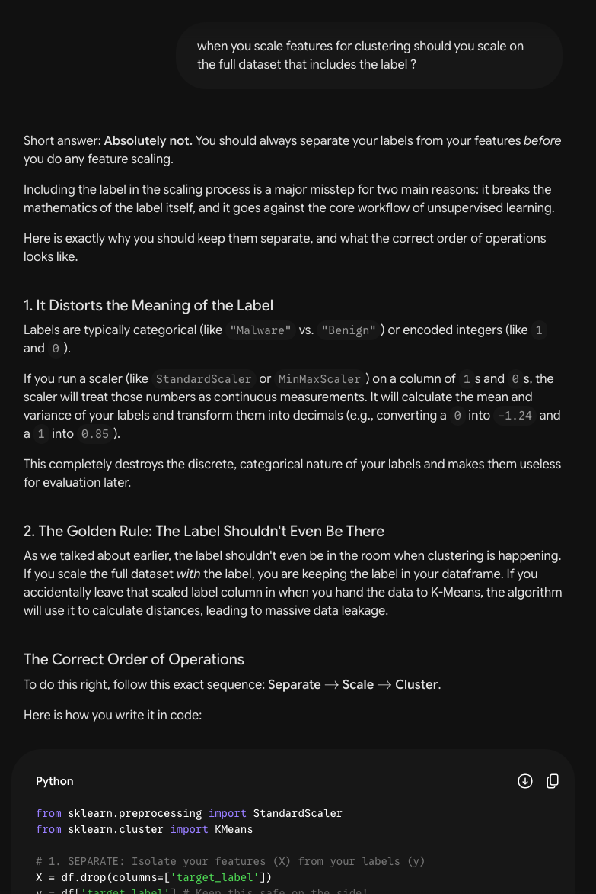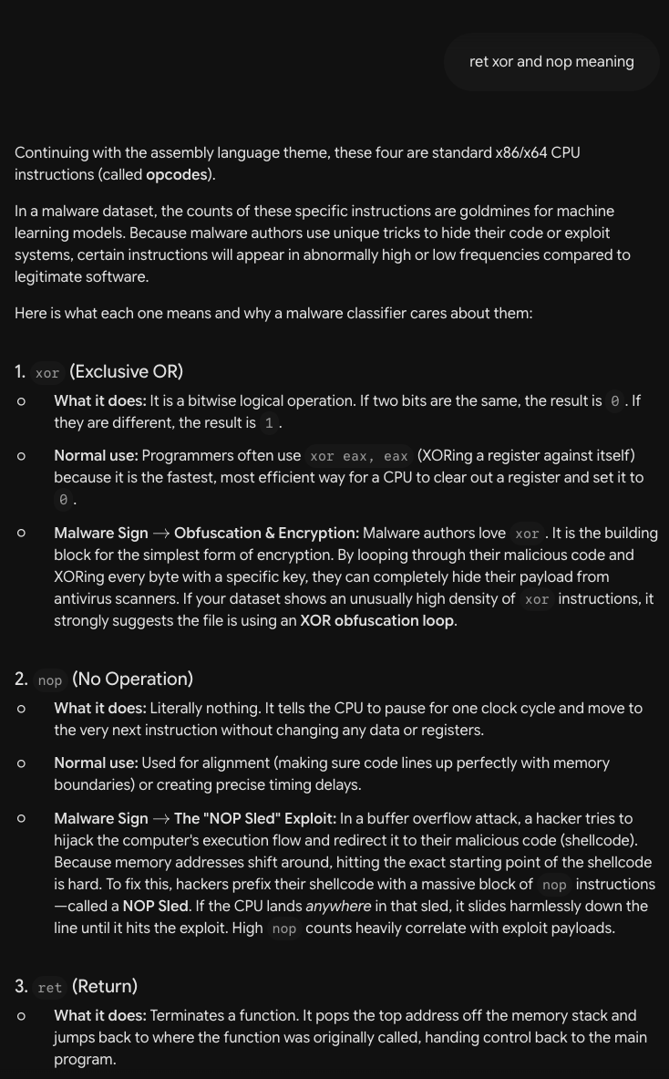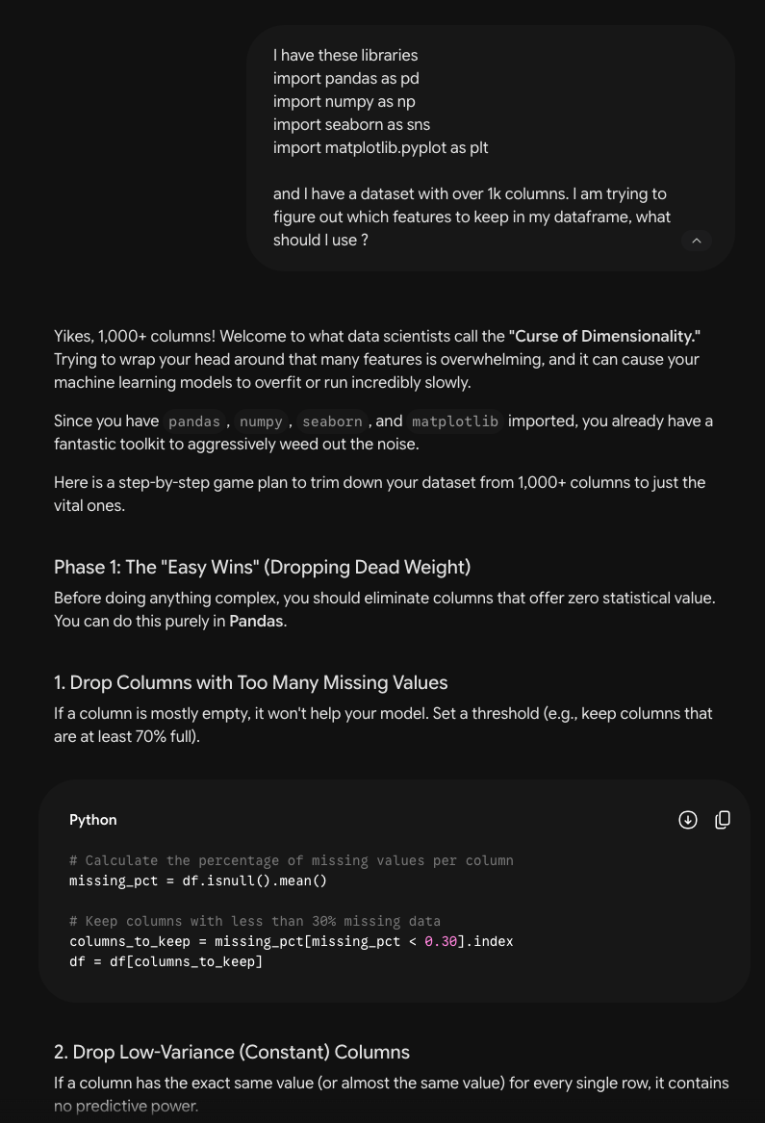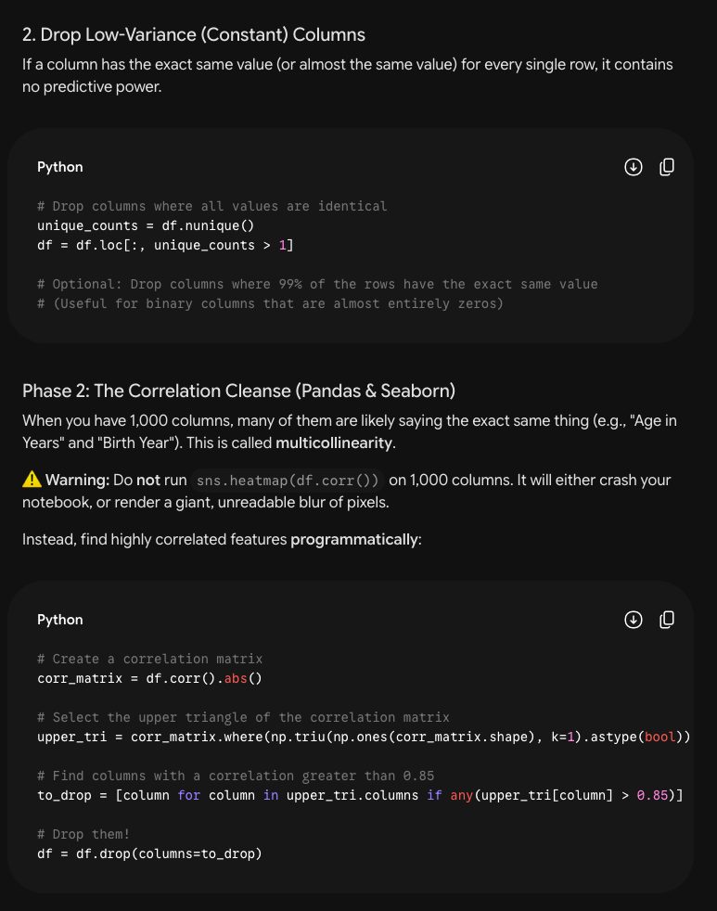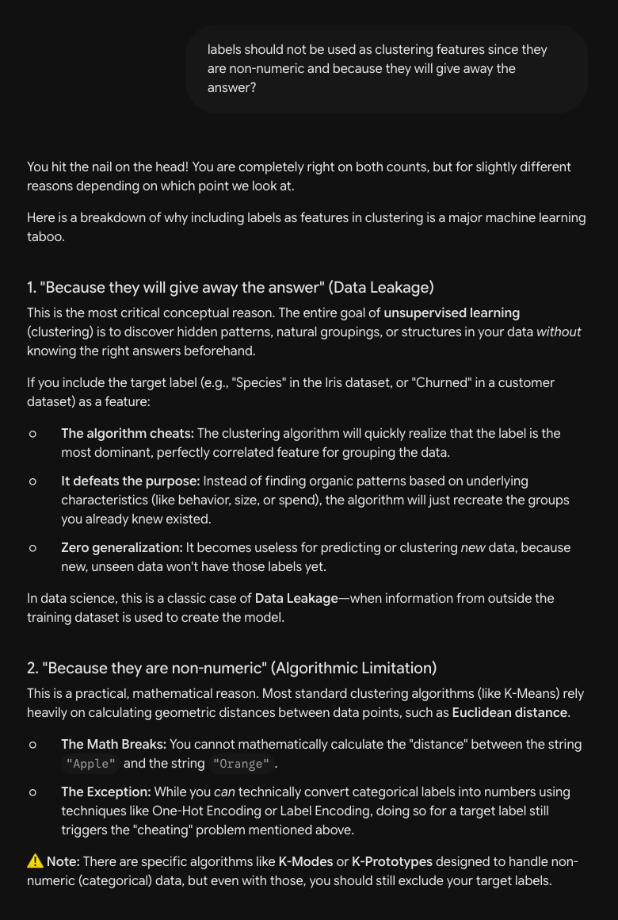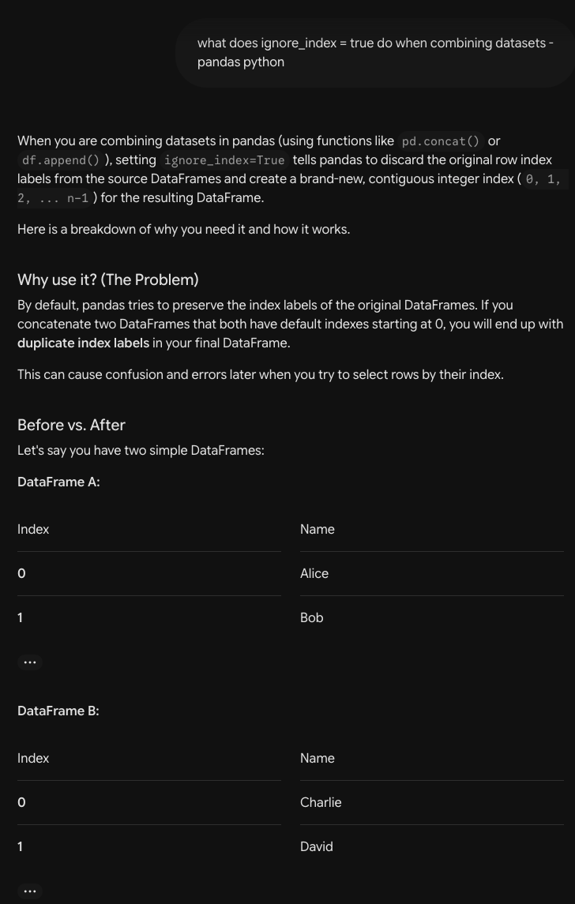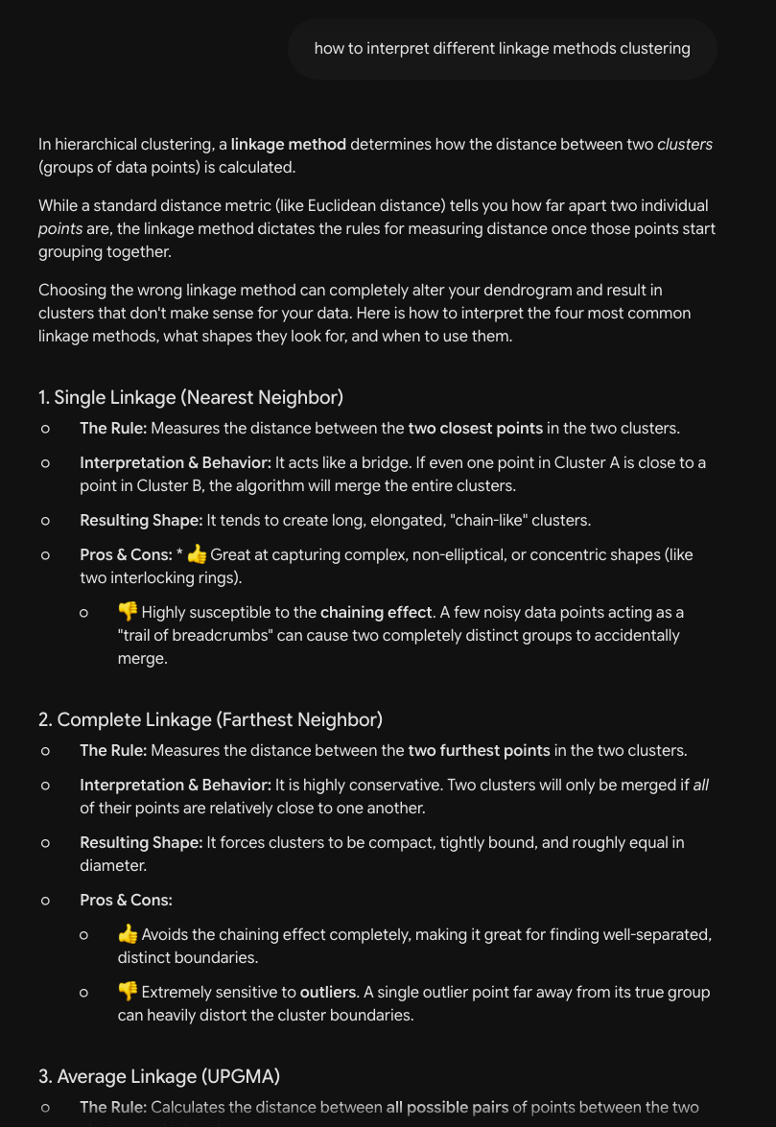

CLAUDE (transcript

## user

Review from the beginning to the PCA before I move on to K-means clustering.

here is what output I need to have so far:

Required outputs:
• First five rows of the combined dataframe
• Shape of each original file and the combined dataframe
• source_label and binary_label distribution tables
• Short explanation of the unsupervised learning rule
Missing value summary before and after cleaning
• List of excluded columns
• Final number of selected features
• Feature selection table
Scaled feature matrix shape
• At least four feature distribution plots
• One correlation heatmap
• One PCA scatter plot
• Short exploratory interpretation

short exploratory interpretation is incoming for the pca and heatmap

## assistant

I'll review the full pipeline against your required-outputs checklist. Let me pull the complete cell sequence with their outputs.

## assistant

Both bugs from last round are fixed — PCA now colors from `y` (`pca_df["binary_label"] = y.astype(str).values`) and the heatmap uses `X_scaled_df.corr()`. I traced the whole path with outputs; the alignment is now correct **by construction**:

- `work` = 17 features + label, attached at 6248 rows aligned → dedup drops **224** rows → **6024** → `X`/`y` split from the same deduped frame → scale `X` only → PCA colored by the matching `y`. ✓ No more luck involved.

## Checklist status

| Required output | Status | Note |
|---|---|---|
| First 5 rows of combined df | ✅ | `df_combined_full.head()` |
| Shape of each file + combined | ✅ | 595 / 2698 / 2955 → 6248×1091 |
| source_label & binary_label distributions | ✅ | value_counts printed |
| Unsupervised-rule explanation | ✅ | brief but present (cell `36a92091`) |
| **Missing-value summary before & after** | ⚠️ **partial** | you only show *after* (on `work`, 0 missing). No *before* summary on the raw combined frame |
| **List of excluded columns** | ⚠️ **gap** | you show *remaining* columns, never an explicit excluded list |
| **Final # selected features** | ⚠️ implicit | `work.shape` shows 18; never states "17 features" |
| Feature selection table | ✅ | cell `e35cfafa` (see note below) |
| **Scaled matrix shape** | ⚠️ **gap** | you `head()` it but never `print(X_scaled.shape)` |
| ≥4 distribution plots | ✅ | exactly 4 |
| Correlation heatmap | ✅ | |
| PCA scatter | ✅ | PC1 26.5% + PC2 9.7% |
| Exploratory interpretation | ⏳ | you said incoming |

Four small additions close the gaps:
```python
# BEFORE cleaning — put right after the combine cell:
print(df_combined_full.isna().sum().sort_values(ascending=False).head(10))

# Explicit excluded list — after features_keep is defined:
excluded = [c for c in df_combined_full.columns if c not in features_keep]
print(f"Excluded {len(excluded)} columns (identifiers, labels, high-missing, low-variance, correlated).")
print("Identifier/label columns explicitly dropped:", ["filename","label","compile_date","source_label","binary_label"])

# Final count — after the split:
print(f"Final selected features: {X.shape[1]}")

# Scaled shape — in the scale cell:
print("Scaled feature matrix shape:", X_scaled.shape) # (6024, 17)
```

## One correctness issue still open (leakage)

Cell `8e863871` still runs the correlation filter with `binary_label` in the matrix:
```python
df_integer_only = df_combined.drop(columns=['source_label']) # binary_label (int) still here
corr_matrix = df_integer_only.corr().abs()
```
So a feature could be dropped *because it correlates with the label* — the one spot still touching the "labels only after clustering" rule. It didn't drop any of your 17 (they all survived), but for compliance:
```python
df_integer_only = df_combined.drop(columns=['source_label', 'binary_label'])
```
Related: your markdown header (`e4a71453`) says you *remove* `source_label`/`binary_label`, but `drop_cols` doesn't — they ride along in `df_combined` through every filter. Functionally fine (you pull the label from `df_combined_full` anyway), but the doc and code disagree. Cleanest is to drop them from `df_combined` and source the label only from `df_combined_full`.

## Minor

- **Feature table honesty:** 9 of 17 rows say *"Randomly chose on visual inspection."* That's honest, but a grader will likely want a reason per feature. At minimum the size/stack ones (`size_init_data`, `Size_image`, `BaseOfCode`, `size_of_stack_reserve/commit`) have a real rationale — image/section sizing and stack config differ between packed malware and normal builds.
- **PCA caveat for your interpretation:** PC1+PC2 capture only ~36% of variance, so the scatter is a coarse 2D shadow of a 17-D space — worth saying explicitly so you don't over-read cluster separation (or the lack of it).

## Heads-up (next section)

The K-Means cells still reference template names that don't exist now — `df_scaled`, `feature_df`, `df`, `label_col`. You'll swap `df_scaled` → `X_scaled`, and decide what plays the role of `df` for the label crosstabs (probably `y`). That's your next round.

Net: the data-flow is clean and leakage-safe except the one correlation line. Add the four print statements and you've satisfied every required output except the interpretations you're already writing.

## user

I don't see a problem with the correlation line, I was just using it to see what columns I wanted to keep not to train any models or anything. i only excluded source_label because it was a str and causing the cell to error

## user

I don't see a problem with the correlation line, I was just using it to see what columns I wanted to keep not to train any models or anything. I dropped source_label in that cell because it is a str and was causing the cell to error

## assistant

You're right, and I'll walk back that flag — it was too strong.

Two things make your case correct:

1. **It doesn't train anything.** A correlation matrix you read to eyeball candidates isn't a model, and your *final* feature set is the hand-picked `features_keep` list. The label never enters `X`, `X_scaled`, PCA, or clustering. That's what the "labels only after clustering" rule actually guards against, and you're clear on it.

2. **In this specific code, `binary_label` can't even bias the auto-drop.** The `to_drop` logic only flags a column if it correlates with a column of *lower index* (the `np.triu(..., k=1)` upper-triangle). `binary_label` is the **last** column, so it's never "above" any feature — the only column it could ever cause to be dropped is *itself*. So even the indirect "a feature got removed because it tracks the label" path doesn't happen here. I was wrong that a feature could be dropped because of it.

And your reason for dropping `source_label` is exactly right: it's a string, so `.corr()` errors on it. `binary_label` stayed only because it's numeric (1/0) now and doesn't error — that's the mechanical reason, not a problem.

So: no leakage, nothing to change there. The only residual is cosmetic — your markdown header says you remove `source_label`/`binary_label` but the code keeps them in `df_combined`. Either tweak the wording or drop them after the correlation step; purely a doc-vs-code consistency thing, not correctness.

That leaves the real to-dos as just the checklist gaps from the table:
- missing-value summary **before** cleaning (the raw combined frame *does* have NaNs),
- explicit **excluded-columns** list,
- `print(X_scaled.shape)`,
- a one-line "final = 17 features."

Those four are what's actually outstanding before K-Means.

## user

Okay review up to and including the elbow plot.

The requirements i am looking to satisfy up to this point are:
18. Run K-Means for K values from 2 to 10.
19. Use random_state=40103.
20. Record inertia and silhouette score for each K.
21. Create an elbow plot and a silhouette score plot.

The requirements I am looking to satisfy next are:
Choose one K and explain your choice.
Visualize the selected K-Means clusters using PCA coordinates.

## assistant

I'll review the K-Means section through the elbow/silhouette plots against requirements 18–21.

## assistant

Reviewed cells `d64bbfc3` (the K-loop) and `0d4796b2` (elbow). Here's how you stand against 18–21:

| Req | Status | Evidence |
|---|---|---|
| 18. K-Means for K = 2…10 | ✅ | `k_values = range(2, 11)` → 2 through 10 |
| 19. `random_state=40103` | ✅ | `random_state=RANDOM_STATE` (=40103) in `KMeans` |
| 20. Record inertia + silhouette per K | ✅ | `k_eval` table shows both for every K |
| 21. Elbow plot **and** silhouette plot | ⚠️ **half** | elbow ✅; **silhouette plot is missing** |

**The one gap:** you compute silhouette into `k_eval['silhouette']` but only plot inertia. Req 21 wants both *plotted*. Add a companion plot:

```python
plt.figure(figsize=(8, 5))
plt.plot(k_eval['K'], k_eval['silhouette'], marker='o', color='green')
plt.xlabel('Number of clusters, K')
plt.ylabel('Silhouette score')
plt.title('Silhouette Score by K for K-Means')
plt.xticks(k_eval['K'])
plt.grid(True, alpha=0.3)
plt.show()
```

Everything else in this block is correct. Minor: the `if k >= 2:` guard inside `evaluate_k_range` is always true (your range starts at 2), so it's harmless dead logic — leave it or drop it.

## Heads-up for your next two requirements (choose K + PCA viz)

Two things worth knowing before you write the "explain your choice" part:

- **The numbers point to K=2, but for a reason you should verify.** Silhouette is highest at K=2 (0.742) and the inertia curve has *no* sharp elbow — it drops almost linearly (≈8k, 7.5k, 4.5k…), so the elbow is ambiguous and silhouette is your stronger signal. That's a clean, defensible justification. **But** a 0.74 silhouette at K=2 on right-skewed count features often means K-Means split off a tiny cluster of extreme outliers (e.g. a few giant `filesize`/`xor` files) from one big blob — which matches your own PCA note that there were "no clear clusters." Before you commit to K=2, print the cluster sizes:
```python
print(pd.Series(labels).value_counts())
```
If one cluster has ~6000 and the other ~20, say so explicitly — that's "high silhouette but not meaningful structure," which is a *better* analysis than just "0.742 is highest." Don't justify K by the benign/malware split — justify it by silhouette + what the cluster sizes show.

- **The next cell (`3612656b`) is still template code** — it references `df_scaled`, `df`, `label_col`, and writes `df["kmeans_cluster"]` / crosstabs on `df[label_col]`. For your PCA-cluster viz you'll swap `df_scaled` → `X_scaled`, reuse your existing `pca_df` PC1/PC2 coords, and color by the K-Means labels instead of `binary_label`. For the label comparison crosstab, use `y` (e.g. `pd.crosstab(y, cluster_labels)`), since you don't have a single `df` carrying the label anymore.

Add the silhouette plot and 18–21 are fully satisfied.

## user

What would the code look like to visualize the selected k-means cluster using pca coordinates

## assistant

You already have the PCA coordinates in `pca_df` (computed from `X_scaled`), and the cluster labels come from that same `X_scaled` — so they're row-aligned and you can just attach the labels and recolor. Here's the cell:

```python
CHOSEN_K = 2 # set to the K you justified

final_kmeans = KMeans(
n_clusters=CHOSEN_K,
max_iter=300,
n_init=20,
random_state=RANDOM_STATE,
)
cluster_labels = final_kmeans.fit_predict(X_scaled)

# cluster sizes — your justification evidence
print("Cluster sizes:")
print(pd.Series(cluster_labels).value_counts().sort_index())
print("\nSilhouette score:", round(silhouette_score(X_scaled, cluster_labels), 3))

# reuse the existing PCA coords (same X_scaled rows, so aligned)
plot_df = pca_df.copy()
plot_df["kmeans_cluster"] = cluster_labels.astype(str)

plt.figure(figsize=(7, 5))
sns.scatterplot(data=plot_df, x="PC1", y="PC2", hue="kmeans_cluster", s=45)
plt.title(f"K-Means Clusters (K={CHOSEN_K}) in PCA Space")
plt.legend(title="Cluster", bbox_to_anchor=(1.05, 1), loc="upper left")
plt.tight_layout()
plt.show()
```

Notes:
- **Alignment is automatic.** `pca_df` and `cluster_labels` both derive from `X_scaled` (6024 rows, same order), so attaching `cluster_labels` as a column is correct — no re-fetch from another frame.
- **Don't re-run PCA here.** You already fit it once; reusing `pca_df` keeps the scatter identical to your earlier benign/malware-colored plot, just recolored by cluster — which makes the two plots directly comparable (a nice thing to show).
- **`.astype(str)`** makes seaborn treat clusters as discrete categories (distinct colors + legend) rather than a continuous colorbar.

For the "explain your choice" requirement, add the label-comparison crosstab right after — this is the *post-clustering* use of the label, which is allowed:

```python
print("binary_label vs K-Means cluster:")
display(pd.crosstab(y, cluster_labels, rownames=["binary_label"], colnames=["cluster"]))
```

That table is what lets you say whether the clusters K-Means found actually track benign-vs-malware or just split off an outlier group — exactly the point I flagged about a high silhouette at K=2.

## user

if i refactored this code would it achieve the same thing:
plot_df = pca_df.copy()
plot_df["hier_cluster"] = cluster_labels.astype(str)

plt.figure(figsize=(7, 5))
sns.scatterplot(data=plot_df, x="PC1", y="PC2", hue="hier_cluster", s=55)
plt.title("Agglomerative Clustering Result")
plt.legend(title="Cluster", bbox_to_anchor=(1.05, 1), loc="upper left")
plt.tight_layout()
plt.show()

## assistant

Mechanically, yes — it's the exact same plotting pattern, so it'll produce the same kind of figure. `sns.scatterplot` doesn't care what algorithm made the labels; it just colors PC1/PC2 by whatever's in the hue column. The `s=55` vs `s=45` is cosmetic.

But two things to check, because that snippet is from your **hierarchical** notebook:

1. **Relabel it, or it lies about itself.** The column is `"hier_cluster"` and the title is `"Agglomerative Clustering Result"`. If this is your K-Means visualization, both are wrong and a grader will read it as the hierarchical plot. Change to:
```python
plot_df["kmeans_cluster"] = cluster_labels.astype(str)
sns.scatterplot(data=plot_df, x="PC1", y="PC2", hue="kmeans_cluster", s=55)
plt.title("K-Means Clusters in PCA Space")
```

2. **The result is only "the same" if `cluster_labels` and `pca_df` are the aligned K-Means objects.** This is the part that isn't visible in the snippet:
- `cluster_labels` must be the **K-Means** output (`final_kmeans.fit_predict(X_scaled)`), not leftover agglomerative labels from this notebook's scope.
- `pca_df` must be the PCA of the **same `X_scaled`** (same rows, same dedup, same order) that produced those labels.

If both come from the same `X_scaled` they're row-aligned and the plot is correct. If you're pulling `pca_df` from one notebook and `cluster_labels` from another, or the dedup differs, the colors silently misalign — same failure mode you already fixed once.

So: same plot, yes — just rename the column/title to K-Means, and confirm `cluster_labels` is your K-Means result and `pca_df` came from the identical `X_scaled`.

## user

these results look terrible. Am I interpreting them wrong?
\=== KMeans: cluster vs binary_label ===
binary_label 0 1
KMeans
0 584 5088
1 11 341
=== KMeans: cluster vs source_label ===
source_label benign malware_virustotal malware_vxheaven
KMeans
0 584 2410 2678
1 11 331 10

=== Hierarchical: cluster vs binary_label ===
binary_label 0 1
Hierarchical
0 591 5217
1 4 212
=== Hierarchical: cluster vs source_label ===
source_label benign malware_virustotal malware_vxheaven
Hierarchical
0 591 2538 2679
1 4 203 9

=== DBSCAN: cluster vs binary_label ===
binary_label 0 1
DBSCAN
-1 30 576
0 565 4709
1 0 46
2 0 36
3 0 25
4 0 37
=== DBSCAN: cluster vs source_label ===
source_label benign malware_virustotal malware_vxheaven
DBSCAN
-1 30 482 94
0 565 2115 2594
1 0 46 0
2 0 36 0
3 0 25 0
4 0 37 0

## assistant

You're not misreading the numbers — but you're reading them as "broken," when they're actually a **coherent and reportable finding**. Three independent algorithms agree on the same story, which is the opposite of a bug. Let me decode what they're saying.

## What the tables actually show

**All three methods produce: one giant mixed cluster + a small carve-off that is almost pure VirusTotal.**

- **K-Means:** cluster 0 = 584 benign + 5088 malware (everything); cluster 1 = 352 points that are **331 VirusTotal, 10 VxHeaven, 11 benign**.
- **Hierarchical:** same shape — cluster 1 = **203 VirusTotal, 9 VxHeaven, 4 benign**.
- **DBSCAN:** big cluster 0 (mixed) + clusters 1–4 which are **46/36/25/37 — every single one 100% VirusTotal, 0 benign, 0 VxHeaven** + ~10% noise.

Two things fall out of that:

**1. The clustering did NOT separate benign from malware.** In every method ~98% of your 595 benign files (584, 591, 565) sit in the *same* cluster as thousands of malware. There is no benign cluster. That matches your PCA observation exactly — the feature space is one dense gradient with no benign-vs-malware gap.

**2. The only real structure that emerged tracks `source`, not maliciousness.** Every small cluster is overwhelmingly `malware_virustotal` with essentially zero VxHeaven and zero benign. So the algorithms aren't finding "malware families" — they're isolating a pocket of VirusTotal samples that happen to share some feature values. **That's a collection/source artifact, not a malware signal** — which is *precisely* the confound your req-41 cell warns about. You now have a live example of it.

## So are you interpreting wrong?

No — you're interpreting them as a failure. Reframe them as a result:

> "Across K-Means, Ward hierarchical, and DBSCAN, the features produced one dominant cluster mixing benign and malware, plus small clusters composed almost entirely of VirusTotal samples. The clusters align far more with **data source** than with **binary_label**, indicating the structure reflects a collection artifact rather than benign-vs-malware separation. ARI/NMI against `binary_label` are correspondingly low."

That's a *strong* discussion paragraph, and it's well-supported by all three crosstabs. Your ARI/NMI cell will confirm it with near-zero numbers — which is the honest, expected outcome, not a mistake.

## Why this happened (worth a sentence in your writeup)

- Benign is only 595 of 6024 (~10%); with Euclidean K-Means at K=2, the split is driven by the *malware* spread, not the tiny benign minority.
- Your features are structural/opcode counts that benign and malware PE files largely share, so they don't encode "maliciousness" — they encode size/composition, which is similar across both classes.

## If you wanted "better" clusters (optional, not required)

Nothing here is wrong to submit. But if you wanted to chase cleaner structure: the source-artifact finding suggests `source_label` separability is stronger than `binary_label` — you could `log1p()` the heavy-tailed count features before scaling to tame the fan, or accept that these features simply don't separate benign from malware and say so. For the assignment, the negative result + the source-confound observation is genuinely the more interesting answer.

Bottom line: the tables aren't terrible — they're telling you the features cluster by *where the sample came from*, not by *whether it's malicious*. Document that and you've nailed reqs 39 and 41.

## user

what does the ari and nmi represent?

## assistant

ARI and NMI are **external validation metrics** — they score how well your clustering (built without labels) matches a known label (`binary_label`), on a single number. Both compare two partitions of the same points: the cluster assignment vs. the true label.

## Adjusted Rand Index (ARI)

Measures **agreement on pairs of points**: for every pair of files, do the clustering and the label agree on whether they belong together? It counts pairs the two groupings put in the same group, and pairs they both separate, then **adjusts for chance**.

- **1.0** = clusters perfectly match the labels.
- **~0.0** = agreement no better than random labeling.
- **negative** = worse than random.

The "adjusted" part matters: with your 90/10 imbalance, randomly dumping everything into one cluster would already "agree" with the label a lot by luck — ARI subtracts that baseline out, so it won't be fooled. That's why it's the more honest of the two here.

## Normalized Mutual Information (NMI)

From information theory: **how much knowing the cluster tells you about the label** (and vice versa), normalized to 0–1.

- **1.0** = the cluster assignment fully determines the label.
- **0.0** = the cluster tells you nothing about the label.

NMI is *not* chance-adjusted the same way, so on imbalanced data it can read a bit higher than ARI for the same partition.

## What they'll show for your results

Given your crosstabs — benign scattered through the big cluster, small clusters that are pure VirusTotal — expect **both numbers to be low (near 0)**. That's the single-number confirmation of what the tables already showed: the clusters don't correspond to benign-vs-malware.

Two interpretation cautions specific to your case:
- **A low ARI/NMI vs `binary_label` is not "the clustering failed"** — it means the clusters don't track *that particular label*. They might track something else (they do: source). You could compute the same metrics against `source_label` and likely get a higher number, which would quantify the source-confound you already spotted.
- **DBSCAN's noise (`-1`) is treated as its own group** in these metrics, which slightly distorts its score — worth noting in your writeup.

So ARI/NMI = "how much does the unsupervised grouping agree with this known label, on a 0–1 scale," with ARI being the chance-corrected (and more trustworthy) of the two.

