About vehicle, I created 4 wheel differential drive vehicle and I added cylinder on the vehicle which radius is 0.5 meter.

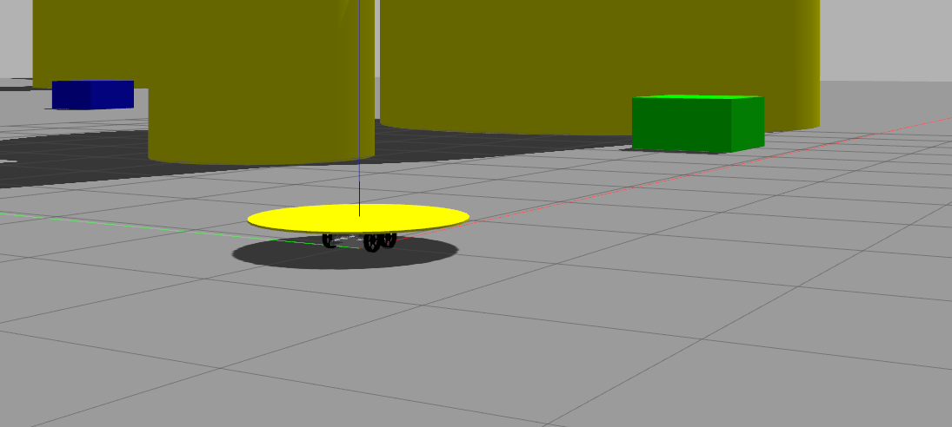
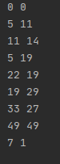
Then, we created a node objSpawner. This run with simulation launch for once. ObjSpawner read the text file and It spawn the obstacles, receivers and senders. Receivers and senders does not have collision because it is symbolic areas to see vehicle reaches there.

There is another node which run other all functions. Firstly, we need to generate the route. It takes coordinates of receivers and senders and it sort them. About the algorithm it looks the nearest point of senders that vehicle has not visited and receivers that vehicle has visited its sender. Then sort them. As you can see figure in right side.

In gazebo, vehicle move with differential drive plugin and it takes cmd_vel as input. We need to control the vehicle. In line_follower function, It takes current position and target position, returns the vector cmd_vel.

After route is generated, we need to generate path to reach target. Firstly, we created graph matrix for aStar algorithm. It takes integer parameter and object matrix which include coordinates of object and radius. Parameter adjust the sensitivity of path currently parameter = 4 which creates 200x200 matrix.

We know the plane for obstacle is moving on has a 50x50 meter length. So we create, as default, a 200x200 Matrix to use it as our grid for the plane. We use 200x200 grid because we want to use as less as computational resourse but in case we need we can increase our grid resolution by the parameter we used to make the grid dynamic.
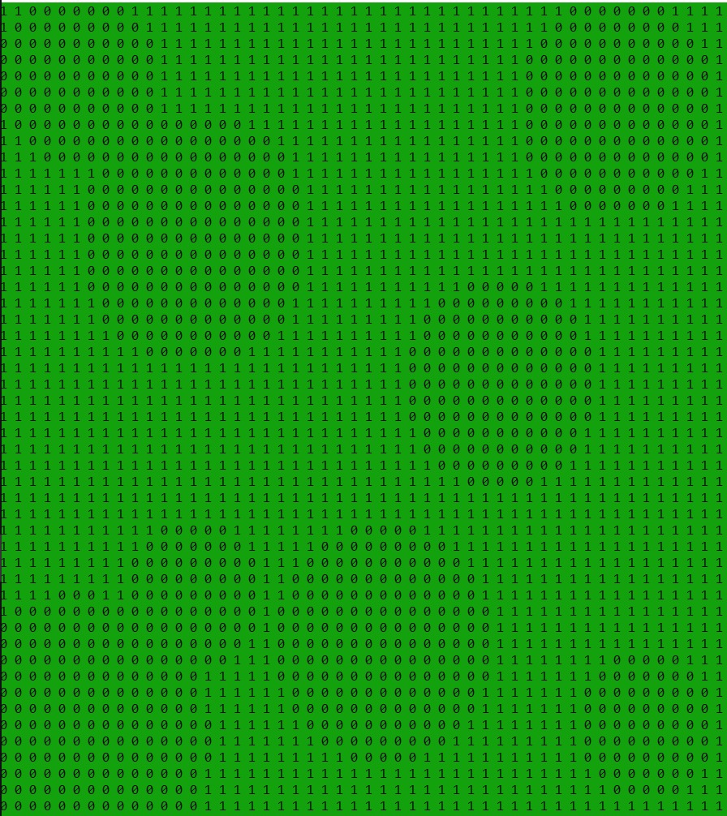

We used A* algorithm to find path between two certain points. We used that method because the alternative way, which is Dijkstra algorithm, relatively used more calculation resourse and time to find best path. Apart from that the implementation of the A* algorithm was relatively easy.

When we try to find heuristics, we could use Manhattan distance or Diagonal distance or Euclidean distance, between them we chose to find our heuristics by Euclidean distance technic. Because it gives us relatively more precise heuristic values then the other two. We create a "struct" structure to keep record of the cell's heuristic and distance from starting point. Apart from that to keep tracking of the path nodes in the matrix we also created parent variables in the struct, both for x and y axis in the grid.

After we created path, line follower takes path coordinates as input and creates the cmd_vel output. Vehicle does not stop until takes the last point of path. It prints the total distance vehicle takes.

