|  |
| --- |
| Circalize  “Impossible to survive >40 seconds”  By Sherry Yuan  Jan 11, 2019 |

**Key Features**

* Supports Java Version 8 and above
* Inspiration from circular motion unit from physic
* No external system needed
* Class “Var” holds variable that will be shared across the class
* Hard to survive more than 40 seconds
* Support Mac and Windows environment
* Recorded highest score

**Content**

Getting Started

To play Circalize, java version of 8 and above should be used.

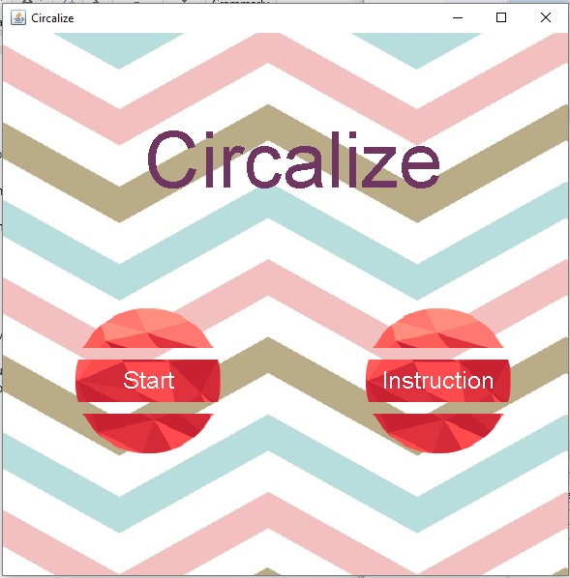

To read instruction, click on “Instruction” button.

|  |  |
| --- | --- |
|  |  |
| Attached | Released |

**Instruction**: The ball (The controlling component) will start off spinning around a pin. Once mouse is pressed, the ball will be released and detach from the pin. The ball only can undergo circular motion again if the ball’s motion path is tangent to the circle. Once the ball is re-attach to the pin, it will continue its circular motion.

The objective of the game is to survive by dodging the blocks and try not to fall out of the field. Each time the ball is attach to a pin, a point will be gained.

|  |  |
| --- | --- |
|  |  |
| Gravitational mode | Space mode |

During the game, there are option to switch to different mode, Gravitational mode and Space mode. To switch between the modes, press “G”. In the gravitational mode, the ball will accelerate down, due to gravity, while in space mode, ball will move in straight line with constant speed. This is a game strategy that can be used to save the ball from colliding with the block.

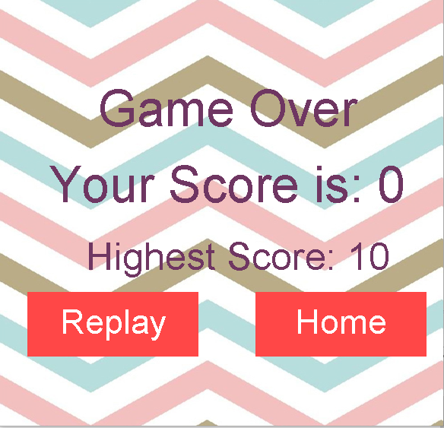

Once the game is over, users have the choice of replay or return to the home page.

If game’s score is higher than the historical highest score, It will be saved to a file called “highScore.txt”.