|  |  |
| --- | --- |
| **Methods** | **Description** |
| KeyPressed | Each time key pressed, the grid will merged corresponding to the direction pressed (A, S, D, W, Q, E, Z, C) |
| keyReleased | Each time key released, check whether the user loss the game, or win the game. |
| mouseClicked | User interaction with buttons by clicking |
| gameOver | Check if the game ended |
| MergeDown  mergeUp  mergeLeft  mergeRight  mergeTopLeft  mergeTopRight  mergeBotLeft  mergeBotRight | Merge the grid corresponding to the directions |
| spawn | Each time a key is pressed, a new node will spawn at a place that is not filled with number |
| createImage | Prepare image needed for the game |
| paintComponent | The graphic get draw inside JPanel, graphic will get repaint according to the condition |
| dimensions | Initialize the grid and screen width and height accordingly to the number of rows and columns. |
| window | Prepare main JFrame that will contain JPanel that updates graphics, and key & mouse event that will be added to JPanel. |

|  |  |
| --- | --- |
| **Variables** | **Description** |
| screenWidth, screenHeight | Control the size of the frame |
| gameOver, win | gameOver = lose, win = win control by Boolean value |
| state | Control game state:  Home = 0, instruction = 1, game = 2, change dimension = 3, result = 4 |
| grid | A 2D array that represents game nodes |
| Row, column | Control the size of 2D array |
| nodeWidth, nodeHeight | Control size of the game node |
| frame | JFrame |
| Win image | the image of win game |
| Arrow image | Arrow indicates by which key is pressed |
| Button image | Image for buttons |

**Sketches**

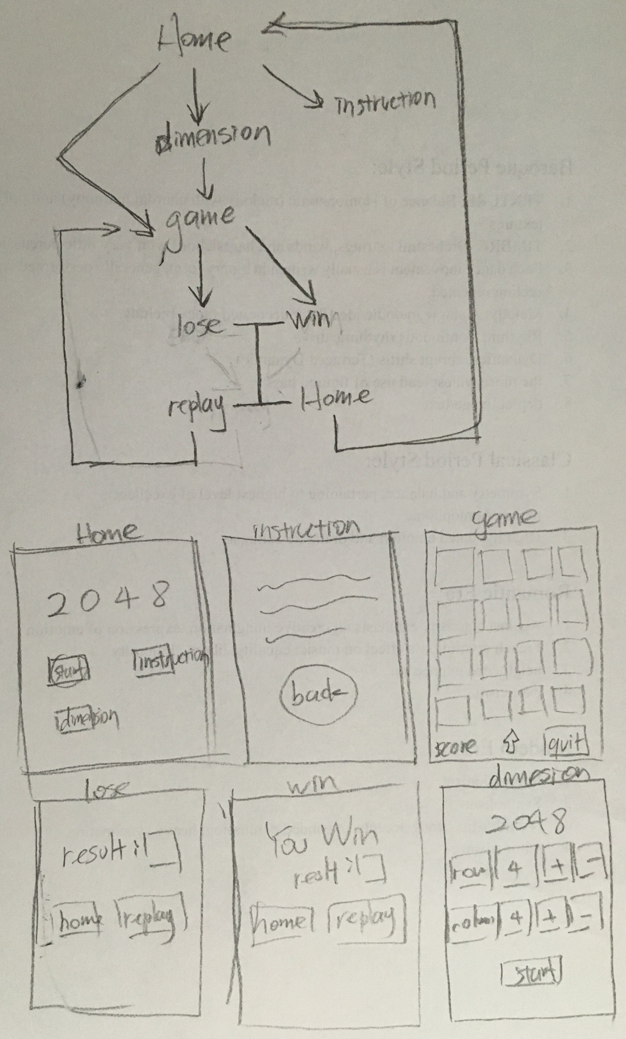

**Logic Planning**

