Cover page

Project title: DATA VALIDATION SYSTEM

Name/surname: BLESSING NWEGAPE

ID number: 1195222

College name: GAUTENG CITY COLLEGE

Lecturer name: MR OWAMI

Date: 22 SEPTEMBER 2026

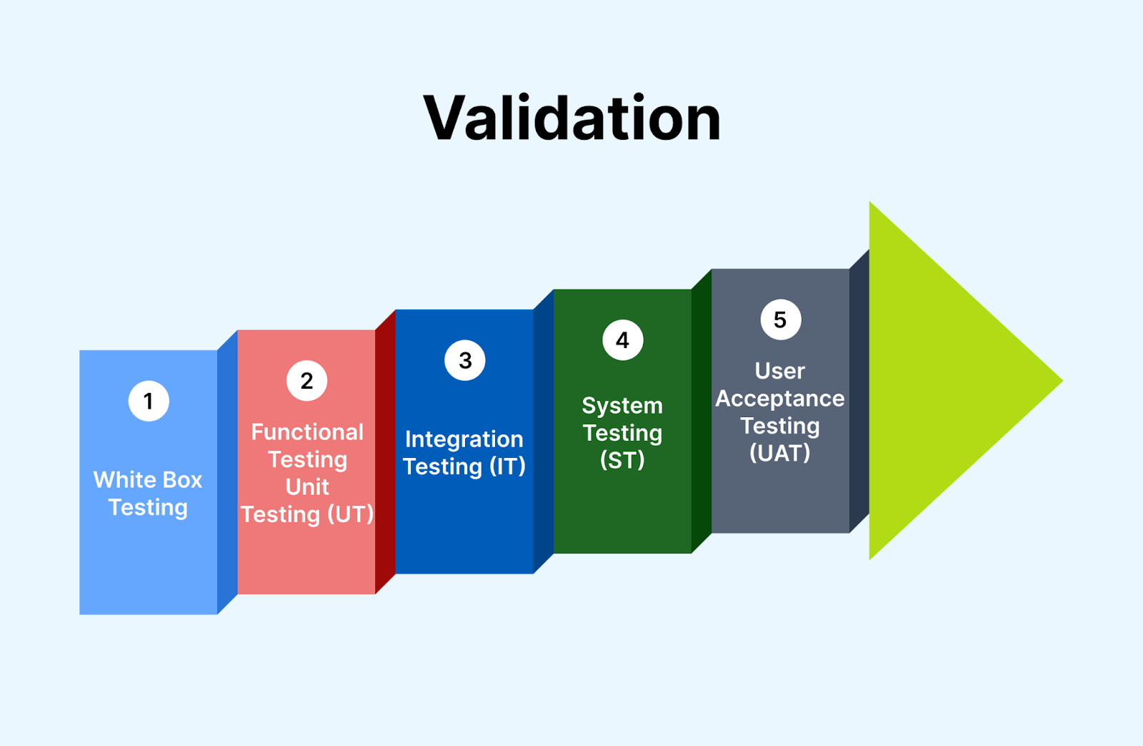

TABLE OF CONTENT

Cover page………………………………………………….1

Table of content……………………………………………..2

Introduction, overview………………………………………………….3

UI component………………………………………………………3

Validation logic…………………………………………………3, 4

Validation button……………………………………………4

Cancel button………………………………………………….4

Sidebar navigation…………………………………………….4

System design………………………………………………..5

GitHub repository………………………………………..5

Conclusion……………………………………………….6

References……………………………………………..6

Data Validation System

Introduction

1. Overview
This is a desktop GUI application built with Java Swing (based on the button styling, spinner control, and window layout). It collects personal or student registration data and validates each field before accepting it into the system.
Suggested class structure:
- ValidationSystemUI.java — builds the GUI (J Frame, J Panel, J Label, J Text Field, J Spinner, J Radio Button, J Button)
- Validator.java — contains the static validation logic for each field
- Main.java — entry point that launches the UI

2. UI Components
Field | Swing Component | Notes
Name & Surname | J Text Field | Free text
ID / Student ID | J Text Field | Alphanumeric
Contact Number | J Text Field | Numeric string
Email Address | J Text Field | Must match email pattern
Age | J Spinner with Spinner Number Model | Numeric range
Gender | J Radio Button (x3) in a Button Group | Male / Female / Other
Validate | J Button | Triggers validation
Cancel All | J Button | Clears all fields
Home / Exit / Help / About | J Button (sidebar) | Navigation

3. Validation Logic
The Validator class centralizes all field-checking rules as static methods, each returning null when the value is valid or an error message when it is not.

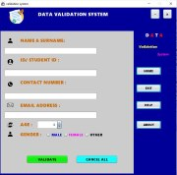

4. Validate Button — Event Handler
The button's Action Listener runs every field's validator, collects any error messages, and either shows a consolidated error dialog or confirms success.
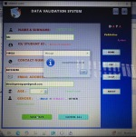

5. Cancel All Button
Resets every field to its default/empty state.
Cancel Button. Add Action Listener(e -> {
Name Field. Set Text ("");
Id Field. Set Text("");
Contact Field. set Text("");
Email Field. Set Text("");
Age Spinner. set Value(0);
Gender Group. Clear Selection();
});

6. Sidebar Navigation
- Home → returns to a main menu (Card Layout switch or new J Frame)
- Exit → System .exit(0)
- Help → opens a help dialog (J Option Pane or separate window)
- About → shows app version / developer info
- 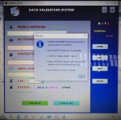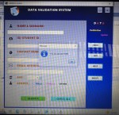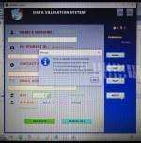

7. System Design

The interface uses a two-panel layout: a wide left panel holding the data-entry form, and a narrower navy-blue sidebar on the right for navigation and branding. This separates data capture from system controls, keeping the form itself uncluttered.

- Color scheme: A dark navy/royal blue is used throughout as the base color, giving the system a professional, corporate feel rather than default Swing grey. White/cream input fields contrast against the blue background so they're easy to locate. Accent colors — a magenta/pink border around the title banner and yellow script-style text for "validation" — are used sparingly to add visual interest without overwhelming the form.

- Branding: A checkmark icon sits besides the "DATA VALIDATION SYSTEM" heading, immediately signaling the form's purpose. The sidebar repeats this branding with a large "DATA" wordmark and "validation system" in a smaller decorative font.

8. GitHub Repository

The complete source code is hosted in a public GitHub repository.

Repository link: https://github.com/ble-001/DATA-VALIDATION-SYTEM/blob/main/README.md

How a marker can clone and run the project:
1. Clone the repository using the link above.
2. Open the project in any Java IDE (IntelliJ IDEA, Eclipse, NetBeans or VS Code).
3. Locate the Main class and run it.
4. The application window will open and is ready for use.
The repository contains a README.md file that also explains how to compile and run the program from the command line.

9. Conclusion

Developing this Data Validation System gave me practical experience in building a complete Java Swing application from design to final testing. The biggest challenges were creating a clean, non-default layout and writing validation rules that give helpful feedback without being overly strict.

I learned how to separate business logic (validation) from the user interface, how to use regular expressions for format checking, and the importance of real-time feedback for a good user experience. The project also reinforced good habits such as meaningful commit messages and keeping a clear README file.

Overall, the system meets all the functional and design requirements of the assignment and is ready for demonstration.

10. References

Oracle. (n.d.). The Java Tutorials – Creating a GUI with Swing. Retrieved from https://docs.oracle.com/javase/tutorial/uiswing/
Oracle. (n.d.). Pattern (Java Platform SE 8). Retrieved from https://docs.oracle.com/javase/8/docs/api/java/util/regex/Pattern.html

