**LS7B Week 2 Lab Worksheet**

In this lab you will use LEGO chromosome models to relate the events of meiosis relate to Mendel’s Laws.

**Part 1. Modeling Meiosis**

Using your LEGO models as an aid, draw the chromosomes as they would appear in each cell shown in the diagram below. For simplicity, you only need to include Gene A and Gene D in your drawings. Be sure to designate which genes/alleles are present in each cell.

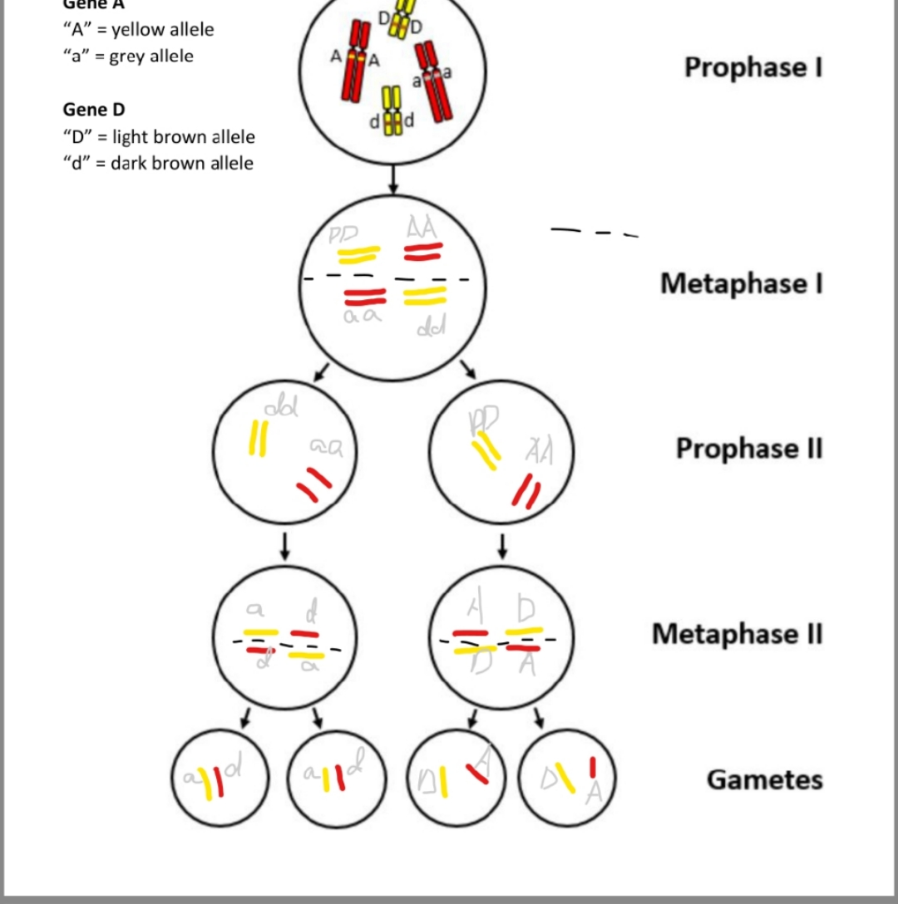

1. Explain Mendel’s principles of segregation and independent assortment.

1) Segregation: gene variants segregate into different gametes; independent assortment: gene variants(allels) of different genes assorted independently into gametes, so one gene's assortment does not affect others.

1. At which phase(s) in your meiosis diagram does segregation of alleles take place? Explain your reasoning.

2) Segregation of alleles: take place during metaphase I for the diagram (it should be anaphase I but not drawn?)

1. At which phase(s) in your meiosis diagram does assortment of genes take place? Explain your reasoning.

3) Assortment of genes: also during metaphase I. when homologous chromosomes separate and align independently at the center plate

**Part 2. LEGO Linkage**

How does crossing over affect assortment of genes into gametes? To understand the physical basis for gene linkage and recombination, you will conduct a simulation and gather data about the recombination frequencies of Genes A, B, and C. For detailed instructions, please refer to the laminated lab guide. Record data from your simulation in the table below. When your group is finished collecting data, add up every column (TOTAL) and enter this in the TA’s spreadsheet.

**Number 5 4 7 4 4 1 8 4 2 2**

**AB:R AC:R BC: NR with 2-7**

**NR for all with 1**

**AB: NR AC:R BC:R with 8**

|  |  |  |  |  |  |  |
| --- | --- | --- | --- | --- | --- | --- |
| **Simulation** | **Gene A & Gene B** | | **Gene A & Gene C** | | **Gene B & Gene C** | |
| **R** | **NR** | **R** | **NR** | **R** | **NR** |
| **1** | 2 | 2 | 2 | 2 | 0 | 4 |
| **2** | 2 | 2 | 2 | 2 | 0 | 4 |
| **3** | 2 | 2 | 2 | 2 | 0 | 4 |
| **4** | 2 | 2 | 2 | 2 | 0 | 4 |
| **5** | 2 | 2 | 2 | 2 | 0 | 4 |
| **6** | 0 | 4 | 0 | 4 | 0 | 4 |
| **7** | 0 | 4 | 2 | 2 | 2 | 2 |
| **8** | 2 | 2 | 2 | 2 | 0 | 4 |
| **9** | 2 | 2 | 2 | 2 | 0 | 4 |
| **10** | 2 | 2 | 2 | 2 | 0 | 4 |
| **TOTAL** | 16 | 24 | 18 | 22 | 2 | 38 |

1. You are now trying to map a new gene locus (Gene X) on chromosome 9. You have determined that the recombination frequency between Gene X and Gene A is 12.5%, recombination frequency between Gene X and Gene B is 25%, and the recombination frequency between Gene X and Gene C is 31.25%. Use this information to determine the location of Gene X. Show your work and explain your reasoning.

The recombination frequency between two gene variants during crossover depends on their physical distance between their loci on their corresponding chromatid.

The closer two alleles are, the less likely they would undergo crossover.

In this case, X is closest to A, then to B, and then to C. Depending on the frequency, if the distance between AX is one map unit, there will be two-units between BX, and around 2.5 map units between CX.

X should be around **pos 3. (**or length AB/3 at 1/3).