Exercise

0. Before you start
- make sure you have “Trust access to the VBA project object model” checked in excel and access:
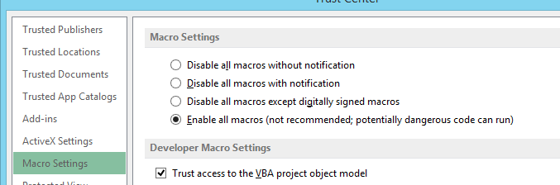
- ODBC Connection
- Create ODBC Connection linked to "\\BG279K12FPS01\Administrative$\Reporting\Data_Reporting\Private\1. Projects\8. Sofia\6.Exercise\VBA\Access DB\Exercise.accdb" in sheet “1.AccessConnection”
-Name the Connection “ODBC_Table” and change the command text to “Select * from tImport WHERE (((tImport.Date) Between #7/6/2018# And #8/8/2018#))” using VBA

- Loops
- Create a sub called “Case_exercise” in module “Exercise”.
- Create a new column (Column S) in sheet “1.AccessConnection” named “Cases”
- Create a code in VBA which will loop through the rows in sheet “1.AccessConnection” and based on the value in column “Split ID” the code must return values in the newly created column. Insert the following values:
If split is below 600 write “5”
If split is between 600 and 799 write value “7”
If split is between 800 and 899 write value “8”
Else write “9”
-Keep in mind that the number of rows could change on refresh of connection

* Tip – Find the last row, create loop using Do or For and use Select Case to write the value in the new column

- Formulas
- Create sub called “TOP_values” in module “Exercise”.
- Find the highest 3 values in Column “Offered Calls”, different from each other using VBA
- Create a field in column “T” named “Top 3”
- Create an excel formula in vba for the new column, which will return “TOP 3” if the value is one of the top 3 values found in step 2, alternative “below Top 3”
- Keep in mind that the top 3 values could change on refresh of connection

*Tip – The excel formula should look like this: if(or(f2=top1,top2,top3),”Top 3”,”below Top 3”)

- Arrays/Connections
- Create sub called “Array_connection” in module “Exercise”.
- Put the whole table from exercise 1 in array
- Find all values in the array with value over “10000” and color those cells in yellow using only VBA
- Find the first value over “10 000” and insert that row in table “tImport” located in the access database from exercise 1 using VBA
- Create an update sql command in vba, which will find the row you inserted and change the field “Site” to your own windows credentials
*Tip – create additional check to verify if the value in the array is in numeric format. Being observant will help you a lot here.

- Outlook/Pivots
- Create function called “Outlook_exercise” in module “Exercise”.
- Create an E-mail with interesting information for Copernicus and add a picture of him in the body using VBA (position text and picture correctly)
- Using the slicer in sheet “2.Pivot” select only the oldest date using vba. Keep in mind that the oldest date might change on refresh of connection
- Attach the file to the Copernicus outlook email and display the e-mail
- The function must return value “True” in the end of the code

- Access password
- There is another database called “Check”, next to database from exercise 1. The password for that database is somewhere in the code
- Find it and create a function called “access_pass” in module “Exercise”, returning the password string

